College Focus Exam #3
Name Date
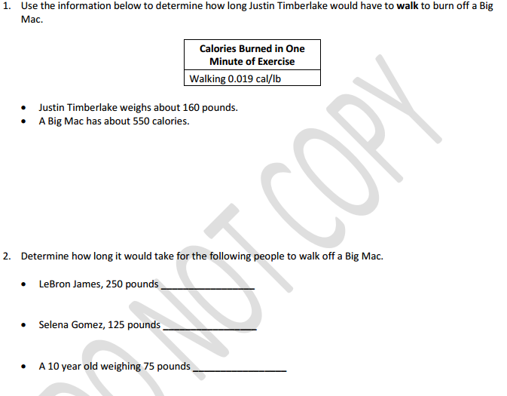

1
#3 (A,B,C,D) #4(M,N)
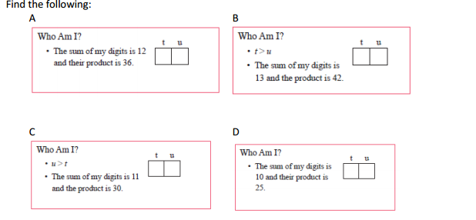5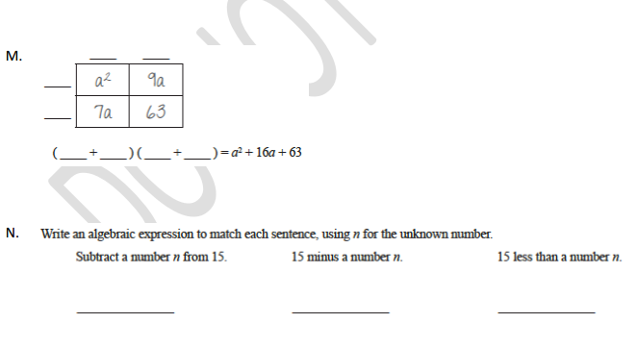
2

6) Sujiter’s age is twice that of his sister. If Sujiter is 16, how old is his sister? 24. Prasanna’s age is twice that of his brother. If his brother is 16, then how old is Prasanna.

7)Carl drove his Prius 55 miles per hour from noon to 2pm: a. How many hours was he driving? b. How far did he go? c. If Carl had kept driving until 5pm, how far would he travel?

8)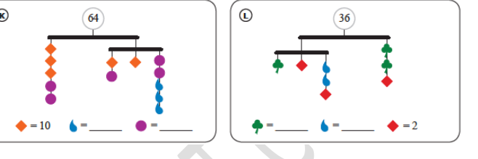

3
9
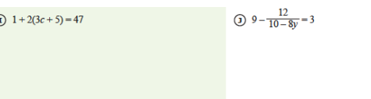
#10
4

Chanllenging Problems #11-12
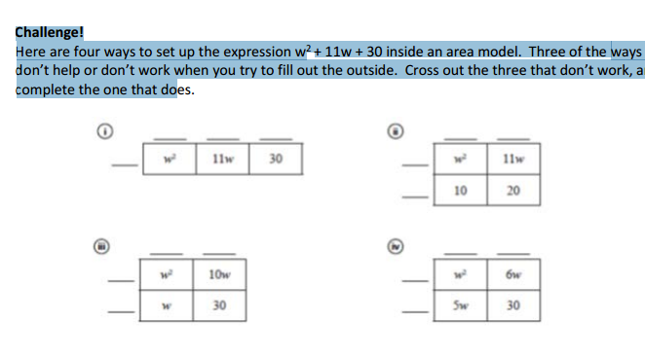

5
#12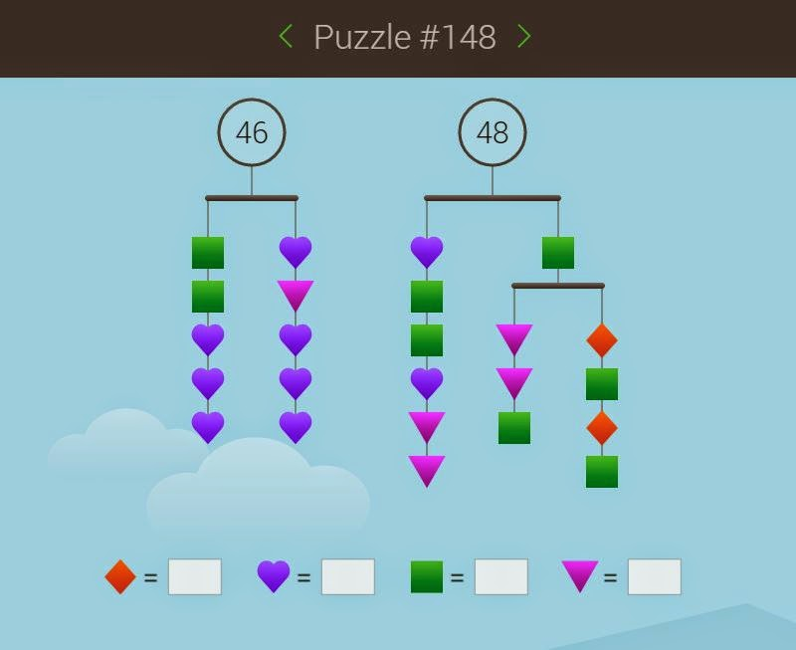

6

