Students’ Voices and Interactions

Ada Mardeda wrote on your Timeline.
March 7 at 2:35pm
I may not say it always.
But, I mean it whenever I say it.
Thank You Teacher
For all the things you have done for me.I was fortunate
I had a teacher
as wonderful
loving and caring
as You.. Happy Teachers Day!! Ju perqafoj zysh :)
Ada Mardeda wrote on your Timeline.
December 31, 2012 at 8:55am
I wish u New Year that brings luck and prosperity..Fills ur home with joy and happiness..Gezuar zysh dhe uroj me te miren per ju...me sh respekt dhe perzemersi...

12UnlikeUnlike ·

Elsa Pepaposted to‎Lucie Mingla
January 20, 2013 near Belvedere, United Kingdom
Zysh Luci we r fortunate that we had a teacher as wonderful, loving, caring as u...............
Happy Birthday
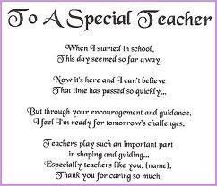
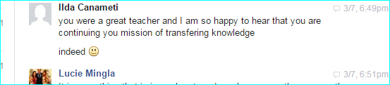
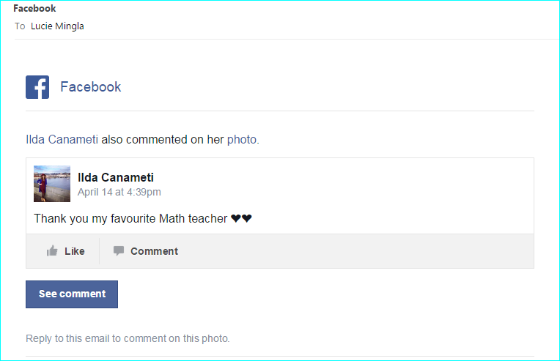

Instructor: L.Mingla
Title: Getting to Know you
Date:
Name:
Course:
Time:
Introduction
You are all amazing people, and I am eager to learn more about each of you. Please help me do so by completing the following handout.
Section I
Please answer questions below:
1. What is your native nationality?
2. How long have you been living in NY?
3. What are you studying for?
4. Where do you see yourself 4 years later?
5. Are you planning to continue your education? Where & what for?
6. What is your favorite activity?
7. What is your least favorite activity?
8. What is your favorite school subject?
9. Have you been involved (or are you hoping to become involved) in any school activities (clubs, sports, etc.)? If so, which ones?
10. What is your favorite type of music?
Section II
Please complete the sentences below.
1. On the weekends I like to…
2. Someone I admire is because…
3. If I could go anywhere for a day, I would go…
4. I learn the most when the teacher…
5. I learn the most when I…
6. I don’t like it when the Professor...…
7. I don’t like it when I’m asked to…
8. I want to know more about….
9. In math I like the most…
10. My ideal job would be…
11. I like to do that job because…
12. Where in the world I can do that kind of job….
13. I like the technology because…
14. The best friend for me is the one that….
15. I want to share with my math professor the fact that….

Math Instructor: L. Mingla
Rules and Routines Student Survey
In a scale 1 to 5 please indicate the importance of:
- Having rules and routines in the classroom
1 2 3 4 5

- Taking charge for my own education.
1 2 3 4 5

- Understanding and doing my assigned work.

- Setting up high expectations for my learning.

- Taking control of my behavior and being a role model for others

- Having a clear stand of disagreement with misbehavior students versus taking advantage and do the same thing

- Understanding that I can be rewarded when I do the right things and following the rules and instructions

- Understanding that are there are consequences for not following instructions and especially for breaking the rules.

- I understand that a better education makes me a better citizen, a better person for myself, my family and the society.

- I understand that my teacher is a certified professional and she is there to help me for my education so I should listen and follow the instructions.

- I know that I need to be college and career ready in order to be prepared for today’ s workforce

Instructor: L.Mingla
Title: Getting to Know You
Binder Section: Daily Work
Date:
Name:
Subject: Mathematics Mat 1375
Period:
Introduction
You are all amazing people, and I am eager to learn more about each of you. Please help me do so by completing the following handout.
Section I
Please answer questions 1-6.
1. Do you have brothers or sisters? If so, how many?
2. What is your favorite activity?
3. What is your least favorite activity?
4. What is your favorite school subject?
5. Have you been involved (or are you hoping to become involved) in any school activities (clubs, sports, etc.)? If so, which ones?
6. What is your favorite type of music?

Section II
Please complete the sentences below.
7. On the weekends I like to…
8. Someone I admire is because…
9. If I could go anywhere for a day, I would go…
10. I learn the most when the teacher…
11. I learn the most when I…
12. I don’t like it when teachers…
13. I don’t like it when I’m asked to…
14. After high school, I will probably…
15. I want to know more about….
16. In math I like the most…
17. My ideal job would be…
18. I like to do that job because…
19. Where in the world I can do that kind of job….
20. I like the technology because…

