$$x^{4 }-2x^{3 }–x^{2}+2x<0$$
$$x\left(x^{3}-2x^{2}-x+2\right)<0$$
$x\left(x-2\right)\left(x^{2}-1\right)<0$
$$x\left(x-2\right)\left(x-1\right)\left(x+1\right)<0$$
So for the equation :
$$x\left(x-2\right)\left(x-1\right)\left(x+1\right)=0$$
Roots are 0, 2, -1, 1
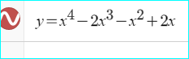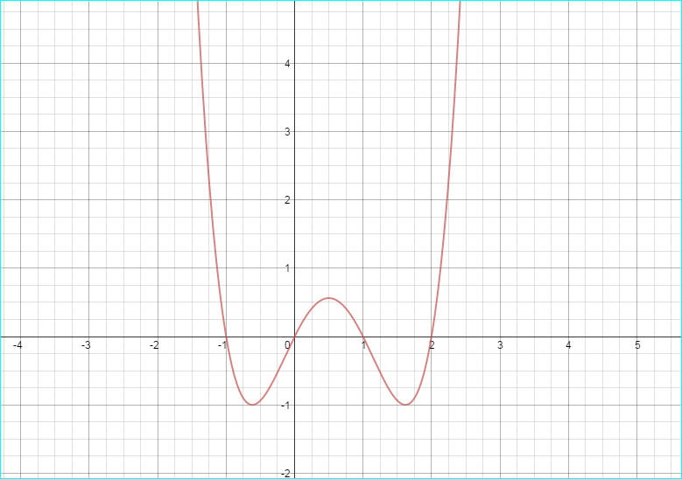
The solution for the inequality is S=[-1,0] U [1,2]

