Early Childhood Caries Prevention

Group Members:

**Hosna Ara**

**Audry Hines**

**Cindy Jimenez**

**Lili Wu**

**Olga Vashkevych**

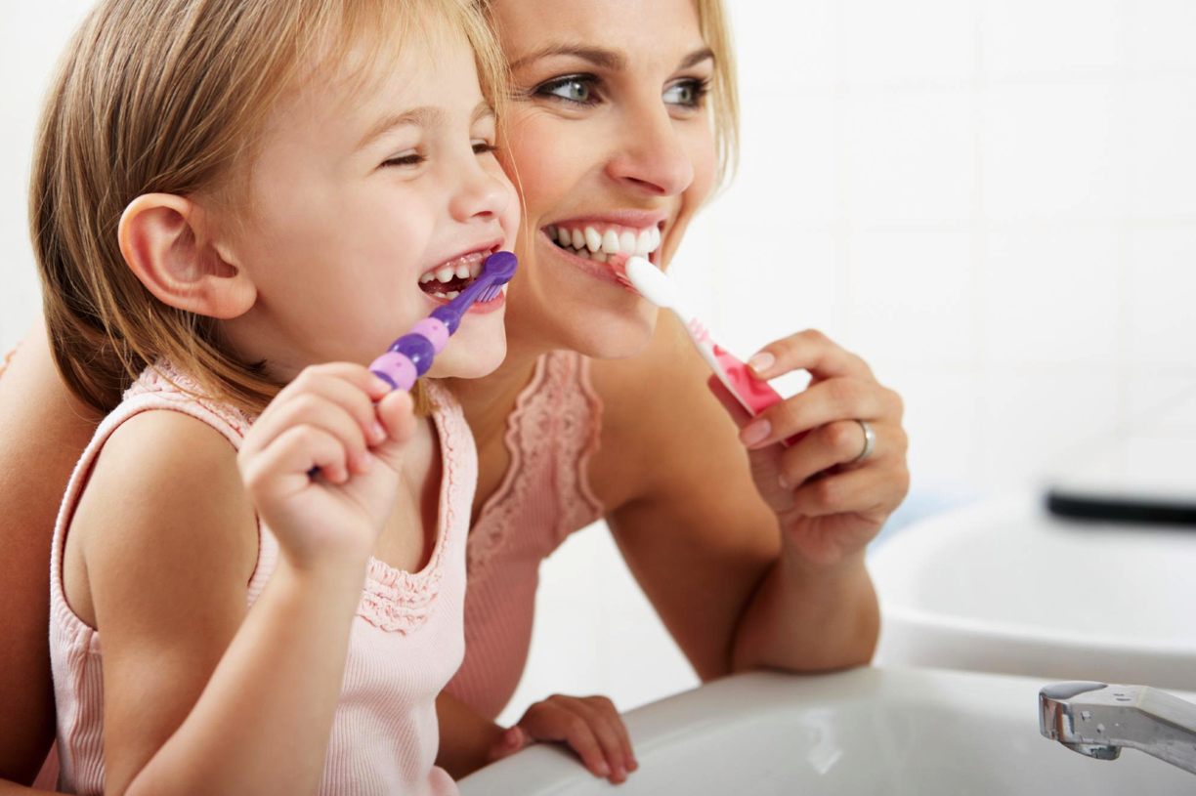

11/15/15

**Professor:** Anty Lam

**Section:** Den 2413/ D270

**Program Topic:** Early Childhood Caries Prevention

**Target Population:** Caregivers (PS 16)

**Setting:** Public School (P.S. 16)

**Introduction:**

Early childhood caries is one of the most common diseases in children; it is a chronic, transmissible and infectious disease. It is the presence of one or more decayed, non-cavitated or cavitated lesions, primary teeth missing due to caries, or filled tooth surfaces in any primary tooth in a preschool-age child between birth and 71 months of age. As stated in the article, “Prevalence of early childhood caries among 3-5 year old pre-schoolers in schools of Marathahalli, Bangalore” by Shilpi Singh, “ECC prevalence varies from population to population; however, children of disadvantaged subpopulations, regardless of race, ethnicity or culture, have been found to be most vulnerable. Statistics indicate that one-third of children ages 2–5 in the United States have experienced caries. (1) Dental caries can lead to serious complications and have detrimental effects on children’s lives, including potentially disabling or fatal infections. (1) Approximately 37% of children aged 2–8 years had experienced dental caries in primary teeth in 2011–2012. Dental caries among children aged 2–5 were nearly 23% compared with 56% among those aged 6–8. (2) According to the article, “Early Childhood Caries” by Yumiko Kawashita, “children should be targeted with a professional preventive program, that includes oral hygiene instructions for mothers or caregivers, along with fluoride and diet counseling.” Therefore we developed a program that targeted pre-school children’s caregivers to increase awareness on the prevention of early childhood caries.

**Assessment:**

*Method: Questionnaire/Survey (See sample questionnaire attached)*

Since early childhood caries is one of the most common diseases among children, we targeted a pre-school that was attended primarily by disadvantaged children with low socioeconomic status. We wanted to evaluate caregiver’s knowledge on oral health and at the same time educate them and bring about behavioral changes. We were able to gather 30 parents of children attending PS 16. We utilized the schools lounge room to implement our activities, a questionnaire was introduced to the parents and it was evaluated by a group of 4 volunteers. Based on the assessment it was determined that 80% of attendee’s children were at high risk for caries, 65% has or had a cavity. We concluded that the issue was frequent sugar ingestion thru baby bottle or baby cup use and frequent snacking. From this small group of people we were able to conclude that childhood caries may be a major problem for this population of children as a whole and for that matter we focused on educating caregivers.

**Planning:**

We had a meeting with the school director to whom we introduced our program and ideas and obtained consent to bring about our activities.The goal of this program is to increase the awareness of early childhood caries among parents/caregivers of preschoolers in order to reduce the caries rate of children less than 5 years of age. Our objective is to introduce parents with different strategies that would help them maintain their children caries free. We will conduct a 30-minute presentation. At the conclusion of this program we expect the parents to be familiar with various caries prevention and intervening strategies, be able to conduct proper oral hygiene practice on their children and be able to differentiate between healthy vs. caries-inducing snacks. We will distribute flyers in person and post flyers on school bulletin boards two weeks in advance to invite parents/caregivers to our event. The event will take place on a regular school day morning after the parents drop off their children. It will be held in a school lounge with a capacity, which could contain about 40 participants. The school will provide a laptop computer and a projector for the presentation.

About 40 parents will be expected to attend the event. Upon arrival, a short questionnaire will be distributed. Through the assessment process we will identify nutritional habits such as frequency of sugar ingestion and provide dietary counseling. We will discuss about bottle weaning techniques and how to distinguish between healthy vs. unhealthy/high sugary content snack choices. At the end, we plan to encourage the parents to periodically take their children for a dental visit.

**Implementation:**

We utilized flyers and posters on the hallway walls as an advertisement of our event. Thirty parents attended our event. First we introduced ourselves and handed out questionnaires with simple questions such as “how many snacks does your child have each day?” While questionnaires were evaluated a short video presentation was introduced to the parents about the importance of first year dental visits. PowerPoint slides incorporating short video clips and vivid pictures were utilized for better retention. We started our presentation with short speech about caries formation due to frequent sugar exposure. We talked about nutritional habits and healthy snack choices for the kids of this age group. We explained to the parents why it is important to limit sugary drinks, avoid sweet and sticky snacks and give a preference to fruits, vegetables and drinking water. We introduced the parents to Xylitol gums and candies and explained to them how they can be a good alternative to regular sweets because xylitol has an antimicrobial effect and can help to fight the cariogenic bacteria in the oral cavity.

In conclusion, we explained to the parents that baby teeth are very important and that caries in the primary dentition increases the risk of caries in the secondary dentition. Therefore, it is essential to take care of baby teeth, choose healthy diet for the child and schedule dentist visits every 6-month. After the presentation, handouts printed with brief oral hygiene instructions and teeth eruption timeline were distributed to the parents as take-home references.

**Evaluation:** *Summative*

In order to evaluate the effectiveness of our program we needed to measure caregiver’s knowledge towards oral health care after our presentation. In addition, we wanted to collect information about how successfully the course proceeded among all the parents’ points of view.

To evaluate the changes in knowledge and behavior among the participants a post survey was conducted at the end of the session. Questions were based on what we introduced through our PowerPoint presentation. The post surveys were analyzed to justify their depth of knowledge. About 80% of the parents were able to answer the questions and gave positive responses. Almost all parents were able to understand the consequences of high sugar food intake. They also understood how the frequency of high carbohydrate containing food related to high caries incidence.

Overall the results indicate that the goal of this program was achieved. The parents were very interactive. All parents showed an overall increase in knowledge and were confident and conscious about food choices and how to prevent their children from developing caries.

**SAMPLE QUESTIONAIRE:**

Answer the following questions by checking Yes/No on the left column

**YES NO**

|  |  |
| --- | --- |
|  |  |
|  |  |
|  |  |
|  |  |
|  |  |
|  |  |
|  |  |
|  |  |
|  |  |

1. Do you think baby teeth are as important as adult teeth?
2. Does your family drink water with fluoride in it or do your children take fluoride tablets?
3. Does your child use toothpaste with fluoride in it?
4. Do you help your child with tooth brushing?
5. Have you or your children ever had a bad dental experience?
6. Any of your children ever had cavities?
7. Does your child complain of mouth pain?

**8.** Does your child take a bottle to bed?

**9**. Does your child walk around drinking from a bottle cup?

**How many snacks does your child have each day?**

**1 2 3 4 More**

**___ ___ ___ ___ ___**

**Office Use Only:**

**Low Risk High Risk**

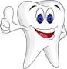 **_____ 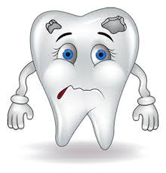_____**

**References:**

1. Çolak H, Dülgergil ÇT, Dalli M, Hamidi MM. Early childhood caries update: A review of causes, diagnoses, and treatments. Journal of Natural Science, Biology, and Medicine. 2013;4(1):29-38. doi:10.4103/0976-9668.107257.
2. Kawashita Y, Kitamura M, Saito T. Early Childhood Caries. International Journal of Dentistry. 2011;2011:725320. doi:10.1155/2011/725320.
3. Singh S, Vijayakumar N, Priyadarshini HR, Shobha M. Prevalence of early childhood caries among 3-5 year old pre-schoolers in schools of Marathahalli, Bangalore. Dental Research Journal. 2012;9(6):710-714
4. R. Gary Rozier, Sally C. Stearns, Bhavna T. Pahel, Rocio B. Quinonez and Jeongyoung Park How A North Carolina Program Boosted Preventive Oral Health Services For Low Income Children Health Affairs, 29, no.12 (2010): 2278-2285 doi: 10.1377/hlthaff.2009.0768
5. Dye BA, Thornton-Evans G, Li X, Iafolla TJ. Dental caries and sealant prevalence in children and adolescents in the United States, 2011–2012. NCHS data brief, no 191. Hyattsville, MD: National Center for Health Statistics. 2015