Learning Places Summer 2017
SITE REPORT #1

Gowanus and Housing
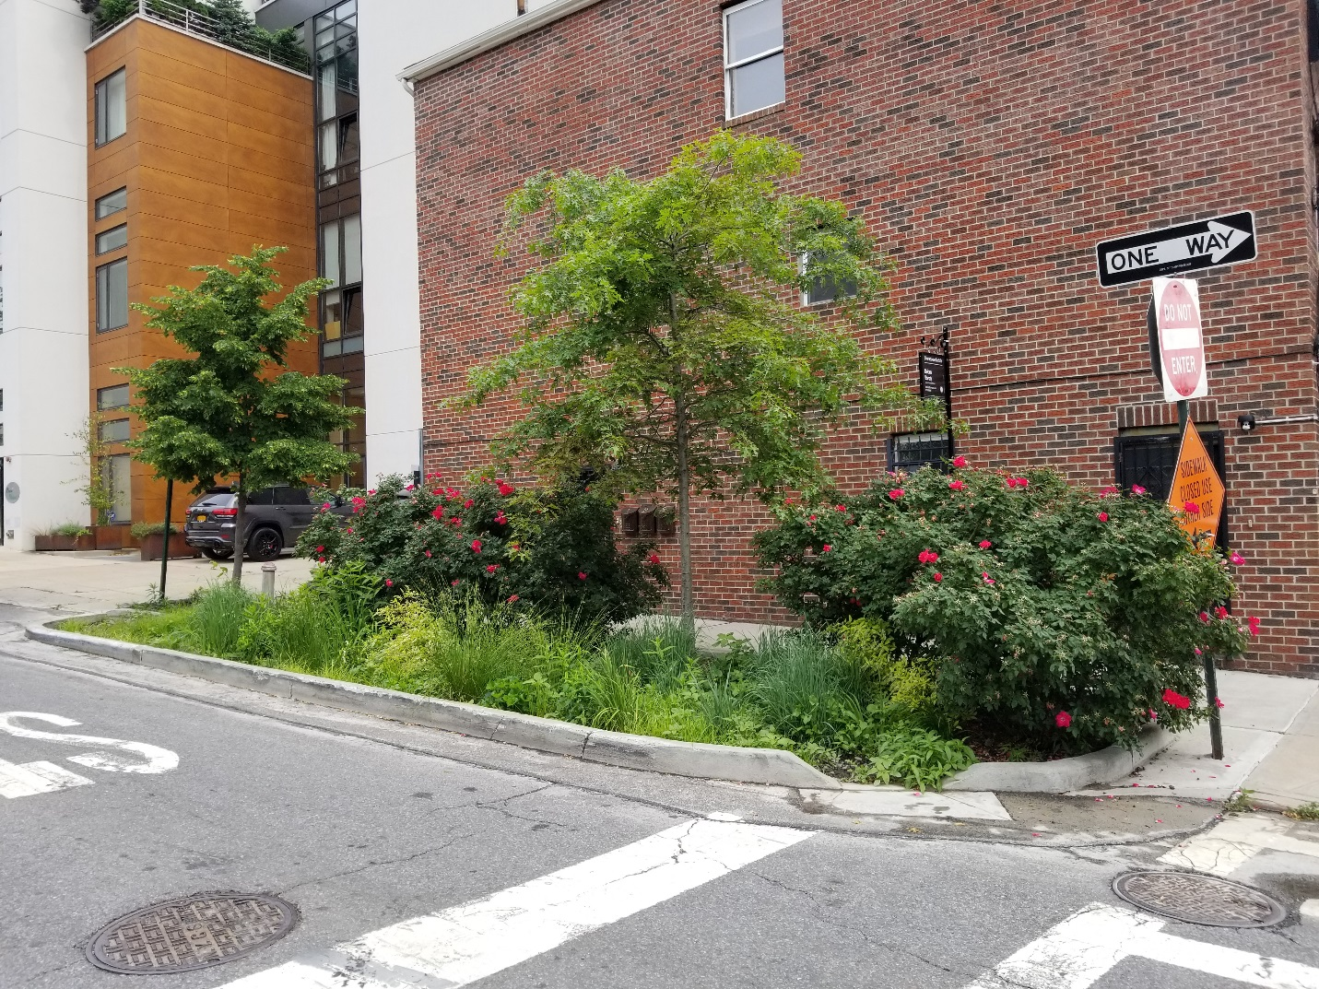

Isaiaah Mccullon
6.12.2017

INTRODUCTION
I never understood what attracted me to the Gowanus, maybe it was the art morals shown around the area, maybe it was the people who lived there or just maybe it was the cultural background of different varieties of food at festivals. However, just about a year ago, being that I’m a student of architecture, my design class was focused on designing a library that would help clean up the canal. As I research Gowanus and walked the streets of the Canal, I began to be aware of the pollution in the area but I noticed that Gowanus is a place that was filled with life despite the negative. Gowanus is where you have historical buildings mixed with old and new infrastructure. Gowanus was the home of multi industries dating back in the 1860’s with a canal built from an existing creek. Today, this neighborhood (Gowanus) is going through tremendous changes trying to better the area which is in dying need.

SITE DOCUMENTATION of GOWANUS
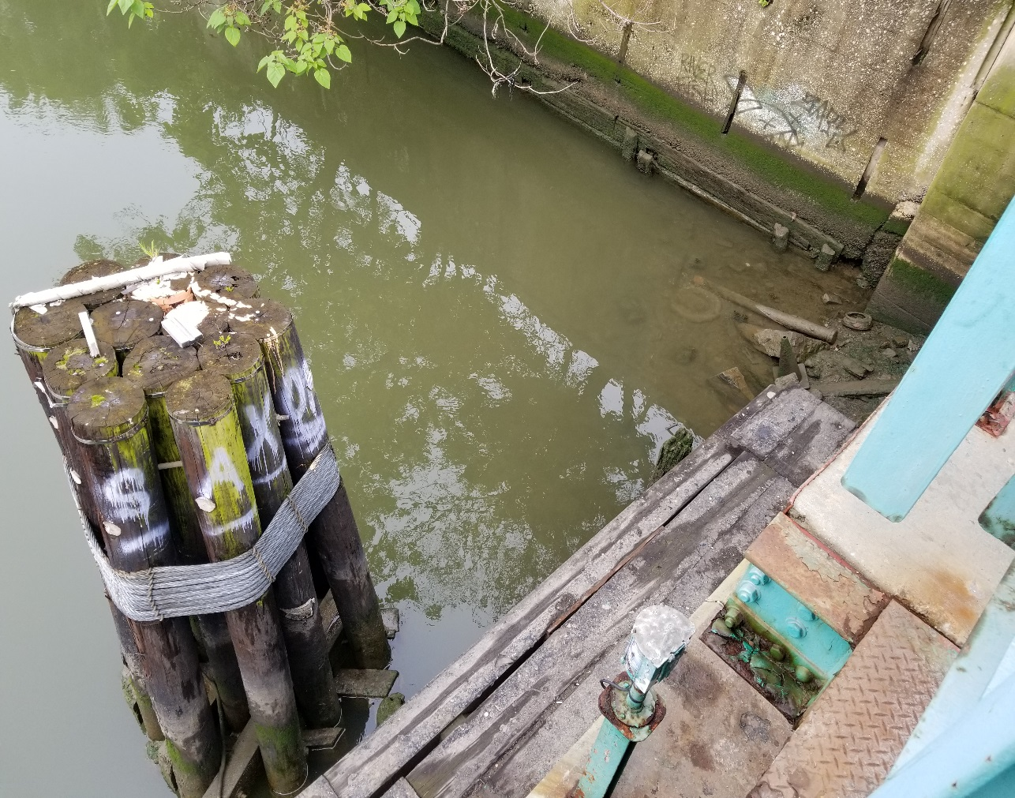
This picture was taking on the Union Street Bridge facing South of the Gowanus Canal. This area was one of the most dominated industries were and just about 100ft lies a sewer system that dumbs storm and waste water into the canal. What is shown in this picture is the polluted water bed with unidentified items. Items that are cover with black, greenish sludge which gives the water in the canal its color around this section of the canal. It is also shown that the Gowanus Canal is extremely out dated of sustainable materials to help keep the canal clean, meaning there’s evidence of lack of maintenance or care of the polluted canal. Furthermore, there are no plants growing in this area.
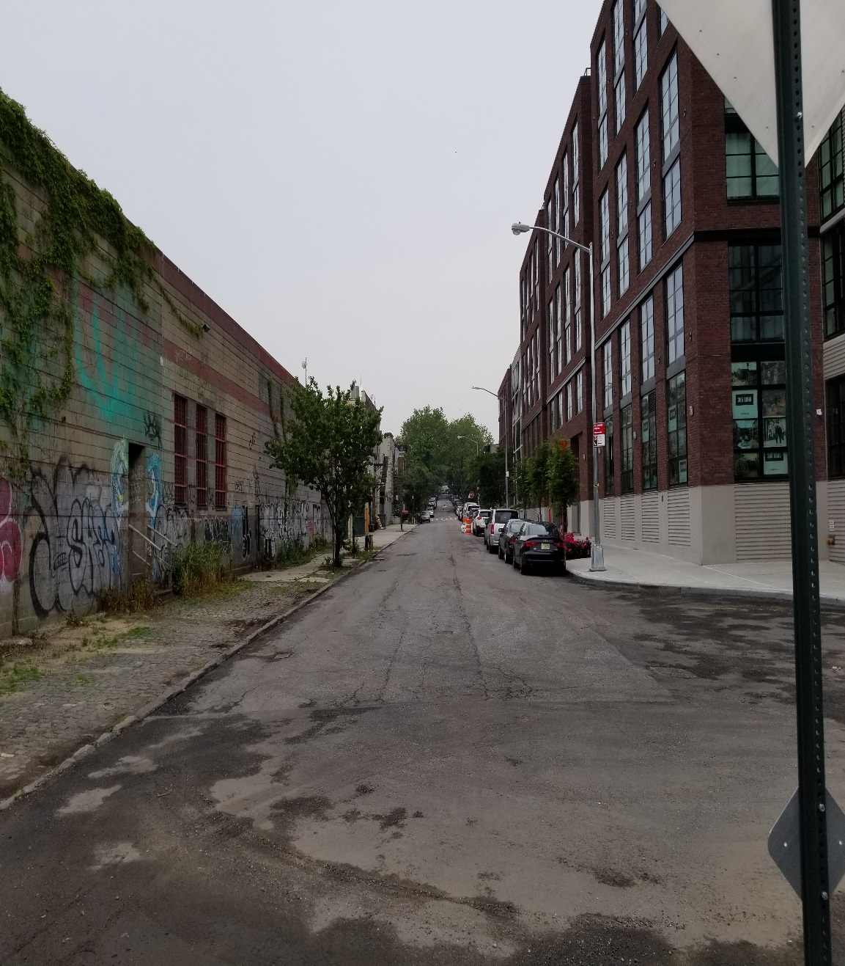
Walking around the new developments around on the edge front of the Gowanus Canal and I stumble abound this area. Its location is on 2nd Street. The canal is approximately no less them 20ft right behind me. Looking ahead from this point was very interesting. Just looking down this street, you can see two extremely different worlds. On the left side, you can experience the Gowanus history by treasuring its graffiti on the exterior, the historical building property of Monadnock Construction Inc., vines growing on parts of the building and the gray granite cobblestone sidewalk in which was very popular in use around the city around the 19th century. On your right of the street is new construction, straightforward design, Huge windows and plain white concrete side walk. The only relationship that these two properties have are the trees. No relationship of context to the area of the new build. The left side doesn’t look inviting however, you still get the feeling of excitement, entertained and more to look at. You would guess that a new build would utilize its space and provide more trees and green space in front such as its residential neighborhood on the next block over in which can be seen in the back.
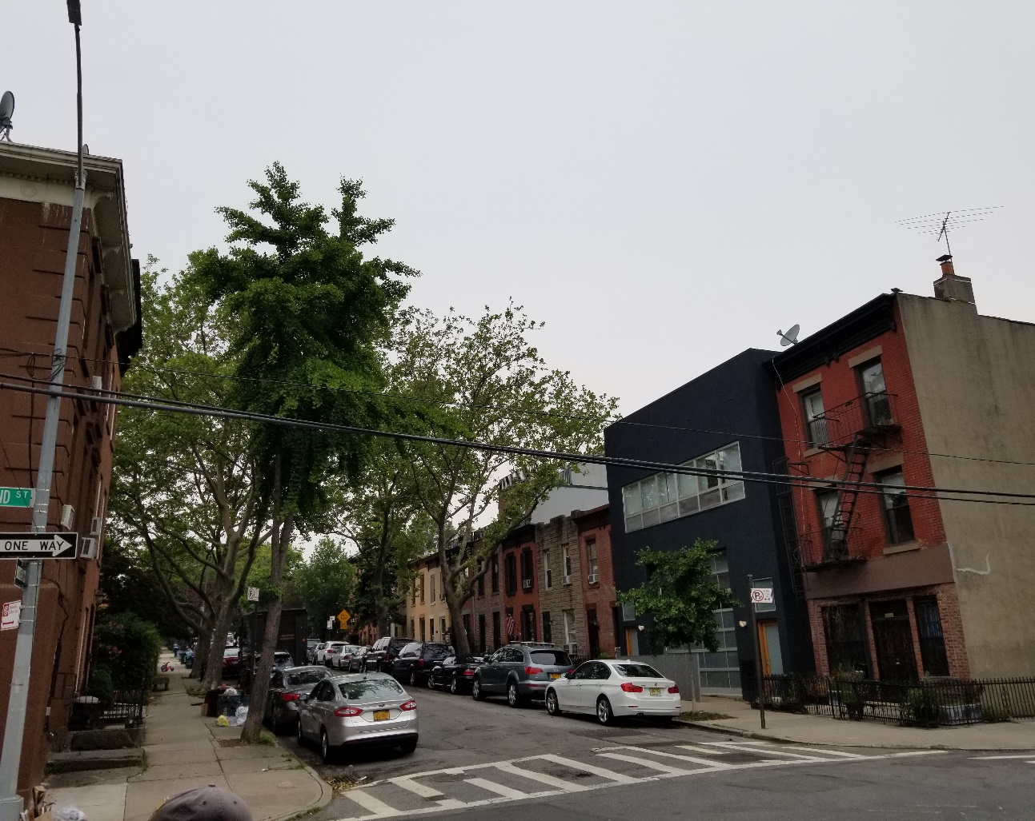
This view was taking on the cross section of Bond Street and 2nd Street. Only two blocks away from the Gowanus canal. What is shown in this picture is historical buildings built along side of new construction. This street is the only street that houses several two story historical buildings in the Gowanus. It’s not easy to find 2 story buildings left around New York City. These two-story buildings were built in 1901 and their zoned to be built higher than they are currently. The floor area ratio is at a fraction of what they can be built on these owner’s properties. What’s interesting is that the building on the corner has a fire escape with a cornice at the parapet level along with the other buildings on this block. The only building that seems to be out of context and doesn’t correlate with any other buildings on this block is the newer with limit architectural features on its façade. What’s important is that developers are ripping the very historical nature out of the Gowanus and doing it without the consent with the community.

SITE DOCUMENTATION of GOWANUS

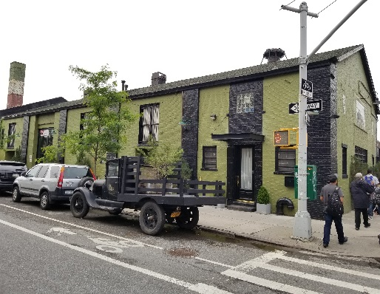
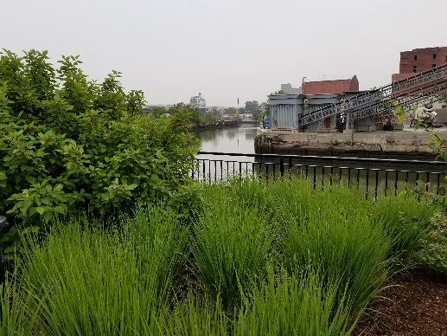
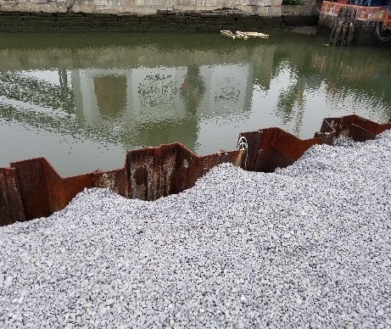
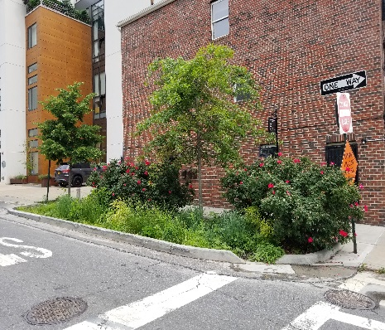
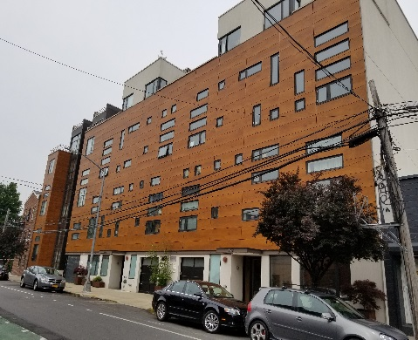
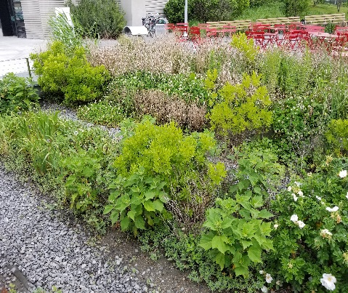
These pictures are taking at various spots around Gowanus showing effort of the change and attempts to cleaning up Gowanus canal polluted waters seabed. Observing the area, you’ll walk by an abundance of new construction on every corner, new buildings going up to help make the area look beautiful, Bioswales being constructed alongside streets that can hold about 2,000 gallons of water, older building being renewed to help give Gowanus character and planting green spaces and shoring walls alongside the canal. Gowanus is transforming into a designated area for the middle class to live and the upper class. This is evidence to remind people that Robert Moses vision of the city still lives on but in a different form.

SITE DOCUMENTATION
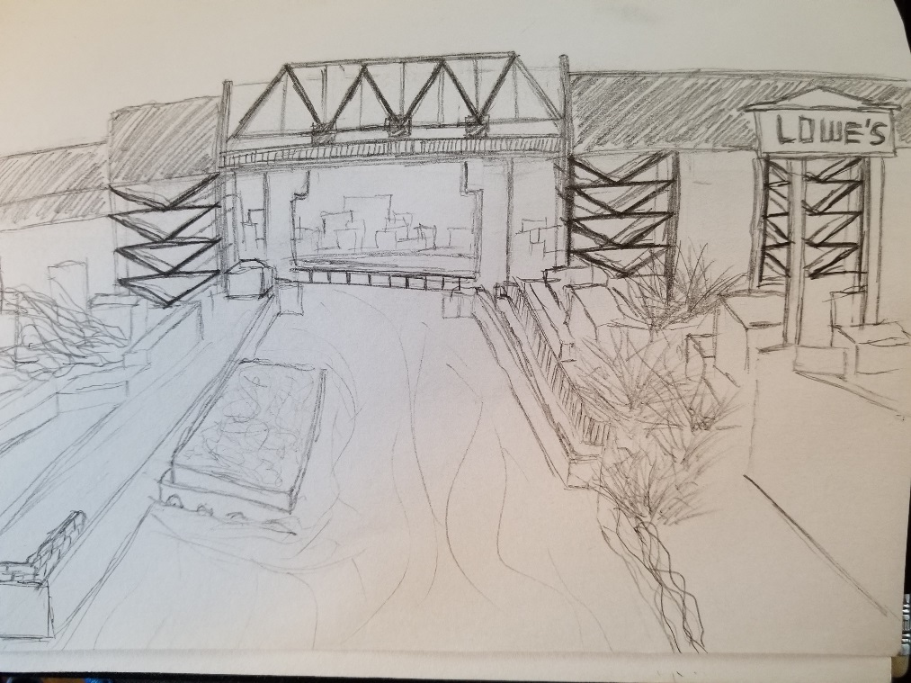
This is a sketch of the Smith street highest station of Gowanus in New York City where you can catch the F train and the G train. You can see along the canal where there is high manufacture on both side of the Canal

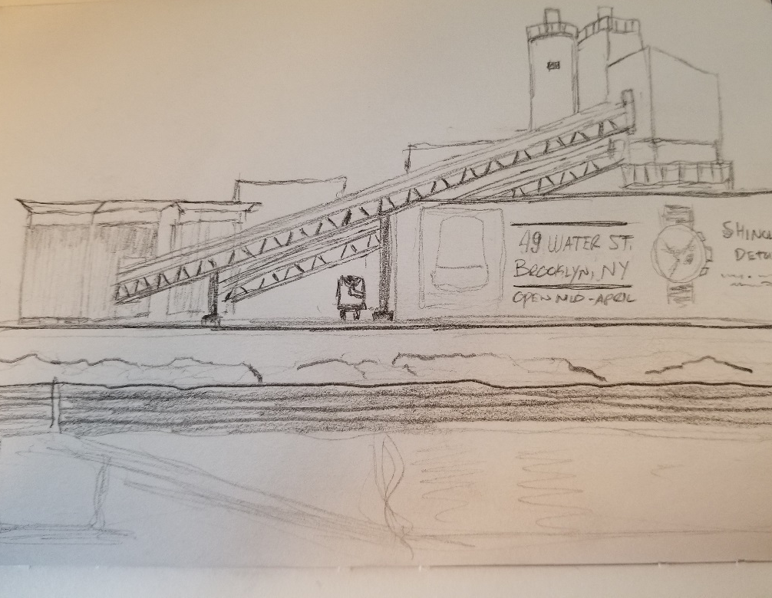
This is a sketch of the Smith street highest station of Gowanus in New York City where you can catch the F train and the G train. You can see along the canal where there is high manufacture on both side of the Canal

SITE DOCUMENTATION of GOWANUS PROJECT HOUSING

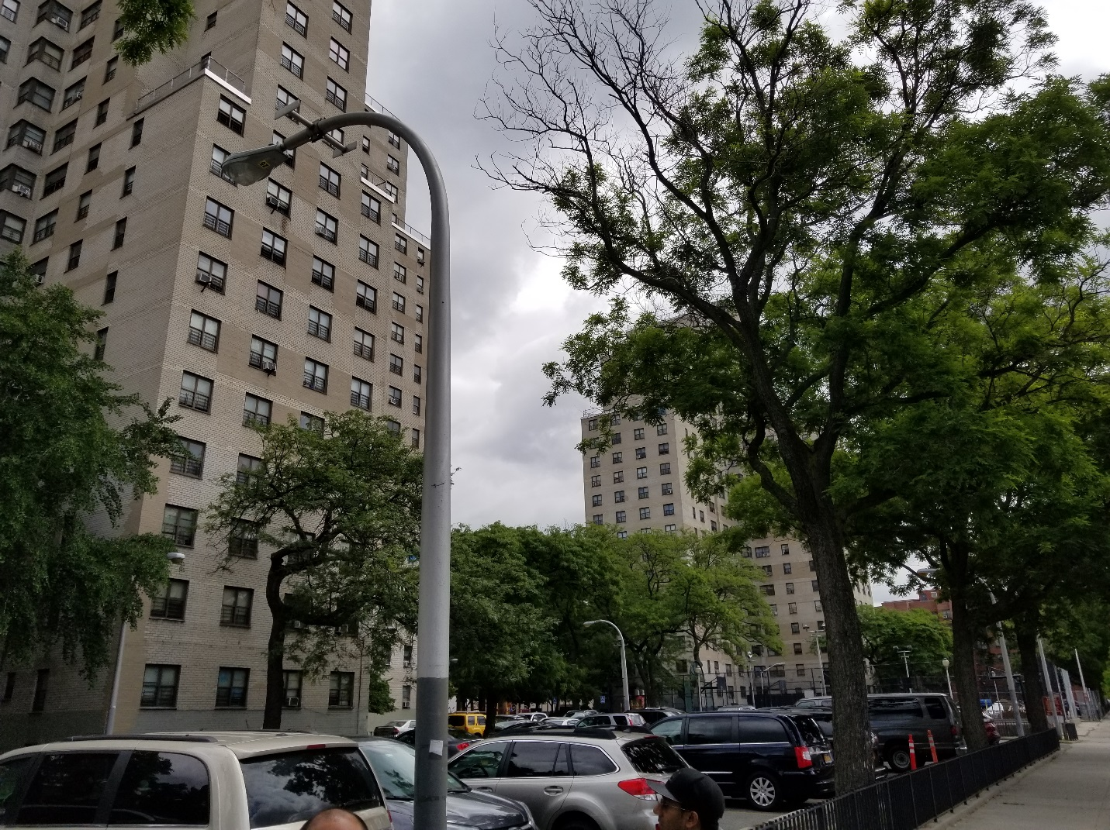
This was taking on the cross street of Nevins Street and Baltic Street, in front of the Wykoff Gardens Projects in Gowanus. A block away from the canal. This was the idea of Robert Moses future of a city. Towers that seem isolated from the rest of the world. Gated and no invited for those who dear walk among the dreaded sidewalks. It’s not attractive to the eye which means it sort of feel like a prison for low income families.

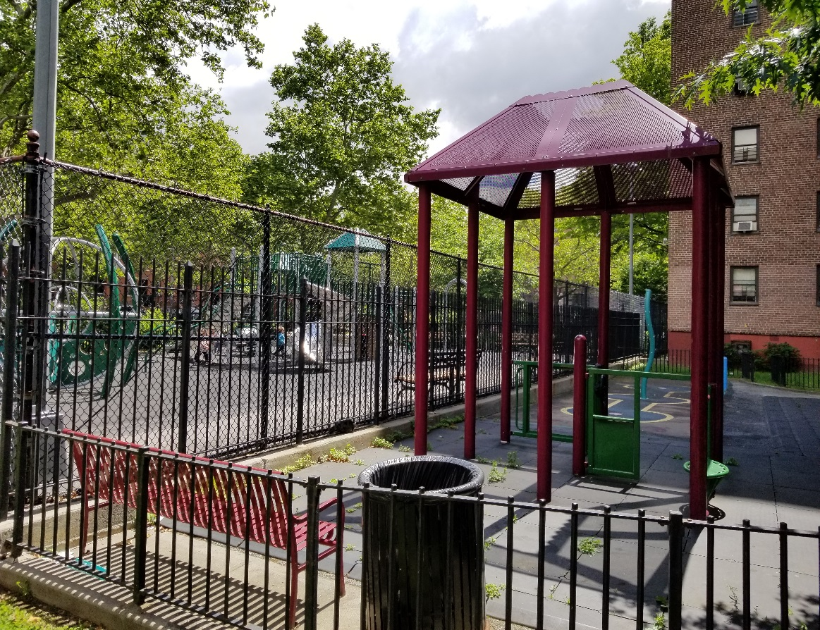
Two playgrounds alongside one other, separated by 2 gated fences to show who belongs in one from the other. This picture was taking in the middle of the Gowanus Housing projects, looking north at the existing playgrounds. On playground looks very inviting, strolling along our class tour, we seen children and parents occupying only one playground opposed of the other one to the right of the picture is left abundant. This is one of the results of Robert Moses idea of relocating residence in confined spaces where people feel isolated from the rest of New York City.
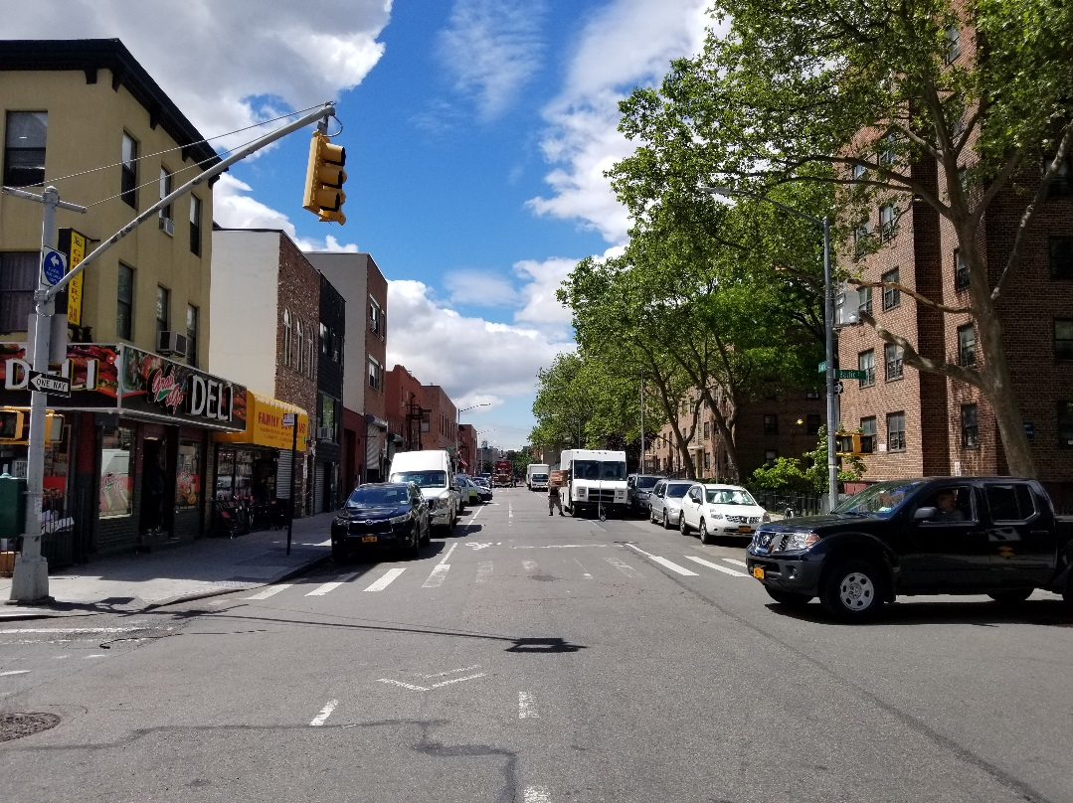
On Baltic Street, the separation by one street of the Gowanus project is seen here. The left side shows no consistency however, character that represent Gowanus. More inviting to the area. On your right seems to be consistent but not inviting, no character and extremely boring.

GENERAL NOTES:
- Gowanus Canal is the worst polluted water in the United States.
- Gowanus is a superfund site to fix up and clean the water of the canal.
- The Gowanus Canal is about 1.8 miles long, 100 feet wide and 5 to 6 feet deep.
- Biolswales that is constructed in Gowanus are built to hold up to 2,000 Gallons of storm water per swale.
- The area of Gowanus Brooklyn is going through many positive changes to help make the are attractive.
- Gentrification is one of the leading changes of the Gowanus that we are faced with.
- Flooding is very common in Gowanus and it get unsafe to be around these times due to the massive pollution of the canal.
- There are uninvited areas in the Gowanus known as the projects that has no identification and or have context relating to its surroundings.
- Combined Sewer systems is the primary problem of pollution to the canal.
- A mammal (a baby whale) died 2 days of being in the Gowanus canal because of the polluted waters.
- Leaning that Gowanus houses many historical building, materials and art work all around.
- Pollution of the Gowanus canal is manly consisted of coal, heavy metals and human waste for decades.
- Zoning is changing the Gowanus and its effecting the demographics in the area.

INSIGHTS/DISCOVERIES
As a student of architecture, watching films such as “Citizen Jane, Battle for The City” and “My Brooklyn” had me change the way I think of architecture. Architects play a key role in changing how the city looks. We tend not to worry about who are our clients and why they would like to build certain structures in areas where it’s not necessary. I wanted to be the one who design attractive apartment buildings all over the city for everyone, not class or race. This is my way of thinking. Learning that these developers and government figure heads are purposely rezoning areas of New York City to push out the less unfortunate which is made up of mostly Black people and Latinos. Neighborhoods are being torn apart to accommodate certain class of people. Being aware that not only Black and Latino people are in a political war, many other cultures are going through similar, if not, the same thing. This makes me want to become a different kind of architect.
The film “Citizen Jane, Battle for The City” by Matt Tyrnauer was extremely interesting. Learning about Jane Jacobs and her battle with Robert Moses was like clash of the titans. I couldn’t of imagine how Robert Moses who was called the “Master Builder” can turn a beautiful city to one of the most dominated flawed cities in the world by building bridges and freeways to accommodate the automobile. Destroyed massive neighborhoods and created superblocks to build the projects which are called “Projects” for low income families that got relocated from the areas that were slums to him, investor and government figures. From a guy to build beaches and pools for communities to enjoy to a guy who showed his true colors of racism towards neighborhood and mixed culture. Jane Jacob faced and brought down a monster to our society and did it with style. She is an icon to the city of New York, which is very much inspiring to those who are facing massive changes in their neighborhoods.
The film “My Brooklyn” documentary goes depth with communities’ changes that goes under people noises. The film focuses on Downtown Brooklyn where Fulton Street was dominated by Black people. Black owned businesses were thriving in downtown are of Brooklyn. It was more of a cultural stand point area for most cultures feeling comfortable shopping and hanging out, other than races people who thought of the area as being a slum and dirty. Due to these analysis from only the people who hated the area for Black people and other cultures, Government figure heads had rezoned the area to only accommodate the middle class which make up most white people in New York City. Downtown Brooklyn is undergoing massive changes that caused most of Businesses to shut down which never reopened any where else. The Downtown project is going through gentrification and most of the community didn’t even know what was going on.
Learning this made me think of what I can do as a future architect because I see a common relationship between both films. Robert Moses destroyed neighborhood to build “projects” that were flawed. Today, developers are building fake affordable housing which seems to be modern day “projects” that look good for the middle class that are flawed as well. Both films show that it’s all about gentrification. Just by this one simple analysis shows where government officials and developers minds are at. They’re not here to help people in communities, they’re here to collect.

KEYWORDS/VOCABULARY & DEFINITIONS
*5 keywords minimum required per site visit

Gentrification: The process by which an (urban) area is rendered middle-class.
Superfund: A US federal government program designed to fund the cleanup of toxic wastes.

Zoning: The division of an area into zones, as to restrict the number and types of buildings and their uses.

Rezoning: A rezoning or remapping occurs when the zoning designation for an area is changed on the zoning map to facilitate policy initiatives, such as preserving neighborhoods and promoting economic development around transit hubs.
Parapet A parapet is a low wall or protective barrier that extends vertically above the roof of a building or other structure.
Bioswale: are landscape elements designed to concentrate or remove silt and pollution from surface runoff water.
Projects: a government-subsidized housing development with relatively low rents.
Floor Area Ratio (FAR): The floor area ratio is the principal bulk regulation controlling the size of buildings.
Floor Area: The floor area of a building is the sum of the gross area of each floor of the building.

Block: A block is a tract of land bounded on all sides by streets or by a combination of streets, public parks, railroad rights-of-way, pierhead lines or airport boundaries.
Modernism: is a philosophical movement that, along with cultural trends and changes, arose from wide-scale and far-reaching transformations in Western society during the late 19th and early 20th centuries.
Demographics: Relating to the structure of populations.
Combined Sewers: Combined sewer systems are sewer systems that are designed to collect storm water runoff, domestic sewage, and industrial wastewater in the same pipe and bring it to the publicly owned treatment works facilities.
Combined Sewer Overflow: A combined sewer overflow is the discharge from a combined sewer system that is caused by snowmelt or storm water runoff.

CITATIONS/REFERANCES
- Discover the story of EnglishMore than 600,000 words, over a thousand years. (n.d.). Retrieved June 9, 2017, from http://www.oed.com/
- (n.d.). Retrieved June 9, 2017, from http://www.oasisnyc.net/map.aspx

- Glossary of Planning Terms. (n.d.). Retrieved June 9, 2017, from https://www1.nyc.gov/site/planning/zoning/glossary.page

- Alexiou, J. (2015). Gowanus: Brooklyns curious canal. New York: New York University Press.

QUESTIONS for Further RESEARCH
- Would it ever be affordable to live in Gowanus due to massive gentrification?
- Will Gowanus change completely and become another hot spot just like downtown Brooklyn?
- When would the city realize that Brooklyn needs to redirect and update their sewer system?

