Learning Places Summer 2017
SITE REPORT #1
GOWANUS TRANSFORMATION
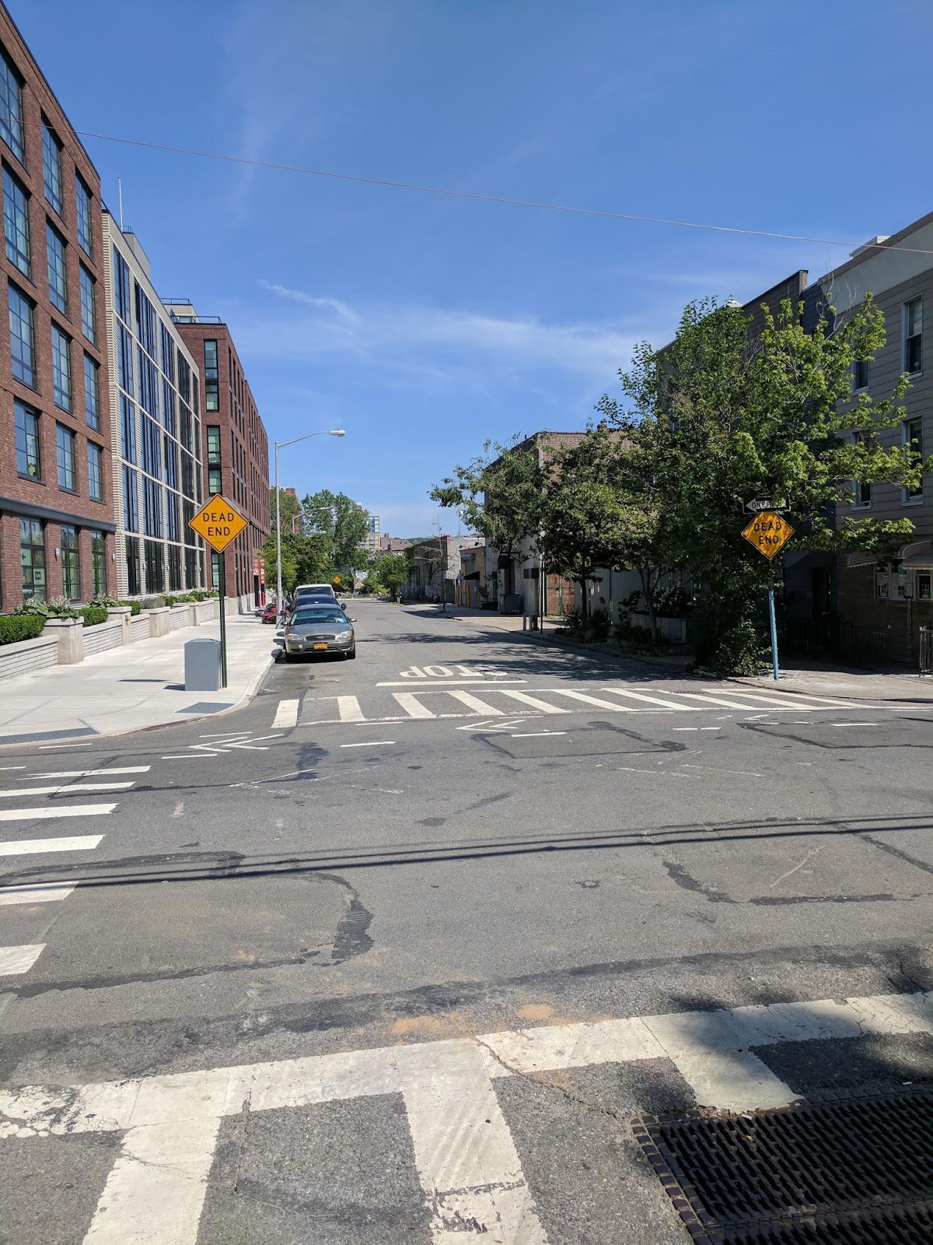

BRENT GEORGE
06.12.2017
INTRODUCTION
The spring of 2017 I was introduced to the Gowanus region in a law class I had. My introduction was a discussion about superfund sites which the Gowanus was a part of. Gowanus Canal was designated a superfund site on March 2th, 2010 by the Environmental Protection Agency (EPA). The EPA gives that designation to the nation’s most contaminated land and water body. For more than a 100 years, companies that lined the Gowanus canal have been dumping industrial waste into the Canal. Contaminants from overflows of sewer systems that carried sanitary waste from homes, rainwater from storm drains and industrial pollutants from the area will all flow into the canal.
Gowanus is nestled between Red Hook which is separated by the Gowanus Expressway, Carroll Gardens, Boerum Hill and Park Slope which is separated by 4th avenue. With the exception of Red Hook, the areas surrounding Gowanus is distinctively different because of their residential nature.
In spite of the many challenges and the superfund designation, the area of Gowanus is seeing a resurgence, not of canal polluting companies, but a resurgence that is made up of luxury townhouses, high-end apartments and gourmet supermarkets.

SITE PHOTO #1

This photo shows the contrasting views between, the old and the new Gowanus. It shows the area in a constant state of improvement, with work being done on the canal, shoring up the walls. This photo is important because it shows the redevelopment of downtown Brooklyn on the far end, slowly, but steadily encroaching on the area and the gentrification that that is sweeping through downtown Brooklyn, will follow through the Gowanus area also.
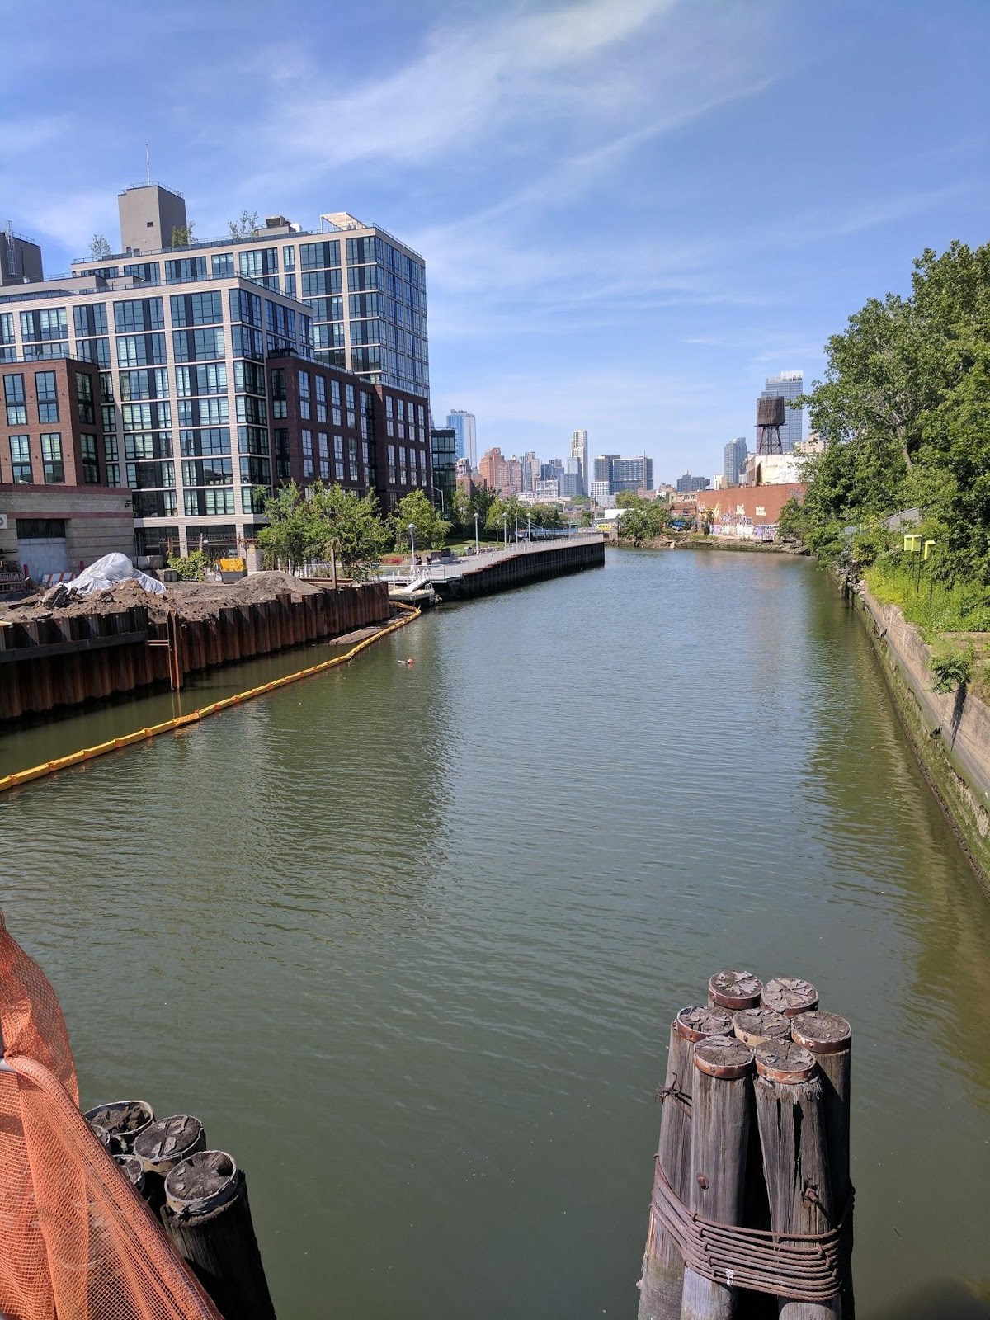
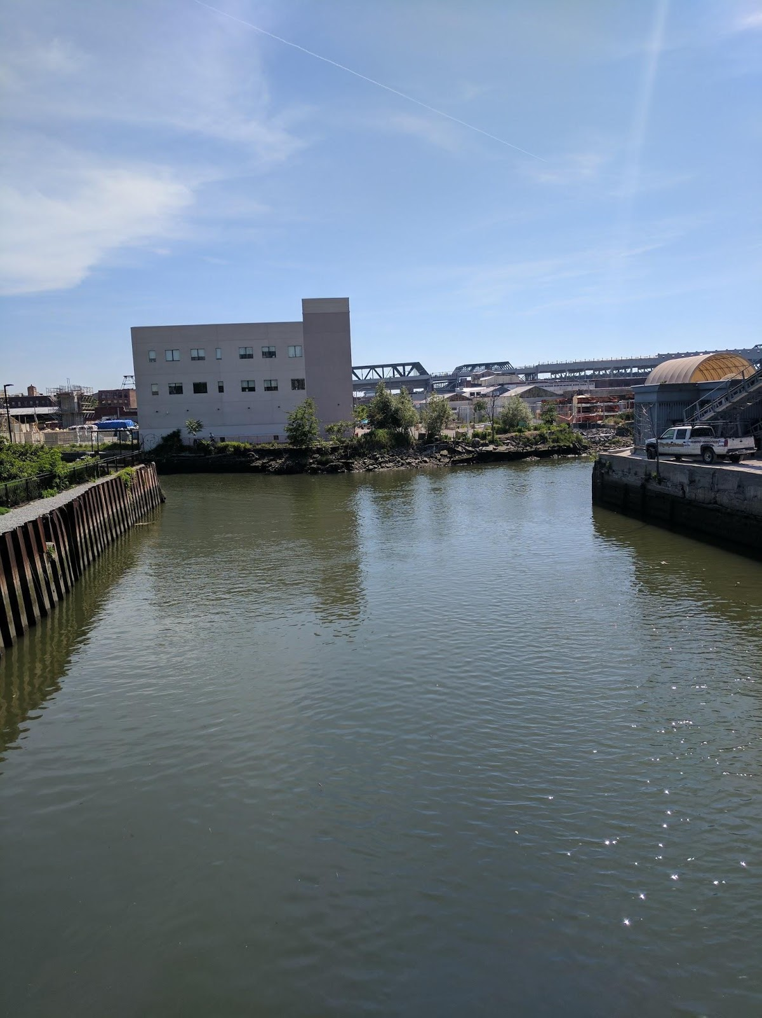

This photo is showing the canal going off in different directions. The discoloration of the water, and the remnants of coal tar mix with raw sewage adhere to the side of canal walls. It is important to see much more work is need on the cleaning up of the canal in spite of all the redevelopment. The new building in the photo shows that in falls into the commercial type and it is following the trend of a different kind structure that will be housing the new businesses.
Gowanus is an area with so much contrasting looks, in the large photo we can see a newly built luxury apartment building in the background of a construction site storing equipment and supplies to reconstruct a section of the canal wall.
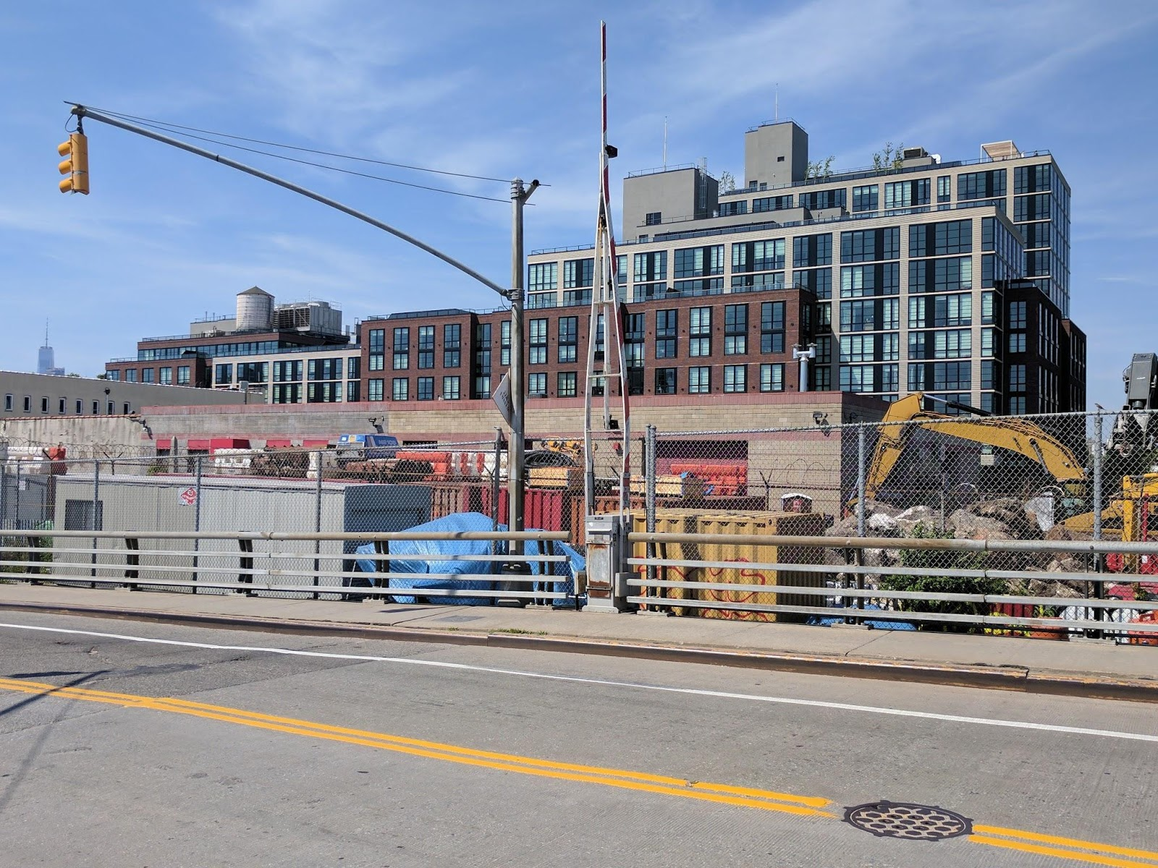

I was so fascinated with that sign saying, “you should move to Brooklyn”. After leaving Whole Foods supermarket traveling west on 3rd Street bridge, that sign is very clear to the left.
Another contrast was seeing a new vibrant business with the new hipsters populating the new trendy restaurants and hotspots. One that caught my attention was, Pig Beach, it was so typical of the new kind of businesses in Gowanus. Typical by not following the same cookie cutter businesses you will find in the surrounding areas.
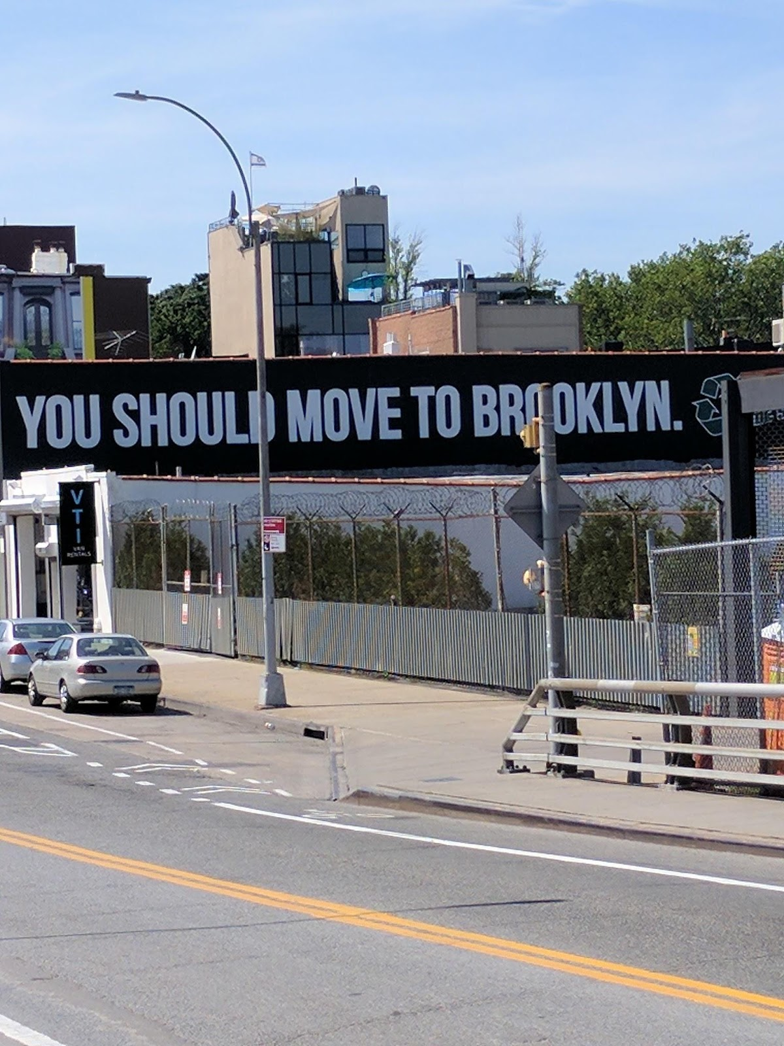
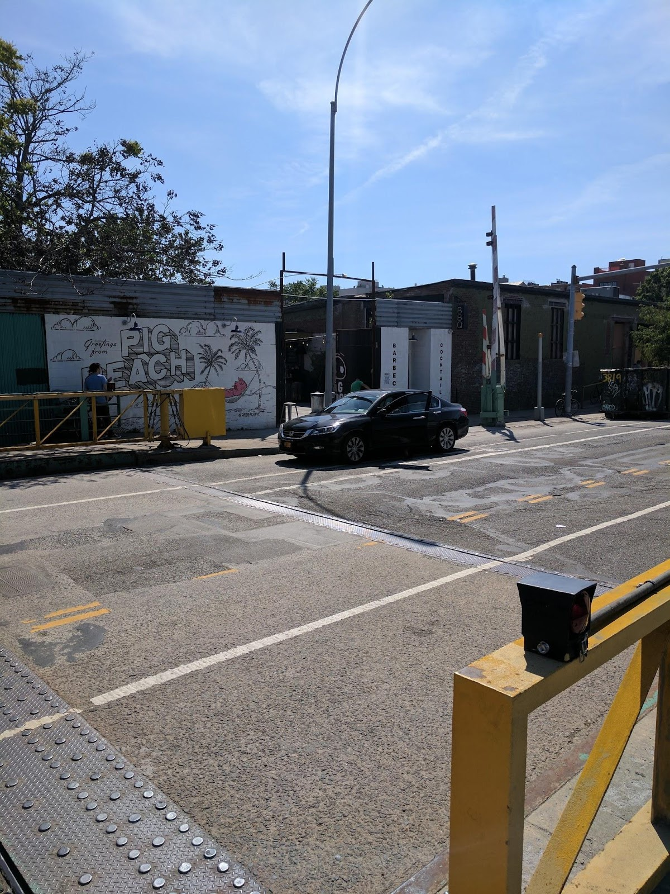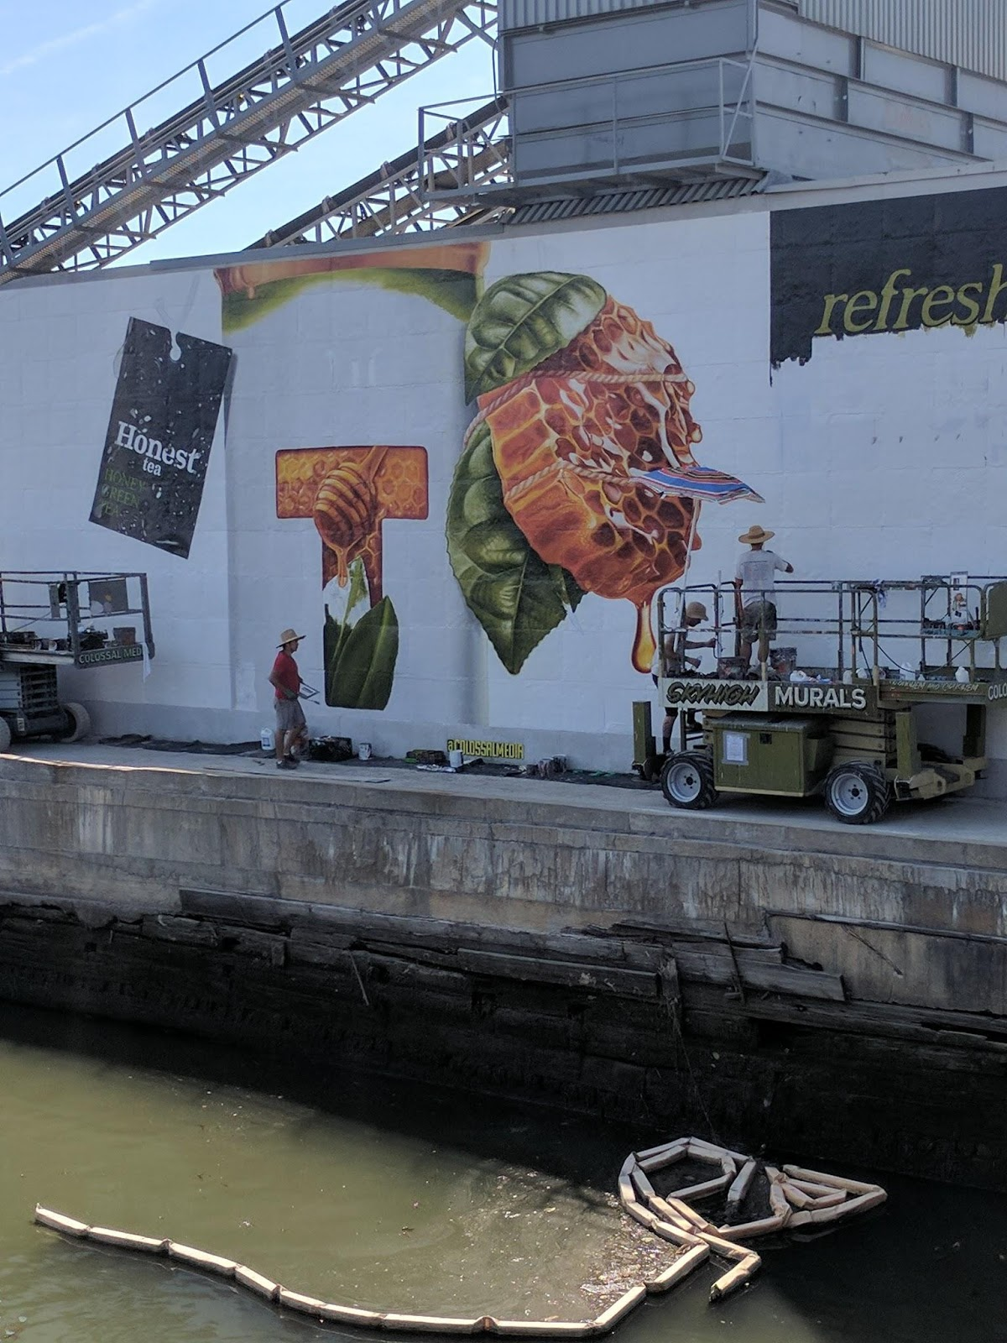

SKETCH #1

My sketch shows an area of Gowanus that is trying to hold on to its commercial side. I word “hold” is most appropriate because of the rapid pace of change developers can swoop in with the help of the city through zoning. The close proximity of public transportation will make the area even more attractive.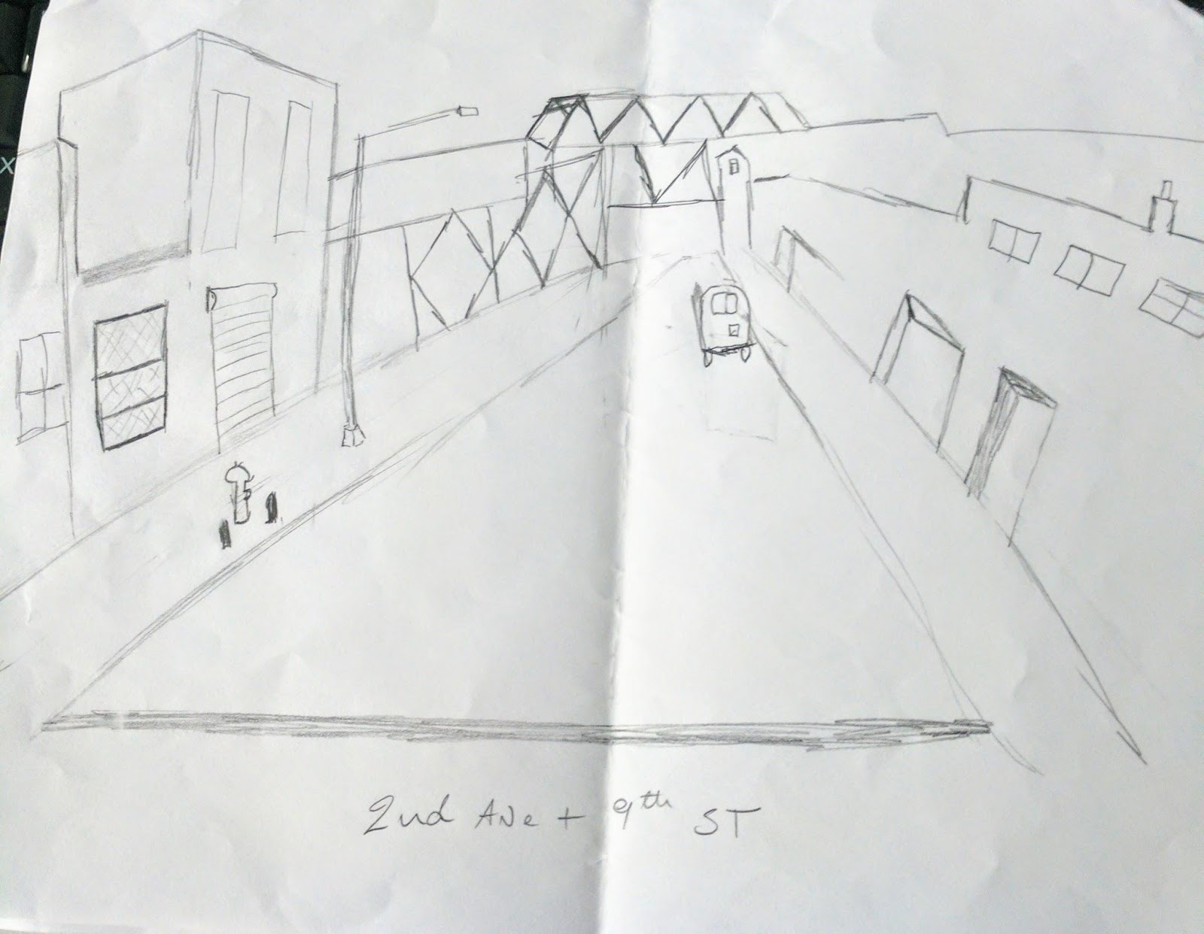

Sketch #2
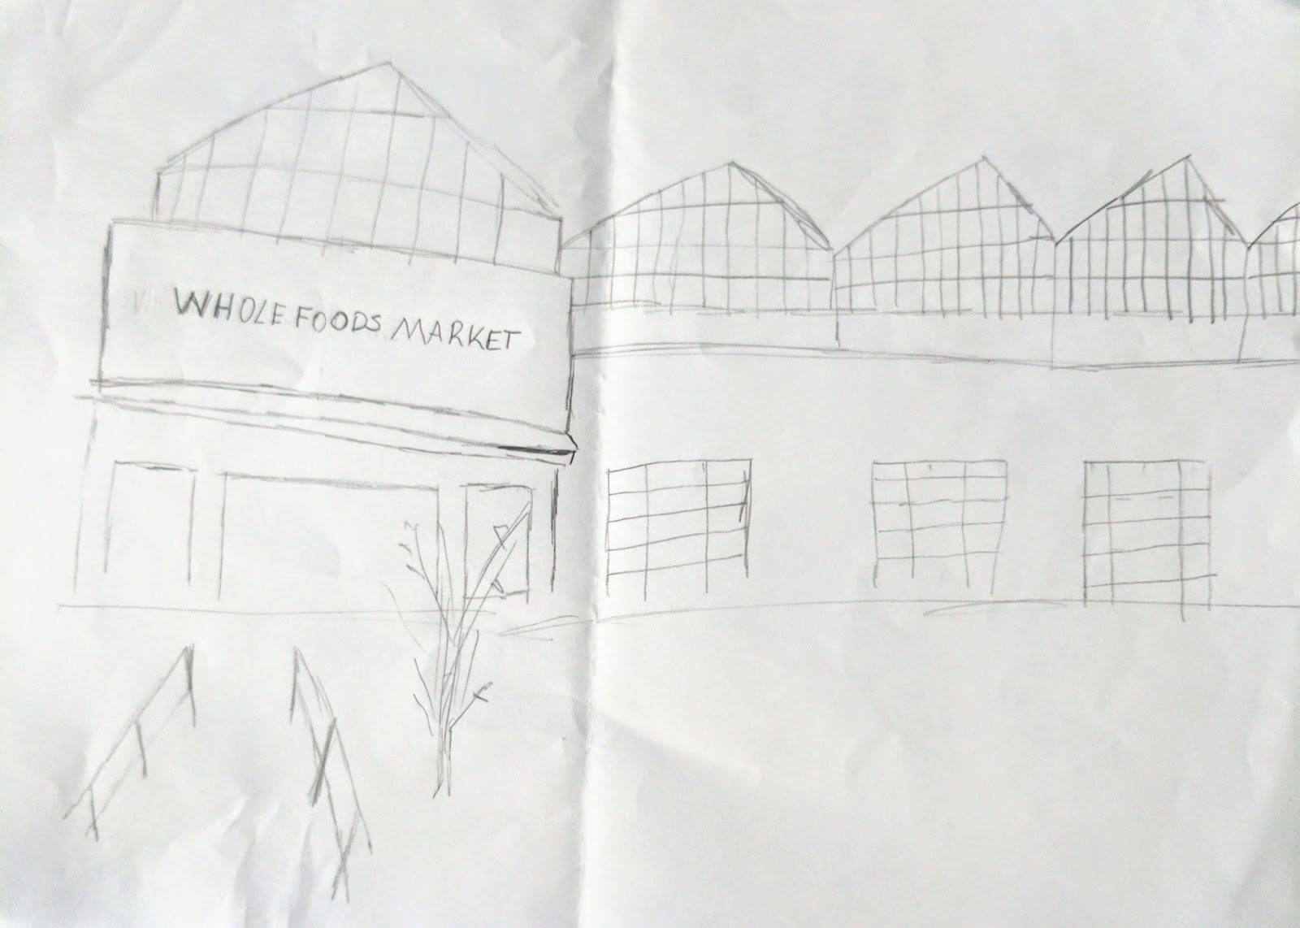
In this sketch is a drawing of Whole Food supermarket; it signifies the changes that are taking place in Gowanus. The introduction of Whole Foods to the area gives a signal to where the neighborhood is heading.

GENERAL NOTES:
- I learnt about the combined sewage overflow (CSO)
- Industries and factories during the 1800s to the mid-1900s were the major polluters of the Gowanus canal.
- The Gowanus canal was overflowed during Hurricane Sandy
- Learnt that they are some species of fish in the canal despite the toxic industrial waste settling at the bottom.

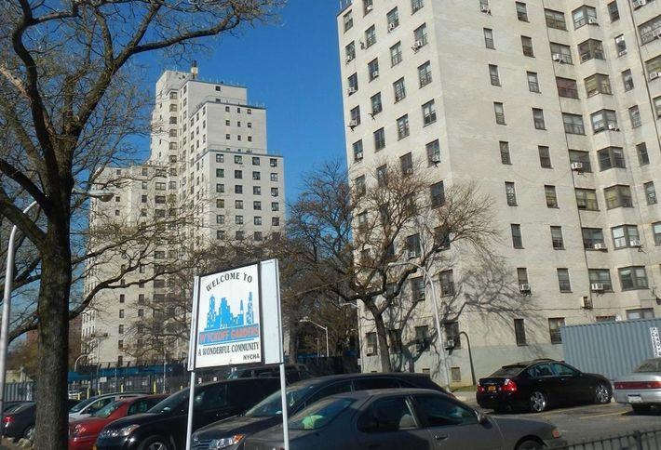

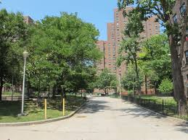

These two photos are of public houses. The top picture is the Wychoff houses, they are not incorporated with the neighborhood. They were much taller than the surrounding buildings, and there were absolutely no activity outside of them. Those two builds seems like “jails”. There were no park areas for children to play, not vegetation. It was just a large paved parking lot. In contrast with the picture at the bottom of Gowanus Houses, those buildings were built with the neighborhood in mind. The buildings on the perimeter of the complex were shorter, and matching with the four and five story brownstones. They area of the Gowanus houses were lush with different size of trees, trees residents can use as shade. The day when the class walked through the housing complex, there were lots of activity outside, residence utilizing the open pathways and the area wasn’t looking intimidating.

These pictures are of one of the hipster businesses that are changing the Gowanus. Pig Beach is the name of the very popular restaurant.

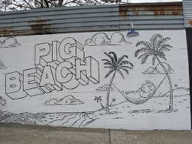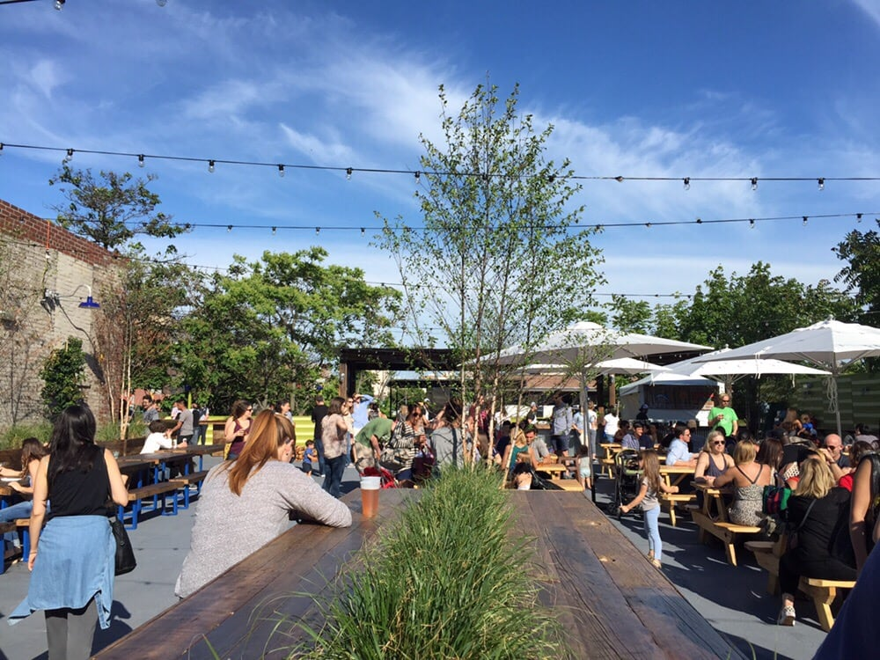

INSIGHTS/DISCOVERIES
Learning places has open to places in and around downtown Brooklyn. The course has allowed me to look at Gowanus with a critical eye and also confirm some of the suspicions. I suspected that the area was in a major transformation, some that were good and some that are bad. The major term for the moment is gentrification, gentrification seems to carry a bad connotation, but not every form of gentrification is a bad thing. Uncontrolled gentrification where families have to be uprooted because they are priced out of the neighborhood, or others feeling isolated because of the rapid charges around them. When gentrification is slow, or controlled, blighted neighborhoods can be transformed, new small businesses can be encouraged and economical life can come back to the neighborhood. I am afraid Gowanus are going the direction of uncontrollable gentrification and will leave many of its residence priced out.

KEYWORDS/VOCABULARY & DEFINITIONS

A Brownfield site is any real property where a contaminant is present at levels exceeding the soil cleanup objectives or other health-based or environmental standards, criteria or guidance adopted by DEC that are applicable based on the reasonably anticipated use of the property, in accordance with applicable regulations.

A Bioswale is a linear, sloped retention area designed to capture and convey water, while allowing it to infiltrate the ground slowly over a 24 to 48 hour period. The slopes are usually planted with native species similar to a rain garden. A bioswale built into a sloped area can also help prevent erosion.

Salt marshes are coastal wetlands that are flooded and drained by salt water brought in by the tides. They are marshy because the soil may be composed of deep mud and peat. Peat is made of decomposing plant matter that is often several feet thick. Peat is waterlogged, root-filled, and very spongy.
Raw Sewage - Untreated domestic or commercial wastewater.

Indigenous plants are, by definition, those native to the locale in question

Sometimes, during heavy rain and snowstorms, combined sewers receive higher than normal flows. Treatment plants are unable to handle flows that are more than twice design capacity and when this occurs, a mix of excess storm water and untreated wastewater discharges directly into the City’s waterways at certain outfalls. This is called a Combined Sewer Overflow (CSO).

QUESTIONS for Further RESEARCH
- How much affordable housing will be set-aside in the new apartment buildings?
- Will Gowanus try to retain some of the commercial spaces for the small businesses that were there before?
- How many of those buildings will be Green buildings, following the trend of whole foods?
- Are the contractors using supplies, and utilizing Craftsmen from the area?

Bibliography
http://www.dec.ny.gov/chemical/brownfields.html
https://www.grownyc.org/openspace/green-infrastructure-toolkit/bioswales
https://www.google.com/search?q=salt+marsh&oq=salt+marsh&aqs=chrome..69i57j0l5.10511j0j9&sourceid=chrome&ie=UTF-8
https://ofmpub.epa.gov/sor_internet/registry/termreg/searchandretrieve/glossariesandkeywordlists/search.do;jsessionid=AgKaWTxvwFDeld8FicxoUL7u
http://www.nyc.gov/html/dep/html/stormwater/combined_sewer_overflow.shtml
https://www.thespruce.com/indigenous-plants-and-how-they-are-used-in-landscapes-2131067
http://www.nytimes.com/2010/03/03/nyregion/03gowanus.html
https://cumulis.epa.gov/supercpad/cursites/csitinfo.cfm?id=0206222

