Learning Places Summer 2017
Brooklyn Public Library and Interference Archive
Site report #2
Brent George
06.19.2017

INTRODUCTION
For our second site report we visited two archives locations for research pertaining to our group podcast project, the Brooklyn public library (BPL) and the Interference archive. On those visits the professors outlines some objectives for the class. These objectives were, what an archive does, what are some of the items stored at the archives, and a more in-depth look at what an archive does.
The first visit was to the all-volunteer, community supported Interference archive, a small and unassuming building in Gowanus located at 131 8th Street, Brooklyn. The Oxford dictionary defines interference as, “ The action of interfering or the process of being interfered with”, so upon entering the building and seeing what were on display in the gallery section it dawned on me why the name interference. On display in the gallery, were some very provocative protest pictures, articles, placards and posters about violence against women and women’s movement. We later learned that the archive collects ephemera, and specialized in documenting social movements and protest history. What I find attracting, is the open stack nature of the archive, we felt free to look and hold the items stored there.
The second visit was at the Brooklyn public library (BPL) main building. In contrast to the Interference archive the BPL is a very large and pronounce building located at 10 Grand Army Plaza, Brooklyn. The archive at the Brooklyn public library is a traditional archive and can be intimidating, with reading rooms, finding aids, call/pull slips and sterile areas. With help from the Archivist, we viewed the sanborn map collection and the letterhead collection. We were told about the large collection of yearbooks from Brooklyn schools. The maps gave us a greater insight of what streets no longer exist, the process of development and the communities that were destroyed for other development.
The both archive serve the purposes that they were created for, and deserve to be cherished. With its controversial and provocative nature, the Interference serves the purpose of documenting the struggles of minority and disadvantaged groups. The Brooklyn public library serve what was created for also, by documenting the large volume of public records everyone is free to access see them.

SITE DOCUMENTATION #1

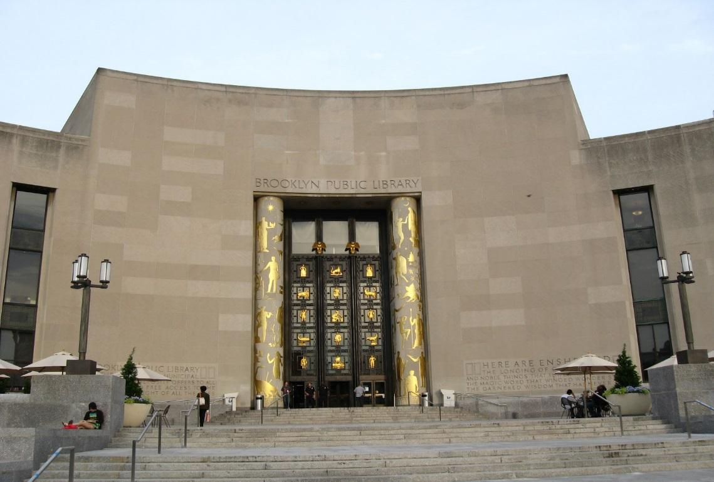
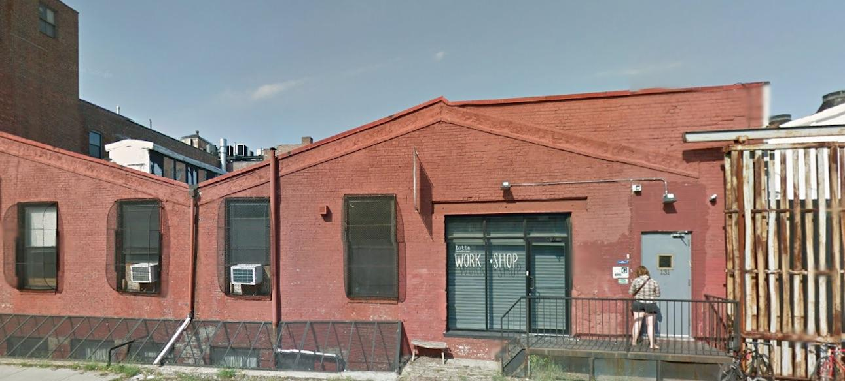
These two pictures shows the contrasting views between the Brooklyn public library and the Interference Archive. The public library seems very imposing, like a gateway to a major part of Brooklyn. In contrast the Interference Archive have a subtle presence. It have a look of belonging to the neighborhood.

Photo #2 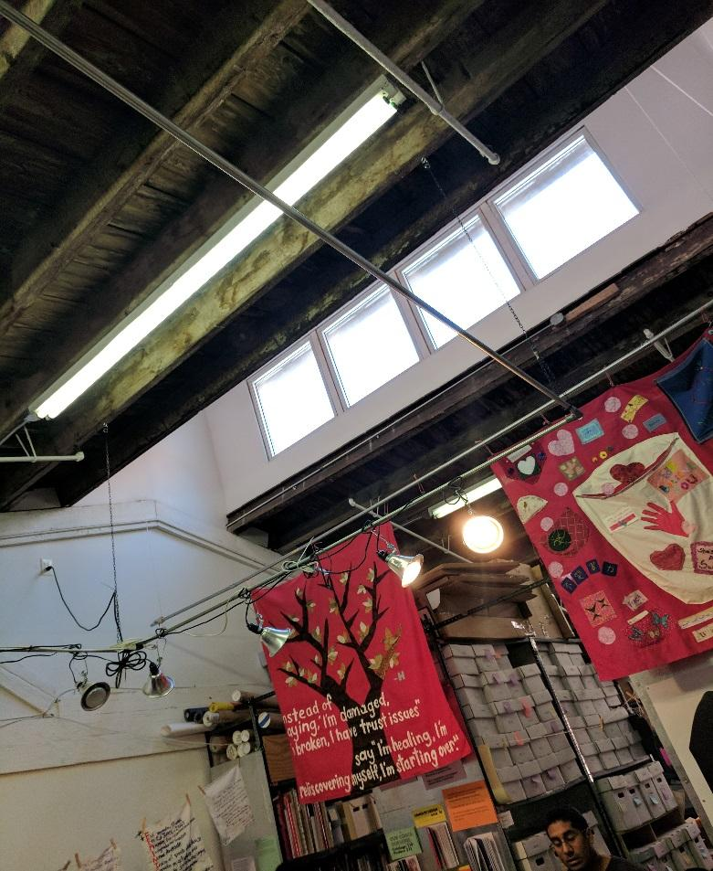

The above photo illustrate the usage of natural lighting to illuminate the gallery area of the Interference Archive. I also observe the incorporation of the aged exposed joist on the ceilings.

Citation for ARCHIVAL SOURCE #3
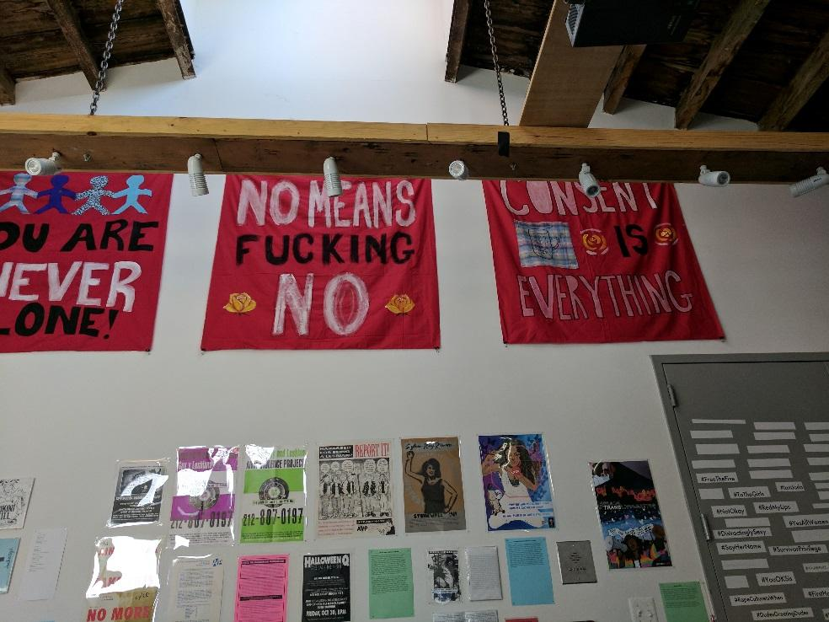
This photo in the exhibit illustrates the provocative and controversial nature of the Interference archive. The exhibit demonstrates the issues women still faces in 2017. It is fitting for the time, with all the news about violence against women, exhibits like this should be celebrated.

References
Legendre, C., & Levick, G. M. (1901, September 14). The East River Bridge As It Looks Today. Collier's Weekly.
CITATION for ARCHIVAL SOURCE #4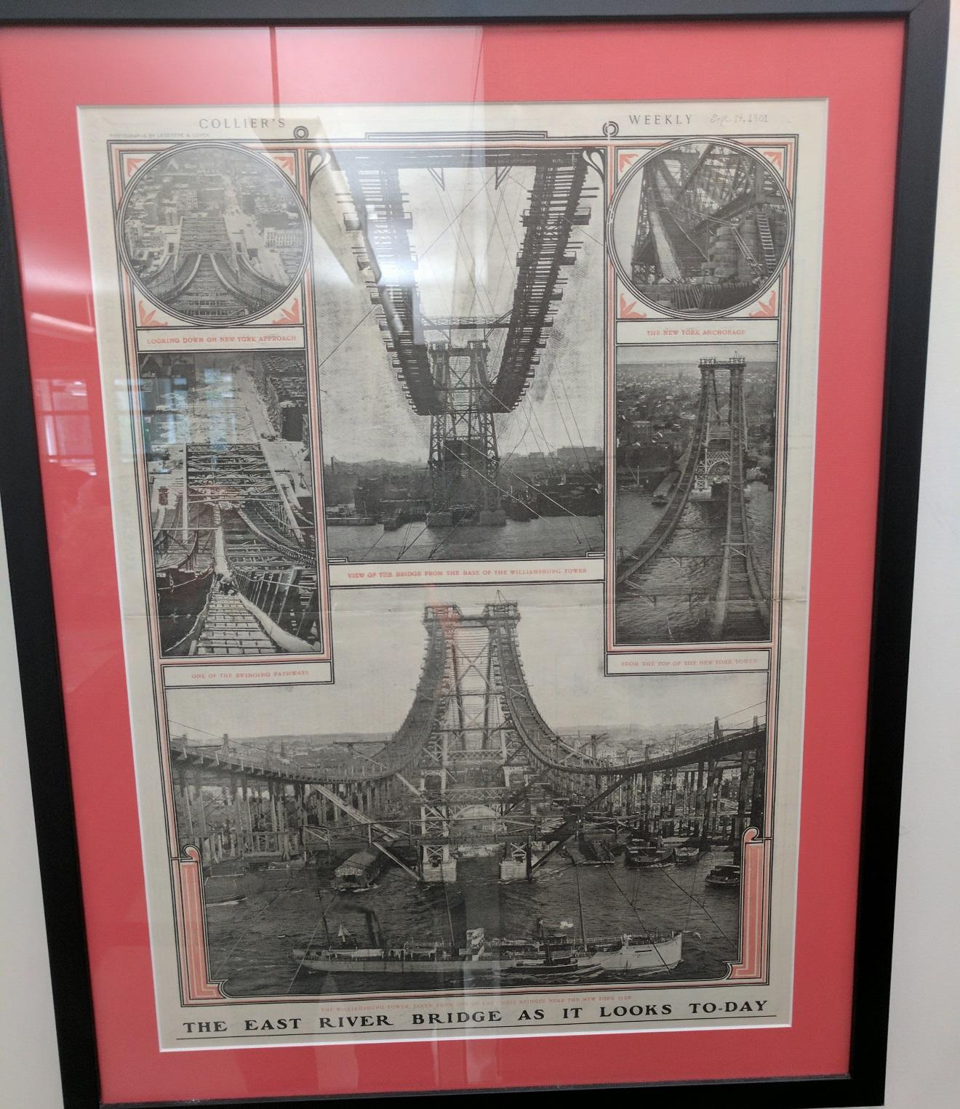

The image is from the Brooklyn public Library archive. It shows the early building stages of the Williamsburg Bridge. This construction demonstrates what kind of engineering was done without the help of modern technologies like computers. The photo shows different Angles of the building, View of the bridge from the base of the Williamsburg tower, one of the swing pathways, looking Down on the New York approach, from the top of the New York tower and the New York anchorage.

CITATION for ARCHIVAL SOURCE #5

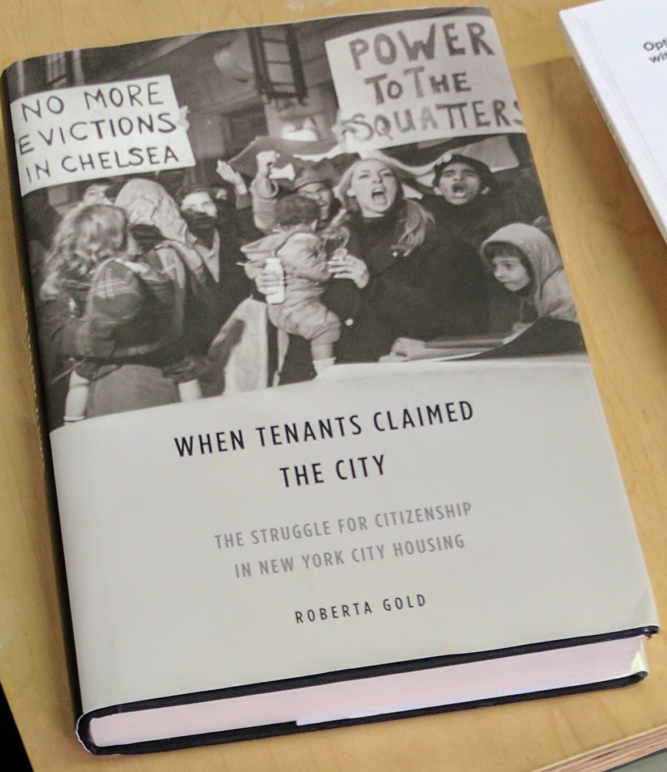

References: Gold, R. (2014). When Tenants Claimed the City: The Struggle for Citizenship in New York City Housing. University of Illinois Press.
The Book drew my attention because of the title and the posters the demonstrators are holding. Robert Moses came to my mine. Knowing about the many evictions that were in effect to make way for his development. After little research, the book is about tenants’ rights. The Rights to stay where they are, the rights of minorities to rent without discrimination. “They insisted that renters as well as owners had rights to stable, well-maintained homes, and they proposed that racially diverse urban communities”. This is so fitting for this time because I can see the same scenario with tenants being evicted, and pushed out because of the cost of rent.

GENERAL NOTES:
- Interference archive is an open stack archive, collecting documents of social movements and protest history
- The defunct Brooklyn Eagle Newspaper donated its archival materials, and eagle statue to the Brooklyn public library.
- Since 1867 the Sanborn Company been producing maps for the purpose assessing fire insurance liability. The maps contain approximately 12,000 American cities and Towns

KEYWORDS/VOCABULARY & DEFINITIONS
Letterhead: A printed heading on stationery, especially one giving the name and address of a business concern, an institution,
Deposit (archive): Documents that are legally mandated to be stored.
Stereo Viewer: An instrument for obtaining, from two pictures of an object, taken from slightly different points of view (corresponding to the positions of the two eyes), a single image giving the impression of solidity or relief, as in ordinary vision of the object itself.
Contour Lines: A series of lines at successive elevations drawn on a map that shows the elevations and depressions of the surface.
Digitized: Converting non digital document, pictures or articles to digital form
Sanborn Maps: Since 1866 Sanborn has created over 1.2 million Fire Insurance Maps detailing the history of 12000+ American cities and towns. The maps were mainly used by insurance companies to assess fire liabilities
Archivist: Acquire, manage and maintain documents, computer files and other materials that have historical importance for individuals, organizations and nations.
Card Catalog: A card that catalogues each item separately in a specific order.

Finding Aid (archive): Finding aids are tools that help a user find information in a specific record group, collection, or series of archival materials. Examples of finding aids include published and unpublished inventories, container and folder lists, card catalogs, calendars, indexes, registers, and institutional guides.

QUESTIONS for Further RESEARCH
- What method can be implemented at the Inference Archive to insure a more sustainable future?
- Where most of the Brooklyn public library funding does comes from and how will it withstand an economical shock, like a drastic cut in its main funding?
- Will the Brooklyn public library digital archive stored in the cloud, or on a server at location?

https://www.archives.gov/research/catalog/lcdrg/elements/findingtype.html
http://www.oed.com/
http://www.sanborn.com/sanborn-fire-insurance-maps/

