Learning Places Fall 2016

Library / Archive REPORT

Brooklyn Public Library
Interference Archive

Patrice Jean

06.17.2017

INTRODUCTION
We visited the interference Archive and the Brooklyn Public Library. The interference archive is a great place that contains anything that was created as part of social movements, they have posters, flyers, photographs, and audio recordings. It is a non-profit organization they only take donation from visitors. The Brooklyn Public Library is a system of Library, it is one of the largest system that we have.

SITE DOCUMENTATION
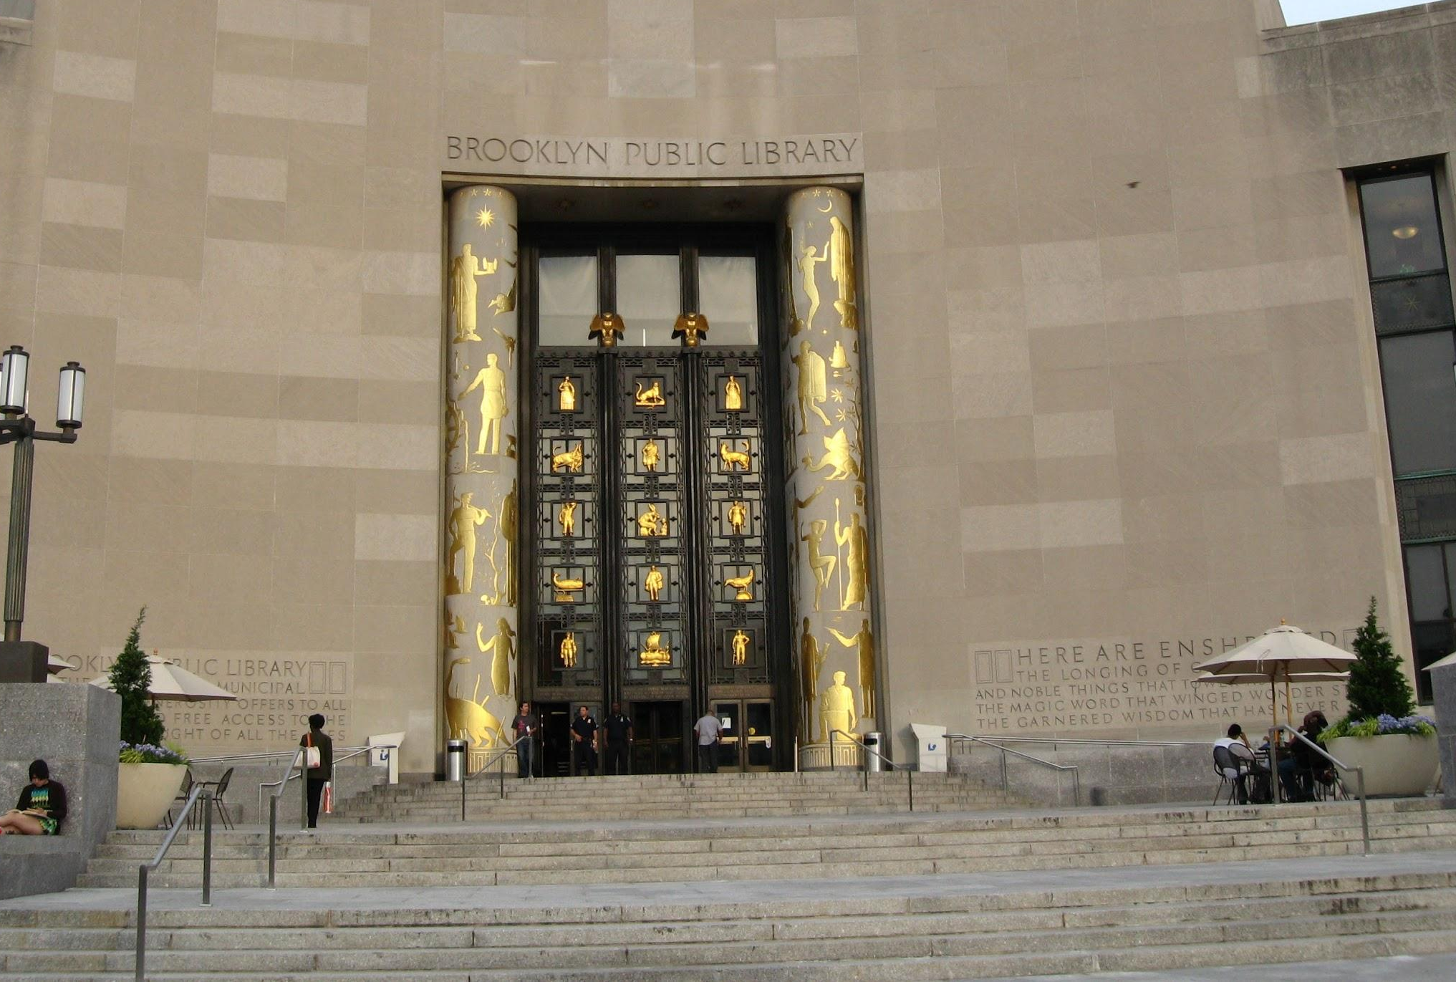

This is a picture of the entrance of the Library. The Brooklyn Public Library is one the largest system of library in the U.S. The catalog makes it easier to make research inside or you can always ask a librarian for help.

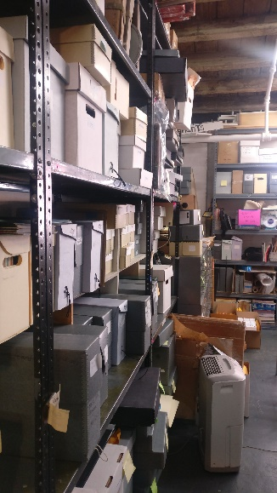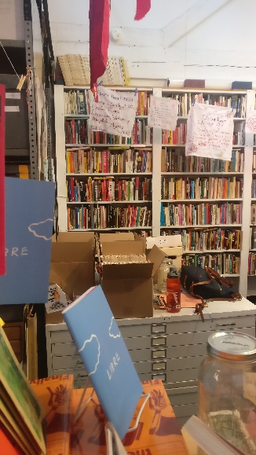

These pictures are showing how documents are saved inside the archive. As we can see, everything is well organize. We have a book shelve section, and the other documents are inside folders in different boxes. They organize in alphabetical order, this make them easy to find and easy to quote. Inside the archive is easy to navigate while looking documents, also they have volunteers that make hunt even easier.

SITE DOCUMENTATION
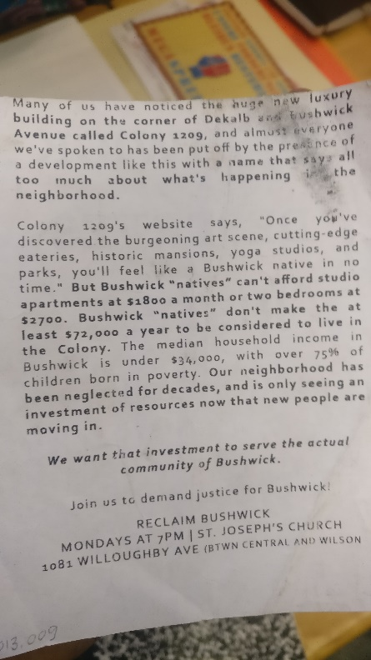
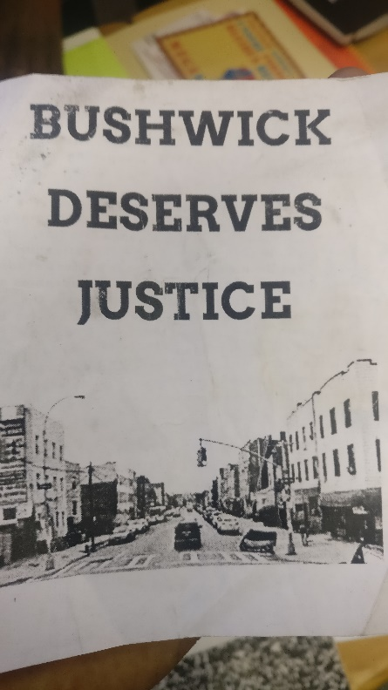

Reclaim Bushwick (n.d) Bushwick Deserves Justice [flyer]. Part of the subject file box under G
Gentrification folder. Interference archive, Brooklyn, NY.

This is a movement against gentrification in Bushwick. In a community, or city people need to be aware of changes that’s happening around them. They noticed that housing is rising up, they doing it in the name of Bushwick native, but Bushwick natives cannot afford to rent the studio they are offering them. This is gentrification.
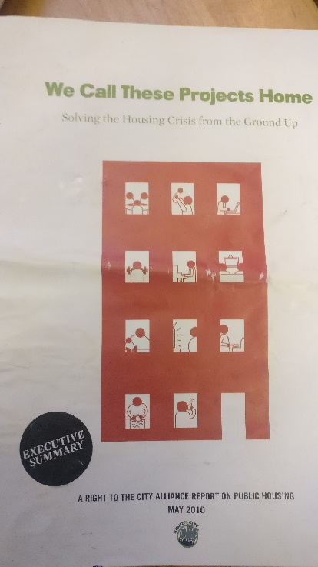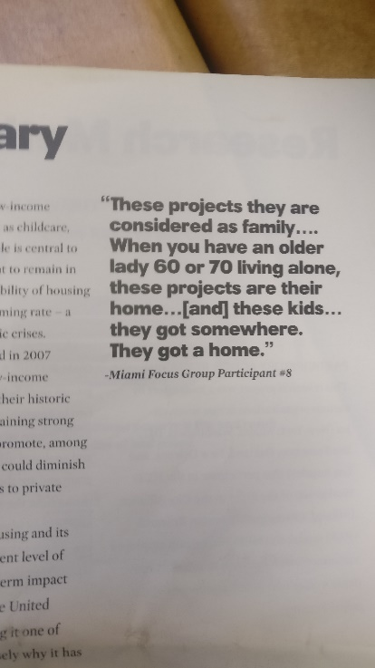
Unknown, (n.d) We Call These Projects Home [oversize Pamphlets]. Part of the Philosophy Box. Interference archive, Brooklyn, NY.

This is movement to help low-income family get affordable public housing. By doing so the will stop the demolishing off old build, this will preserve and strengthen historical building. The problem is not preserving historical building, but the fact that after renovation the house if not affordable for the people that was living there already. They have to move and find somewhere else affordable for them. When they do so the price of the land also rises this factor determine a hot location for these designers.

GENERAL NOTES:
- Interference archive is to explore the relationship between cultural production and social movements.
- The Brooklyn Eagle has merge with the Brooklyn Public Library and all there are accessible to the public.

KEYWORDS/VOCABULARY & DEFINITIONS
Containerization: Trans. To pack into, or transport by means of, containers
Suburbanization: The action of making something (esp. a rural area) suburban; the fact of being suburbanized.
Revitalization: The action or an act of revitalizing someone or something; the fact of being revitalized
Pamphlet: A short handwritten work or document of several pages fastened together; a handwritten poem, tract, or treatise. Obs.
Eminent domain : Ultimate or supreme lordship; the superiority of sovereign power over all the property in the state, in accordance with which it is entitled to appropriate by constitutional methods any part required for the public advantage, compensation being given to the owner.
Urban Renewal: The redevelopment of areas within a town or city, typically involving the clearance of slums
Modernism: A usage, mode of expression, peculiarity of style, etc., characteristic of modern times. Later more generally: an innovative or distinctively modern feature. Frequently in pl.
Segregation: The separation or isolation of a portion of a community or a body of persons from the rest.

Questions for Further Research
- How do we determine the liability of historical documents?
- How archives collect resources? And what are the factors in categories them?
- Between archive and library which is the most reliable source to get document from and why ?

References
OXFORD ENGLISH DICTIONARY. (n.d.). Retrieved June 20, 2017, from http://www.oed.com/

