Learning Places Summer 2019
SITE REPORT #3
“Emissions to Cadman Plaza Park”
SiteReport3.BrandonGenesisMaryamAntonieta
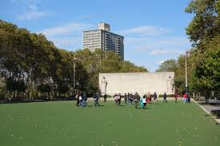
Park goers enjoying the field and park memorial.

STUDENT NAME: Brandon, Genesis, Maryam, Antonieta.

SITE OBSERVATIONS

GOOOOAAAAALLLLLLLL!!!!!!!!! REMEMBER THE FALLEN DON’T JUDGE A BOOK BY ITS COVER
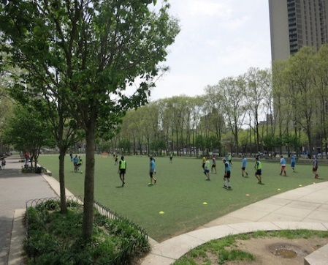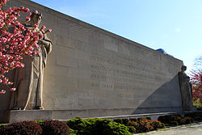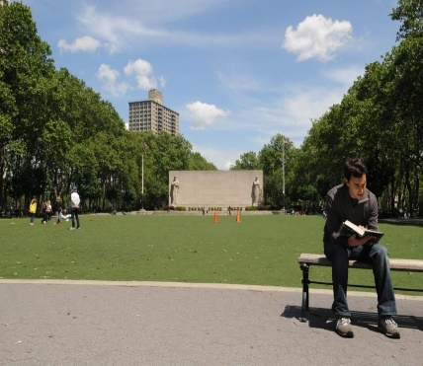
Park goers playing soccer. WW2 Memorial. Park goer finds a quiet place to read.

General instructions:
- Be sure to draw meaningful connections between what you observed and the purpose of the performative intervention. In other words, how does the performative intervention respond to, or integrate directly with, the specific material conditions of the site.
- Pay attention to the criteria for the sources you select. One source can be an internet source but other MUST be a newspaper source, archival source, academic source.
- Your sources should be Relevant and Credible.
- Describe the area where your performance will take place. What architectural structures are present? Describe the different shapes / forms and dimensions.
Located on the border between the neighborhoods of Brooklyn Heights and Downtown Brooklyn the park hosts a multitude of memorials. The park is named after Reverend Dr. Samuel Parkes Cadman (1864-1936), a Brooklyn Congregational minister and radio preacher known for his oratory. He was pastor of the Central Congregational Church in Brooklyn for 36 years and founded the Federated Council of Churches in America, which he headed from 1924-1928. There is a massive memorial in the center of the park which honors Brooklynites who served in World War II. Designed by Charles Keck (1951-1975), the memorial stands 24 feet tall. At its dedication in 1952, it was one of the largest monuments in New York City. The northern end of Cadman Plaza Park houses a statue of former NYC mayor William Jay Gaynor who served from 1910-1913. Architecturally, the park is sectioned into multiple squares and rectangles boarded by trees.

- Who are the people you observe in this space? What are some patterns of movement of people (are they passing through, stopping, moving in a single direction, moving in multiple directions)?
Around noon to 3 pm, small children playing soccer, court house workers on their lunch break, tourists, nannies, and commuters can be spotted throughout the park. After 4 pm, more adults can be found within the park. The field is portioned off length wise by multiple parties playing soccer. Joggers skateboarders and cyclist can be seen going around in either direction on the pathways. People reading, talking and relaxing can be found on the benches.

- How do the man-made / architectural structures inform how people use and move through the space?
The memorials are the centerpieces of the park which influence forward movement. The structures command attention at the end of the walk ways and lawn. As seen in the “Don’t Judge a Book By its Cover” picture, the memorial will draw onlookers towards its presence no matter where you are in the park.

- How will your performance respond to the people and patterns of movement that are already happening in that space?
Our performance will gather the attention from onlookers by first being a visual stimulant to all the different groups of people within the park. People by the bench areas and walkways will be the first groups willing to interact. These are the groups enjoying leisure activities with low impact of interruption as oppose to the groups of people engaged in a soccer game.

- How can you take advantage of the built spaces to create a staging area for your performance? Is your performance stationary or does it move throughout the space? It is interactive?
The memorial itself acts as a stage during the stationary portion of our performance. However, through the walkways the performance will have a better chance of interacting with more people. Especially the people who are not inclined to move from their predetermined areas.

RESEARCH
Central Research Question related to your performance topic (as you understand it based on conversations with your group and the research you’ve conducted--this doesn’t have to be uniform across group members and your questions can inform each other’s perspectives):
What precautions have NYC taken to reduce CO2 emissions?

Find, cite, and write a critical summary for 2 sources (1 internet source / 1 newspaper, archival, or academic source) related to your question.
Sources might be about the central issue your performance is responding to, the place where your performance takes place, tactics or strategies from similar performances, or the community that you hope to engage with your performance. Whatever the sources you choose, you should describe what the main point of the source is and HOW IT RELATES TO YOUR CENTRAL RESEARCH QUESTION.

MLA Citation for source 1:
COLUMBIA UNIVERSITY | SCHOOL OF INTERNATIONAL AND PUBLIC AFFAIRS MPA IN ENVIRONMENTAL SCIENCE AND POLICY Reducing Greenhouse Gas Emissions in New York City, A Community Challenge Prepared for the New York City Mayor’s Office of Long Term Planning and Spring of 2012 http://mpaenvironment.ei.columbia.edu/files/2014/06/Reducing-greenhouse-emissions.pdf
What is the main point of the source? How does it relate to your project?
The source, written by MPA in Environmental Science and Policy program at Columbia University’s School of International and Public Affairs’ was designed to be a practical, real‐world application of the skills acquired from the summer and fall workshop semesters, describing an environmental problem and then creating an operational and implementation plan to address the issue. The project, completed on behalf of NYC Mayor’s Office of Long‐Term Planning and Sustainability directly answers the question of, “What precautions have NYC taken to reduce CO2 emissions?”

MLA Citation for source 2:
“Cadman Plaza Park.” Cadman Plaza Park Highlights : NYC Parks, www.nycgovparks.org/parks/cadman-plaza-park-and-brooklyn-war-memorial/history.
What is the main point of the source? How does it relate to your project?
This source was used for information regarding the sites function, history and creation. How Cadman Plaza Park came to be and why it will be an influential site was discussed within this website. See question 1 answer for critical summary.

