Learning Places Summer 2019
SITE REPORT #2
Newtown Creek Nature Walk

NAMING PROTOCOL. When saving and posting your site reports on OpenLab, please follow the following format: SiteReport#.LastnameFirstname. Here’s an example: SiteReport2.SwiftChristopher.

Cover I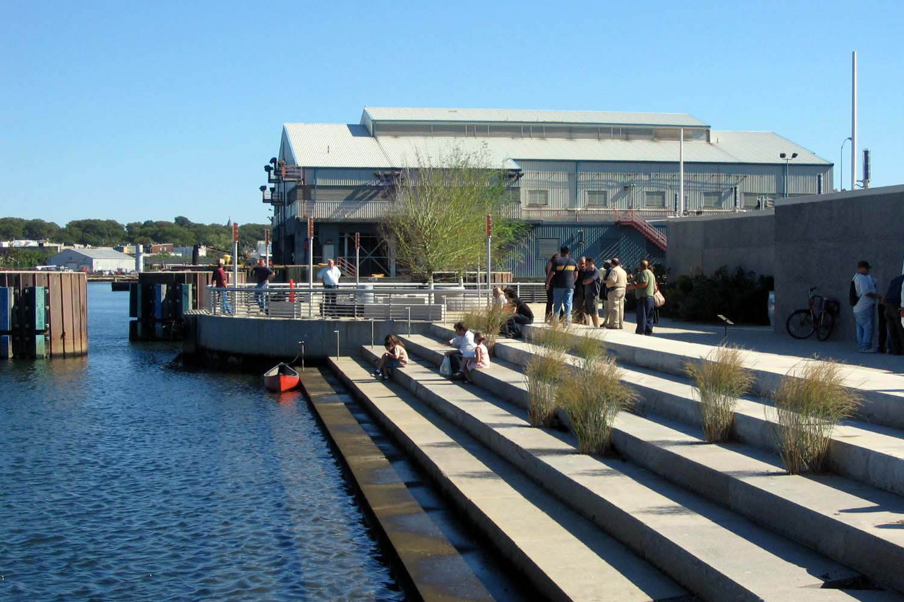mage
Steps give life to the living
Select a meaningful image to that captures your perception of the site we visited and provide a caption explaining what the image is.

STUDENT NAME: Star Love

SITE OBSERVATIONS Newtown Creek
Insert 3 photographs and provide a creative title for each image. The title should be a word or short phrase that suggests a theme or conceptual association related to the photo.
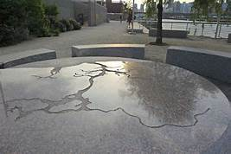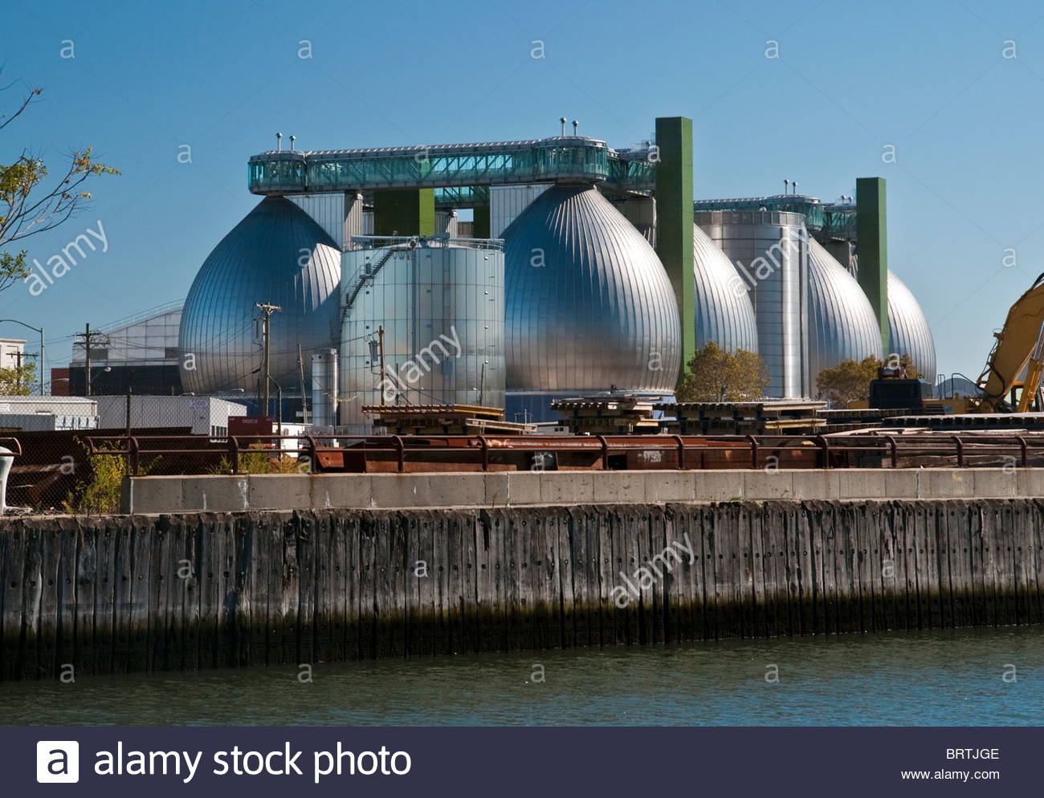

Table of vision and direction Stinky job but something’s gotta do it!

- Historically, what are some of the important developments that have created the current landscape of the Newtown Creek area. Refer not only to the reading and Prof. Spellane’s lecture, but also what you learned on the Newtown Creek Alliance tour (hint… estuaries, for instance)?
- A major development that happened during The American Industrial Revolution in Newtown Creek was when the nations first kerosene refinery was born. It was made from Astral Oil and made people’s lives much better because it was used in lighting lamps; which was a much safer way to read and perform other activities after the sun went down.
- Discuss the historical remnants that you observed in the current landscape.
- I observed a round granite table with the top part etched with a map of the Newtown Creek’s historical watershed. The Director of Advocacy and Education demonstrated how the map was used to find particular areas inside of Newtown Creek if a person was lost. She poured water into the designs of the map and I saw the map come to life. Each crevice saturated with water represented an area inside of the Newtown Creek. I thought this round granite table was one of the coolest exhibits shown to me that day.
- In what ways is the natural environment contained or shaped by the architecture of the Newtown Creek Nature Walk designed by George Trakas? In what ways is the natural world repossessing spaces that have been over-polluted or industrialized?
- The natural environment is shaped by the architecture of the Newtown Creek Nature Walk because of its large amazing wide steps that leads down into the water creek. These steps allow visitors to come into close contact of everything inside and surrounding the water, such as, the city skyline, boats, ducks and other birds, etc.. In additon the ground provides space for all living things to co-exist.
- Discuss one instance of architectural semiotics. Choose only one building or built structure. If the building or designed structure could talk, what would it say?
- If the Digester Egg could talk it would yell loudly and say “I am happy to help with getting rid of all the nasty stinky gunk and bacteria from the water creek, however, I wish I could shorten the wastewater treatment process, from two months to three weeks”. “This would allow me to triple the amount of unwanted fifth from the water creek”.

- If you were to stage a performative intervention in a specific site (i.e., a single structural aspect of the walk or industrial remains) where would you stage it and what message would your performance convey?

- I would stage my performance on top of the deep wide steps leading towards the creek water. This area would be a perfect performance stage because the visitors could sit on each of the steps while relaxing and listening to my performance. The water and all living things surrounding would provide a calm and attentive audience; this would be my best performance of all times. I would pretend to have lived amoung the Native Americans also known as the Matinecock and the Maspeth. The visitors would hear about how I lived by the creek with the Matinecock tribe, fished and farmed. My husband fished for haddock and oysters, some other stapled foods were strawberries, chestnuts, etc. I would express to the visitors how disappointed I am in seeing all of the man made infrastructure that surrounds my home. I truly believe that the visitors would appreciate seeing a live performance that was organic, rich in history and full of culture.

FURTHER RESEARCH
Research Question (should follow directly from your above observations, and be complex, specific, and researchable):
Is it possible to shorten the length of time it takes the Digestive Eggs to treat the wastewater?

Find an article from a journal, website, or newspaper that you believe will help you answer your question
MLA Citation for source:

How many sources did you look at before selecting this one? Why did you select this source? How does it address all or part of your research question? Be specific.

Is this source credible? How can you tell (what criteria did you base your evaluation on)?

What other sources or further information would you need to answer your question? Where would you look for them?

