Learning Places Fall 2016
Library / Archive REPORT
NEW YORK PUBLIC LIBRARY(NYPL)

Gurjot Nijjar
11.07.2018
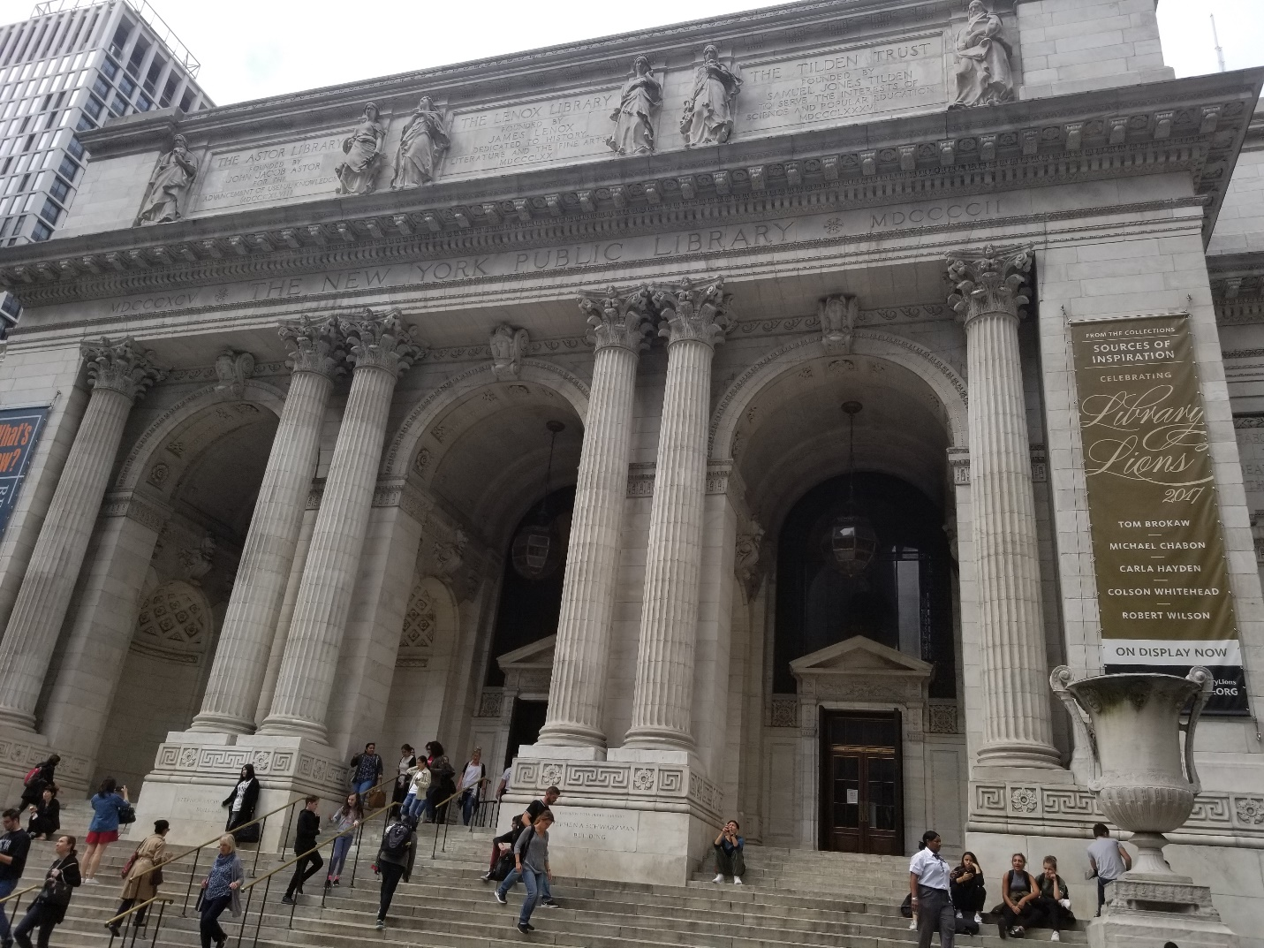The entrance for New York Public Library located 42nd street in Manhatten

INTRODUCTION
We visited the New York Public library for our second library visit in the Baltic and Slavic map reading room, expand our research on Brooklyn and Gowanus area. Miss Carmen Nigro was very helpful with her detailed knowledge about The Brooklyn area predating from 1766 to 2009. This library is located in the heart of Manhattan next to the famous Bryant park on 42nd street and between 5th avenue and 6th avenue. The name of the building is Stephen A. Schwarzman about a block away from time square. I drive all over New York city and I cannot even count the amount of time I have passed by this building, and never thought how beautiful was this building from inside. Although, it’s a Library but for me it didn’t felt anything less than visiting European Museum. Not being an Architect major I was able to appreciate the beauty and the style of the building. I expect to learn more about gentrification and old neighborhood of Brooklyn through rare old maps and documents.

SITE OBSERVATIONS

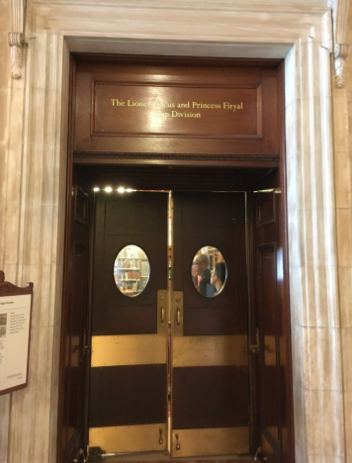 The Lionel Pincus and Princess Firyal Map Division.

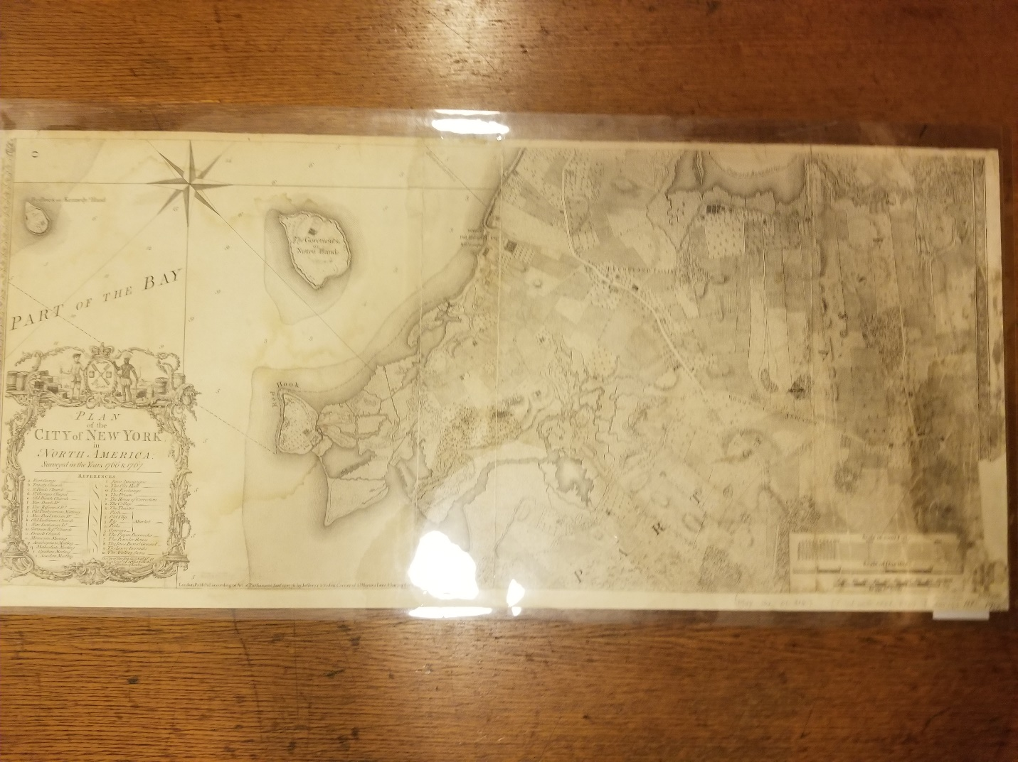Ratzer map of Brooklyn in early 1767

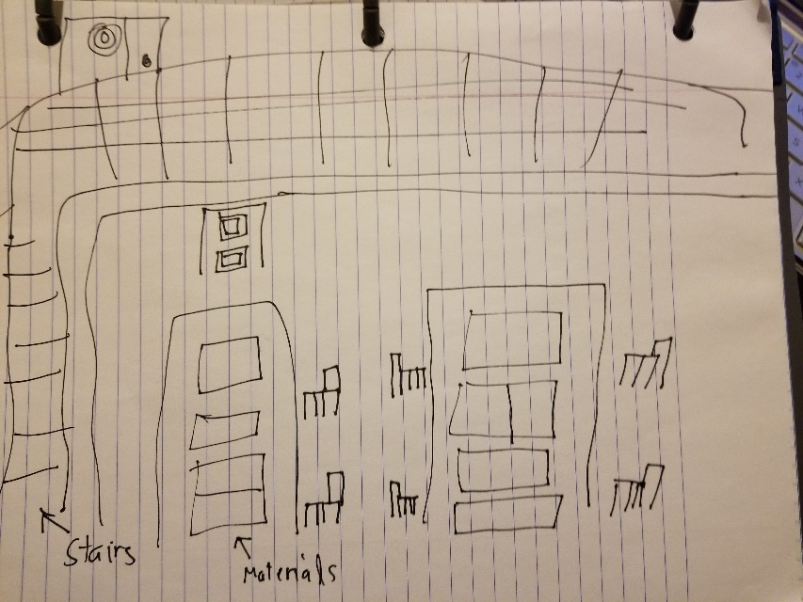 Sketch of Baltic and Slavic Reading Room by Gurjot Nijjar

What is the Genius Loci, or spirit, of this place?
The spirit of the NYPL is the serenity that you feel as soon as through those doors. The building is huge from inside and the lights and color inside is just perfect. Even if you are not into books or reading but this building is worth the trip at least once. What I have learned that the Stephen A. Schwarzman building has was they call A Beaux-Arts Architecture, what makes it beautiful. I have never been to a museum in my life but if or when I do, I would expect it to feel just like my trip to NYPL.

What kind of archive or library is this? What kinds of materials / sources does this place collect?
We visited the archival rare book division. The archive room we went to had huge collection of rare and very fragile maps and books and other related items. But in general Archives are collection of record that could vary from a single letter to a book or a dairy, reports, digital recordings and other historical collections. The NYPL currently has more than 50 million collections of these items. The NYPL different divisions for different record, such as:
- General Research Division - The General Research Division is located in the Rose Main Reading Room and Bill Blass Public Catalog Room, which together serve as the gateway to the Library’s world-class research collections of more than 43 million items. These two rooms serve as the central humanities and social sciences research hub of the Stephen A. Schwarzman Building.
- Miriam and Ira D. Wallach Division of Art, Prints and Photographs – The Wallach Division also serves as the access point to the Spencer Collection of fine bindings and illustrated books. Together, these collections include more than one million works of art in various mediums and formats, complemented by nearly 700,000 monographs and periodicals.

- Manuscripts and Archives Division - The Division holds over 29,000 linear feet of manuscripts and archives in over 5,500 collections. The strengths of the Division are the papers and records of individuals, families, and organizations, primarily from the New York region. These collections support research in the political, economic, social, and cultural history of New York and the United States.

- Irma and Paul Milstein Division of United States History, Local History and Genealogy - The Division has a renowned collection of family histories and other genealogical collections, with a particular focus on the New York region. Included in the collections are published works from the New York Genealogical and Biographical Society library, photographs, vertical files, postcards, and other visual ephemera.

- Dorot Jewsih Division - The Dorot Jewish Division was established as a distinct collection with funding contributed by Jacob Schiff in 1897, just two years after the formation of The New York Public Library. Abraham S. Freidus, cataloger of the Astor Library's rich collection of Judaica, was appointed the Division's first chief and presided over its rapid growth for twenty five years.

- Lionel Pincus and Princess Firyal Map Divison - Established in 1898, our holdings include more than 433,000 sheet maps and 20,000 books and atlases published between the 16th and 21st centuries. The collections range from the global to the local scale and support the learning and research needs of a wide variety of users.

- Rare Book Division - The Rare Book Division is rich in Americana, especially books printed in the Americas before 1801. The holdings of European Americana are mostly from the earlier period, up to 1600. The collection of broadsides—of which there are approximately 20,000—contains many items of American interest. The division also holds American newspapers printed before 1865.

- Henry W. and Albert A. Berg Collection of English and American Literature – The Berg Collection contains some 35,000 printed volumes, pamphlets, and broadsides, and 2,000 linear feet of literary archives and manuscripts, representing the work of more than 400 authors. Printed books in English date from William Caxton’s 1480 edition of the Chronicles of England to the present day, and the manuscripts encompass an almost equally lengthy period.

- Carl H. Pforzheimer Collection of Shelly and his Circle - The Carl and Lily Pforzheimer Foundation, Inc. donated the Shelley and His Circle Collection to The New York Public Library in 1986. Today, the Collection continues actively to acquire books and manuscripts relating to major and minor figures of the Romantic era, as well as works that illuminate the social, political, and cultural history of the age.

Who might use this collection and for what purpose?
This collection can used for variety of purposes such as personal research, academic purposes for students, record search, historian and authors. Just anyone who was learn more about New York than an average New Yorker.

Are there any special rules for using or accessing material?
Yes some of the material very fragile and made from old material and taped all over. We were told that in order to move the pages, we had to ask our professors or miss carmen to avoid further tearing or destruction of the pages. Others then that material that were in good condition or laminated we accessible upon requested.

SOURCE ANALYSIS
(2 citations of sources found and a brief analysis of each source—photos optional)

CITATION for ARCHIVAL SOURCE #1 (consult this website for help with citations)
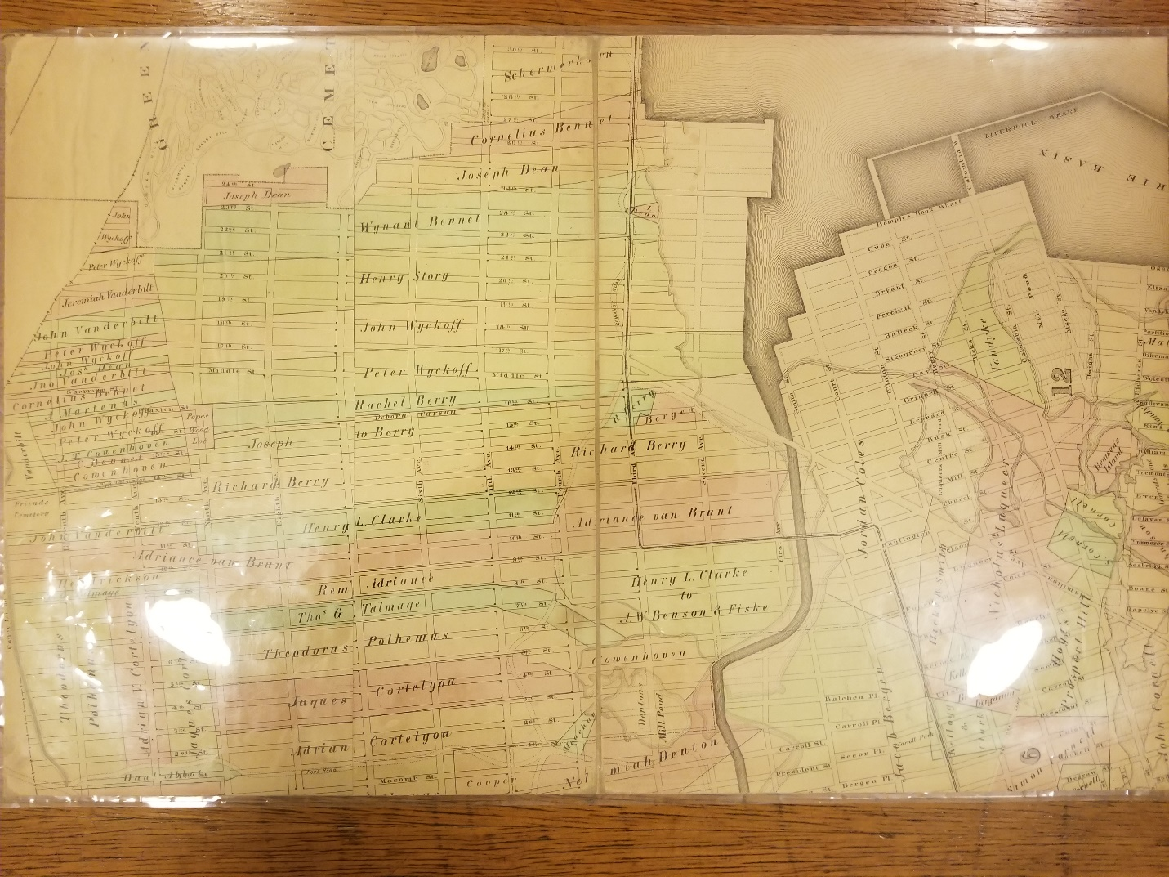 The first fire Insurance map by The Robinsons in 1886
- What is this source and what is its purpose?
This is the first fire insurance map from 1886. The insurance company will go to every building in city to inspect them to see which building was made from wood and which building was made out of brick. The map was created just so that they can set a price for different building.
- Who created it and who was it created for?
The map was created The Robinsons. It was created to see which building was made out of what material and how much fire resistant is it. Also, to give each building different insurance rate.

- What does this source tell us about the place we are studying? What themes or subtopics does it relate to?
This source helps us to understand what industries were and helps us to understand the conditions of the building in the Gowanus. It helps to me to relate to my topic of Artists in Gowanus because they are currently residing in these old brick buildings and working their art on the concrete floors of these old bricked industries.
- How might it be integrated into a research project? What question could it be used to help answer?
These fire insurance maps help to understand the condition of these old buildings that are still standing in Gowanus. For research project I would ask these building can still be preserved or modified and bring up to the code. If studied carefully these building can tells the history of Gowanus after these big buildings were shut down.

CITATION for ARCHIVAL SOURCE #2 (consult this website for help with citations)

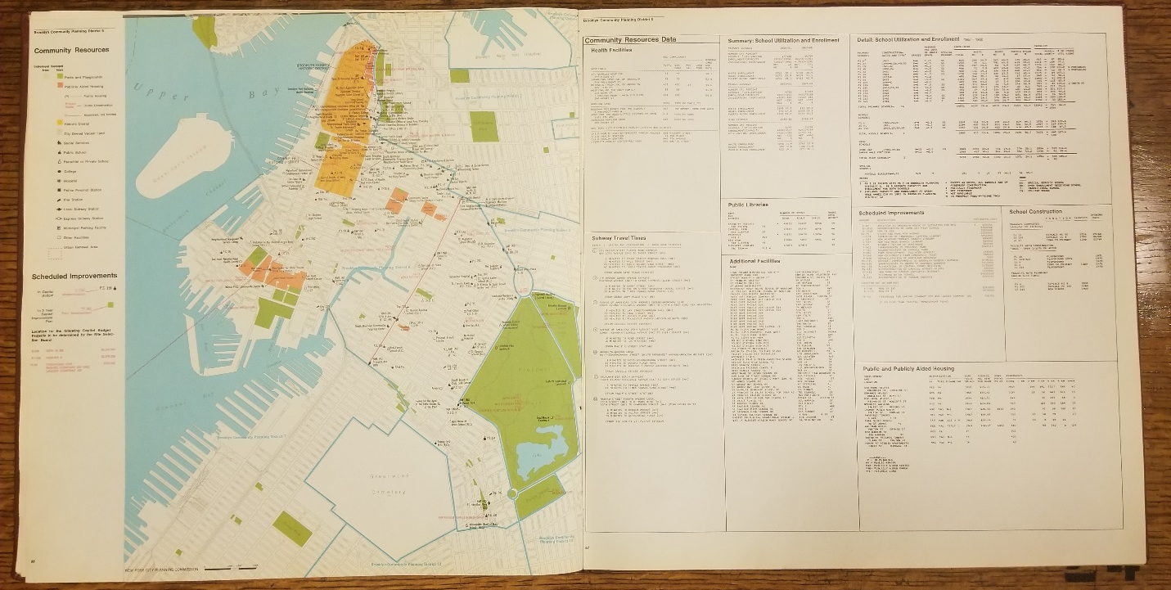Plans for Brooklyn, New York (1969), by the New York City planning commission to bring in more people and make Brooklyn look for attractive.
- What is this source and what is its purpose?
This is the plan by New York City Planning commission to bring community together. This is what urban renewal looks like. Making the city looks like a community and not just construction projects.
- Who created it and who was it created for?
It was created by the New York City Planning commission. It was created to make the city look more community, rather the just jungle of concrete building. It was created for people outside Brooklyn and given little details on side about the all the benefits and resources that are being offered.
- What does this source tell us about the place we are studying? What themes or subtopics does it relate to?
This map gives us the concept of Brooklyn to understand. The urban renewal helps to look at the area as a community. It gives us the list of all the resources and public space that is accessible in each neighborhood. It somewhat relates to help an artist that is forced to relocate, to look for new possible neighborhood, that also helps a little with inspiration.
- How might it be integrated into a research project? What question could it be used to help answer?
This can be integrated into a research project, for artist to look for new places that might be affordable with bunch of resources and accessibility. But, then it would beg the question that how long would it take before gentrification and zoning to happen, and the artists will again be forced to move. Yes the map does say about resources, but in reality who does the resource belongs to and how actually have the access to it. These kind of questions can be integrated into our research.

GENERAL NOTES:
- Always ask the library staff for assistance before touch anything.
- Fire building maps where yellow means wood and pink means brick.
- Artist living in the brick buildings that might not be up to code but still standing.
- Make appointment in order to access rare and fragile material
- Concept maps and Sam Borne fire insurance maps.

QUESTIONS for Further RESEARCH
- How to access archive that has material which is not available online digitally.
- When was the beginning of Gentrification Era?
- Transition from old to new community. How can both community can coexist. How can community can come together to save old history and prevent drastic changes.
WORK CITED:
Library, T. N. (2017, October 29). https://www.nypl.org/help/about-nypl/history. Retrieved from History 7 of The New York Public Library: www.nypl.org
Robinson’s atlas of the city of Brooklyn, New York : embracing all territory within its corporate limits; from official records … [1886] plate 29
Map Div. (Sanborn Map Co. Insurance maps of N.Y.) Offsite
More than 4,000 entries for archival collections and other materials held throughout NYPL have been made available for online browsing. Most entries include a link to a collection-level description. Over 2,000 collections are described by detailed guides. You can also search the full-text of both types of descriptions.

