Learning Places Fall 2017  
**Library / Archive REPORT**

NYPL MAP ROOM

# YUYING XIAN

10.30.2017

# INTRODUCTION

Describe the scope of the activity, geographic, and logistical details about the site visit. Include information about your expectations of the place and whether your expectations lived up to reality.

This is our second library visit. New York City Public Library is located near Bryant Park. It is a gigantic neoclassical building with a lion sculpture in the front plaza. My expectations were to learn how to get access to the materials and how the map can help us to analysis the Gowanus history. I also expected to learn when and why the artist move to Gowanus.

# SITE OBSERVATIONS

# (include photographic documentation and visual notes—at least 2 photographs 1 sketch required)

A group of people standing in front of a building

Description generated with very high confidence

A room with a large window

Description generated with high confidence

A picture containing indoor

Description generated with very high confidence

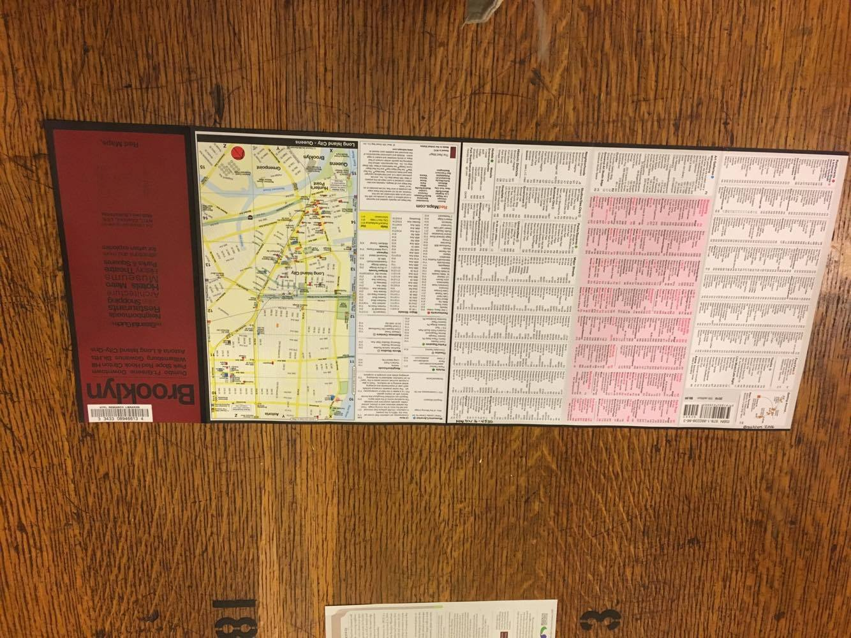

A close up of text on a white background

Description generated with very high confidence

What is the Genius Loci, or spirit, of this place?

The Genius Loci of NYPL is the Map Room where located on the second floor. I think it is the Genius Loci because it shows history map to visitors. I believe that people can learn many things from history, especial history map. The other reason is some of the history maps are only found in here.

What kind of archive or library is this? What kinds of materials / sources does this place collect?

There are many varied materials collecting in the library, such as maps, books, magazines, movies, photographs, music and arts. The most impressive collection is the history maps, like the fire insurance map, blue printing map, digitized maps, and atlases. Their materials are not only used by locals but also by international research. It has many old collections as well as new collections.

Who might use this collection and for what purpose?

Many people will use this collection, such as personal research, students, visitors, professors, and governments, etc. People use it because they are interested in these topics and want to learn something new. People use it as some references for their research, like us. In addition, some people use it to get inspiration, such as singers, cineastes, and artists.

Are there any special rules for using or accessing material?

To access these materials, people need to ask the librarian. Moreover, visitors can not touch the map without the permission from librarian. Many of the fire-maps and atlases are only can access in the map room.

# SOURCE ANALYSIS

(2 citations of sources found and a brief analysis of each source—photos optional)

Lionel Pincus and Princess Firyal Map Division, The New York Public Library. (1916). City of New York. *Board of Estimate and Apportionment. Use District Map*. Retrieved from http://digitalcollections.nypl.org/items/510d47e4-767f-a3d9-e040-e00a18064a99

# **CITATION for ARCHIVAL SOURCE #1 (consult this** [**website**](http://guides.lib.purdue.edu/c.php?g=352889&p=2378064) **for help with citations)**

1. What is this source and what is its purpose?

It is a blueprinting map made in 1916 when the city started zone the districts. The purpose of this map is showing the usage of the streets in 1916.

1. Who created it and who was it created for?

The city engineering department created it, and it was created for the government to prepare for the zoning. It also created for developers who was looking a space.

1. What does this source tell us about the place we are studying? What themes or subtopics does it relate to?

This source tells us the different districts in Gowanus. It showed where developers can build their building. It is related with zoning and gentrification.

1. How might it be integrated into a research project? What question could it be used to help answer?

From this map, we can see where developers or governments wanted to build the new buildings in 1916. Compared with the new map, we can know what would happen in the undetermined districts. From this map, we can figure out if there are any artist studios opened in this undetermined district.

# **CITATION for ARCHIVAL SOURCE #2 (consult this** [**website**](http://guides.lib.purdue.edu/c.php?g=352889&p=2378064) **for help with citations)**

Lionel Pincus and Princess Firyal Map Division, The New York Public Library. (2016). West 16th Street Map Co. Inc. 5th edition. *Brooklyn Red Maps*

MAP | West 16th Street Map Co. Inc. | 2016 | 5th edition.

1. What is this source and what is its purpose?

This is a guide map created in 2017. It is tourist visiting the New York City in Dumbo, Ft.Greene, Downtown, Park Slope, Red Hook, Clinton Hill, Williamsburg, Gowanus, Bk.Hts, Sstoria and Long Island City-QNS. It shows the neighborhoods, restaurants, shopping, art galleries and so on.

1. Who created it and who was it created for?

It is created by West 16th Street Map Co. Inc. and it is created for people who what to visit Brooklyn.

1. What does this source tell us about the place we are studying? What themes or subtopics does it relate to?

This map tells us where is the shopping malls, cafes, art galleries, and restaurants. It related with the artists, public spaces, and gentrification.

1. How might it be integrated into a research project? What question could it be used to help answer?

From this map, we can know where has the art galleries in Gowanus, so we can go to interview the artists. From this map, we also know how many art galleries in Gowanus or in Brooklyn. When art galleries become one of the attractions in our city, it means people care about arts. It can help us to analysis the relationship between art galleries and artist.

# GENERAL NOTES:

* Make an appointment before using the map room.
* Don’t touch the map without librarian’s permission.
* If we need the citation, we can email the librarian with the picture, section number and period.
* Different colors in the map present different materials, pink is wood; yellow is concrete.
* There are many art galleries or studios in Gowanus.

# QUESTIONS for Further RESEARCH

1. How can we find a map related to the artist?
2. If an artist creates a map, what will it looks like?
3. How many artist studios open in Gowanus, and how long have they been in Gowanus?