Randy Apanah
LIB 2205 ID
Revised Library Report 2

Things I Changed In Library Report 2

I fixed my citations for the analysis section
- Better explained my observations about the NYPL
- Thoroughly answered the questions to full detail

Learning Places Fall 2017
Library / Archive REPORT
NYPL Map Room
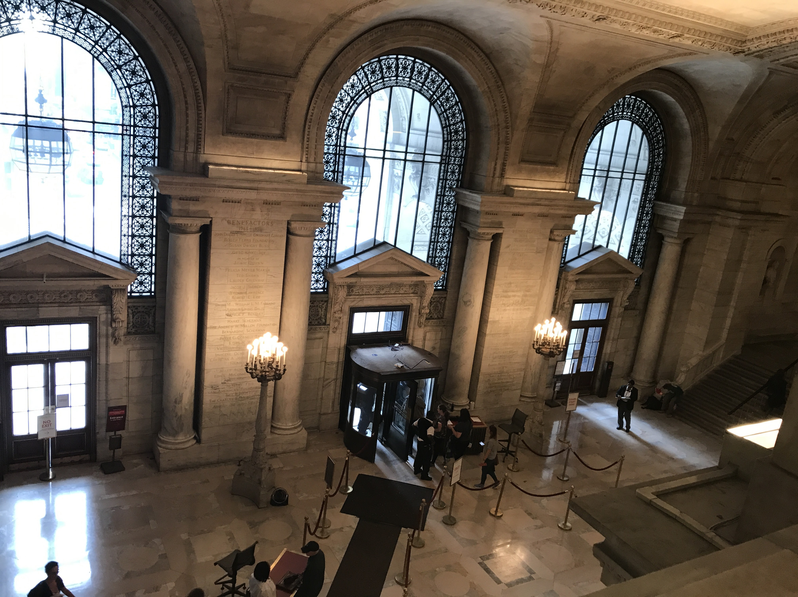
This photo was taken upstairs of the NYPL Map Room. I chose this image to show how well constructed this library was built and designed.

Randy Apanah
11.26.2017

INTRODUCTION
As a class, we visited the New York Public Library Map Room. I never visited a map room so I was eager to see what was offered at this library. At first, I thought it would be a regular room with maps with the given terminiolgy. When we arrived, we were greeted by one of the employees where she thoroughly explained the library and what it has to offer to the public. I became amazed at the different types of maps they had on display. Certain maps displayed ranged from years from the early 1800’s. You can tell by the material of the pages in the paper as well as the condition of the paper. I learned that the insurance companies go to every building in the city to see what objects are made of wood and brick to inspect, map and code every area of the city in order to determine what insurance rates would be charged per properties. Many industries were built around the canal. I find it very different that the maps were constantly updated from 1903 and 1907. Maps were refined and parts of some maps were glued in order to stay current with the places. If we werent introduced to coming to this library, I don’t think I would have came on my own. I am grateful for having the opportunity to come and learn about new places.

SITE OBSERVATIONS
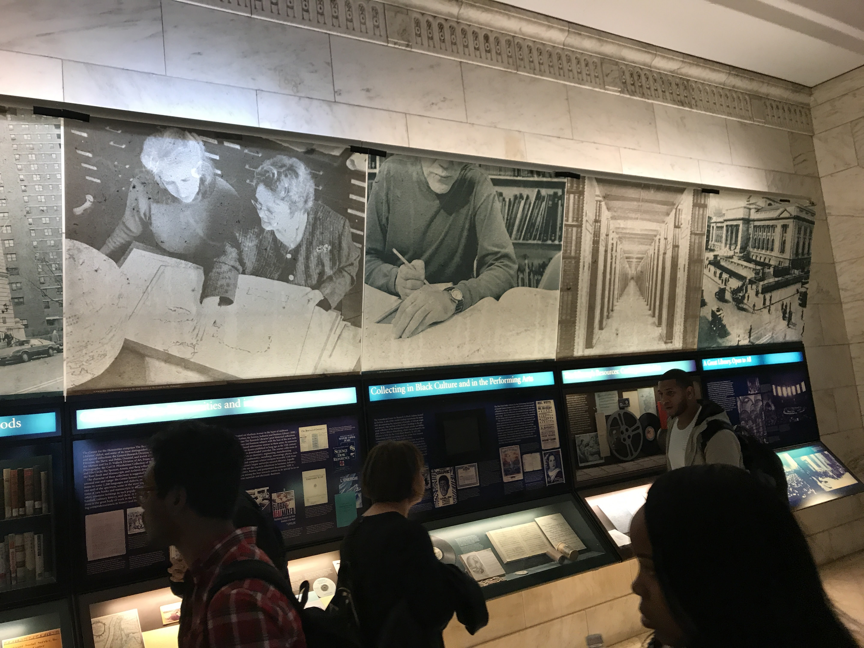
This image was taken in the hallways of the New York Public Library to show how some of their resources are displayed throughout the library.
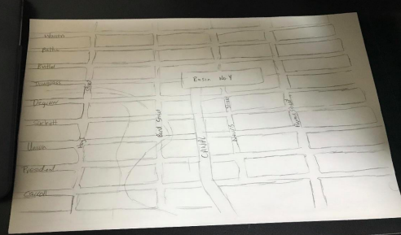
This was a sketch that I made which was part of a longer map which was titled “Plan of the Drainage of that part of the City of Brooklyn.”
What is the Genius Loci, or spirit, of this place?
The spirit of this place in my opinion was a little more serious type of environment where individuals are quietly reading and seeking information from the library. In my opioin, the people really brought out the spirit in this library.

What kind of archive or library is this? What kinds of materials / sources does this place collect?
The NYPL Is open to the public when the facility is open. It is also a non-profit organization. It offers a wide variety of material for the public as well such as movies, books, maps and more. It carries several types of archives within different divsions of the library. Related to our topic of research, we were focusing mainly on the Lionel Pincus and Princess Firyal Map Division.
Who might use this collection and for what purpose?
People who are composing research of places from the earlier time will find this library useful. My class and I are doing a project on Gowanus and this has been the most useful site visit in my opinion. The resources are citable and are physically present from the mid-18th century. In my opinion, it’s always good to have a physical copy or reference of information when doing research. This library has so many different editions and maps, atlases and information in which anyone can easily find and include into their researches.
Are there any special rules for using or accessing material?
Due to the age of the physical print, pages must be turned by library personnel to avoid damage. Resources may also have to be reserved in order to save you time when arriving to the library. Because there are so many resources, this gives the librarian a chance to pull prints from different shelves to suit your criteria. Due to the fact of old and worn pages, its easy to determine that this material has been created from an earlier tim eperiod because the quality in print is different.

SOURCE ANALYSIS
(2 citations of sources found and a brief analysis of each source—photos optional)
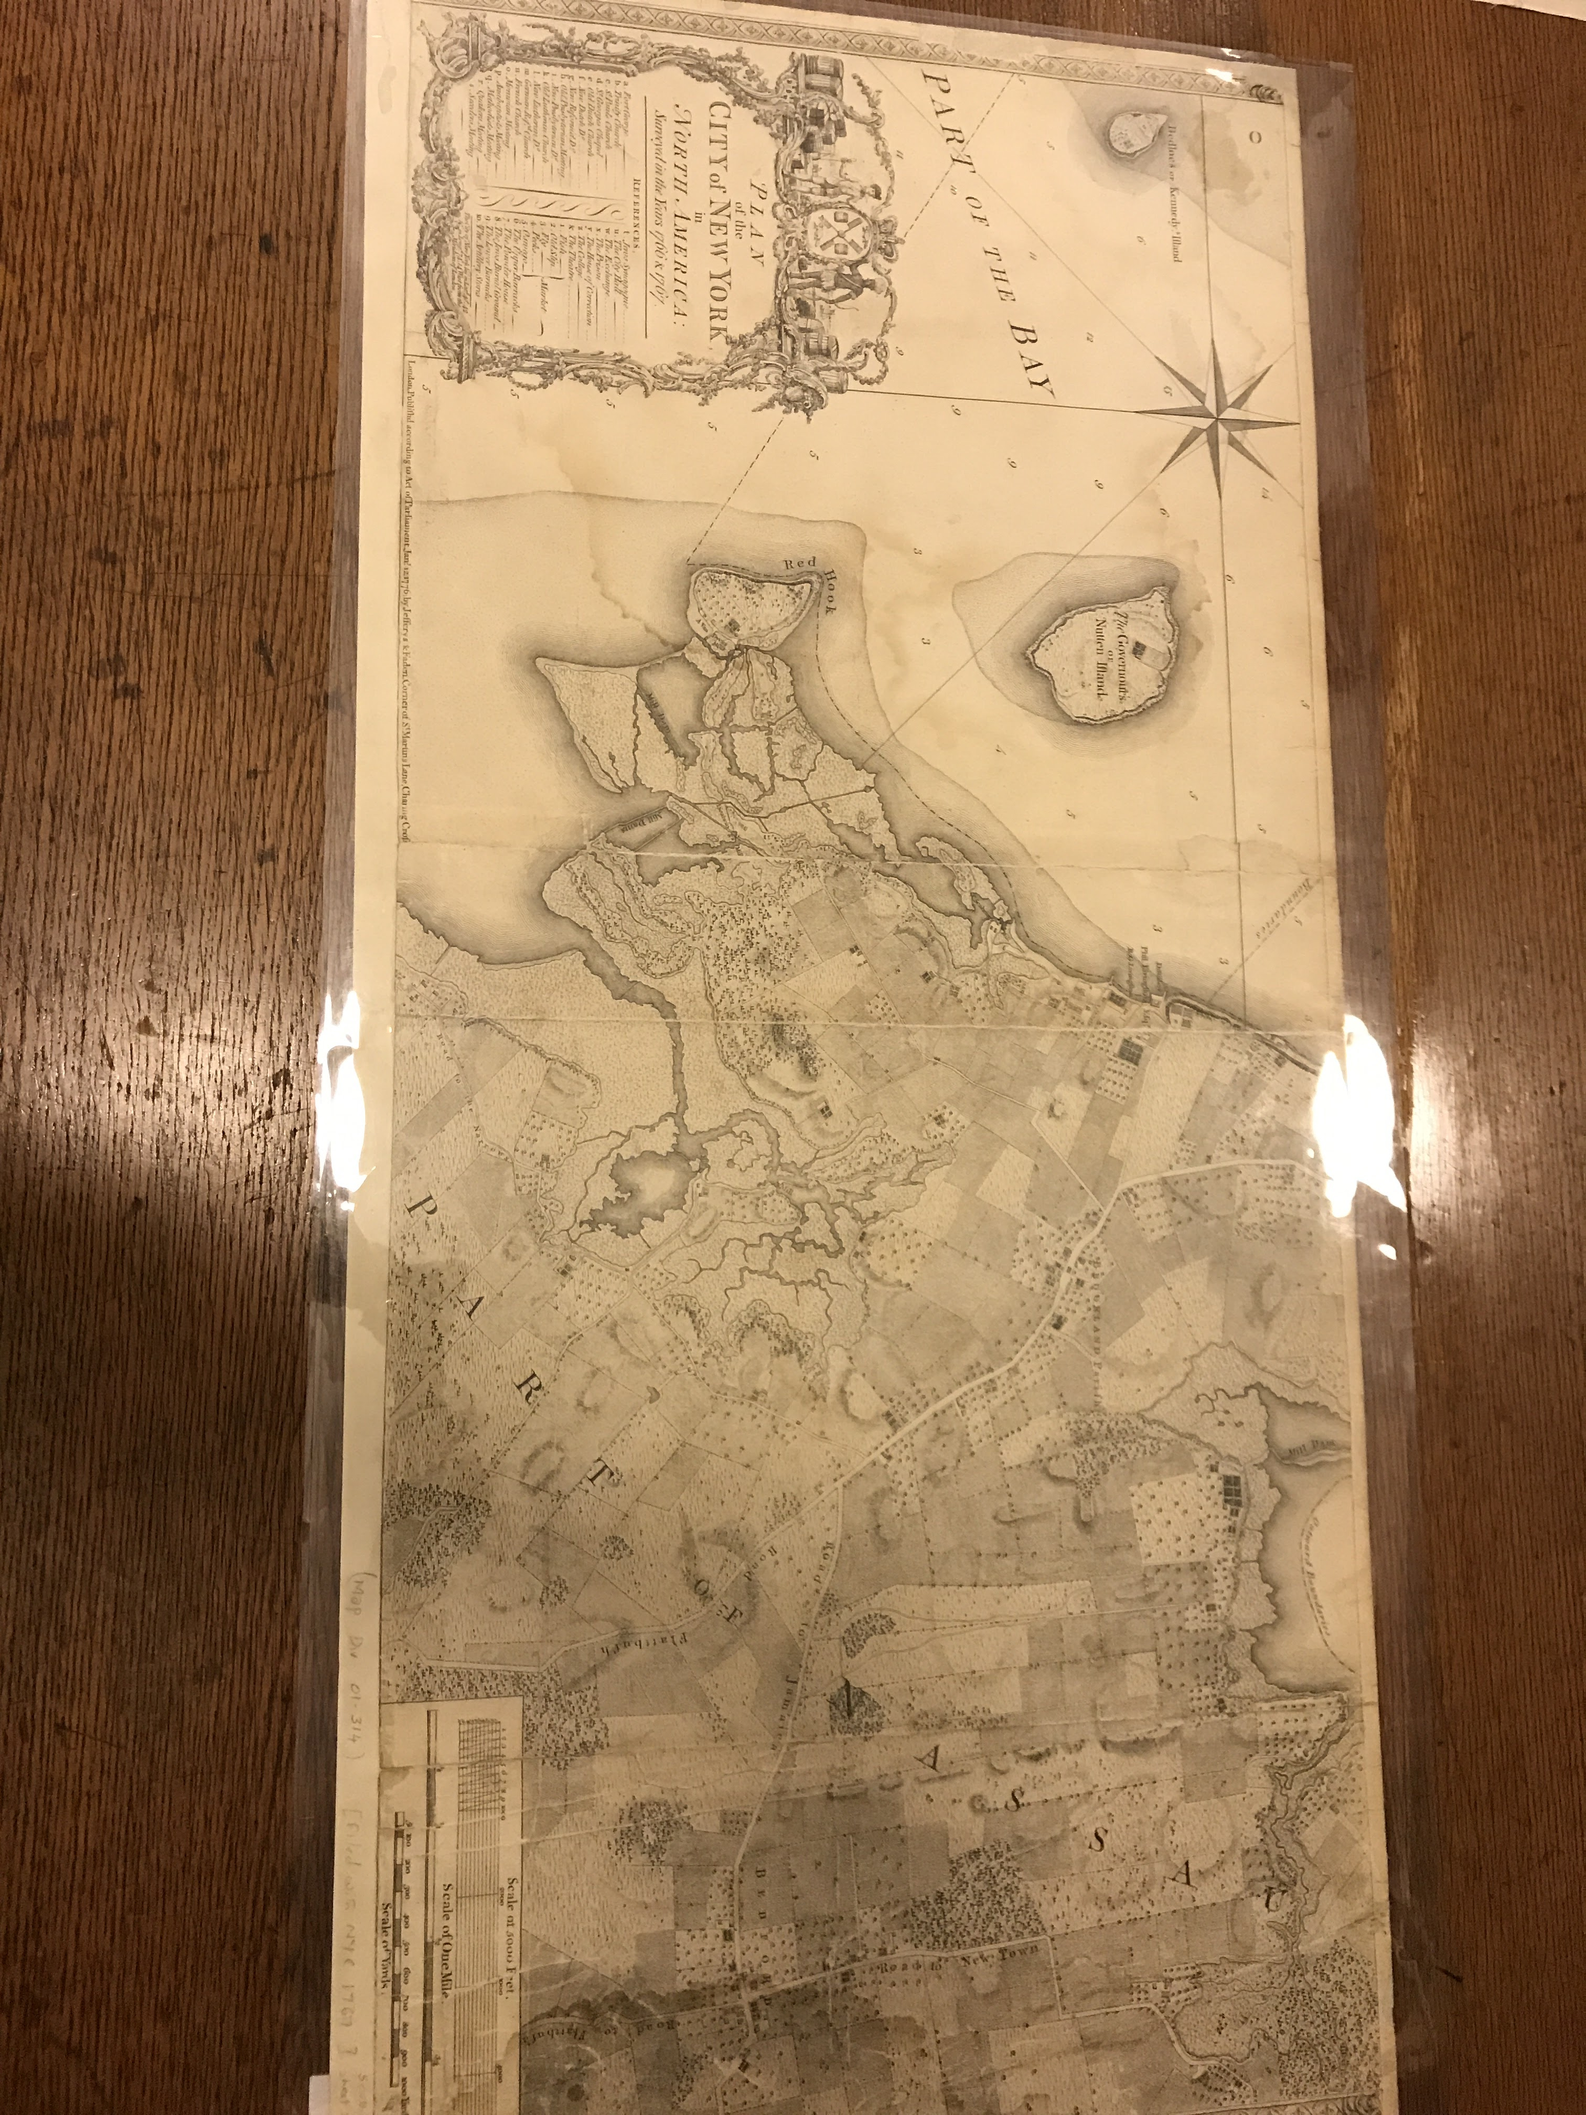

CITATION for ARCHIVAL SOURCE #1 (consult this website for help with citations)
Lionel Pincus and Princess Firyal Map Division, The New York Public Library. (1776). Plan of the city of New York in North America : surveyed in the years 1766 & 1767 Retrieved from http://digitalcollections.nypl.org/items/8bd31a8f-cfed-3cb6-e040-e00a18061cd0 - Citation taken from NYPL website.

- What is this source and what is its purpose?
This map outlines what the area consisted of and ooked like in the yeears 1766 and 1767. This citation was taken from the website because the map above and map the website displays is the same type of map.
- Who created it and who was it created for?
According to the NYPL website, this map was created by Bernard Ratzer who was the cartogrpaher of this map. It was also published by William Faden and engaved by Thomas Kitchen. It was created as a source for references when it came to city planning and insurance mapping purposes.

- What does this source tell us about the place we are studying? What themes or subtopics does it relate to?
We are studying the city of Gowanus in class. This map is an image from the earlier tim ebefore all of the new devleopments and consturction. It gives us, the researchers a good idea as to what the structure was like back in eariler time versus how it looks today.

- How might it be integrated into a research project? What question could it be used to help answer?
This can be easily be integrated into a research project because this is a map form earlier 1700’s, Our topic of discussion for our project is Gownaus explaining public spaces and places. These maps show some type of public places that were in the maps shown above but isnt currently in the area.

CITATION for ARCHIVAL SOURCE #2 (consult this website for help with citations)
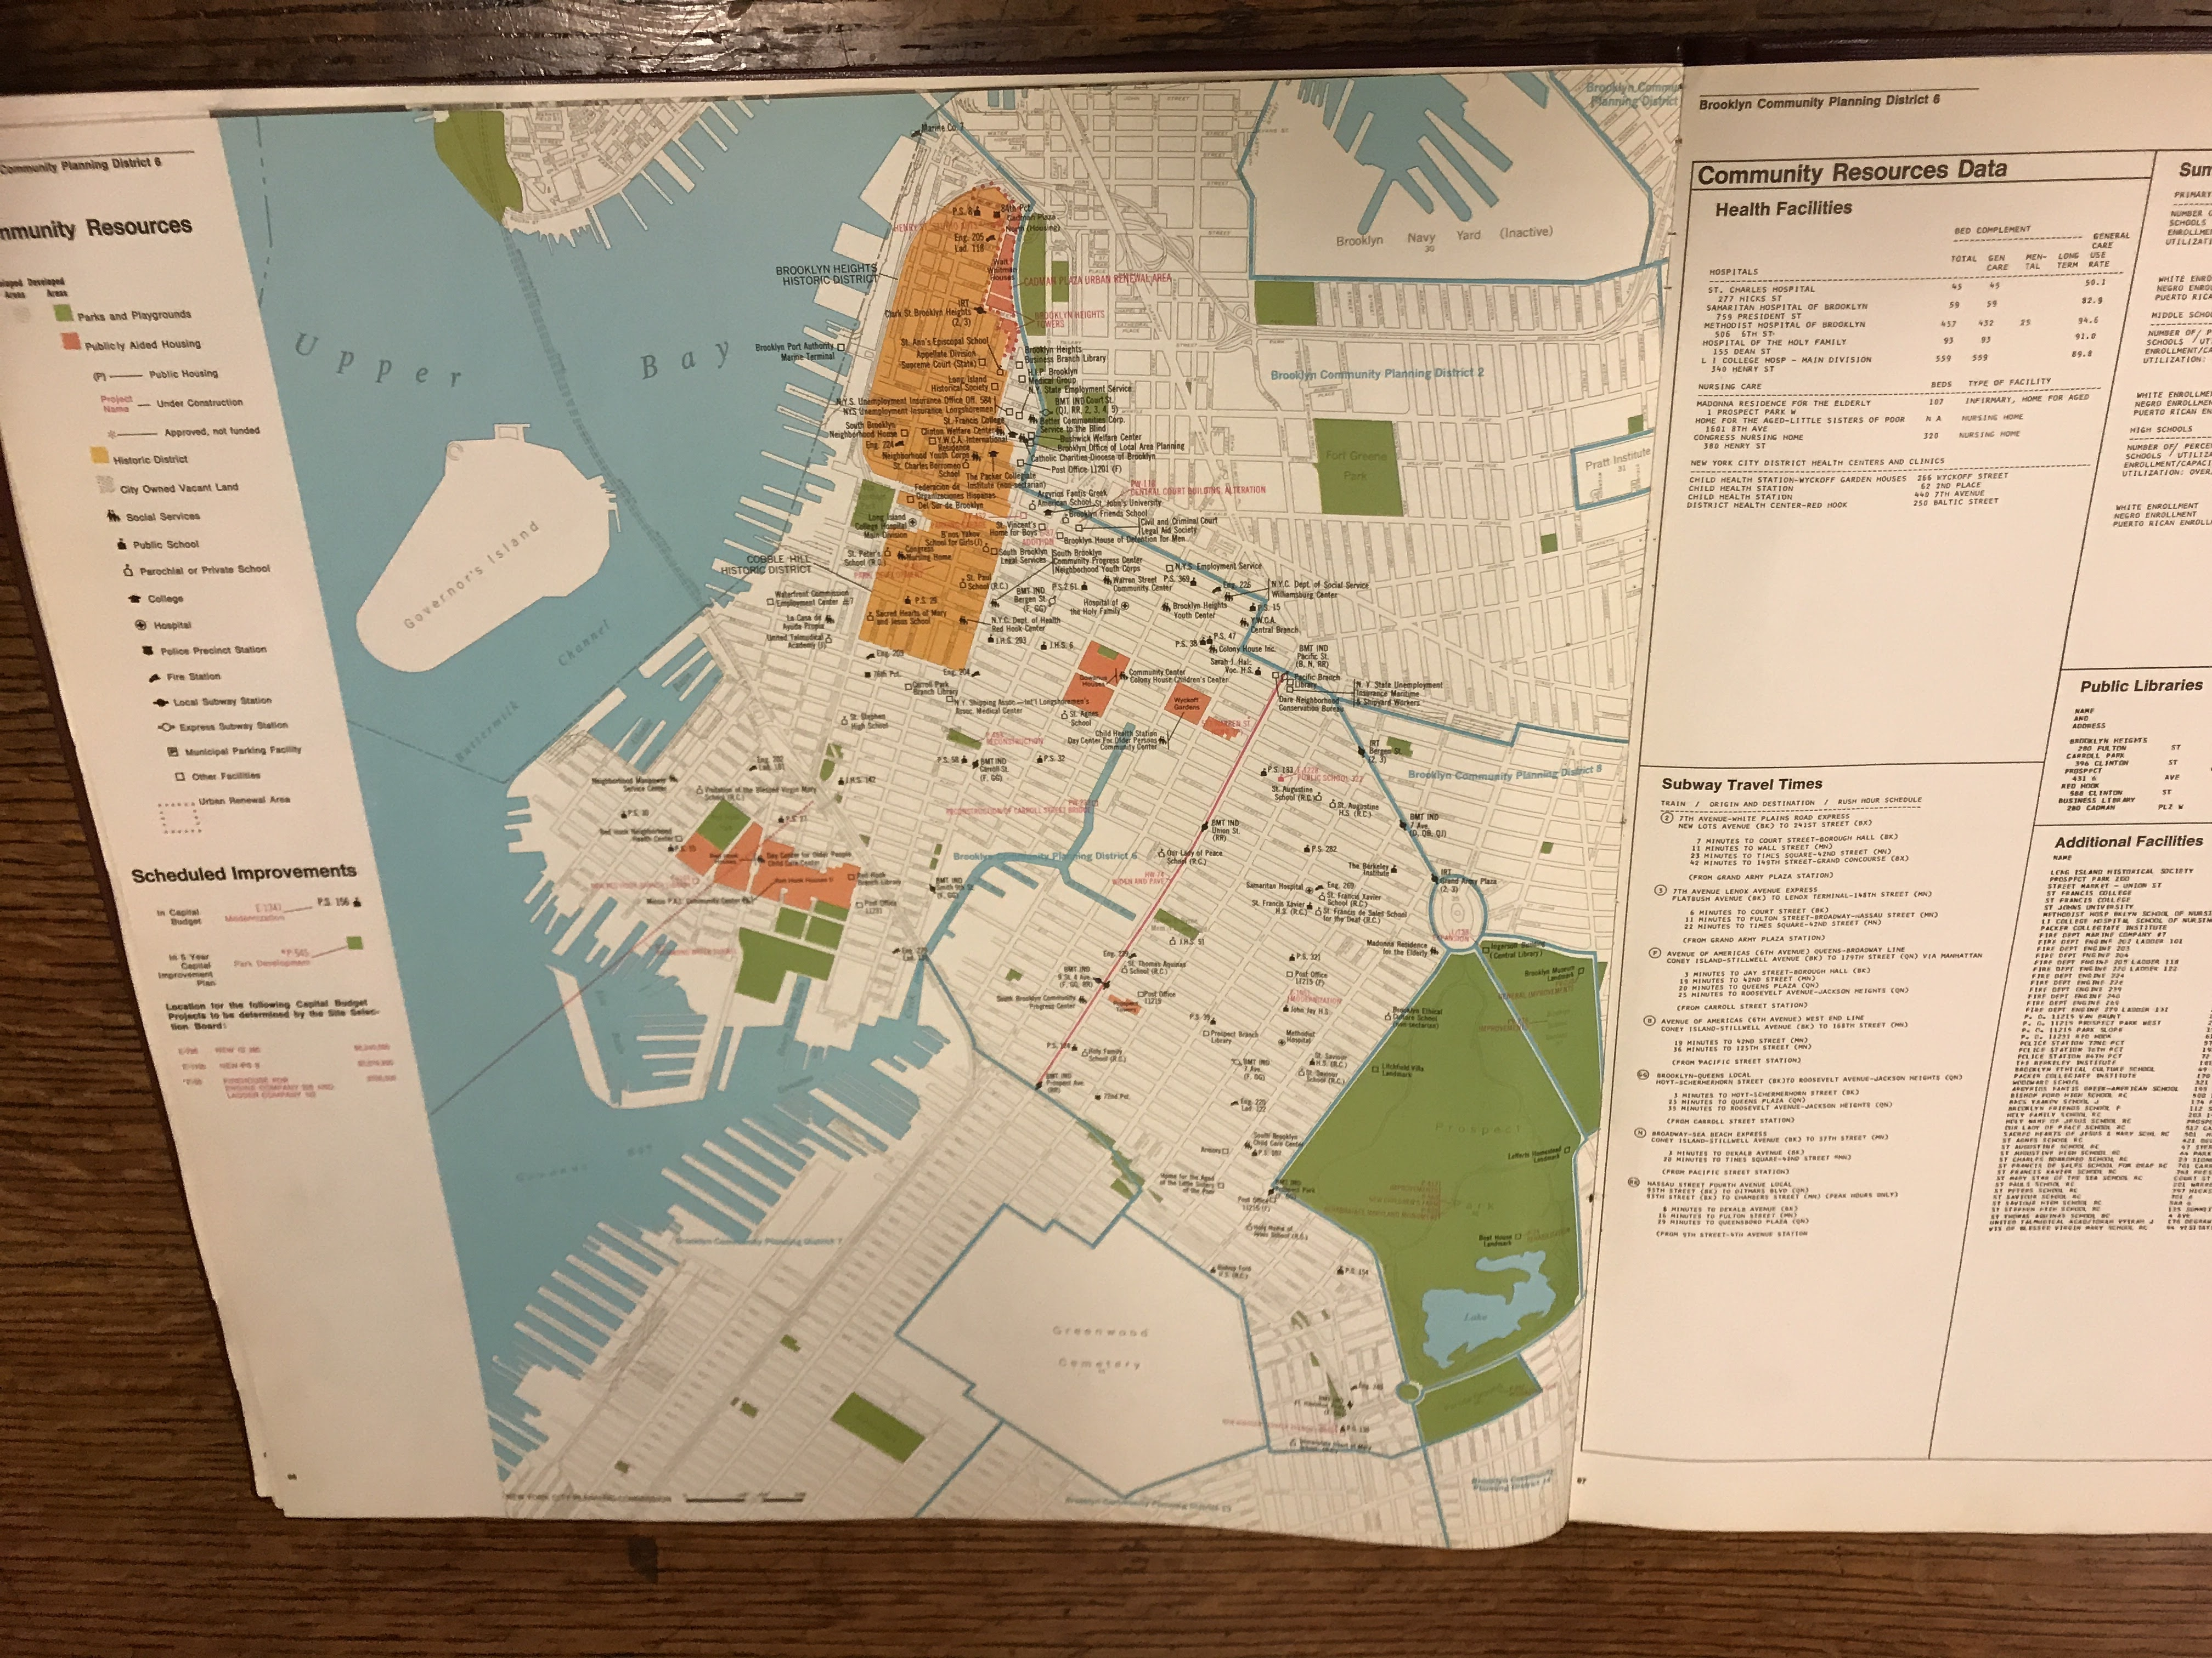
Community Planing District (1969). Scheduled Plans For New York City(Map). Lionel Pincus and Princess Firyal Map Division, New York Public Library.

- What is this source and what is its purpose?
The map is an image of the several community resources along with scheled improvements for the city.

- Who created it and who was it created for?
The map was created by the Community Planning District in 1969. It easily identifies several places and spaces in the area as shown in the key. The key offers many different types of places that are color coded and shown in the maps.

- What does this source tell us about the place we are studying? What themes or subtopics does it relate to?
This source tells us or gives us an visual of how zoning or structuring took place in this time period. Scheduled improvements have been made and are taking effect within the map as shown above. We can use this to compare and contrast the several places from this time period to todays structure of the area.

- How might it be integrated into a research project? What question could it be used to help answer?
This might be integrated into a project for a group whose looking to back track at all the different places or community resouerces that were present. They can use this map as well as several others to gather their findings.

GENERAL NOTES:
- Maps were used by cab drivers before GPS- regular navigation map street map of Brooklyn. Displays Bridge between the 70s and the modern era.
- Tri-boro bridge authority- the purpose of pamphlet was the Gowanus improvement project. The improvement talked about was highway building and glorifying the elevated highway showing construction defense industries in 1941.
- The map is updated and glued into changed parts between 1903 and 1907. The blue map has lines to depict how far the corners can be. 1916- first zoning regulation - associated with working on the districts to separate residential versus industrial.

QUESTIONS for Further RESEARCH
- Does the map room has a specific section of criteria in which was defined for green infrastructure since that seems to be a bigger section in Gowanus?
- In what year approximately was there an unpolluted canal before it became contaminated and polluted?

