Learning Places Fall 2017
SITE REPORT #3
GOWANUS OPEN STUDIOS
Cover Image: ART IN GOWANUS CANAL: This photo is taken by Janice Everett. It was taken near the Gowanus Canal in 2017. I am surprised that it just looks like in the forest.
YUYING XIAN
10.30.2017
INTRODUCTION AND PRE-VISIT REFLECTIONS
After the previous visit, I am expecting to learn about the development of Arts Gowanus and how the Open studio event affects local community. In multiple aspects, this event shall effects on local community and artists in New York City. For instance, the financial benefits from visitors brought by the event, human traffic that interrupts local residents, and so on. Through interviewing local people, I will expect to understand what effects does the events leads to, and determine if it is a positive or negative impacts to the community.
SITE DOCUMENTATION: Take notes and sketch in your notebook, take many photographs – search for angles and details that really tell a story and use those to report your documentation. Your site documentation will include the following:
- MAP OF AREA OF INVESTIGATION -- on a map like the one below chart the route of the walk and mark the following: (a) significant stops; (b) Locations and directions of your photos and sketches.
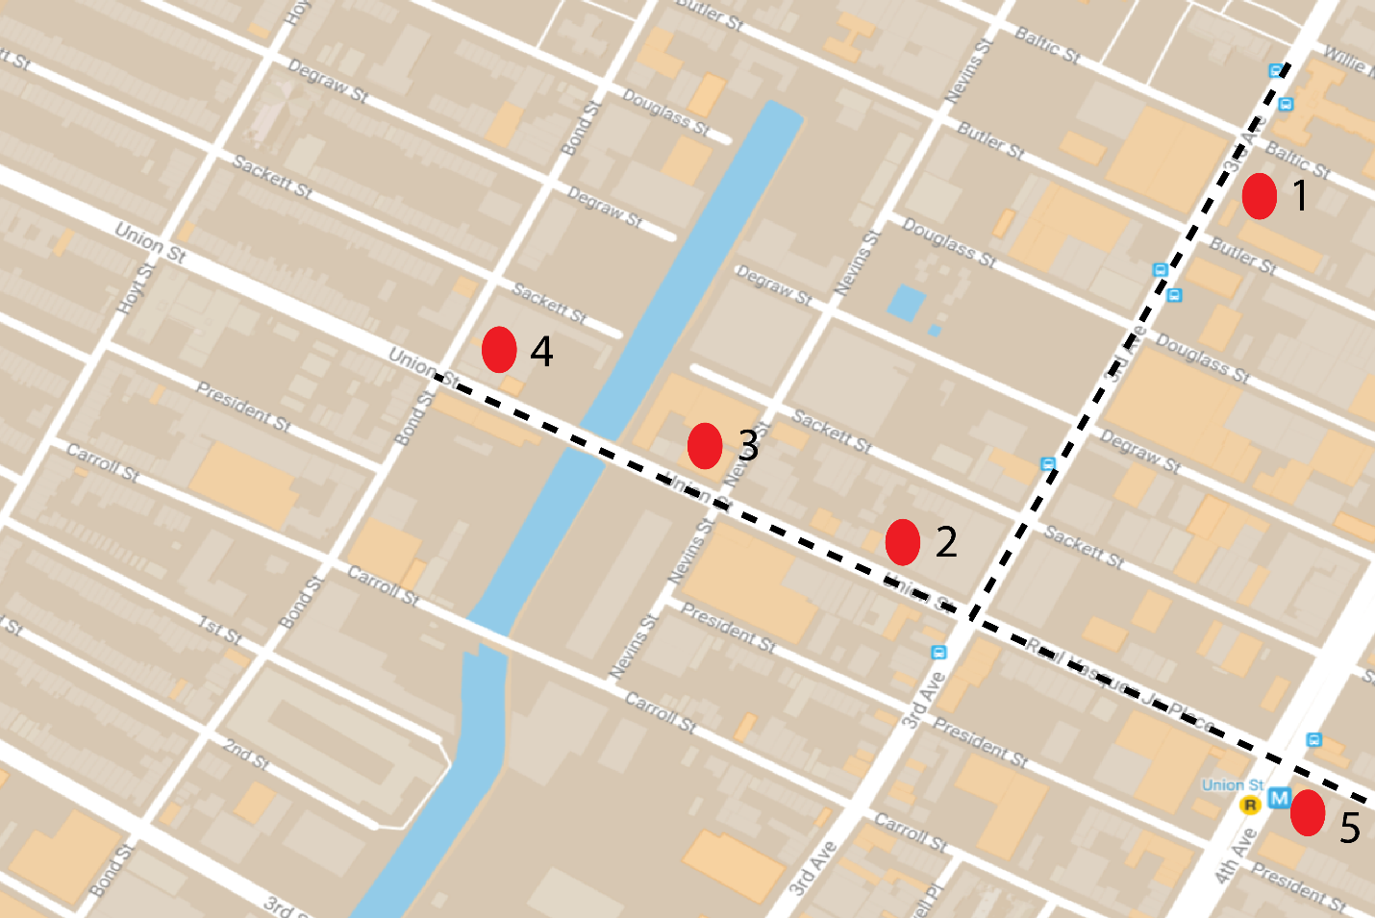
- PHOTOS AND SKETCHES: Provide a minimum of 4 photos and 2 sketches of places, elements, processes, people or anything else that you found significant and meaningful during the walk. Focus on scenes that relate to ecology, the environment and public spaces. Feel free to include IN ADDITION other “findings” that you found intriguing. For each photo provide captions and explanations – why is the image shown significant for your exploration.
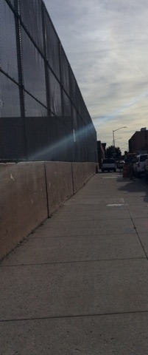

MANUFACTORY STREET: This one was taken at the first stop where has many old manufactories. The street is empty where only has cars, buildings, and few passengers who going to visit the studios.
The Gowanus Reflection: This one is taken by Janice Everett in the Gowanus Canal. She uses her vision of art to create a beautiful Gowanus.

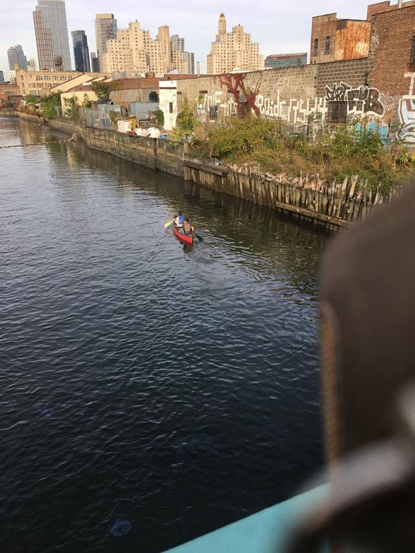
KAYAKING IN GOWANUS CANAL: People are kayaking in Gowanus Canal. I took this picture on union bridge. I think it is very dangerous to kayak in the river since it was polluted. Many visitors are shocking of it.
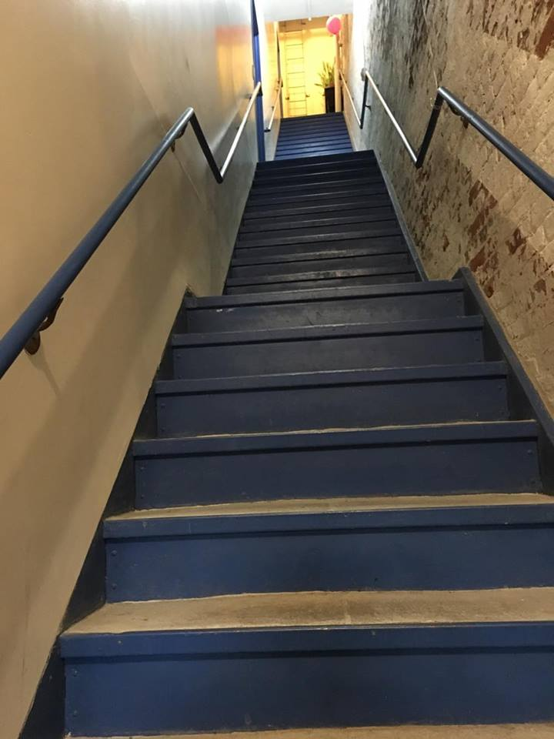
OUTSIDE THE STUDIO: I took this picture when I got up the studio. The wall was very old, and you can even see the brick on the right side of the wall. Compared with the inside of the studio, it seems two different places.

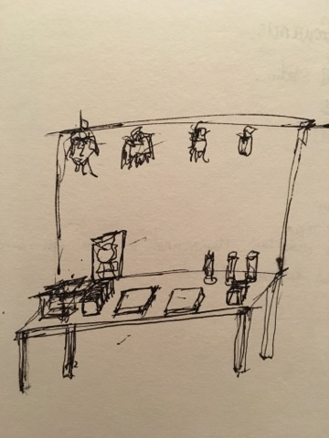

WELCOME TO GOWANUS OPEN STUDIO: This sketch is showing that there are guide maps, plants, books, postcards on the table. From each studio, it has a small table that providing snacks, drinks, and guide maps. Many of them are sponsoring from small business around gowanus area.

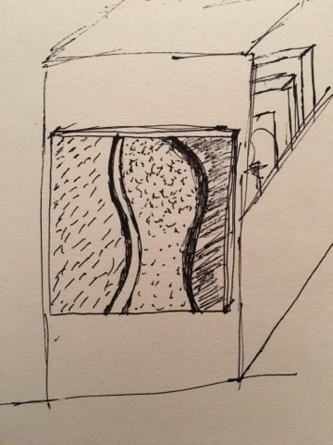
RIVER: This sketch is hanging on the book shelf in one studio. The artist inspired from her hometown where is a suburban area with beautiful nature.

ANALYSIS:
The Gowanus Open Studio have been operating for over 20 years, which makes it significant event for artists and local community. Through the interviews conducted and images taken, it is apparent that this event have shaped the nearby area and recorded a lot of changes in Brooklyn. The studio expanded from Bergen Street to 18th Street, and from Court Street to 5th Avenue. Within these blocks, buildings, shops and restaurants seems to be more developed and welcoming. However, outside of these blocks area, the streets nearby are comparatively old and not well maintained. From this observation, it be interpreted that the open studio event attracted a lot of attention from both visitors and government, therefore the nearby area are renovated to match up with the demand from visitors. This is a both positive and negative sign for local community. It is positive since it brings more business and cash flow to blocks nearby; but it is negative because it also greatly changed the original atmosphere of the neighborhood.
On the other hand, this event does affect artists as well, in a good way mostly. Because it gives them a place to express themselves and their opinions. The images shown above are awarded pictures taken a photographer. For comparison, I took a picture of the river as well. It can be seen the river is not as nice and clean as the award pictures, but more polluted and dark in color. The photographer was trying to reveal an issue: the river is polluted and not as beautiful as before. He was trying to prove his point through using contradiction of this picture with the real river itself. And these series of photo does grad the attention from media and government in facing this issue. This cannot be done without the exposure support provide by the open studio. Hence, it helps artists and local residents to express their opinions through artworks and photos. Moreover, there are a lot of pictures of the “old Brooklyn” in the studio where people can record and feel the history of Brooklyn. The studio does helps New York citizen and visitors to understand more about the local culture and history of this neighborhood. Which I see as a compensation for changing the neighborhood.

KEYWORDS/ VOCABULARY (these must be words you learned on this walk such as specialized vocabulary, city agencies, names of businesses or significant people – they must be specific to the topic of the walk) *5 keywords required per site visit
- Inspiration
- Environment
- Studio
- Reflection
- Rezoing

QUESTIONS for FURTHER RESEARCH: (these should follow directly from your analysis section and be complex and specific enough to serve as the basis of a research project; do not include questions you can answer with a quick google search)
- How can artists get help if they have to move out?
- How can artists help the neighborhood?
- How the rezoning effect the local artists?

