Randy Apanah
LIB2205ID- Learning Places
Site Report 3 Revision Cover Sheet

What I have changed in the Site Report?
- Introduction- I have given a more in depth introduction about the area and tried to best describe my expectations
- I created my own map with my own points via Google Maps to show the places we visited
- I included detailed images with come descriptions to give the reader a better understanding of my visit
- For the analysis, I stuck to one topic and gave thorough responses and included my opinion and gave both positive and negative sides of my observations.

Thank you for allowing me to revise my site report.

Learning Places Fall 2017
SITE REPORT #3
Exploring Gowanus (Groupwork)
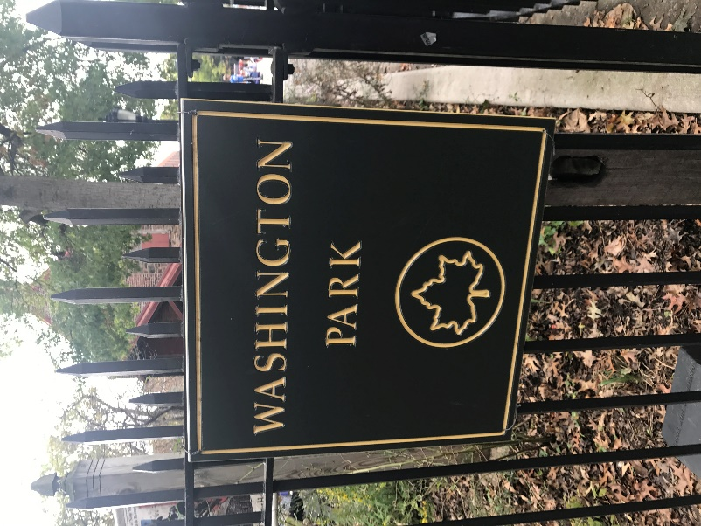
This is a sign of Washington Park. It is a well-known public space in the Gowanus Area. I chose this image as my cover image because a park is generally classified as a public space or place.
Randy Apanah
11.24.2017
INTRODUCTION AND PRE-VISIT REFLECTIONS
We have been conducting research and visiting Gowanus, Brooklyn numerous times this semester. After being given a research project, my group and I were excited to visit and learn new places around Gowanus. Reviewing back to our first site visit of Gowanus, I didn’t have any kind of knowledge or background, other than what was presented in class. Looking back to show how much Gowanus had a learning impact on the group, I have learned more about Gowanus than I expected. In my group specifically, we are researching public spaces and places in the Gowanus area. Our topics to cover and research should be based on our site visits and data that we learned in Gowanus.
SITE DOCUMENTATION:
- MAP OF AREA OF INVESTIGATION – Below is a map of the places we visited on the site visit. We first met up as a class at the Whole Foods Market which is the blue marker on the map. We divided into groups and we first visited 422 Smith Street which was St. Mary’s Park which is the black marker on the map. The park was undergoing construction. However, it will be open to the public in March 2018. We then visited Washington Park which is the orange marker, where we visited also the Old Stonehouse. After gathering images and documentation, we headed back to the Carrol Street subway station which was the green marker.
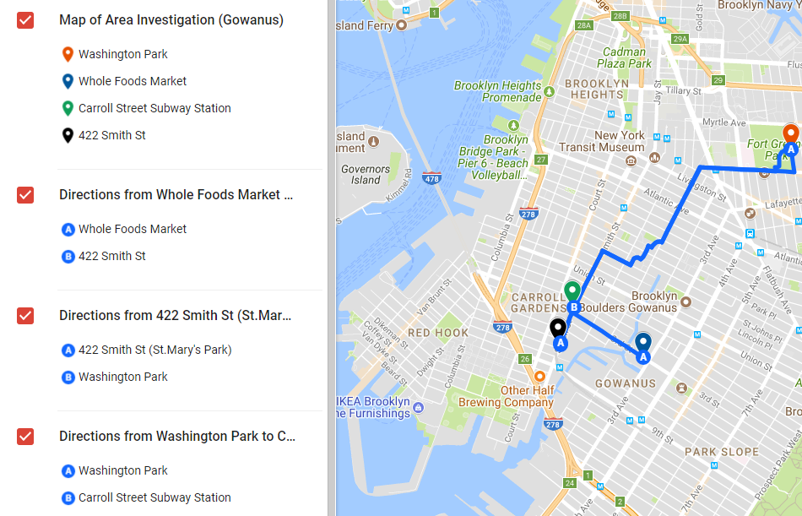
- PHOTOS AND SKETCHES:
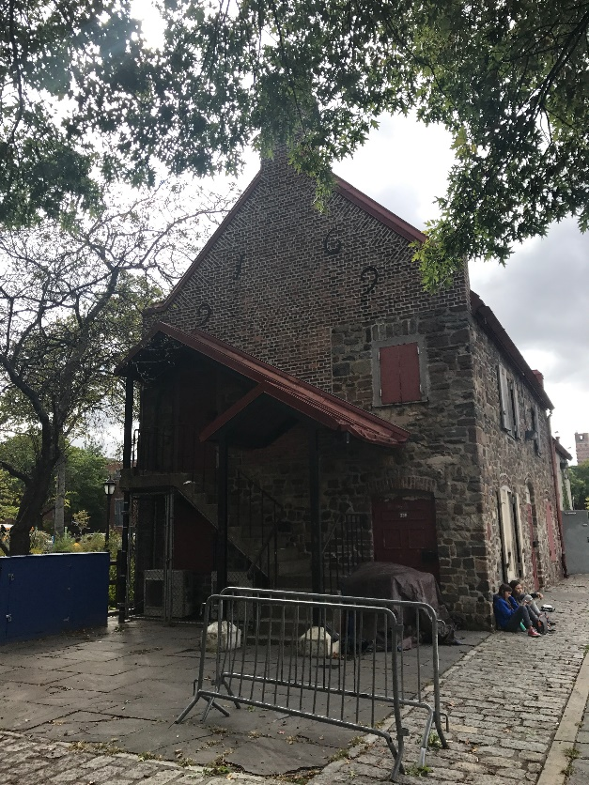
Old Stone House
This is an image of the Old Stone house in Park Slope, Brooklyn. This house played an important part of the 1776 Battle of Brooklyn. This is located right next to Washington Park and Byrne Playground near 4th and 5th avenue.
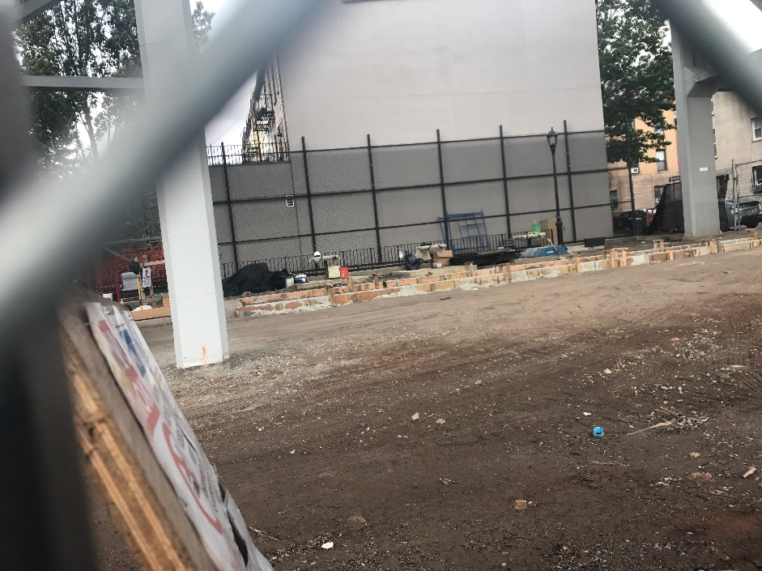
St. Mary’s Park
This picture has been taken from outside of the park by the fencing area. This park is under construction and will feature a brand new public space and place in the Spring of 2018. This shows the development of the area and the continuous uplifting and renovations of the Gowanus area.

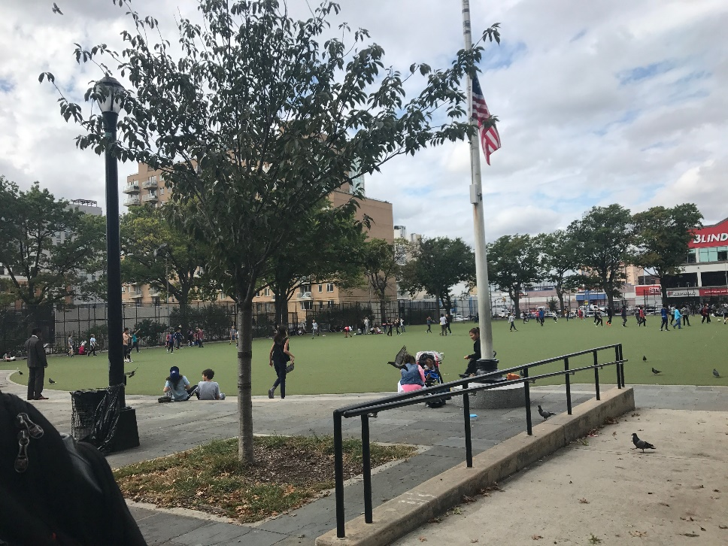
Washington Park Field
This was a picture taken from outside of Washington Park. It shows the type of environment which lies here in Gowanus. Kids are playing, sitting, running, eating and just enjoying the space given for the community.

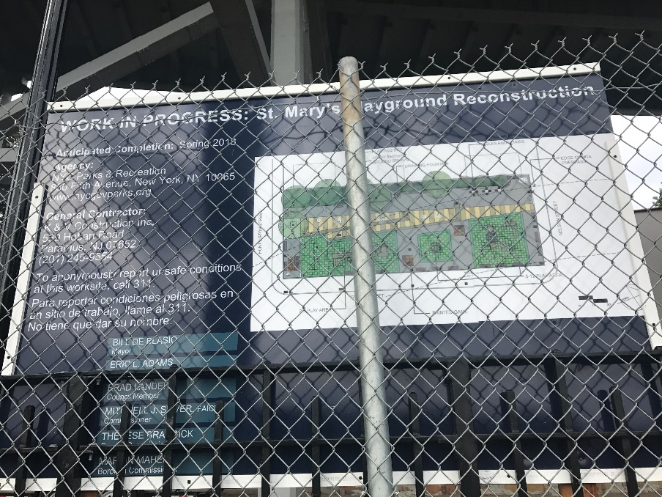
Work Permit for St. Marys Playground
This image gives the public an idea of how the playground will look after completion of the construction with estimated completion date. I thought this is important because it shows a NYC legitimate work permit to perform construction in the area.
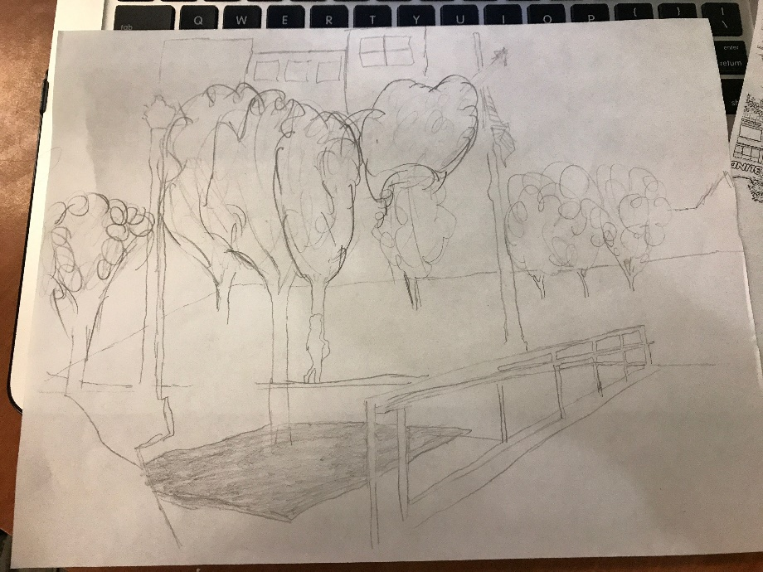
Sketch: Washington Park Field
This is a hand drawn sketch of the Washington Park field from a distance. It only shows trees and railings with buildings in the background. I chose this photo because it gives a view span of how big the public space really is. In addition to the space, it has a lot of grass and play area for smaller kids.
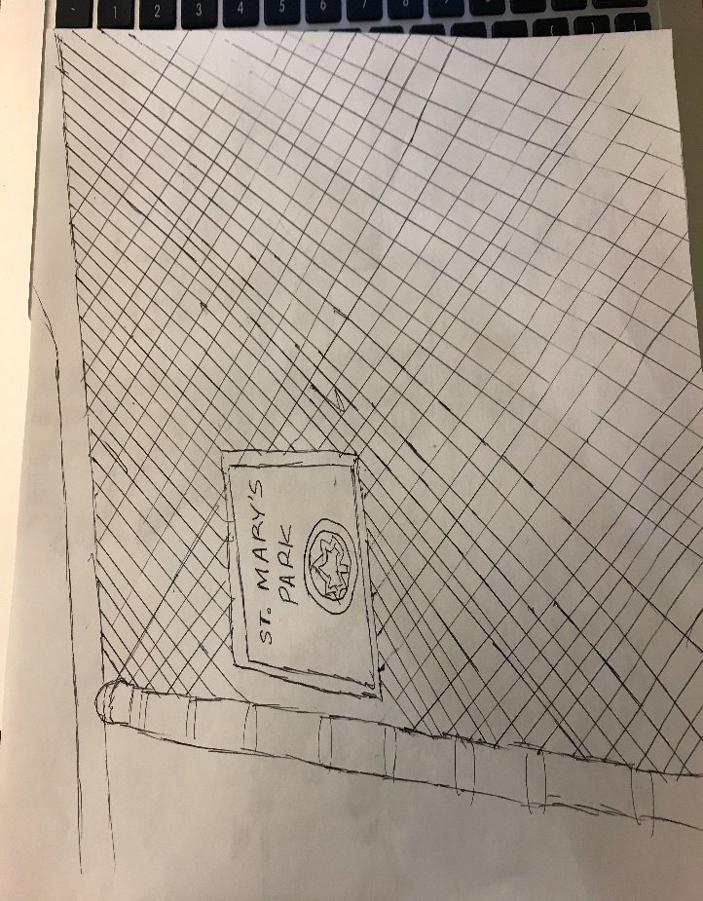
St. Mary’s Park Sketch
This is a sign of St. Mary’s Park. The sign is placed on a fence. The fence is a temporary fence due to the construction of the playground. I chose to sketch this because it shows the constant construction occurring in the Gowanus area. In addition, a park is promised to the community. Currently, it is available due to construction but will be soon available to the public in the spring.

ANALYSIS: During the walk, my group and I explored different public places in the area. I would like to focus on the scene of Washington Park. As shown in the images above, many of the kids are playing and having a good time with supervisor of their guardians. Positively, its available to the public. It gives everyone in the community a freedom or recreation area. Further down is a basketball and handball court which is also available. The spirit of Washington Park in my opinion seems to be a bit relaxed and a happy setting for everyone. It’s important to think about what these people would do if the park wasn’t here. This may be a disadvantage for the public. It will negatively affect them because its placed conveniently for those who walk with their kids. Its nearby to a school so that parents who have children can spend some time with their kids after school at the park. The environment wouldn’t be the same if the park wasn’t here. This area brings in children and young adults of all ages due to the amenities it has to offer. It can slightly affect the neighborhood as well. For example, people may visit a nearby deli or supermarket after school and visit the park after to relax and have some fun. If the park wasn’t there, people wouldn’t be going to the deli as often in my opinion if they don’t have intentions of sticking around the park. In other words, the park brings the deli customers for beverages, and snacks. Nearby of Washington Park is St. Mary’s Park as well. This park is currently closed due to construction and wouldn’t be available until the spring of 2018. If Washington Park wasn’t placed here and St. Mary’s Park is not available, this brings the people of the community no nearby convenient park for the kids.

KEYWORDS/ VOCABULARY (these must be words you learned on this walk such as specialized vocabulary, city agencies, names of businesses or significant people – they must be specific to the topic of the walk) *5 keywords required per site visit
- Whole Foods Super Market
- Washington Park
- St. Mary’s Park (422 Smith St.)
- Economic Development
- Old Stone House

QUESTIONS for FURTHER RESEARCH: (these should follow directly from your analysis section and be complex and specific enough to serve as the basis of a research project; do not include questions you can answer with a quick google search)
- What are the rules and regulations for entering the Brooklyn Stone house? Is it open to the public?
- Besides the two parks mentioned above in the analysis section, there is a school nearby of the parks. Would it be possible to share the public playground space with the community if Washington Park wasn’t there due to the inconvenience of lack of public spacing?
- Are there any city zone regulations or rules depicting how many parks should be granted in a specific area for the public community?

