Learning Places Fall 2016
SITE REPORT #2
The Gowanus Conservancy
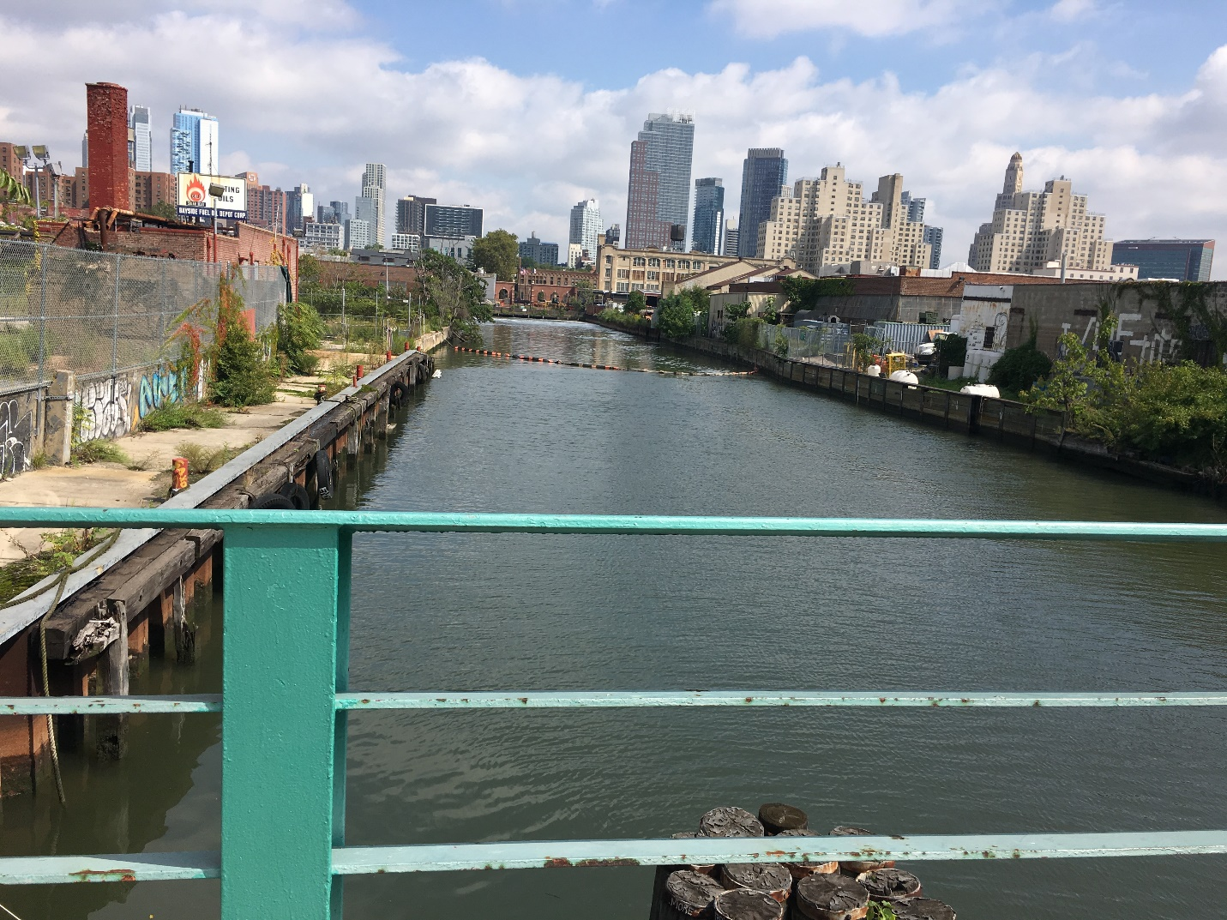
This is an image of the Gowanus Canal taken from the Union Street draw bridge next to Pig Beach. The skyline in the background eludes to what this undeveloped land can one day become.

Sanaya Brown
10.03.2017

INTRODUCTION
Prior to the site visit, I already knew what to expect as far as the appearance of the community because we were told that we would be following a trail similar to the one of the first site visit. Of course, like in any tour, background information and history is given, so this was expected. But much of what Christine said was well known due to in-class videos and discussions we have engaged in and the Joseph Alexiou presentation a few weeks ago. We did know that this area of Brooklyn was once a salt marsh and that the canal gave way to industrial uses in the 1860s. Prior to the visit, we learned from Joseph Alexiou that Coal tar and Sewage were two of the main pollutants of the Gowanus Canal. During the first site visit, we saw that oxygen was being pumped into the canal from the flushing tunnel at the northern end of the canal as a measure to… Sewage overflow was another topic we spoke in depth about prior to this visit. We learned that… However, even after having known all this history, I did expect to gain a lot of insight on federal and community based intervention methods to clean the Gowanus Canal and prevent sewage overflow. I also expected to learn more about the role the Gowanus Conservancy plays in solving the issues that the canal presents (i.e.: The Sponge Park). I hoped to gain some insight on the community point of view and/or opinion and the goals for the future of the canal.

SITE OBSERVATIONS
The first stop was the Union Street bridge just below Pig Beach and consisted of introductions and background information about the Gowanus Conservancy and the Gowanus Canal. The Gowanus Conservancy is a non-profit organization and having started 11 years ago in 2006, they are the environmental steward for the Gowanus Canal. Christine informed us that we will be getting into the ecological past, present, and future of the canal. We were told that we were standing in a space that was floodable because we’re in low lands. In terms of how the canal relates to Brooklyn, it is the lowest laying part. If you look at the map, there are ridge lines about where the colored blocks end and the white space starts. So, when we begin to get into how the landscape was before roads were built, that is our watershed area. But all this changed when the city built roads and sewers and now the area of land is a sewershed.
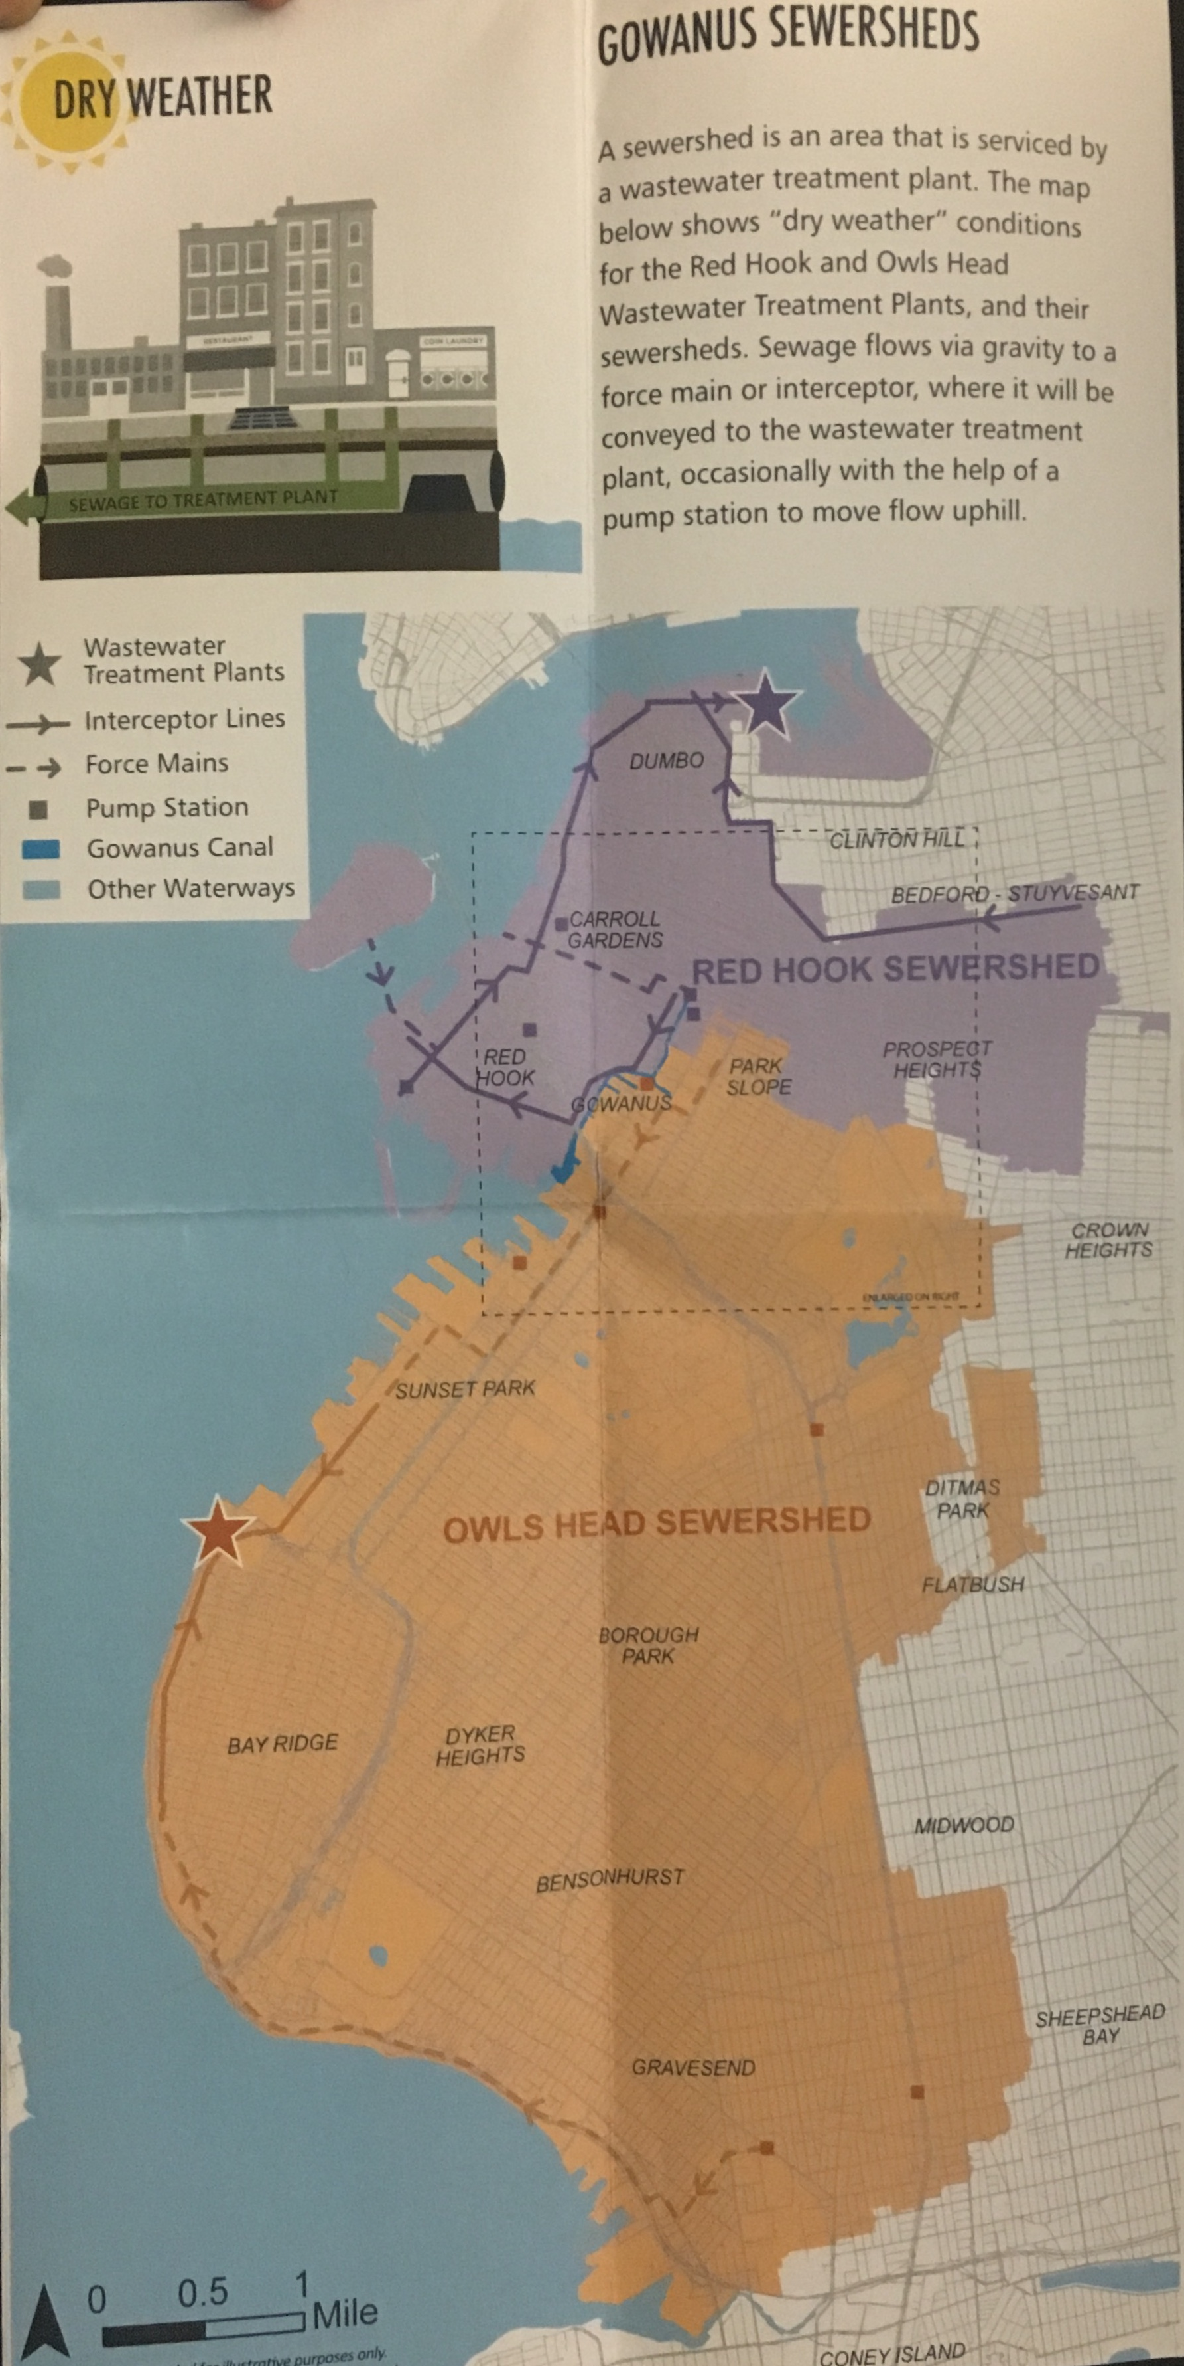
We spoke more about Combined Sewer Overflow as well which is a major water quality issue in the canal. Right now, all our underground sewer lines lead to a water treatment plant that cleans waste water every day and then releases it back into our water bodies when it is at a safe water quality level. But during a rain storm, additional water is being added to our sewer lines, including storm water running off the streets, and those sewer lines can’t hold all the waste water and storm water at the same time; Thus, causing an overflow. This system was designed to outflow into our waterways to relieve the pressure on the sewer system. The map below depicts the footprint, so to speak. All the storm drains in the surrounding areas shown on the map go into the Gowanus because it is the lowest point of the watershed. The overflow from any household or business, flushing toilets and using water, as well as rain fall in this area, goes to the canal. This was very surprising to me because this is such a large area of land. The sewage of households nowhere near the canal (i.e. Grand Army and Prospect Heights) could possibly end up in the canal. It’s almost as if the people that live in these areas are contributors.
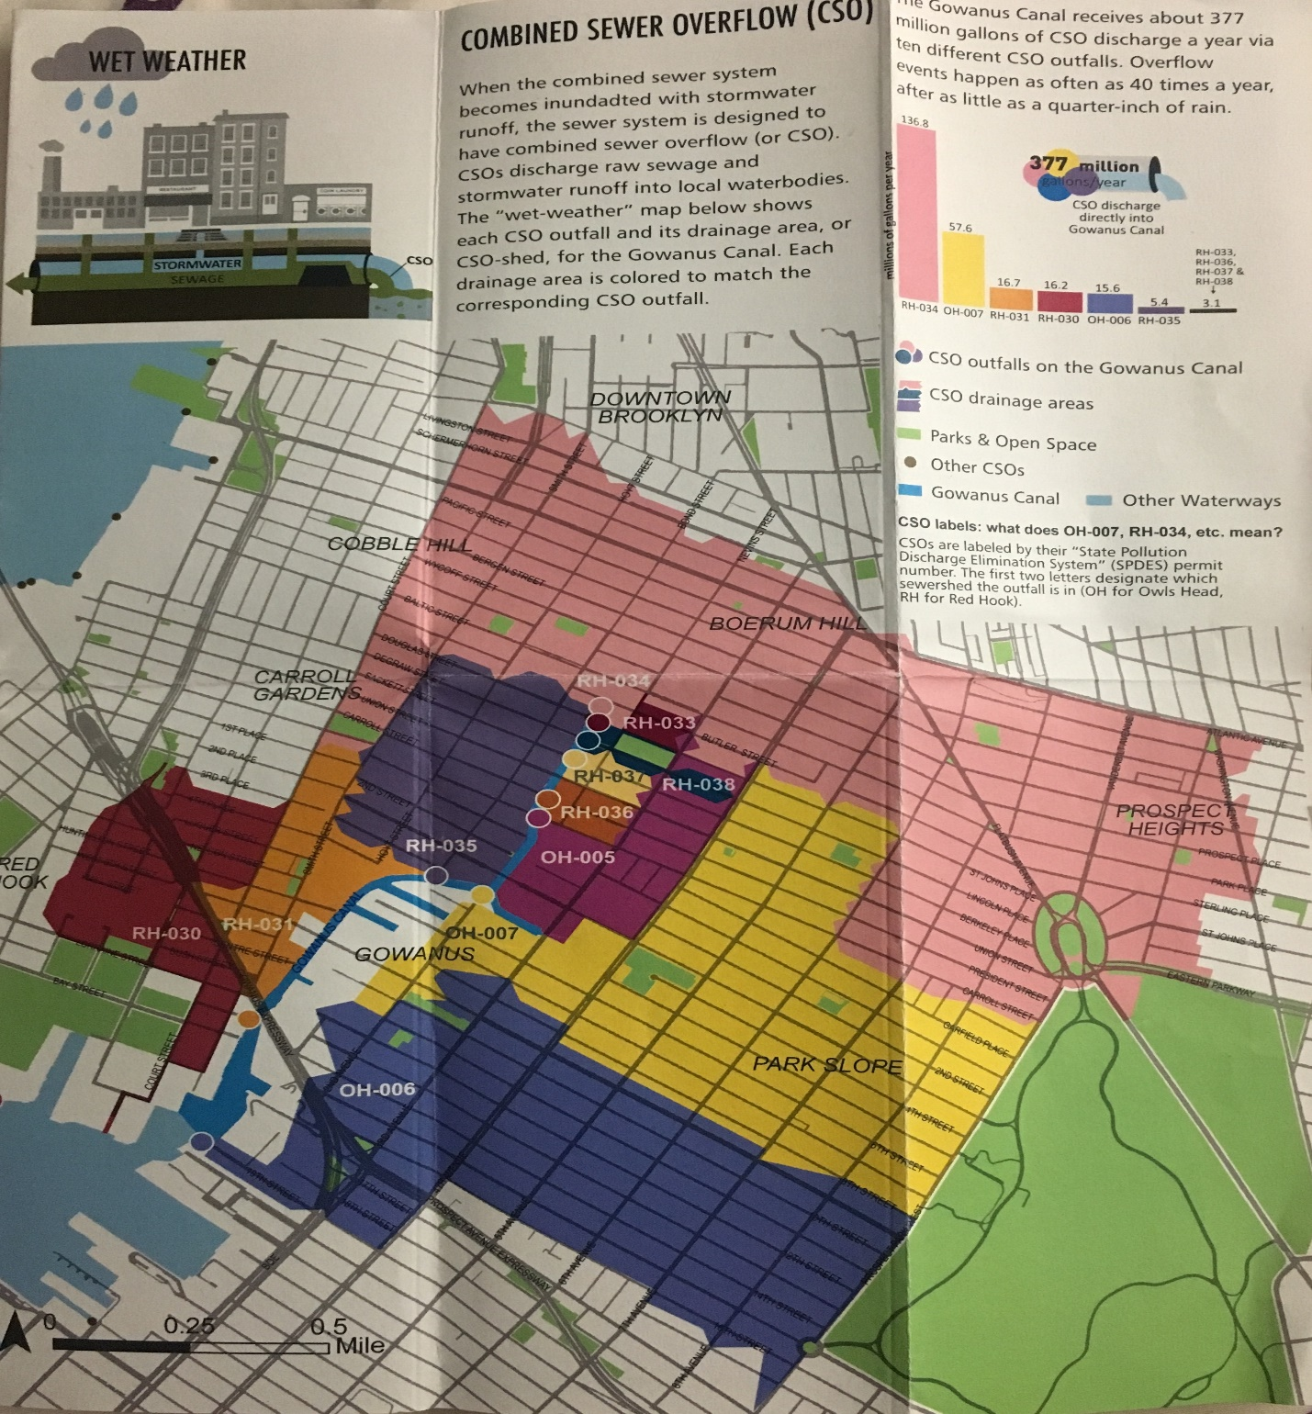
This is a photo of the geographical footprint of all the storm drains in the surrounding areas that contribute to the Combined Sewage Overflow in the Gowanus.
Christine also drew awareness to the frothy, bubbly water at the northern end of the canal (meeting point of our first site visit) which we already knew was a result of the water being oxygenated. From where we were standing, the white foamy substance did seem to stay in that small area however; it appears the oxygen did not travel very far from its initial starting point. But Christine did say that the goal here was to oxygenate a very stagnant part of the canal as most of the sewage over flow comes out of that pipe. So, it is serving its purpose.
The next stop was the Sponge Park (which is a pilot) right next to the new housing development (363 Bond Street). So, previously we discussed that as rain falls on the roads and sidewalks, the rainwater goes into the sewers thus, causing the overflow. But if the amount of rain water that flows into the sewers can be reduced, overflow can be prevented. Hence, we have green infrastructure. She explained that the goal of the Sponge Park is to soak up rain water and hold it so that it doesn’t make it to the sewer system. We saw the drain at the curb; it’s an inlet where the water enters. However, that Sponge Park only takes in rain water that rolls down that block (from bond street to the Sponge Park), even though it can hold way more rain water. The city doesn’t let water cross streets.
Then we spoke about the most noticeable thing in the area, the development. Christine informed us that it was the first of its kind in the Gowanus area; no one had lived on the Gowanus Canal since it became the Gowanus Canal. That particular area is zoned for manufacturing which means, legally there cannot be residents living in said area. However, the building received spot zoning allow them to create a residential development on that spot. The area is also undergoing rezoning so that is occupied by mainly commercial, residential and little manufacturing developments. There is a public space behind the development, almost as if this is the “backyard” of the development. However, the public space is privately owned but the development.
As we were leaving we saw another form of green infrastructure being implemented known as rain gardens So from the sidewalk perspective you see a normal cursive side garden full of soil and greenery. But from the roadside perspective you see these little dips in the edge of the curb which allow water the runs off the street in and collects it.

The next stop was Whole Foods. When we got there, across the canal you could see a lot of construction taking place. Christine informed us that the area that were now standing in is a protected manufacturing zone but there are loopholes. For example, one of the developments for which we were watching was for a storage company (a commercial space). There are also many hotels in the area too. Here, Christine just gave us some insight as to what the vision was for the canal and things to expect.

ANALYSIS/DISCOVERIES
Dredging of the canal is expected to begin some time in the fall. The clean up is going to cost 500,000,000 dollars most of which is private money; most of the money is coming from the original polluters. Dredging consists of digging up pollutants from the bottom of the canal and capping it. But the process will be very smelly and will possibly activate contaminants that were already at rest. Christine mentioned that it could be 10-15 years before we see the final product of the canal. So that’s 10-15 years of expected construction. I do not see residents finding this to be appealing. However, I do see promise for there to be a more eco-friendly environment that allows interaction between the Gowanus Canal and the public, with the Conservancy’s involvement.

KEYWORDS/ VOCABULARY
- Combined Sewer Overflow
- Green Infrastructure
- Grey Infrastructure
- Bioswales
- Rain Gardens
- Dredging

QUESTIONS for FURTHER RESEARCH
- Why can hotels and storage developments be built in these protected manufacturing zones? Where is the loophole?
- How will the rezoning in the Gowanus area affect the manufacturing businesses in the area?
- How will the dredging and construction on the Canal affect the property value in the area prior to completion?

