Learning Places Fall 2017
SITE REPORT #2
Gowanus Canal Conservancy Site Report
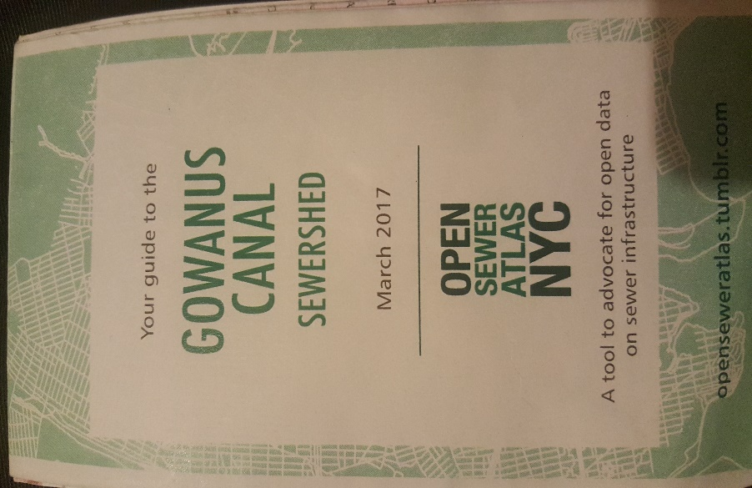
picture of the Gowanus Canal Sewershed that explains the work happening in Gowanus, Brooklyn.
Gurjot Nijjar
10.05.2017
INTRODUCTION AND PRE-VISIT REFLECTIONS
Prior to this visit to Gowanus Canal, I reflected on what I have learned so far about the Gowanus. In the class we learned about the history of Gowanus to the current issues from the professors and the guest speaker Joseph Alexiou. From our first visit to the canal, we grasp the visual idea of the Gowanus and witness the issues ourselves. Honestly, I had no expectation of learning anything that we didn’t covered in the class like the pollution, zoning, etc. but after this visit I learned a lot more about the Gowanus and the great things that are happening for the betterment of the Canal.
SITE DOCUMENTATION:
MAP OF AREA OF INVESTIGATION -- on a map like the one below chart the route of the walk and mark the following: (a) significant stops; (b) Locations and directions of your photos and sketches.
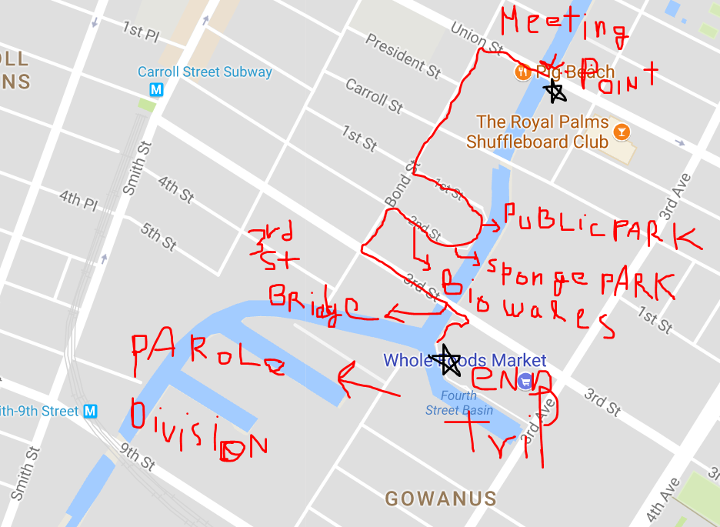

PHOTOS AND SKETCHES:
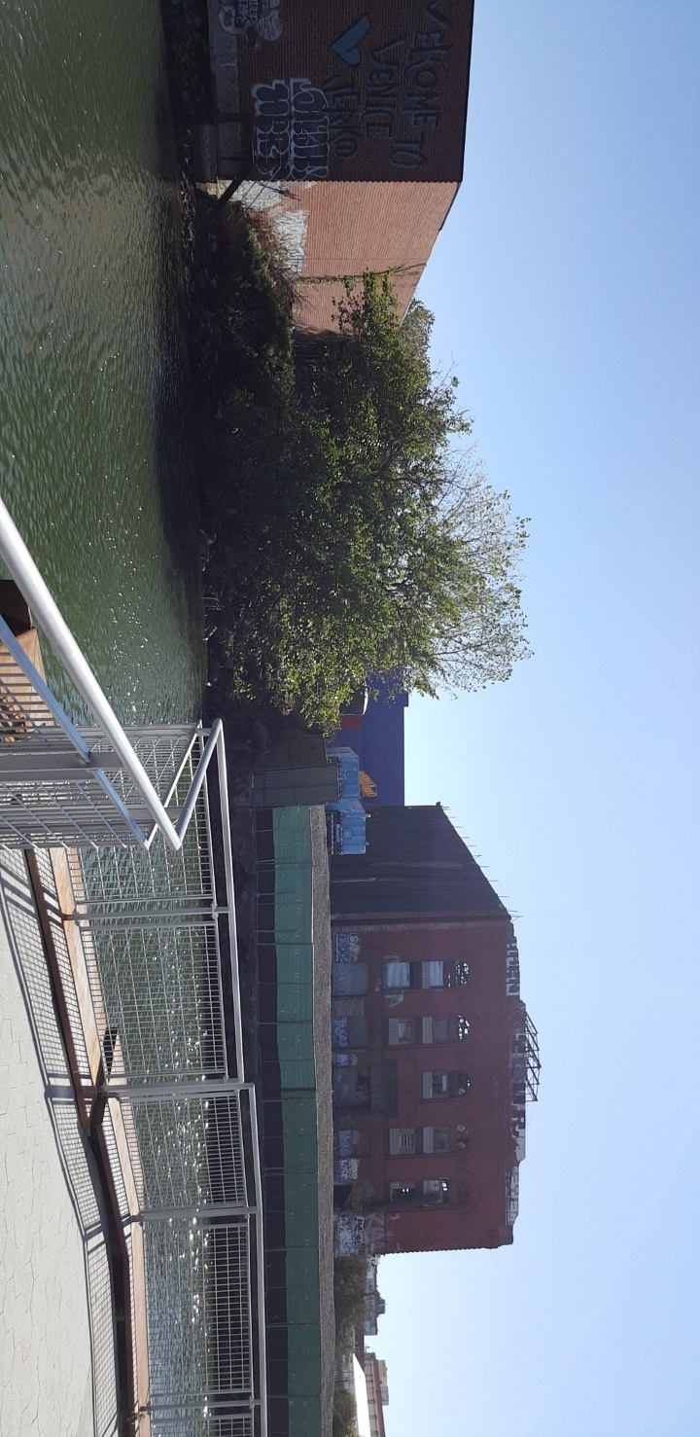Private Public Space: this image is from the newly build luxuary apartments along the canal. This public space is build because the new luxuary building exceeded over 30% of the giving and according to the ny state law they are required to build public space or green space.

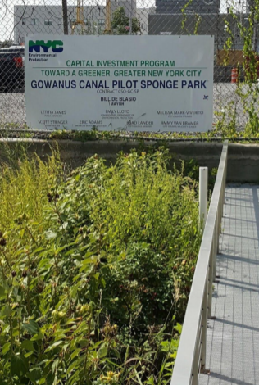
Sponge park: this is an example of green infrastucture, that is build to hold water during flood in the area. This particular sponge park can hold the water from one block.

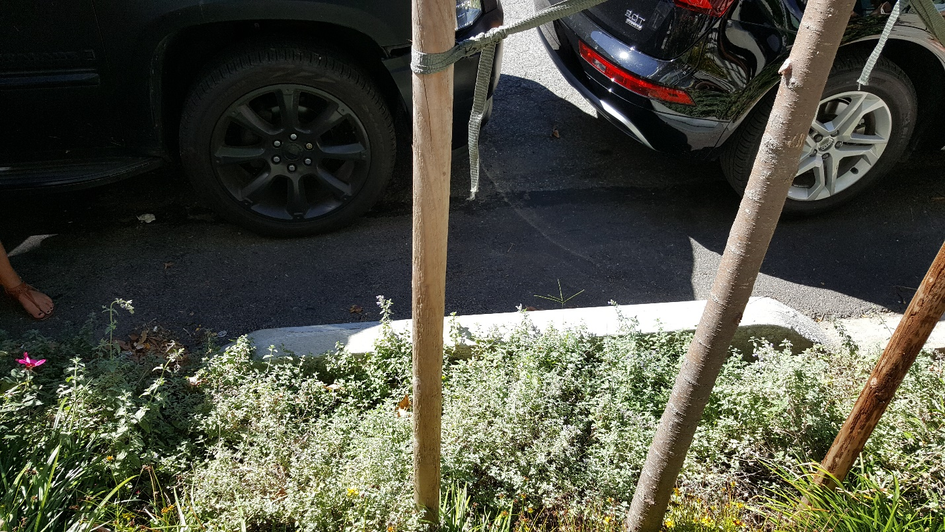Rain Garden (Bioswales): this image of bioswales is build in Gowanus to use the rain/ street water to feed it to the plants. It serves 2 purpose, one is that it promote’s green and second it prevent flooding.

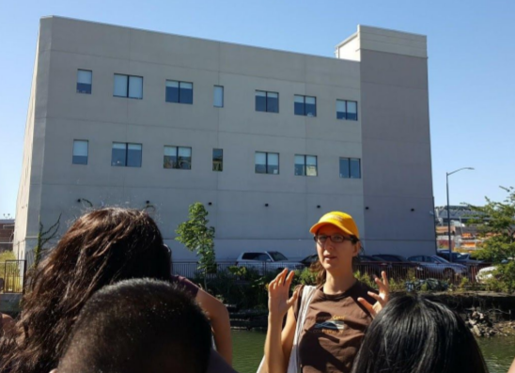
Parole Devision: Nyc correction build this recently in Gowanus that currently hold about 53,000 people and residents currently living in the Gowanus are not happy with this building.

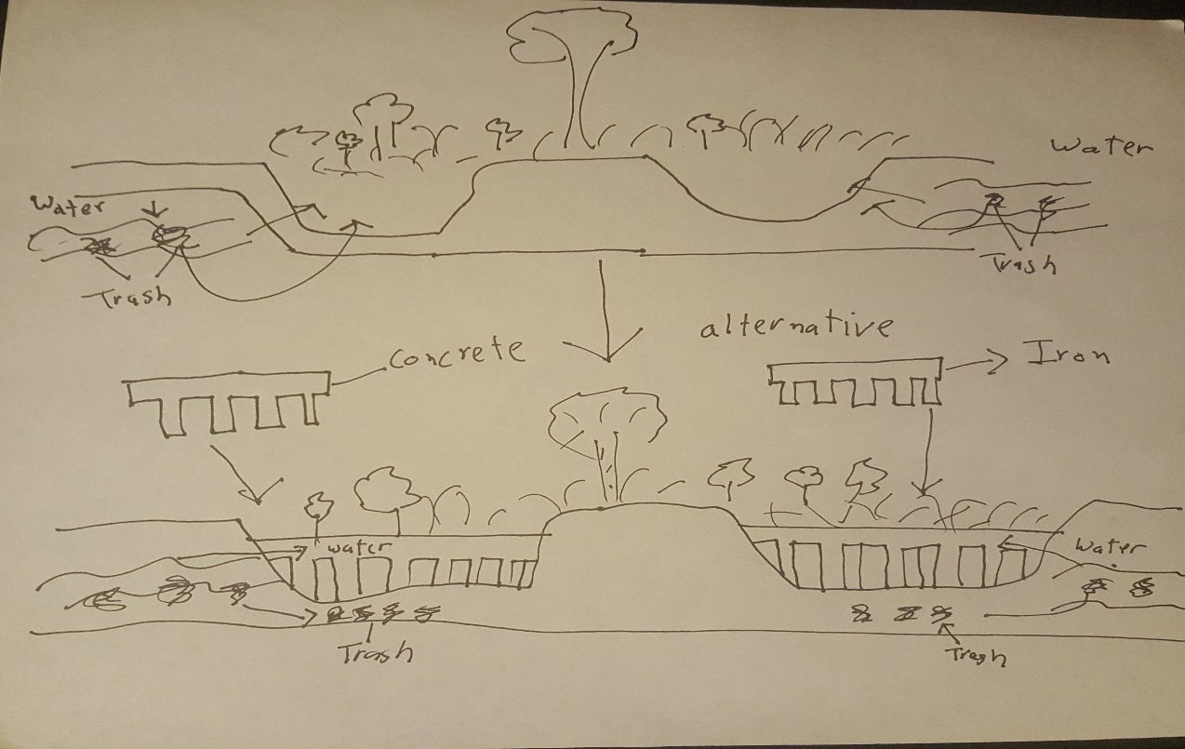
Bioswale Alternative: I took a step further, during our trip the speaker said that it some residents are not happy with the Bioswale because it collects trash. To me bioswale is a wonderful idea and should be build in all the flood prone areas. So I suggest to build this concrete or iron small walls between the space, so the water can flow into the bioswale through the gap but the trash will be blocked on the outside.

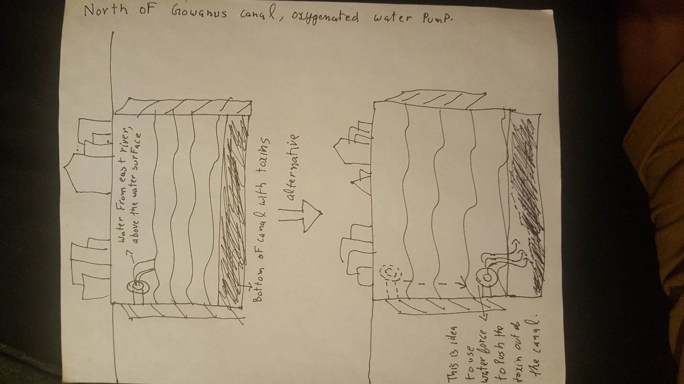Water Pump Concept: another idea I sketched was to shift the water pump from EPA build to the flood of the canal. The purpose of the pump is to push oxygenated water from the east river into the help it clean but my idea is to shift that water pump near the floor of the canal because that’s where most of the pollution is located. With the pressure from the pump, it might start pushing the toxin away from the north of the canal and help it clean. Hence, using natural force to clean the canal.
ANALYSIS:
During our trip with Christine from The Gowanus Canal Conservancy, we learned a lot of positive things that are happening in Gowanus and things that need improve. I must say by far this was the most positive trip we had, because so far, we had been learning about pollution, zoning and eminent domain. For my topic I had choose the topic that had my most attention Rain Garden and environmental agencies like DEP, EPA and DEC.
Super fund came in effect after the water act that was passed in 1970. One of the main purpose of the act was to clean the water of the Gowanus canal. Super fund anticipated to clean the canal by 2022, but due to few issue that has been delayed to 2030 now. One of the main issue with the canal is the sewage over flow, because all the pipes from the nearby area of the Gowanus canal merge into one tunnel that exits in the canal. This may cause flooding especially during heavy rain storm. But the city and the environmental agencies are taking precaution to address this possible issue. In 2012 the New York City Departmental of Environment Protection (DEP) and Conservation (DEC) came together to start a program called the grey Infrastructure and green Infrastructure. Grey infrastructure is a natural habitat like that Rain garden (Bioswale) that holds water during over flow of water and green infrastructure is a manmade like Sponge Part that hold water during rainstorm. The Rain Garden is an amazing concept because it not only hold water to prevent flooding but it also filters the water from the toxins, purify the air, reduce the little water puddles in the street and it promote green that help global warming. Some people are very happy with this idea of Rain Garden but some people in the neighborhood are not happy with this little structure because they say it collects street trash and invites rodents and little unwanted animals to their neighborhood. Another issue with the green infrastructure like the sponge park is that the city and the EPA can build these but they are very limited on man power that help to maintain them. It’s mainly because of the limited funding, even though the city was able to charge the people who originally polluted the canal, but it still needs a lot of help with funding and community support and volunteering help. (there is Bioswale event coming on November 16, 2017 that I am planning to attend to learn more about the collaboration between DEP and NYC to plant more trees.)
The first zoning that happened in NYC was in lower Manhattan in 1910 in bulk. Fast forward to the current time and let’s focus on Gowanus. It’s the most upcoming neighborhood in NYC and the developers knows this, that’s why they bought the properties especially at the north end of the canal and waiting for the zoning to happen so that they can build on the properties and double or triple their investments. Although, the city has a law that if the building passes from the 30% of the area, they have to build public and green space. But that’s easier said than done, the floor of the canal is still very polluted with the coal tar and black mayo. It needs a lot of attention because the toxin from the canal can slowly climb the buildings nearby. We also need to address the land pollution because when there is land pollution, it usually ends up in the water or the canal. Agencies like the Super fund, GCC, DEP, EPA and DPA (water quality) are trying their best for the city but they need a lot of help like funding wise & manpower. Once they clean the canal they can focus on rest of the Brooklyn and even NYC. People and the big official might not understand this now, but all the cleaning and protection the environment will help to maintain the future and for the betterment of tomorrow.

KEYWORDS/ VOCABULARY
- Toxic Building
- Land Pollution
- Displacement
- superfund
- EPA and DPA

QUESTIONS for FURTHER RESEARCH:
- How can we clean both land and water pollution in the gowanus?
- What else can we do to have the city focus on the environmental problems?
- Developers have already bought the property in gowanus and waiting to double their money, how can use this for the betterment of the environment before zoning happens?

