Learning Places Fall 2016  
**Library / Archive REPORT**

First Library Visit

# Gerald Altman

10.5.2017

# INTRODUCTION

Going to the Brooklyn Public Library in the Grand Army Plaza was an interesting experience. Going in for an experimental dive trying to find what exactly we wish to study. Going in, I thought it was going to be stiff and boring, but it actually turned out quite contrary.

# SITE OBSERVATIONS

What is the Genius Loci, or spirit, of this place?

The location was able to give off a fancy air while still being inviting. The outside was filled with architecture was filled with golden statues of pictures that reminded me of Greek or medieval images, giving off an impressive, if somewhat imposing air. 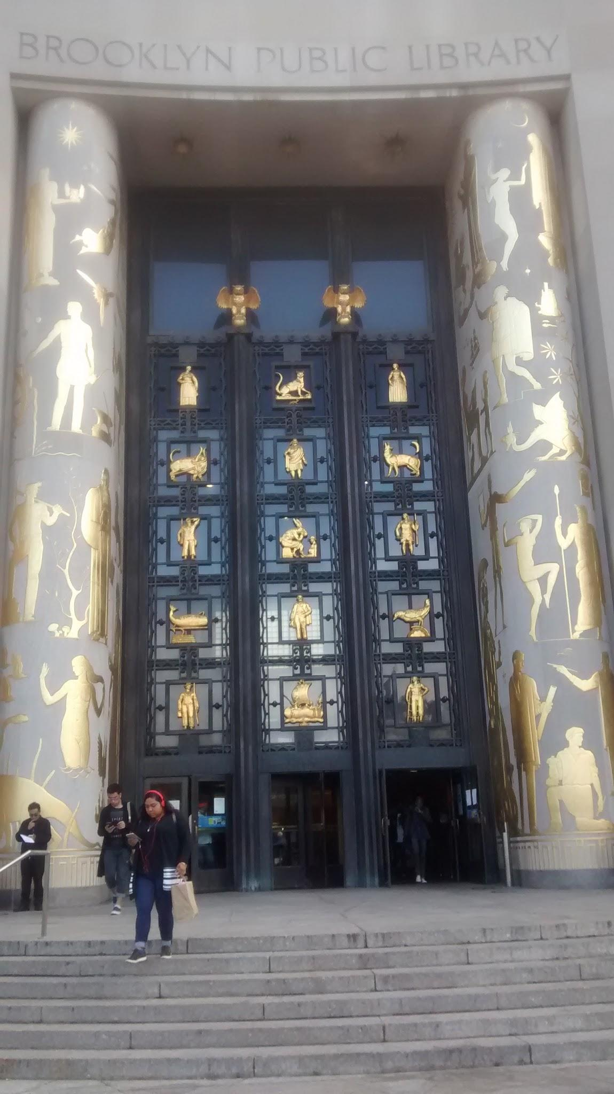

Figure 1 - Image of the outside. Note the impressive gold architecture.

Despite the imposing outside, inside was more inviting. The modern electronic devices, such as the escalators and screens, alongside the display cabinets were more inviting.

What kind of archive or library is this? What kinds of materials / sources does this place collect?

The Brooklyn Public Library, as its name implies, is mostly a public space capable of holding many books for the public. However, we specifically spent time in the Brooklyn collection, which contains countless documents of various types as long as it relates to Brooklyn. It contains everything from modern books to old maps and newspaper clippings. It even contains yearbooks from various schools.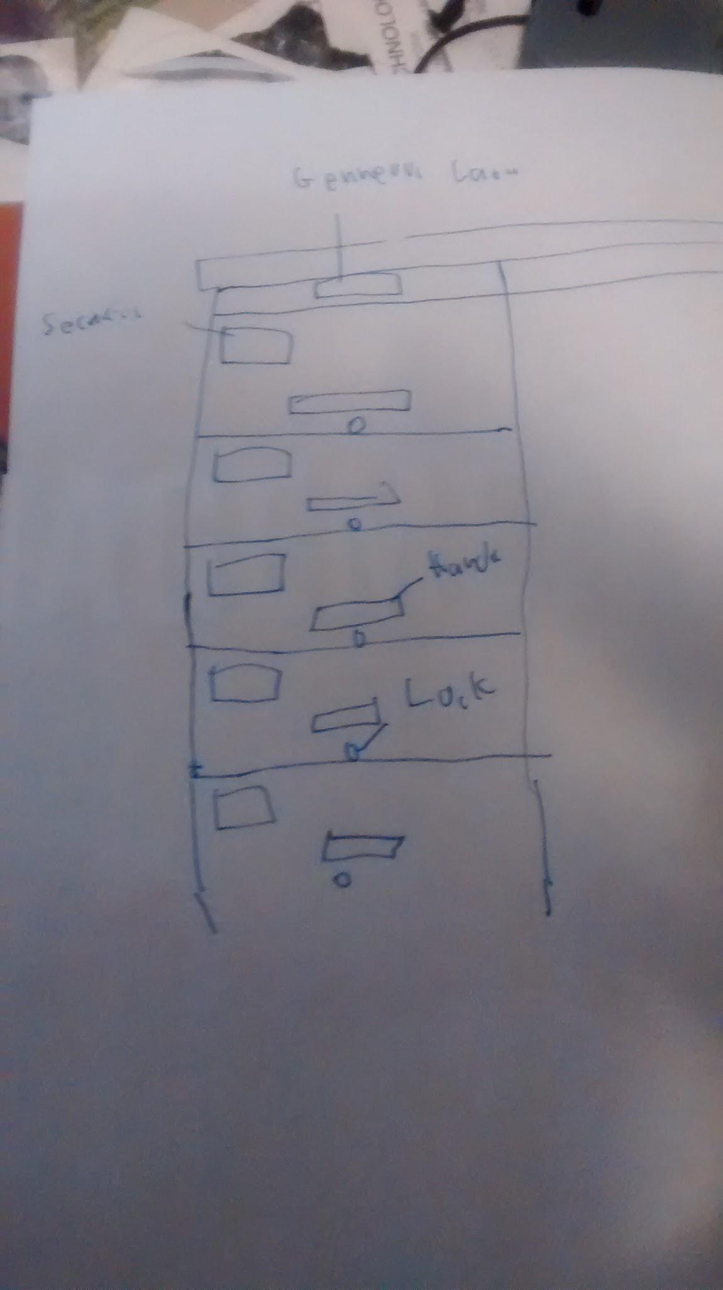

Figure 2

Diagram of File cabinet used to hold newspaper clippings.

Who might use this collection and for what purpose?

Anyone with interest in studying Brooklyn would likely find something of use here. Of note is the old Fire almanacs, which contain notes on how houses used to be. This is of note to anyone who wishes to recreate how Boston used to be.

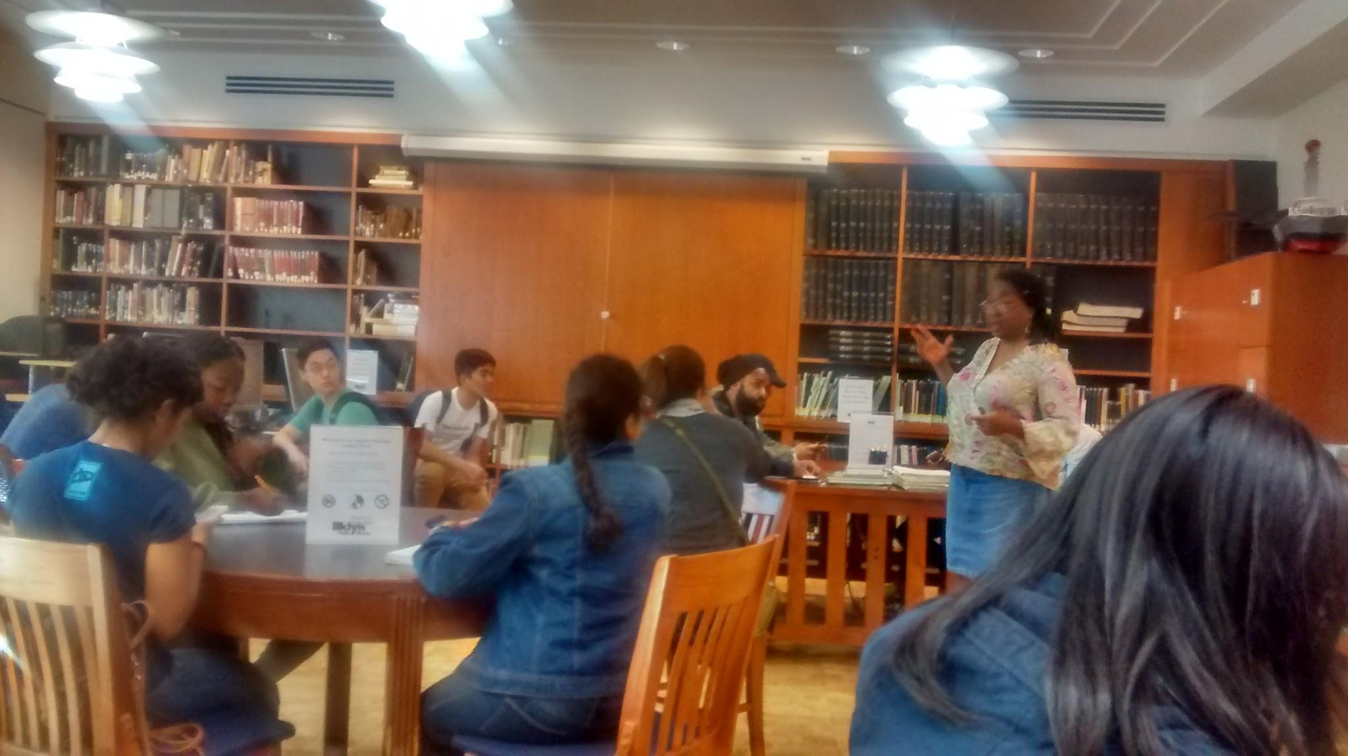

Figure 3

Image of Boston Collection

Are there any special rules for using or accessing material?

While special permission is needed for certain rare materials such as unique books, newspaper clippings, and maps, no special handling is required.

# SOURCE ANALYSIS

# **CITATION for ARCHIVAL SOURCE #1**

Atlas of The Borough of Brooklyn City of New York, Volume One, 1903, By Hugo Ullitz, C.E., The Brooklyn Archives, Brooklyn Public Library, Grand Army Plaza, Brooklyn, NY

1. What is this source and what is its purpose?

The Atlas of The Borough of Brooklyn city of New York was created to state the buildings of the city and notes on its construction. It was created to see what sort of buildings are likely to be more vulnerable to fire.

1. Who created it and who was it created for?

It was created by Hugo Ullitz, who made this map as an aide to fire departments. It also served as a map for the public that the library would update.

1. What does this source tell us about the place we are studying? What themes or subtopics does it relate to?

This tells us how Brooklyn used to look like. Here, we can trace the development of Brooklyn from its beginnings to how it is today.

1. How might it be integrated into a research project? What question could it be used to help answer?

Looking into the past arrangements of buildings might offer key insights into how the Gowanus used to be.

# **CITATION for ARCHIVAL SOURCE #2**

Plunz, R., Culligan, P. J., & Columbia University. (2007). Eco-Gowanus: Urban remediation by design. New York: Columbia University Urban Design Program.

1. What is this source and what is its purpose?

This is a book analyzing the Gowanus Canal, and how it can be redesigned to clean up pollution without destroying the current genus loci.

1. Who created it and who was it created for?

This book was made by Richard Plunz, who studied the Gowanus Canal as part of a university project. He published his findings to demonstrate what he thinks is possible for the canal to develop as, and gather interest in his vision.

1. What does this source tell us about the place we are studying? What themes or subtopics does it relate to?

The start of the book starts by going over the history of Gowanus’s pollution problems. It then transition into a discussion on how to reform the Gowanus to be better. He believes that is possible to keep Gowanus Genus Loci even after renovating it to be more eco-friendly.

1. How might it be integrated into a research project? What question could it be used to help answer?

Using this, we can take a look at a hypothetical future version of the Gowanus Canal. We can then examine what exactly that would entail about the future use of the Canal.

# GENERAL NOTES:

* There are 4 main types of contamination - Heavy metals, which lay on the surface, LNAPLs, which stay on the shore, DNAPLs, which go into the silt, and Dissolved contaminants, which dissolve into the water.
* The Gowanus can be considered a brownfield - a location that can be incentivized to be developed due to prior polluting activities.
* The Gowanus area has been occasionally been considered to be best dealt with by turning much of the surrounding area into a parking lot. Doing so would make business more attractive, but at a cost of making cleanup near impossible.
* The author of Eco-Gowanus suggests that turning the Gowanus into an industrial farmland can help clean up the canal.
* The author also states that might be best to make Gowanus not industrial, institutional, or residential, but a unique mix than can also include environmental study area.

QUESTIONS for Further RESEARCH

1. Can the Gowanus water really be used to water plants?
2. Should we encourage development of the Gowanus so it can be cleaned?
3. Is simply sealing away the pollution a better alternative to cleaning it?