Learning Places Fall 2017
Library / Archive REPORT
Brooklyn Public Library

YUYING XIAN
10.09.2017

INTRODUCTION
Describe the scope of the activity, geographic, and logistical details about the site visit. Include information about your expectations of the place and whether your expectations lived up to reality.
The central library of Brooklyn Public Library is located nearby Grand Army Plaza. I expected that the outer appearance of the library looks like a squared box as many others, but this library has a grand façade with two giant columns of gold decoration. I was only expected to be able to read books and old newspapers at the public space. Exceeded my expectation, I was able to go into a reservation room to read atlas and some clippings, and other rarely seen books. This experience shows me more aspect of Brooklyn and inspired me.

SITE OBSERVATIONS

(include photographic documentation and visual notes—at least 2 photographs 1 sketch required)
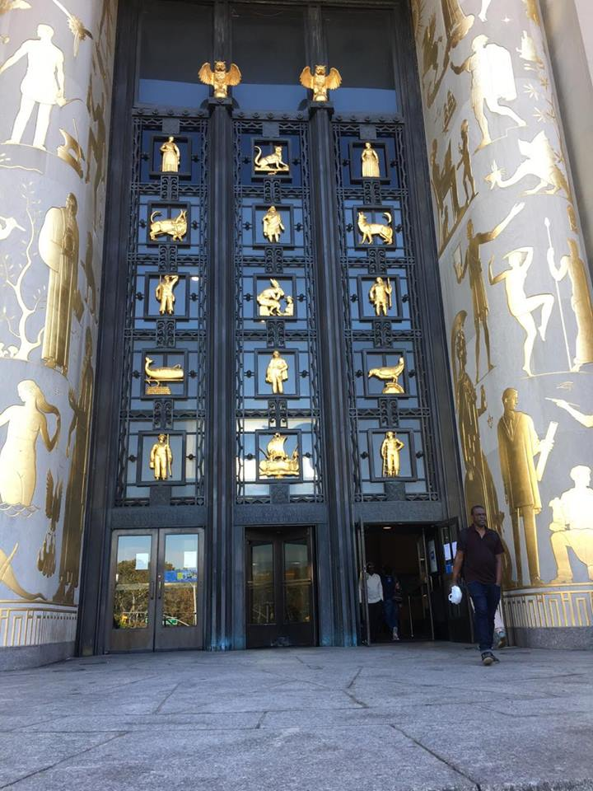
A: Grand Entrance
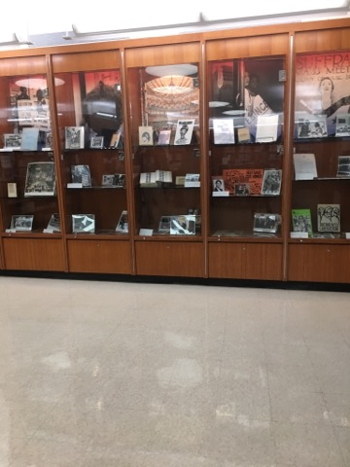
B: Showing History Shelf
The Layer of The Brooklyn Library Archives Maps Collection Room

What is the Genius Loci, or spirit, of this place?
The Genius Loci of this place is a collection room where all the historical materials such as atlas, photos, and newspapers are kept.
What kind of archive or library is this? What kinds of materials / sources does this place collect?
The library collects clipping from Brooklyn Daily Eagle and from New York Times. As well as atlas of Brooklyn, articles, pictures and archived materials.
Who might use this collection and for what purpose?
- Writers will use this collections as reference. 2) Superfund people are using it to see what business at canal. 3) Lawyers find the original house outline on atlas when they want to change their house layers. 4) Photographers use the photographs from 1930 to 1950 online
Are there any special rules for using or accessing material?
On the second section of the room, the books need to requested at the reception table before access. On the reservation room, there are only aged copies, so it can only be use at the room but not outside of the room.
No water and food in the room.

SOURCE ANALYSIS
(2 citations of sources found and a brief analysis of each source—photos optional)

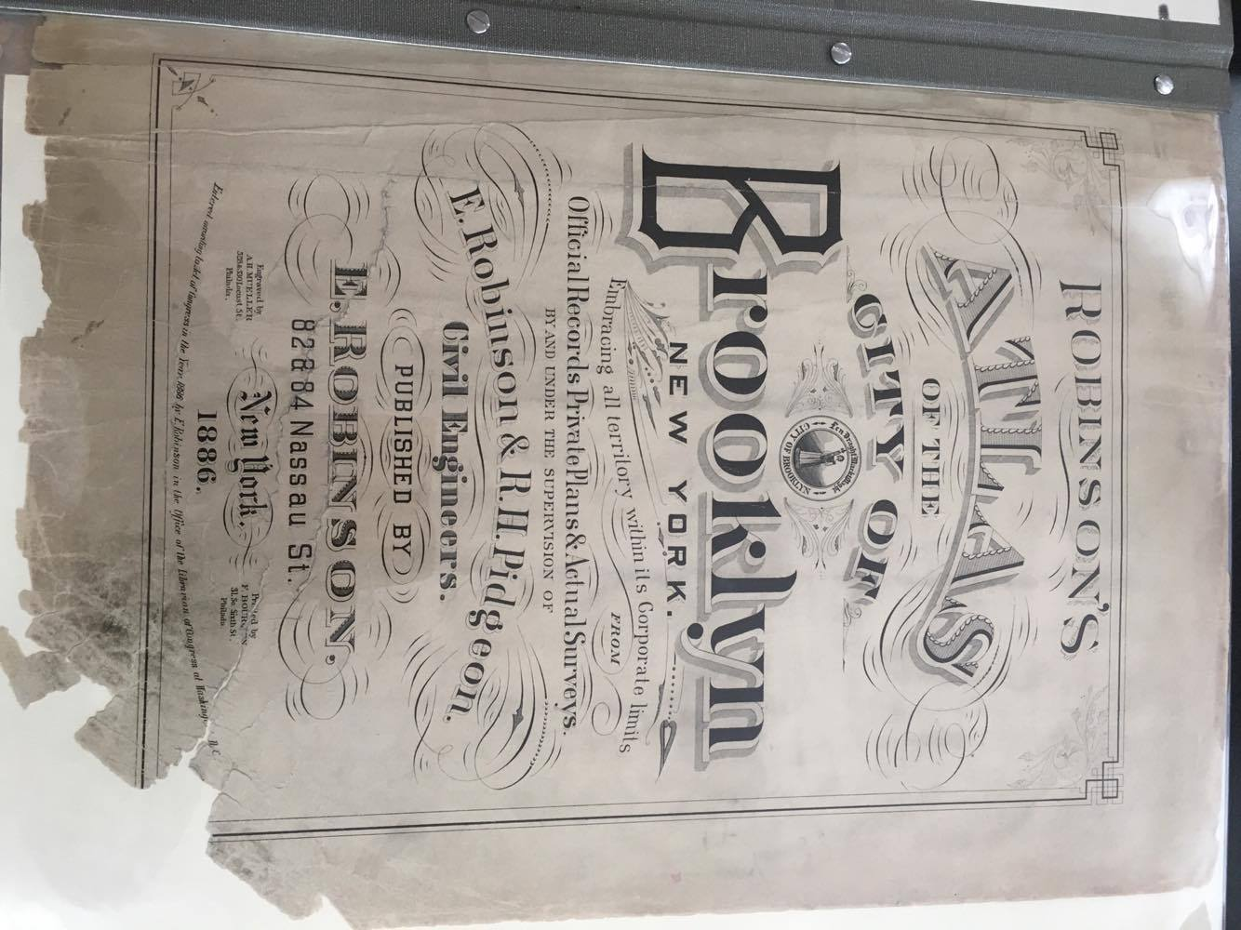
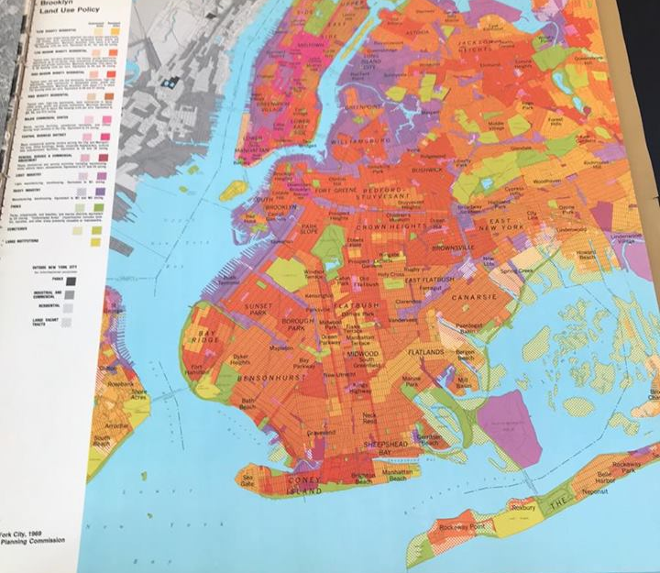
Robinson, E. (1886). [Robinson’s Atlas OF THE CITY OF BROOKLYN NEW YORK]. The Brooklyn Archives Maps Collection, Brooklyn Public Library, Grand Army Plaza, Brooklyn, NY

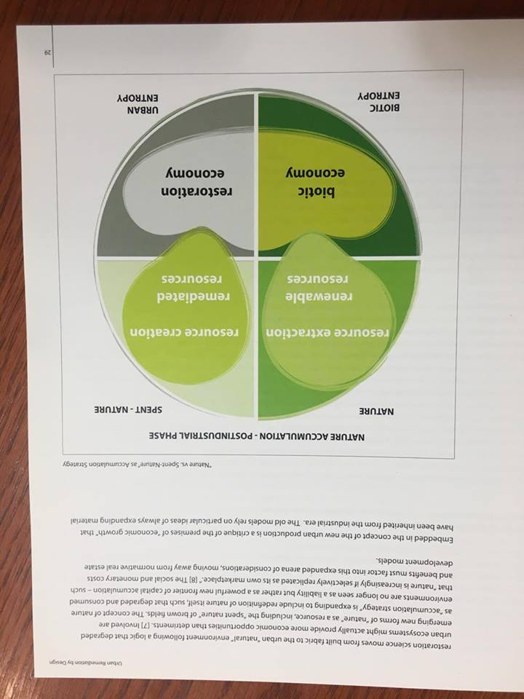
Plunz, Richard. Eco-Gowanus: Urban Remediation by Design. Graduate School of Architecture, Planning and Preservation of Columbia Univ., 2007.

CITATION for ARCHIVAL SOURCE #1 (consult this website for help with citations)

- What is this source and what is its purpose?

It is a map from Atlas of Brooklyn. It shows the land use in Gowanus Canal in 1886. It shows the buildings in the city, with notes of the constructions and materials.

- Who created it and who was it created for?
It created by E. Roblinson & R.H. Pidgeon. It created for Atlas of Brooklyn, which shows the original buildings outline with all sort of business, industries, factories in the city.

- What does this source tell us about the place we are studying? What themes or subtopics does it relate to?

It tells how the local businesses look in 1886 surrounding Gowanus Canal. It related to gentrification, superfund, and land using.

- How might it be integrated into a research project? What question could it be used to help answer?

The map gives us a reference of land usage, and compares with nowadays, it tells us which companies are still existing and who should responsible for the polluted canal. It helps us to trace the city development from 1886 to now. Moreover, considering the past arrangements of land usage, it shows how the Gowanus used to be and how have it changes.

CITATION for ARCHIVAL SOURCE #2 (consult this website for help with citations)
- What is this source and what is its purpose?

This is a book written by Plunz Richard. It analyzes the site, Gowanus Canal, and design how to clean up the pollutions.

- Who created it and who was it created for?

The book is created by Plunz Richard, and it was created examples for urban design students and environmental study students.

- What does this source tell us about the place we are studying? What themes or subtopics does it relate to?

The book starts from the history of Gowanus, and explained the reason of pollution, as how it is being polluted in Gowanus Canal. Then author do research on the site and analysis the site. He also designs an eco-friendly Gowanus Canal.

- How might it be integrated into a research project? What question could it be used to help answer?

This source provides us an example of solve the pollution in Gowanus Canal. It offers us examples and images on designing an eco-friendly Gowanus.

GENERAL NOTES:
- There are many materials we can use for our research project, so talk to librarians and they can help you to find the sources relating to your topic.
- Map is not only a picture, it can tell a lot of information.
- When we use the material from the map, we should take a picture of the cover page to cite.
- There are some factories, like Coal Tar, Tobacco Warehouse, and Tile Coal, still existing in the site.
- From the book Eco-Gowanus, the author believes that cleaning up Gowanus Canal is designing a new hybrid urbanization model balancing natural science, social science, technology, and humanities.

QUESTIONS for Further RESEARCH
- How to build an eco-friendly Gowanus Canal?
- Will new residential building bring new pollution to Gowanus Canal?
- How the zoning and housing get changing in Gowanus Canal?

