Learning Places Fall 2017
SITE REPORT #2
GOWANUS CANAL
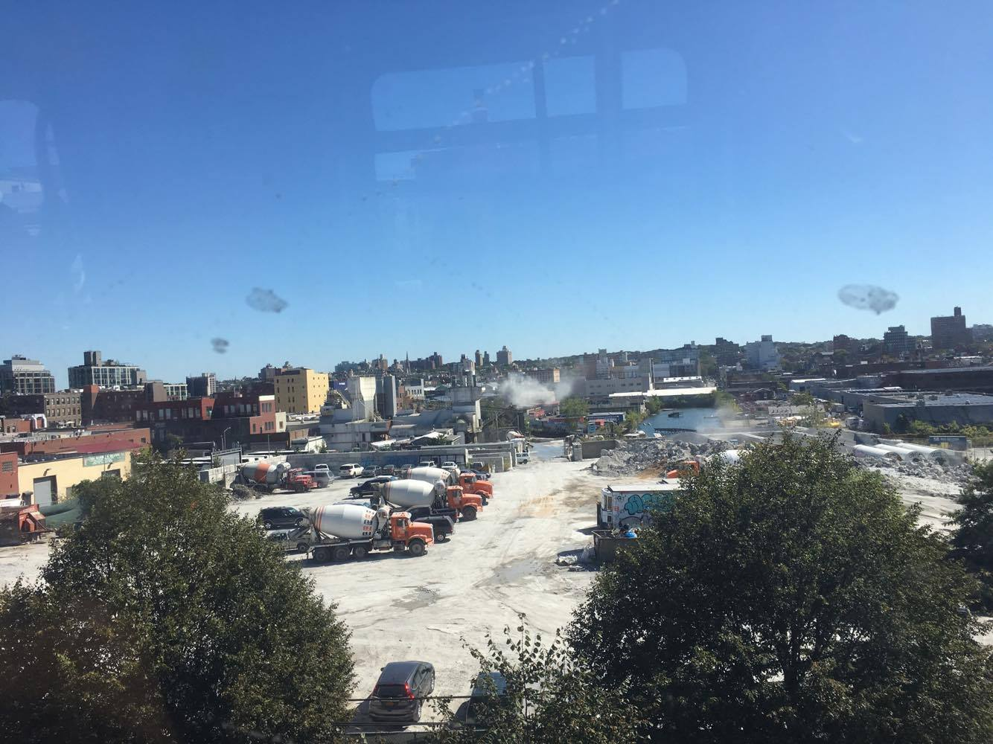
GOWANUS CANAL AND ITS INDUSTRIAL AREA:
I took this photo when I took the F train on 4th Avenue. It shows one basin of the canal and a cement factory nearby the canal.
YUYING XIAN
00.00.2017
INTRODUCTION AND PRE-VISIT REFLECTIONS
During the first site visit to Gowanus Canal, I learned the basic information of Gowanus canal, like its history, location, and new constructions. I expect to learn more about what is the next step to cleanup Gowanus canal. Going on the second site visit to Gowanus Canal, I learn some new facts that government agencies get involving the Gowanus canal cleaning up plans. I am interested in how the new projects help to clean up the Gowanus canal.

SITE DOCUMENTATION: Take notes and sketch in your notebook, take many photographs – search for angles and details that really tell a story and use those to report your documentation. Your site documentation will include the following:
- MAP OF AREA OF INVESTIGATION -- on a map like the one below chart the route of the walk and mark the following: (a) significant stops; (b) Locations and directions of your photos and sketches.
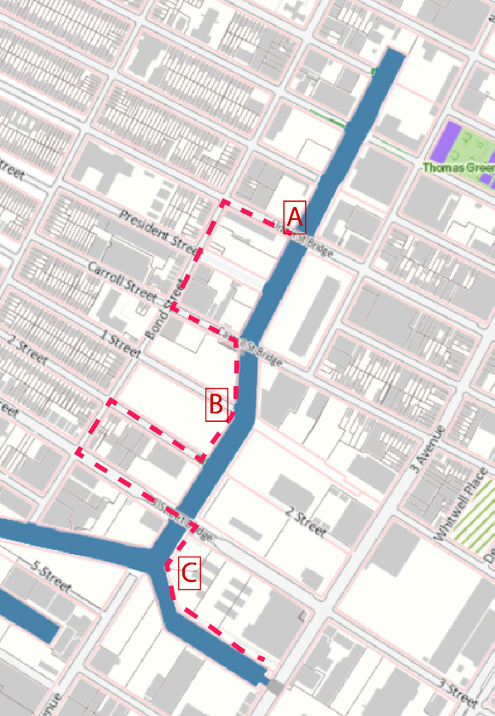

A is the first meeting stop, where the class meet Gowanus Canal Conservation group.
B is the second meeting stop, where is a public space near the new residential project.
C is the final stop, where is facing whole food.

- PHOTOS AND SKETCHES: Provide a minimum of 4 photos and 2 sketches of places, elements, processes, people or anything else that you found significant and meaningful during the walk. Focus on scenes that relate to ecology, the environment and public spaces. Feel free to include IN ADDITION other “findings” that you found intriguing. For each photo provide captions and explanations – why is the image shown significant for your exploration.
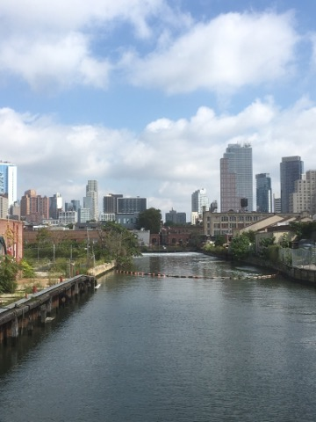
A: UNION STREET BRIDGE: I took this at the first stop meeting with GCC educator, Christine. It is located at union street. It shows the end of the canal and the flushing tunnel.
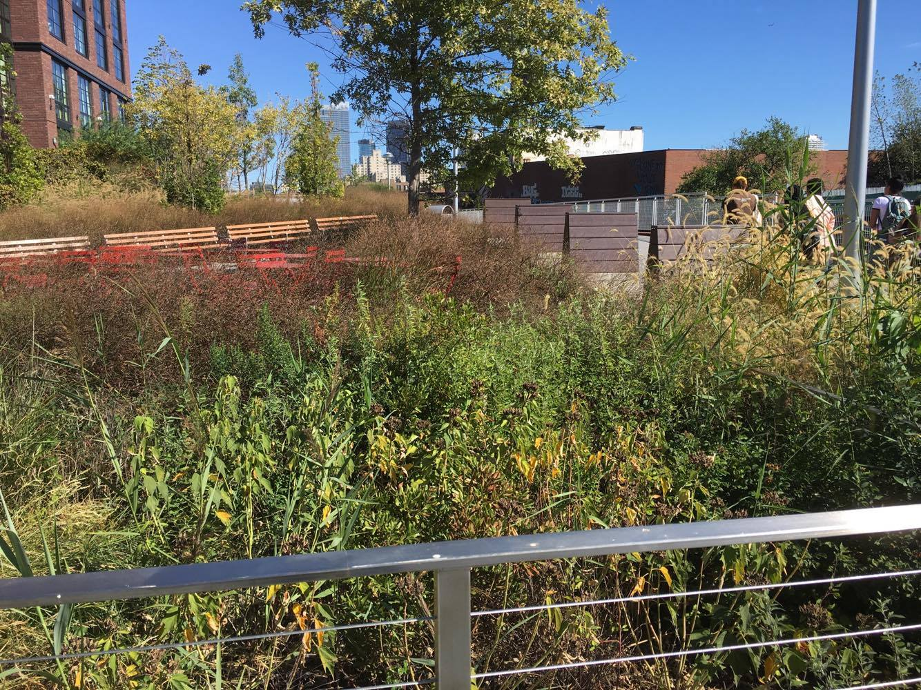
B: SPONGE PARK: I took this picture at the second stop, where is a waterfront space. It is located at the end of 2nd street. It is a sponge park which capturing storm water and mitigating waterflow. It is one of the most important green infrastructure project by government agency and taking care by DEP.
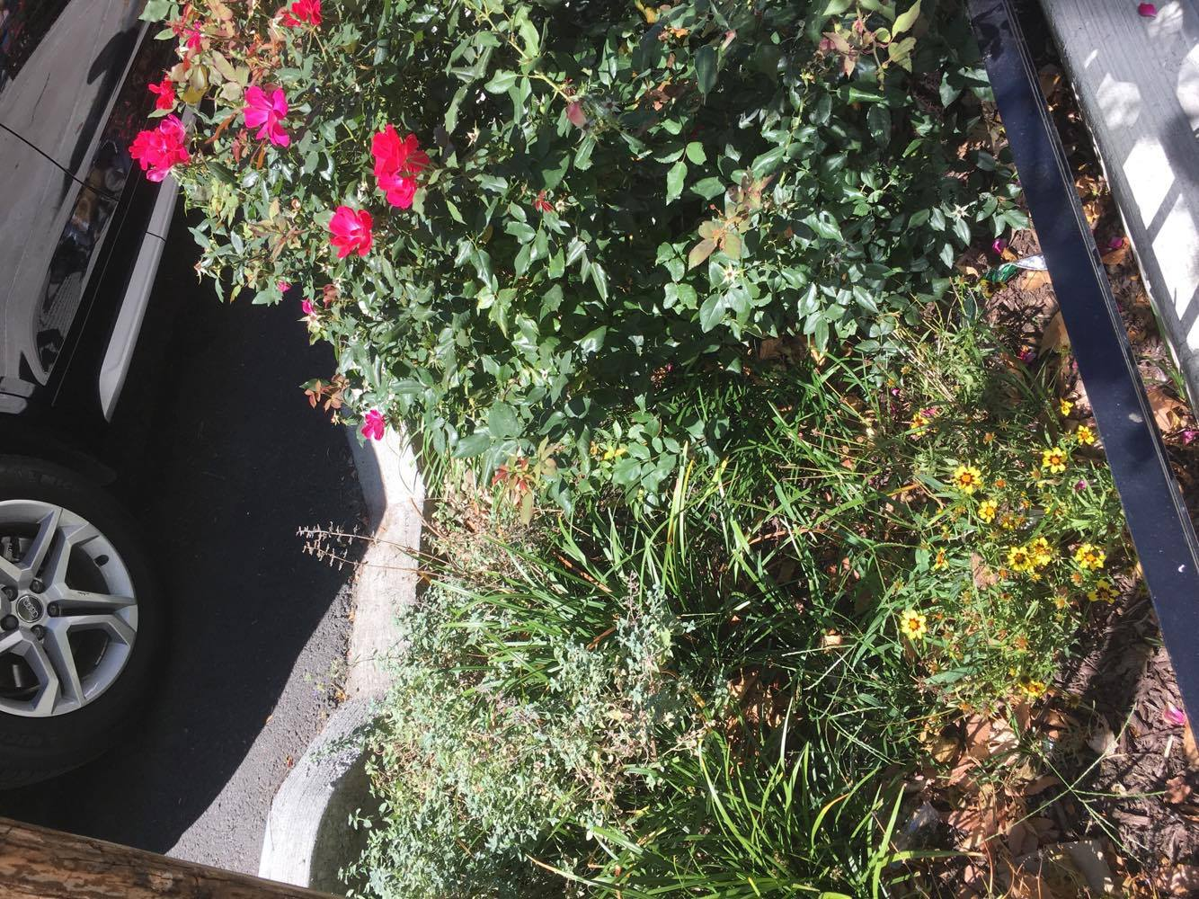
BIOSWALE: It is a bioswale, which collecting and filtering rain water from the street. It is one of the green infrastrture by the site.
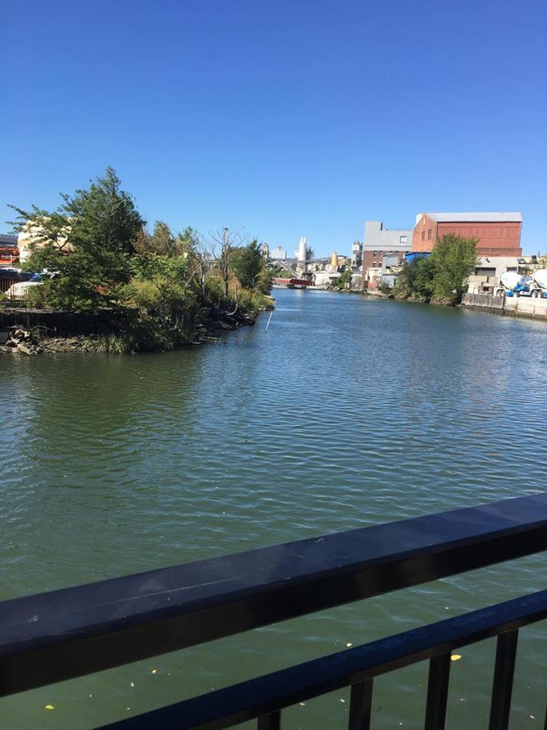

C: CANAL FACING WHOLE FOOD. This picture is canal facing the whole food, where is the last stop the class met. It has oyster project to clean water.

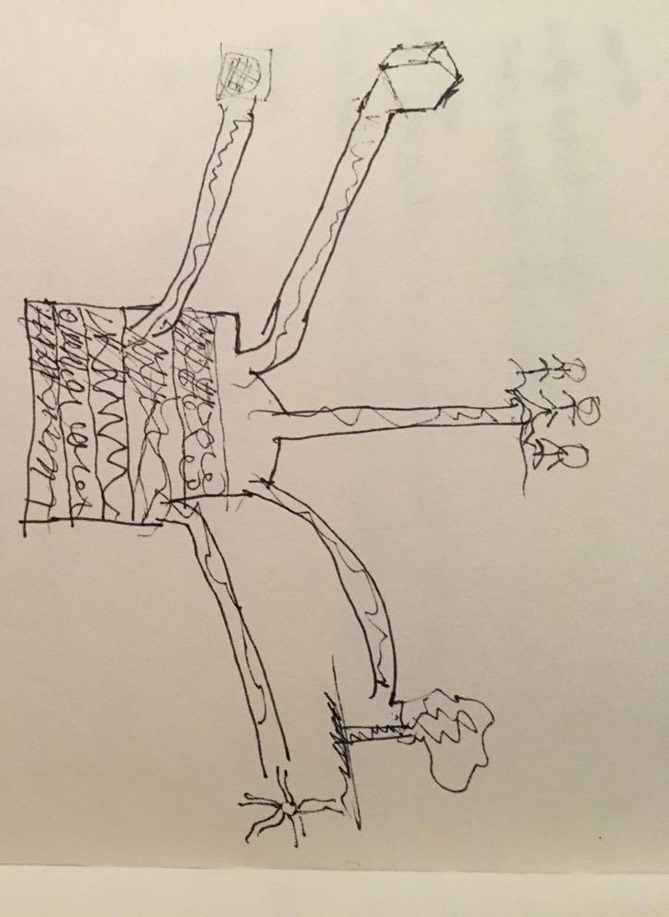
D: COMBINED SEWER SYSTEM: I sketch the idea what goes into the sewer tank.

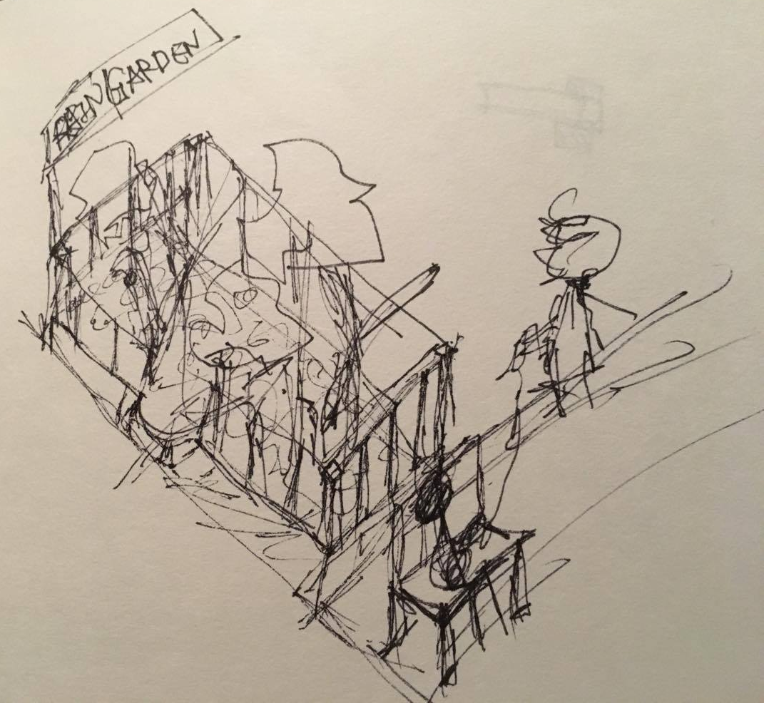
E: RAIN GARDEN

ANALYSIS: Select one of the topics discussed on the walk and 1-3 most important of your images (from those presented in the documentation section) and develop a 300-500-word discussion of that topic. Be specific and consider multiple points of view of that topic. Consider how it might affect the neighborhood, people, environment, art, development or anything else that you detect as significant either positively or negatively or both. How are your images relevant to the discussion? How will this topic affect the Genius Loci, or spirit, of this place? Does it have any ramifications for the rest of Brooklyn?

One of most polluted waterway in America, the Gowanus Canal. It have been polluted by all kind of industrial waste, especially by chemical poison, extensive coal gas, and combined sewer overflows.
During the site visit at GCC, Christine mentioned many facts about public space, waterfront, green infrastructure, and combined sewer overflow, and so on. All the information provided is about how to develop a new Gowanus Canal. The ultimate goal is to, build an environmentally sustainable and ecological friendly neighborhood. In terms of developing an ideal Gowanus canal, the most important concern is to address the pollution and flooding problem. And I am looking into how the green infrastructure can mitigate the storm water. The pictures I am showing above are Sponge Park and Bioswale, which both of them are green infrastructure. This Sponge Park is a 1,800 square foot park on the end of 2nd Street, which filtering the rain water from only one block but all the way to Bond Street. The bio retention cells under the plants also absorb and filter the rainwater, which helps to reduce gallons of rainwater from entering directly Gowanus Canal. I believe it is a wise choice for the canal, as it can help to prevent flooding. However, the maintenance for plants and gardens is comparatively harder. From the picture, Sponge Park, it seems like there are weeds growing up in the garden. As Christine mentioned during the trip, maintaining the garden does not only require with government agency involvement, but also the local residents and volunteers participation. Another picture for Bioswale, it is a cooperated green infrastructure project with Sponge Park. It is a curbside rain gardens, located near the sidewalk. It has the capacity to capture estimate 2,500 gallons of storm water when it rains, thereby reducing the chances of sewer overflows into Gowanus Canal. The Genic Loci of the Gowanus Canal is improving public’s living standard. Therefore, these actions contribute to an ideal neighborhood

KEYWORDS/ VOCABULARY (these must be words you learned on this walk such as specialized vocabulary, city agencies, names of businesses or significant people – they must be specific to the topic of the walk) *5 keywords required per site visit
- Green Infrastructure
- Grey Infrastructure
- Combined Sewer Overflow
- Sewershed – wastewater treatment plant
- Sponge Park

QUESTIONS for FURTHER RESEARCH: (these should follow directly from your analysis section and be complex and specific enough to serve as the basis of a research project; do not include questions you can answer with a quick google search)
- How will the rain garden effect the Gowanus Canal?
- What other green infrastructure project will be here?
- How can residents get more involved help conserve the environment?

