Learning Places Fall 2016
Library / Archive REPORT
A Visit to the BPL Grand Army

Sanaya Brown
10.09.2017

INTRODUCTION
Our first library visit occurred at the Brooklyn Public Library on Grand Army Plaza. The library is located amongst a round-about along with Prospect Park and the Soldiers’ and Sailors’ Arch. I knew what to expect as far as appearance because I currently live within walking distance of the library. However, I have never visited any of the private rooms or any of the archival collections. I expected to walk into a room of fragile artifacts and ancient texts, having to wear gloves the entirety of the time spent, and being unable to touch anything. But it was not like that at all. There were no gloves required and we were invited to touch, search, and observe as we please if we are careful. We searched a variety of books and articles about the Gowanus ranging in topics from people displacement to ecology. The search helped us to get insight on a topic for our final project.

SITE OBSERVATIONS

As you approach the library, it is very grand. The large concrete staircases and the concave inward look of the building can be very intimidating. As you walk towards the doors, it does feel as though the building will swallow you up. The gold ornamentation along the windows and pillars outside gave the library more of a museum-like presence. But the ornamentation also helped lend a hand to the abundance of culture the building contains. This helps the building to feel a bit more welcoming.
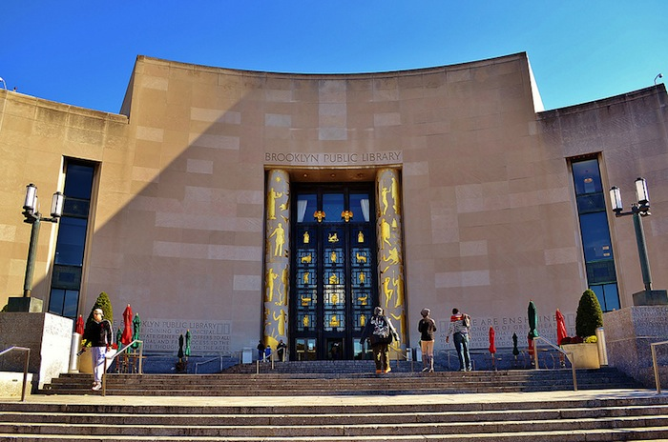
The Central Library’s grand structure and ornate décor exudes to the culture and history contained inside.

When we walked into the library, we were led upstairs and into a room full of file cabinets, book-filled shelves, and a few exhibits. June, our guide, filled us in on what we were looking at, what was surrounding us, and what we can expect. The file cabinets contained newspaper clippings dating as far back as the early 1900s. There were even clippings from the Brooklyn Daily Eagle, an old newspaper we spoke about in class.
Before walking into the second room, June revealed that everything in these rooms are specifically about Brooklyn and neighborhoods in Brooklyn. She told us that the documents and books in the second room would be extremely hard to replace, maybe even irreplaceable so they MUST be handled with care. As we walked in, there is a spirit of time as in past, present, and future because we were surrounded by this collection of history about Brooklyn, where I was born and raised nearly my entire life. June first showed us some Brooklyn Fire Insurance Maps dating back to the 1800s. So, individuals like Joseph Alexiou or members of the Conservancy who may want to trace the structural history of an area may want to look through this collection. She also told us that the room contained an impressive collection of yearbooks so someone who may want to find an older relative can look through these books for insight.
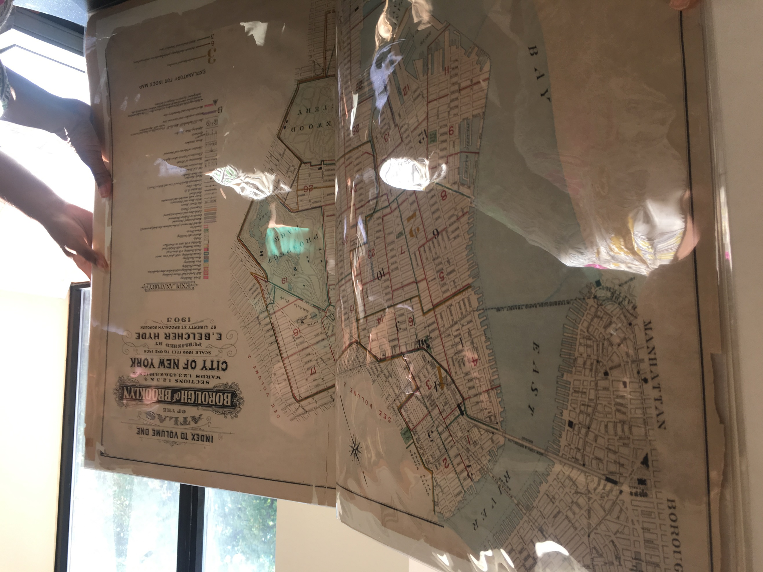
These maps depict building footprints, lot dimensions, shoreline locations, and a few even show property ownership around Brooklyn.

We then went to the table where she had pulled a selection of books about the Gowanus. She also pulled a few manila folders from the cabinets with the newspaper clippings in them. Her only rule when handling the manila folders was to keep the clippings in their designated folders; Order does not matter. Everyone searched for texts/documents that related to a topic that they may be interested in, taking pictures of the publishing information, any relevant dates, etc.

SOURCE ANALYSIS

Freeman, L. (2006). There Goes the ‘Hood: Views of Gentrification from the Ground Up. Philadelphia, PA: Temple University Press.

This book sets out to speak on how residents living in neighborhoods in which gentrification is underway, are truly affected by the transition. The book contains a series of interviews between himself and residents of the predominantly black neighborhoods of Harlem and Clinton Hills. Freeman took a page out of Jane Jacob’s book so to speak. The book gave a voice to the people allowing them to speak on how they are coping with the changes and what THEY would desire to happen in their community instead. This source shed light on the issue of gentrification and the fear of displacement in these changing low-income areas (“the Hood”). Displacement of residents and businesses in the Gowanus area is an issue I am considering focusing on for my final project. Like Lance Freeman, I would like to get the perspective of local business owners and residents. Do they fear that the transition to a more residential and commercial community, rather than an industrial one, will force them to have to leave because of increased costs?

Kilgannon, C. (2014, October 9). In Gentrification’s Shadow, Campground for Homeless. The New York Times, pp. A27-A32. Retrieved October 10, 2017, from https://www.nytimes.com/2014/10/09/nyregion/in-gentrifications-shadow-a-campground-for-the-homeless-in-brooklyn.html
This newspaper article in the New York Times (2014) depicts the effects of displacement and gentrification on longtime, local residents. Many people ask, “What happened to those business owners and residents that were pushed out due to the inability to keep up with the costs?” Well, this source provides an answer to the “Where are they now” question we all have. City planners and developers can benefit from reading such articles so they can see what their implementations are doing to the community. From there, they can make the necessary changes to their plans to prevent displacement and homelessness. The article focuses on a group of Park Slope natives that have now taken shelter in a tent alongside the Gowanus Expressway; this is extremely relevant to what we are studying as it hits so close to home.

GENERAL NOTES:
- Many locals view gentrification as systematic force used to drive out a particular group of individuals.
- Level of education, as well as, upbringing, regardless of race, can qualify you a gentrifier.
- “Homeowners face little threat of displacement because a bulk of their housing costs are tied to maintenance and servicing debt used to purchase their home, neither of which will be affect by gentrification.”
- “Under New York City’s rent regulations, when a tenant moves the unit is deregulated and the landlord can charge the market rent.”

QUESTIONS for Further RESEARCH
- Who is the “gentrifier”?
- How will conditions in the canal be affected by the incoming residential and commercial developments?
- Is gentrification directly correlated to homelessness? If so can we expect an increased number of homelessness in the Gowanus?

