Learning Places Fall 2017
Library / Archive REPORT
Brooklyn Public Library Achieve (bpla)

Gurjot Nijjar
10.22.2017

INTRODUCTION

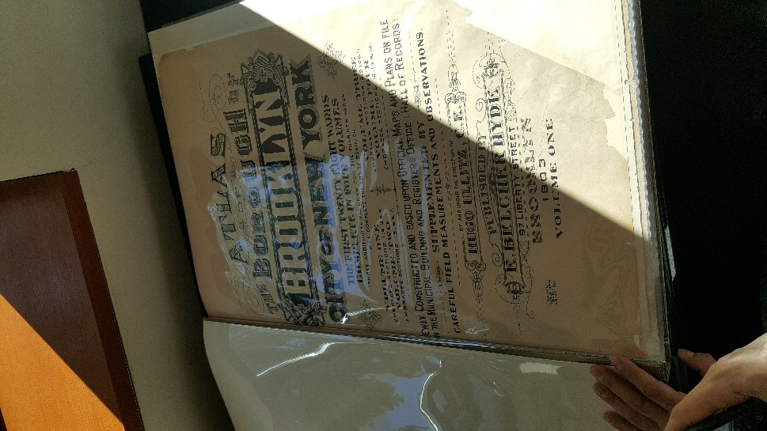This was first visit ever to The Brooklyn public Library, and it was much better then I imagine, if I have to compare it, I would say that it was the Grand Central station of books. Brooklyn Public Library is one of the most iconic building in NYC located in the heart of Brooklyn and surround by some of the few famous places like the Prospect Park, Brooklyn Museum and Brooklyn Botanical Garden. The BPL doors first opened in February 1, 1941 which makes it about 76 years old and it has quiet the collection to show for it.

Our visit to the Library was to explore the history of Gowanus by researching the archives. So we sat in the Library’s History Division and explored the old historical documents one by one. We had amazing opportunity to look at historical makes, old books, old newspapers / articels related to Brooklyn and Gowanus Canal. I was just happy to visit because it was my first visit but I had no expectations but to look at few books, but it was amazed to the collection they had and how far it can back in history with their rare historical collection.

SITE OBSERVATIONS

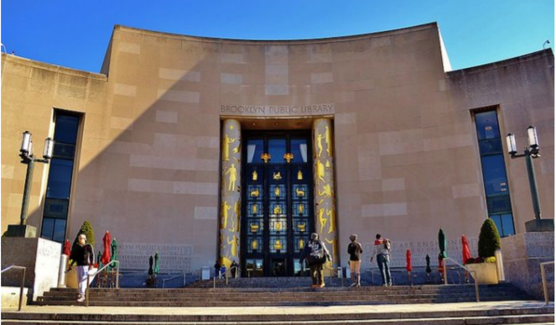
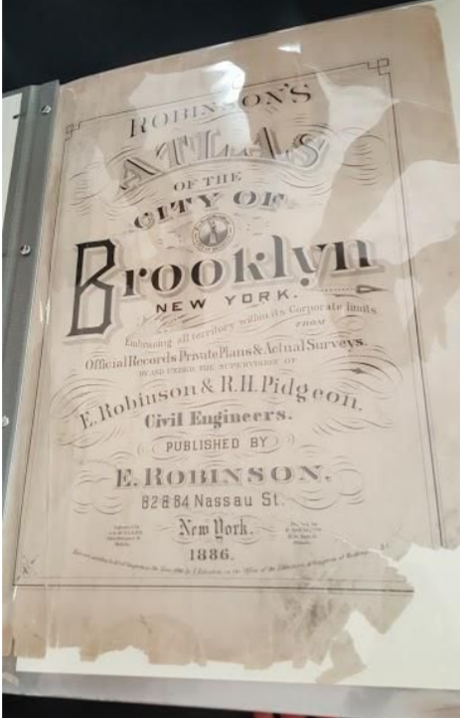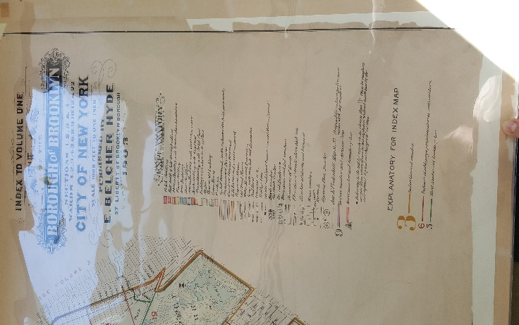
Cover and Index of the Atlas at Brooklyn Public Library

What is the Genius Loci, or spirit, of this place?
I believe the Big Golden entrance door to the library, one may say that it makes them feel like entering a great Egyptian king’s palace or like a open book with gold inscriptions.
What kind of archive or library is this? What kinds of materials / sources does this place collect?
The BPL collection goes from pre-colonial to the present date. It contains historical materials on the social and cultural documents of Brooklyn. According to the librarian, they have about 5000 books, over 200k photos, very old newspapers articles, maps, atlases before and after the changes in Brooklyn, old phonebook directories, years that predates to 1910 and many more items.
Who might use this collection and for what purpose?
That for anymore who wishes to explore more about the history in Brooklyn, or someone who wants to write a book about the history of Brooklyn like our guest speaker Joseph Alexiou.
Are there any special rules for using or accessing material?
Yes, we were asked to close our book bags and to very careful with the material and utilized one resources at a time.

SOURCE ANALYSIS
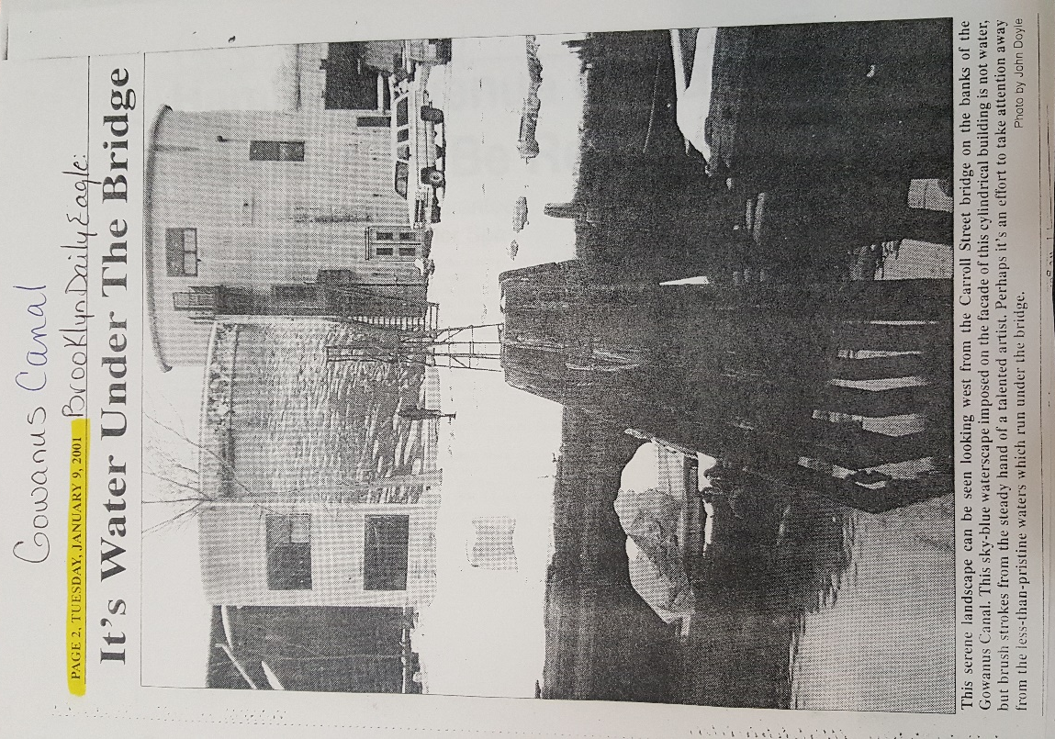
Doyle, J. (2001, January 9). It’s Water Under The Bridge. Brooklyn Daily Eagle
- What is this source and what is its purpose?
In this newspaper article from the Brooklyn Daily Eagle, was found in the BPL archival book. In this article by John Doyle, he depicts about the painting done on side of the cylindrical building of blue water that is reflecting the clear blue sky. This view from the Carroll Street Building is serving a purpose depending on the viewer. whether the person choose to look at this image and choose to ignore the water in canal is not as blue as it should or makes them question that why is the water under the bridge is not blue as it should be.
- Who created it and who was it created for?
Author John Doyle and it was created for the Brooklyn Daily Eagle
- What does this source tell us about the place we are studying? What themes or subtopics does it relate to?
This article related to the ongoing issue about the pollution in Gowanus Canal. Some artist brush sky blue water on the side of a building, which may cause someone to stop for a second and see what the actual color of water is and what it should be. This maybe cause a upstir in people from the community and make effort to do something about the pollution in the canal. This topic can future be exploring for zoning, community and zoning laws, gentrification and governmental agencies in charge of cleaning the canal and the neighborhood.
- How might it be integrated into a research project? What question could it be used to help answer?
This article can be used for the purpose, that how far close have we gotten since then to clean the canal. Who is in charge of the cleaning project, what is the government doing about and what efforts have the community made to keep it clean

CITATION for ARCHIVAL SOURCE #2

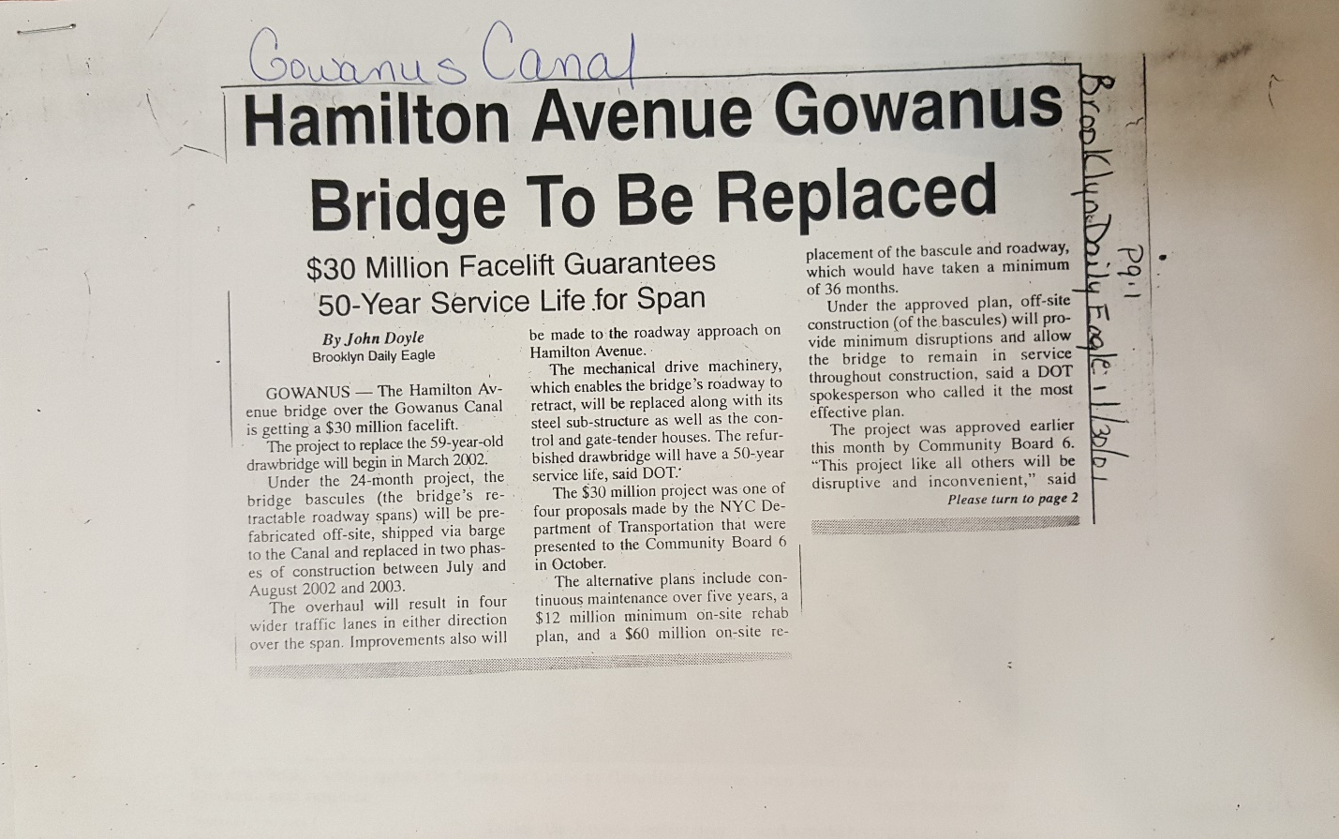

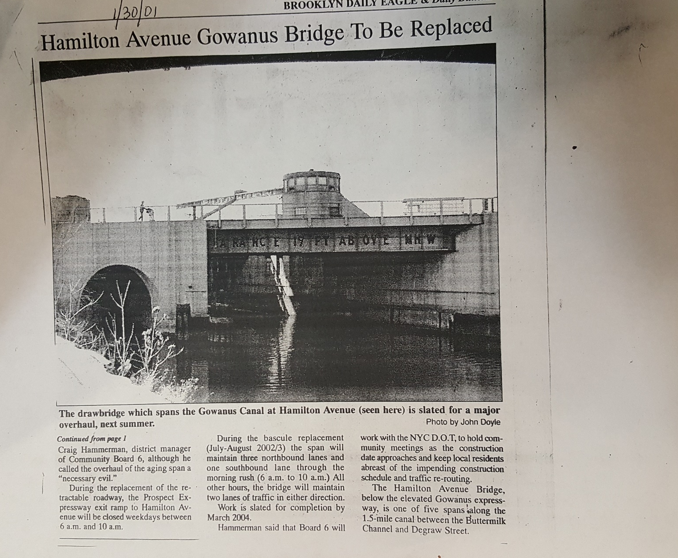

Doyle, J. (2001, January 30). Hamilton Avenue Gowanus Bridge To Be Replaced. Brooklyn Daily Eagle.
- What is this source and what is its purpose?
This is article from Brooklyn Daily Eagle and its purpose is to inform that the Hamilton ave. bridge is going under $30 million-dollar construction which would take about 2 years to complete. It’s an inconvince to some community member but it’s a project that NYC D.O.T. is necessary
- Who created it and who was it created for?
Author is John Doyle and its by the Brooklyn Daily Eagle
- What does this source tell us about the place we are studying? What themes or subtopics does it relate to?
It related to politics, community affairs, NYC DOT, bigger city official that makes the decision for the other boroughs without consulting the community.
- How might it be integrated into a research project? What question could it be used to help answer?
It could be integrated in a research project, because it goes to show how $30 mil dollars can be spending to keep a bridge maintain, so why not find something similar that keeps the canal cleans?

GENERAL NOTES:
- Biosphere and Ecosystem
- Displacement of the community due to zoning
- Canal’s super fund
- Governmental involvement and city’s official involvement
- Artist struggle and developers power

QUESTIONS for Further RESEARCH
- What area have already been purchased by the developer, prior to the zoning?
- Where are the artist moving to, after being forced to move out?
- What changes are happening in the community, who is actually living there now, the old or new residents?

