Learning Places Fall 2016
Library / Archive REPORT
Brooklyn Public Library Archive Visit
Andrew Alleyne
10/10/17
INTRODUCTION
Our visit the to the Brooklyn archive was one filled with pure excitement and joy. Before embarking on our visit, I expected to learn various astounding facts about Brooklyn and the Gowanus. Many of the historical achieves on hand are store in a room on the second floor. To access these archives, you must set an appointment with the librarian responsible for them to view. The scenario of the archive slightly lived up to my expectations. I envisioned a secret room filled with gigantic maps and dusty book enclosed by a vault with a passcode. However, that wasn’t the case, the room allowed onlooker to look in an observe.
SITE OBSERVATIONS
(include photographic documentation and visual notes—at least 2 photographs 1 sketch required)

What is the Genius Loci, or spirit, of this place?
The spirit of this place certainly was the entrance. It made me feel calm, fascinated and ready to explore beyond its doors.
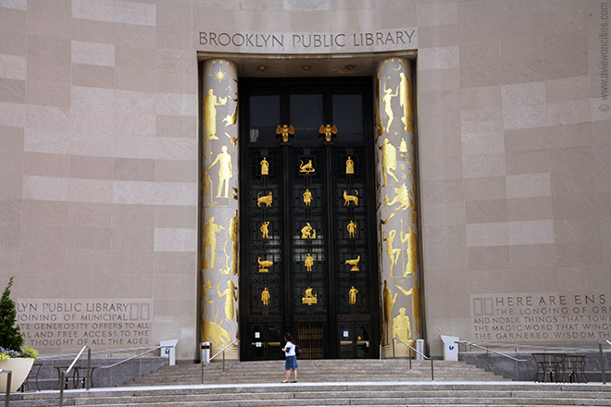

What kind of archive or library is this? What kinds of materials / sources does this place collect?
As the name suggest, The Brooklyn Public Library is a library that is completely open for public usage. Within the library they collect historical books, maps and documents that are related to Brooklyn’s ever-changing landscape. For instance, the library holds a section related to Brooklyn and it's community.

Who might use this collection and for what purpose?
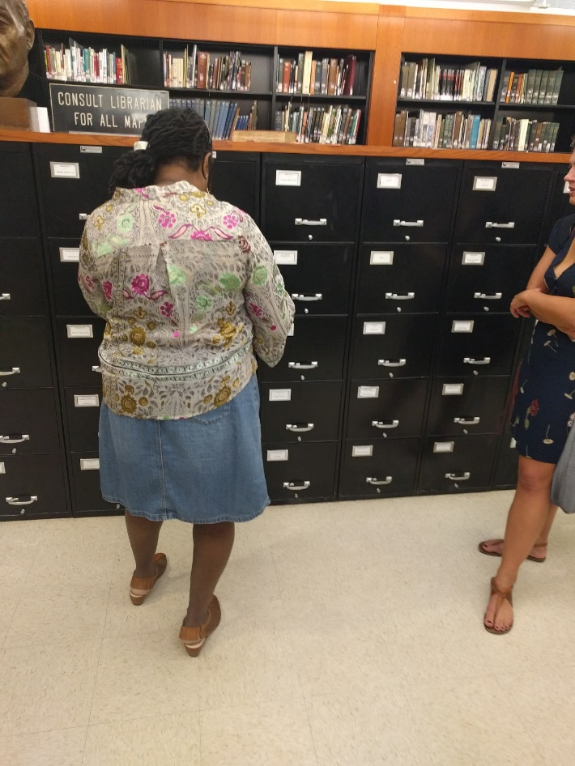
The collection of historical books or maps may serve as information for either developers, property owners, researchers and the community. Developers / property owners may want knowledge on what type of area existed before investing. Researchers on the other hand may find this information useful as they may serve as links to different events. The community may use this information for general knowledge. For instance, Superfund may use these maps to find out who may have been responsible for the Gowanus Canal’s pollution.

Are there any special rules for using or accessing material?
There are special rules when accessing the material in the archive. To being with we were warned that we cannot remove items from the area or rearrange them as we please. Another rule mentioned is that some documents may require you to wear a protective glove to keep them safe as the pages may be fragile.

SOURCE ANALYSIS
(2 citations of sources found and a brief analysis of each source—photos optional)

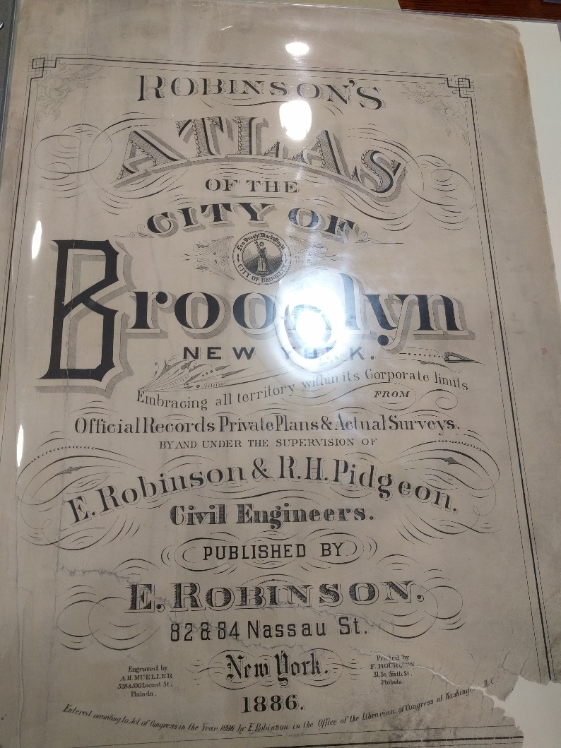
CITATION for ARCHIVAL SOURCE #1 (consult this website for help with citations)
The Brooklyn Public Library, Archive Reserved Room. Robinson,E. & Pidgeon,R.H., Robinson’s Atlas of The City Of New York.,1886.

What is this source and what is its purpose?
This Atlas provide a comprehensive overview of the Brooklyn Real Estate Properties in the year 1886.

Who created it and who was it created for?
The Atlas of Brooklyn was created by two cartographers, E.Robinson and Pidgeon, R. H. (Roger H.). The Atlas provide information for developers and the community.

What does this source tell us about the place we are studying? What themes or subtopics does it relate to?

The source provides information about the Brooklyn in the year 1886. It details many of the businesses that existed then and informs us in detail about what they were made of.

How might it be integrated into a research project? What question could it be used to help answer?
The resources provided will prove beneficial if a research was to be conducted. It can be integrated in a research project that focuses or deals with land change over the years. They may be able to assist in answering questions such as:
- What existed on this property before XYZ date?
- Was the area covered by water or subject to a garbage plant?

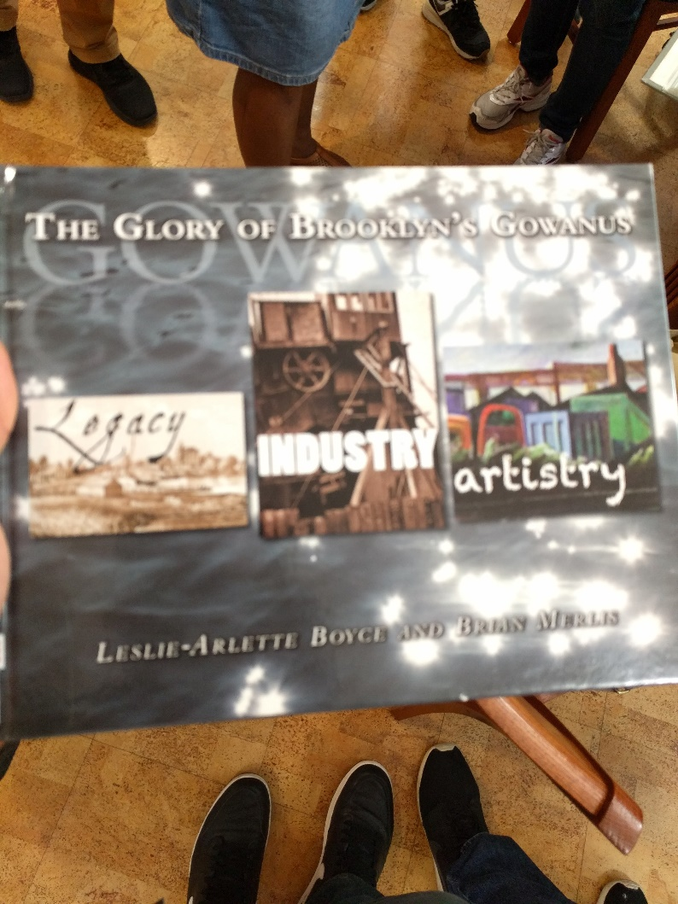

CITATION for ARCHIVAL SOURCE #2 (consult this website for help with citations)
What is this source and what is its purpose?
The books purpose is to provide the history of the Canal through changing times. The source of this book is from the two authors who are artist that have worked in the Gowanus area.

Who created it and who was it created for?
The Glory of Brooklyn’s Gowanus was written by Leslie-Arlette Boyce & Brian Merlin. It was created to inform people of the history that surrounds the canal as it changes through the years.

What does this source tell us about the place we are studying? What themes or subtopics does it relate to?
The source provides information about the canal throughout the year to its current state. Many of the subtopics range from businesses to the community that developed afterwards. It also focuses on the how the canal affected their artistry.

How might it be integrated into a research project? What question could it be used to help answer?
The information provided here is useful for a research project as it dives into different time periods of the Gowanus. It gives us a firsthand experience of what artist and the community go through with the change of time. Question that can be raised from this information source are;
- How has the area developed over the years?
- How does the Gowanus further an artist and their style?
GENERAL NOTES:
- Recording information about the surrounding area may prove beneficial.
- The information provided on many maps can be comprehensive and detailed.
- Howard Golden reserve room stores books and information about the Gowanus that may aid further research.
- Most of the Atlas’s were made for fire insurances.
QUESTIONS for Further RESEARCH
- How does Superfund plan to deal with the aquatic life of the Gowanus during its clean up phase?
- Due to the change is power are there any signs of further support for the Gowanus Canal clean up?
- What after effects may be possible when sealing the Canal?

