Learning Places Fall 2019
SITE REPORT #1
name of site report

NAMING PROTOCOL. When saving and posting your site reports on OpenLab, please follow the following format: SiteReport#.LastnameFirstname
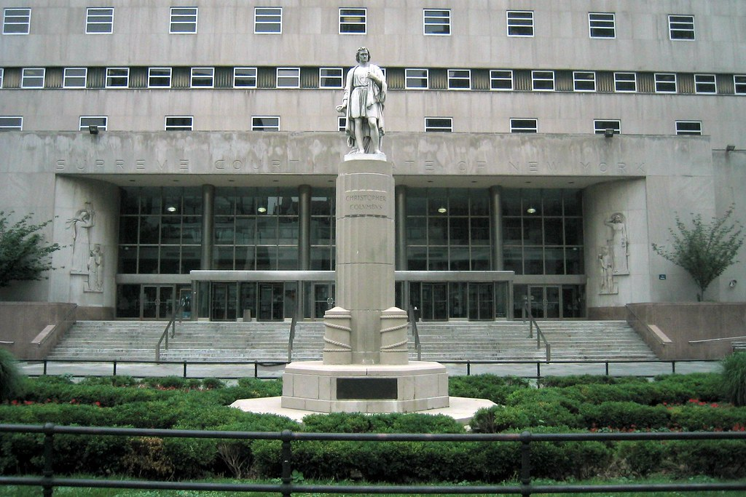

STUDENT NAME: Keron Anthony Smith

PART 1: SITE OBSERVATIONS

- What are some general observations about the character of this neighborhood? What does it remind you of? How does it make you feel?
- It's one of my favorite neighborhoods to visit in Brooklyn, the Brooklyn Heights area in which the Kings County Court is located is a very busy area filled with working people and busy students.

- How is the natural world contained or shaped by human activity or architecture? In what ways does the natural world invade or disrupt human activity, planning or architecture?
- One way nature is shaped by human activities is through our own desire for personal gain and expansion. This could be represented through constant zoning changes, real estate development, and/or over population of a certain area. In some cases the natural world would invade our personal domain, for example when there are storm surges and the gowanus canal and nearby waterways overflows therefore causing severe flooding.

- What people did you observe in the neighborhood and what activities are they engaged in?
- While doing rehearsals and while conducting the actual performance I observed a large amount of people. These people consisted of government workers, regular city employees, students from both college and grades below. I believe we encountered this large variety of people due to the location we decided to pick. It was the epicenter for foot traffic due to the court house behind us and the train station and farmers market adjacent to us.

- Reflect on a specific place you viewed in this neighborhood. A specific place means a single building, or an intersection, or an individual built structure, etc.

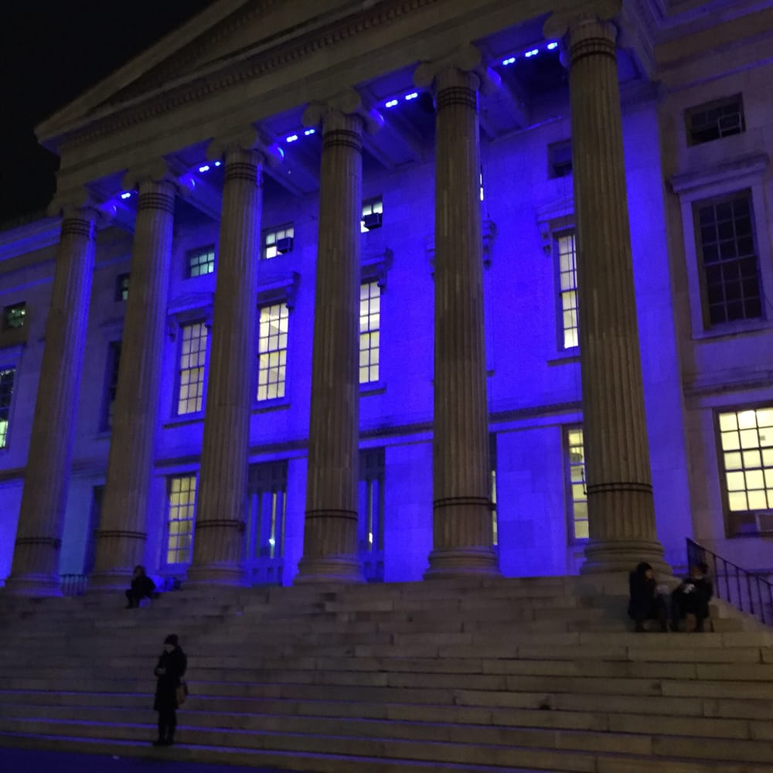
! FARE EVASION TICKETS KEEP OUR LIGHTS ON !
  - What is the program of the space? How are people meant to interact with one another and with the environment?
- The program of the space is intended to serve as an entrance for the Kings County Brooklyn Supreme Court. The space seems very welcoming to passer byers who are looking for a quick seat to catch while on their way to their destination, also this spot attracted a lot of students and skateboarders because of the structure of the stairs and seats that were set up. This was a contributing reason to why we had to change the location of our performance in the first place.

  - describe a possible creative reuse of this specific space for a performance:
- Which areas are best for performers/activists and which areas are good for observers? Do these spaces overlap? Mention specific objects and structures in your answer.
- The stairs before reaching the courthouse doors would act as a great stage for performance. I say this because the stairs are offested widley and elevated from the regular sidewalk, therefore making it easy for bystanders to compare it to a stage if there were to walk by and see our performance. In Front of the stairs was a seating area which would be extremely convenient for attracting an audience. Theses chairs would also later come in handy with our performance giving BOB a platform to stand on.

- What kinds of performance would work best (intimate or grand; processional or
-The beat type of performance would be a grand presentation or theatrically stunt in order to grab the attention of people passing by and relay your message to them. This type of space wouldn't really benefit a more intimate performance such as one on one conversations due to the amount of foot traffic and the fact that it is a federal court house which means the area is an epicenter for offices, businesses, and schools. These are among these common type of people to stop and engage with an intimate performance because of their busy schedules.
- stationary; text and/or music; interactive or passive audience; etc.)?
-When reflecting about our performance we noticed that although we didn't generate a lot of pedestrians interaction, the ones we did attract were highly engaged. They asked questions about the cause we were fighting for and why, there was even one lady who was so inspired about our performance that she was willing to debate with us in the cold about every reason we were wrong to feel the way we do. That type of debate was very healthy and gave us a lot of insight on how the opposing side felt about having CUNY students have free or reduced MTA access.

QUESTIONS for FURTHER RESEARCH. These should follow directly from your analysis section and be complex and specific enough to serve as the basis of a research project.
Questions might relate to architectural or environmental observations, socio-political problems and/or solutions, demography, history, zoning, civic processes, performance strategy, etc.
- What Percentage of CUNY use the MTA to get to school ?
- What can be done by city officials to fix crisis between CUNY students and affording MTA access?
- Is it possibility CUNY students are specifically targeted when it comes to fare evasion.

PART 2: RESEARCH
Choose and revise one of your research questions for further research.
Revised Research Question:

Find and cite 2 sources that address your question in MLA format. Respond to the questions below.

CITATION 1: https://www1.nyc.gov/site/nypd/bureaus/transit-housing/transit-district-30.page
https://www1.nyc.gov/site/nypd/stats/reports-analysis/subway-fare-evasion.page

Why did you select this source? How does it address all or part of your research question?
- I selected this source because it shows the arrest and citation rates at each specific transit spot in the city as well as the demographic of the sample study.
Is the source credible? Why or why not?
- This is a credible source because the data provided as well as the statements given come directly from the NYPD and its representatives.

CITATION 2: https://www.collegefactual.com/colleges/cuny-new-york-city-college-of-technology/student-life/diversity/#secGeographic

Why did you select this source? How does it address all or part of your research question?
- I ended up choosing this source because it a trusted database that collects and shares information about the specifics behind the population of each CUNY college campus in the city. After reviewing the statistics I was able to conclude that there could be a direct correlation between diverse student body here at city tech and alarming increase of fare evasion citations and arrest within the past year. (Q2 Fall 2018 to Q2 Fall 2019 number of citations rose from 303 to nearly 1600 people)
Is the source credible? Why or why not?
- The source is a credible source because it gives insight into the college costs, way of life, population, and area of location. Specific statistics like these are recorded and gathered from the schools themselves and are displayed to the public in order to help them apply for schools or just have a better overall view of the institution that their investigation.

PART 3: Performance Reflection (after second site visit)
Write a 200 word reflection about how you felt during the second visit to the space and during the performance activities. How did this visit change your perception of the place and your relationship to the natural and built environments? Did the experience of ‘performing’ in the space (i.e., moving your body) teach you anything new about the landscape or architecture?
- During the second visit we noticed the congestion and obstacles we faced with the first location we picked to act out our performance. Although environment and landscape of the area would have been very convenient for displaying a performance and relaying a message to the public there was just too many people. Students and workers used the stairs as a quick place to rest whilst enjoying the view while skateboarders used the seat and table in front of the stairs to make make-shift ramps. We decided to relocate to in front of the Kings County Supreme Court Building which in own was provided a stage and audience setting as well. The train station directly adjacent to us made sure we had constant stream of audience members while the courthouse behind us symbolised the City of New York as well as the right to protest for what you believe in. By conducting this performance I was able to notice something interesting between the locations we chose and the reactions we received. Although the original courthouse settings had much more people surrounding the area when we did practice runs not many people interacted with us or asked us questions. When we relocated to the secondary courthouse near the 2 and 3 train entrance. I noticed that there was a lot less people residing in the area itself but while performing and practicing we had audience member stop and watch, ask questions, and even debate with us on our beliefs.

