Learning Places Fall 2019
SITE REPORT #3
MTA Group Project

SiteReport3.GurungJatin.
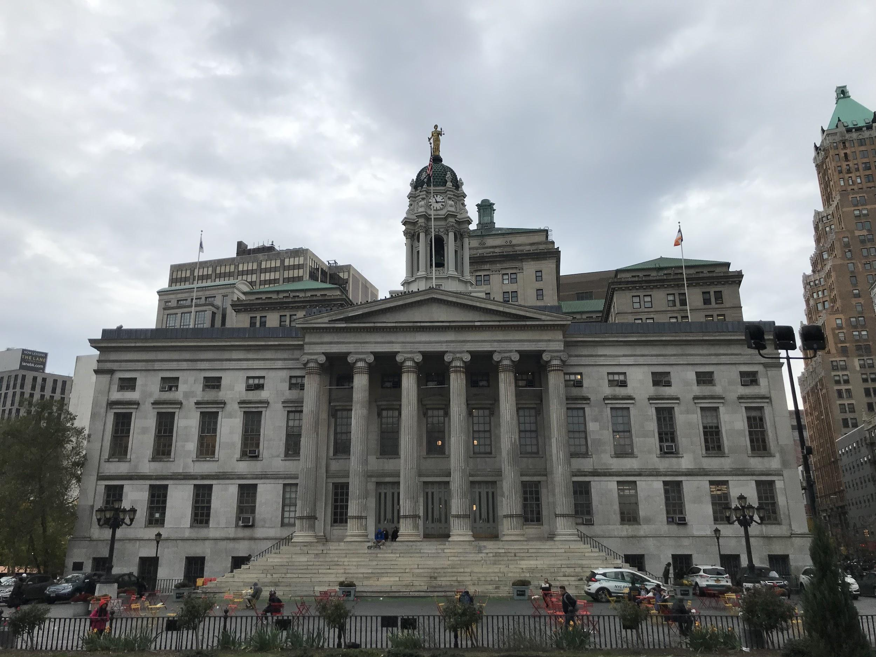
“The law is made for man, not man for the law.”

STUDENT NAME: Jatin Gurung

SITE OBSERVATIONS
- What are some general observations about the character of this place? What does it remind you of? How does it make you feel?
- It is a very busy public space with heavy traffic flow of people. Every Tuesday, Thursday and Saturday from 8 am to 5 pm, there's also a farmer’s market that operates year around. There’s also a Columbus Park with a fountain. There’s a bustling Borough Hall metro station and B25/26 bus stop. There’s a no skateboarding sign posted but you can see young teenage kids skateboarding. The exterior of the building where we will be doing our performance reminds me of John Grisham’s novel. I feel like I am actually one of his character in the book playing my part.

- How does this place and its architecture relate to your performance? Think about the social meaning of the space (eg. civic, recreational, retail, etc).
- Since our performance is set in a courthouse setting there couldn’t be a better choice than Borough Hall. Before Brooklyn merged into five boroughs of New York City it used to house City Hall and stopped performing any governmental works after the merge. Even though Borough Hall is not an actual courthouse, but the history it carries and the symbolic architectural values it holds makes this place special and relevant to our performance.

- Discuss the program of this space. How are people meant to interact with one another and with the environment?
- The construction of Borough Hall was completed in 1848. There’s a park facing the front of the Borough Hall. The corridor in the front has some seating areas for the general public. The area usually has lots of foot traffic because it’s surrounded by commercial spaces and it also has a major metro hub. The Borough Hall is situated in a place where there's lots of space for public use with benches, chairs and tables. People can just sit and enjoy a conversation over coffee or can just sit by themselves and enjoy the view of the hustle and bustle.

- Describe some of the activities that people are currently engaged in. How might they interact with or respond to your performance when it is staged?
- People around the vicinity were engaged in various activities such as skateboarding, sitting on the benches and chairs and eating their food or drinks. During the day of our performance we might be able to get their attention away from whatever they are doing and get their attention to our performance. The way the viewers might be able to interact is by asking us questions about the performance and giving us feedback.

- Draw a ground plan of your space with the performance site and audience clearly defined in your drawing.
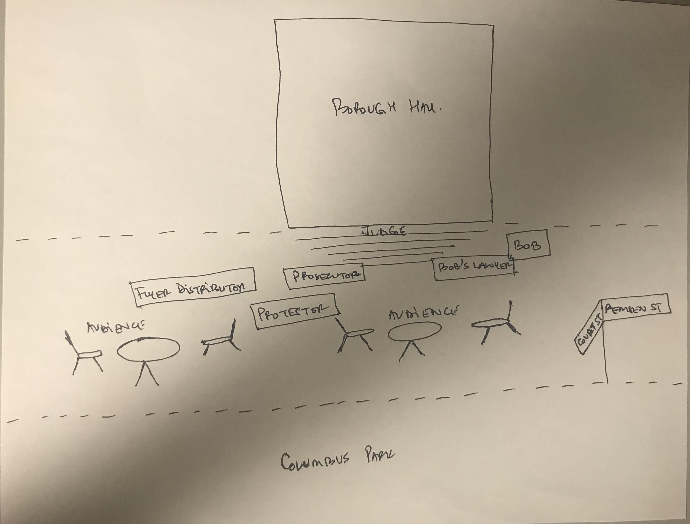

QUESTIONS for FURTHER RESEARCH. These should follow directly from your analysis section and be complex and specific enough to serve as the basis of a research project.
Questions should relate to information you will incorporate into your performance and/or share with audience members.
- Question?
- How can the MTA make it feasible for CUNY students to commute to and from school?
- Question?
- How can the City of New York help ease the financial burden on students attending CUNY?
- Question?
- How does a public school graduate help lower the unemployment rate?

FURTHER RESEARCH
Choose and revise one of your research questions for further research. Refine your question following from examples that we’ve discussed in class.
Revised Research Question:
- How can the City of New York help ease the financial burden on students attending CUNY?

Find and cite 2 sources that address your question in MLA format. Respond to the questions below.

CITATION 1:
Hilliard, Tom. “CityViews: As Mayor & Council Clash Over Fares, CUNY MetroCards Offer a
Compromise.” City Limits, 6 June 2018,
https://citylimits.org/2018/06/06/cityviews-as-mayor-council-clash-over-fares-cuny-metr
ocards-offer-a-compromise/.

Why did you select this source? How does it address all or part of your research question?
I chose this source because it’s a well written article about the everyday struggles of a student attending CUNY. The city can make it so much easier for students attending CUNY to stay on track to graduation just by offering a free metro cards to deserving students. Since students attending CUNY are already burdened by fooding, housing and other everyday expenses, if the city offers incentive to take away this commuting expenses then I believe this will not just uplift the students spirits but will also help them achieve their goals.
Is the source credible? Why or why not?
The source is credible because it is a non profit organization which has been putting out factual information based on their investigative journalism since the beginning.

CITATION 2:
“About ACE at John Jay.” John Jay College of Criminal Justice, 12 Sept. 2019, https://www.jjay.cuny.edu/about-ace-john-jay.

Why did you select this source? How does it address all or part of your research question?
The CUNY already has programs in place such as ASAP (Accelerated Study in Associate Programs), SEEK (Search for Education, Elevation and Knowledge) for students enrolled in two years college and ACE (Accelerate Complete Engage) for John Jay students. The only problem with these programs is it only covers part of the students and doesn’t cover the entire students. So if the CUNY can initiate CUNY wide programs then that would be really helpful for students across the system.
Is the source credible? Why or why not?
Yes the source is credible because the information was taken from CUNY John Jay’s website.
What further information would you need to answer your question? Where would you look for additional sources?
Further information such as total amount of students enrolled at CUNY from CUNY website, NYC budget from NYC council website, MTA’s website, NYPIRG Straphangers Campaign website can all be helpful to gain additional information.

