Learning Places Fall 2019
SITE REPORT #3
COLUMBUS PARK

NAMING PROTOCOL. When saving and posting your site reports on OpenLab, please follow the following format: SiteReport#.LastnameFirstname. Here’s an example: SiteReport3.SwiftChristopher.
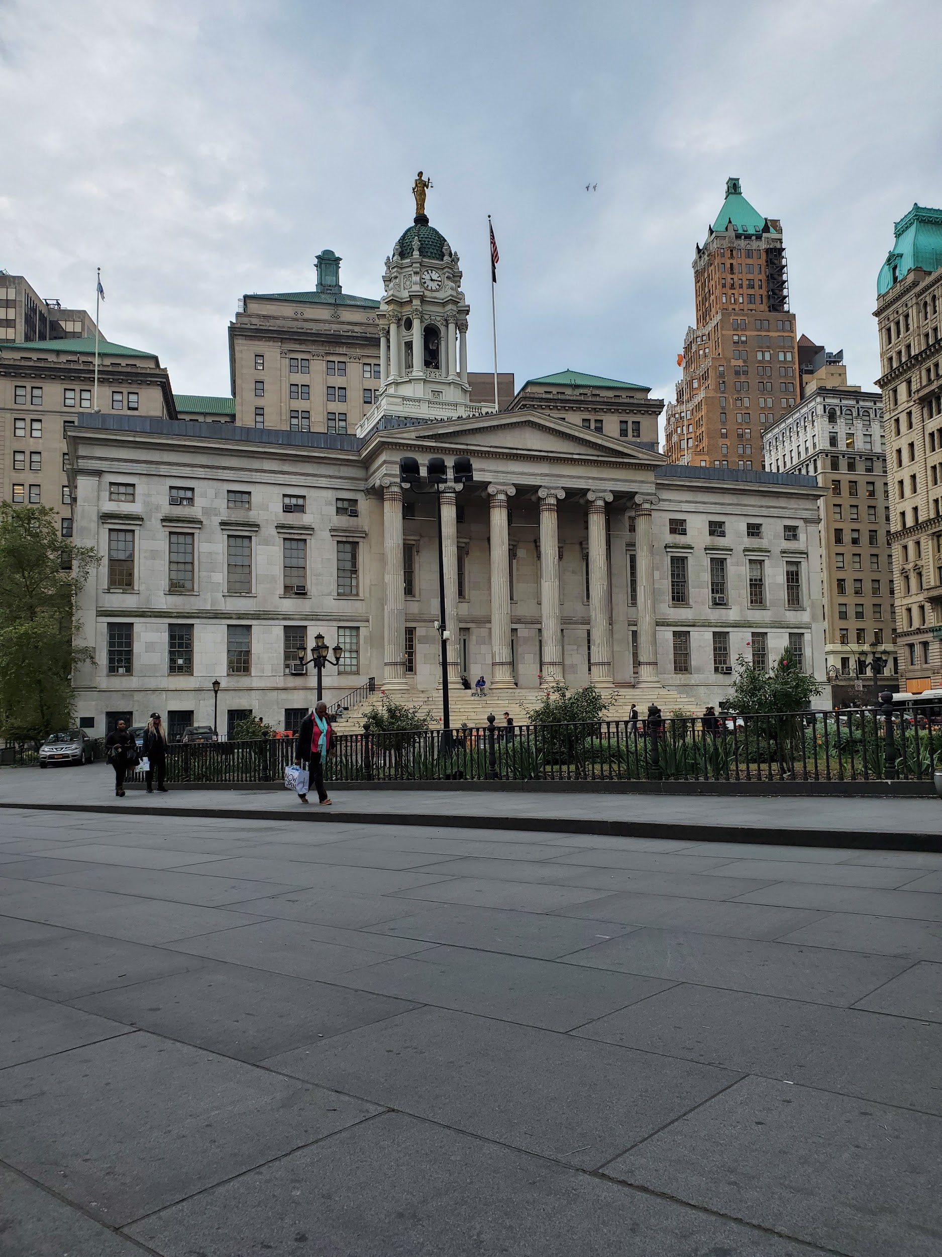
Select a meaningful image that captures your perception of the site you visited and provide a caption explaining what the image is.

STUDENT NAME: CESAR ZAMBRANO

SITE OBSERVATIONS
- What are some general observations about the character of this place? What does it remind you of? How does it make you feel?
Generally this is a massive space. This place is full of people walking by, skateboarders, marketers, people smoking, etc. I observed many people walking by in peace, having conversations with one another and generally having a good time. This place is an ideal space to relax and observe people walking by. This space reminds me of a park in Ecuador named “El Malecon 2000.” The vibe is exactly the same in which people walk by, break the rules: for example, skateboarding, and see the beauty of the natural world. This place makes feel very comfortable and easy. It's a place where I would come in my break time and listen to music alongside viewing the buildings and buying goods from the nearby markets. I would come here and eat lunch with my friends. The green market accepts SNAP/ EBT. These green markets are located all over the city. Lastly a woman approached us wanting to get a call from our phones. She looked shady and was a complete stranger so we were cautious. We gave her a phone call and went on with our day.

- How does this place and its architecture relate to your performance? Think about the social meaning of the space (eg. civic, recreational, retail, etc).
This place is a perfect example of architecture that relates to my groups performance. This place is where a courthouse building sits in the center of it all, and our performance has to do with “Bob” being in front of a judge on a case where he jumped the turnstile in the subway. The amount of stairs that the courthouse is a focal point of walkers to view, and will be the center of our performance. The way the architecture is placed gives our performance the “main stage,” we will be right in the center of it all, the seats placed right in front of the performance, bystanders viewing our actions, and be the focal point of Columbus Park. The social meaning of the space is communication. Whether there are sellers in the markets interacting with consumers or friends chilling and having conversations with one another, this place is a popular spot to walk by and get to your destination.

- Discuss the program of this space. How are people meant to interact with one another and with the environment?
The program of the space is to interact with one another and view the nature around you. There are plenty of benches around in which can be used to converse with peers or even strangers you meet around. If you aren't sitting on the benches, you could be eating with friends in front of the courthouse where there are seats and tables. You can also go to the market to buy fruits and all kinds of foods right there in the park. There is a train station where you can use to reach a destination. Others use this space to skateboard, which is prohibited. There is a sign saying “NO SKATEBOARDING” \and what do kids do? They skateboard anyway. Every time I go there, there is at least one kid skateboarding and falling off, I find it very funny. There are also people in the staircase, either smoking or on their phones.

- Describe some of the activities that people are currently engaged in. How might they interact with or respond to your performance when it is staged?
Activities that people are engaged in his conversation. I sit on the bench observing and I hear people walk by having a conversation. People also sitting down and having a good time with friends. When people walk by you barely hear there conversations because of the background noise and traffic. When people approach you, you can hear what they are talking about clearly, this is because of the amount of space that there is and elevating conversations when spoken. I expect to see people in the tables looking at our performance from their seats. I also expect people to come watch what's going on, mainly because of “Bob.” The distribution of our informational metrocards should also bring intrigue and people to see how we can make changes. I expect people to videotape us, take a picture of us, and put us on the internet. Things can go two ways, people will support our beliefs and want to join us in making a revolution, or just ignore us/ think we are silly for being out performing in the cold. I hope to get a positive response from the people and help them learn at least one thing in their day.

- Draw a ground plan of your space with the performance site and audience clearly defined in your drawing.
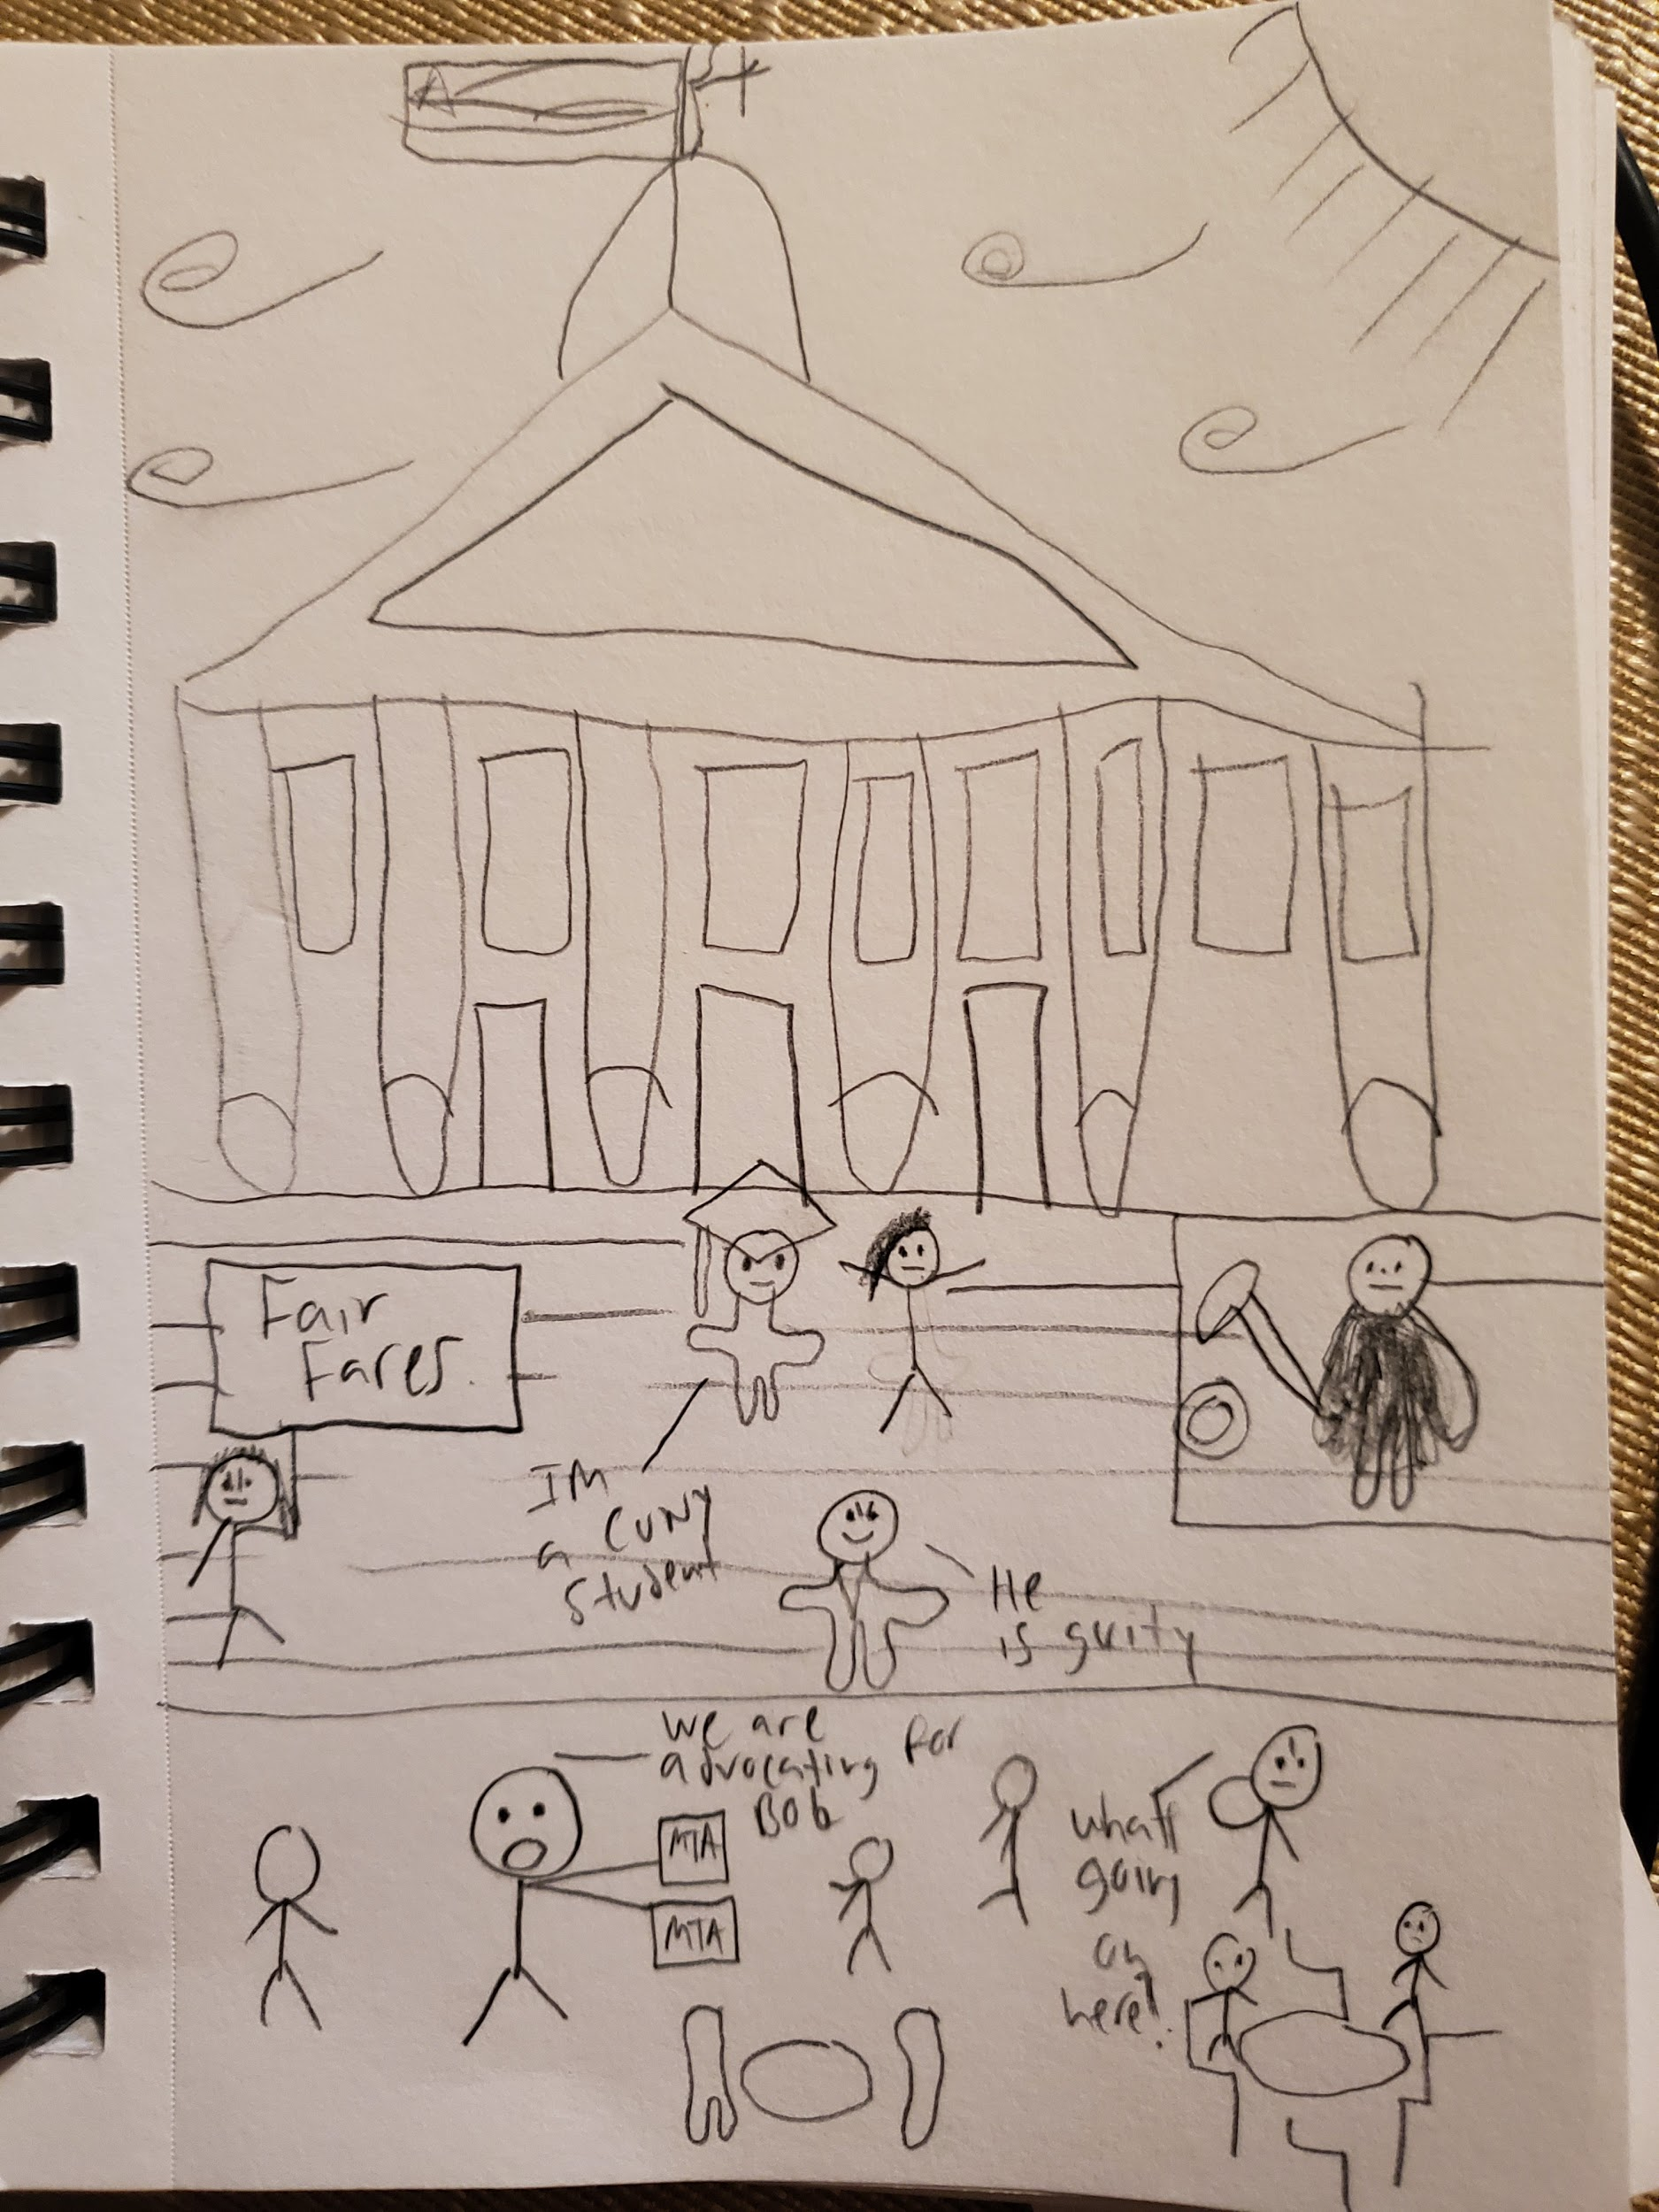

QUESTIONS for FURTHER RESEARCH. These should follow directly from your analysis section and be complex and specific enough to serve as the basis of a research project.
Questions should relate to information you will incorporate into your performance and/or share with audience members.
- Question? Why can't CUNY students be given free metrocards like highschoolers?
- Question? What percentage of the CUNY student base, use the MTA?
- Question? Is it cheaper to let a student jump the rail? Or pay police officers to stand in the subway?

FURTHER RESEARCH
Choose and revise one of your research questions for further research. Refine your question following from examples that we’ve discussed in class.
Revised Research Question: Would it cost more to let people jump the rail or pay police officers to stand at the subway stations?

Find and cite 2 sources that address your question in MLA format. Respond to the questions below.

CITATION 1:
/staff/jake-Offenhartz. “Photos, Videos: NYers Jump Turnstiles En Masse To Protest Police Brutality On The Subway.” Gothamist, Gothamist, 2 Nov. 2019, gothamist.com/news/decolonizefareevasionnprotest.

Why did you select this source? How does it address all or part of your research question?
I selected the source because I know that this event actually took place. I’ve seen the videos of this wonderful protest happen on facebook and instagram. The article speaks about people jumping the rail and how the NYPD is a racist. This addresses my part of the research question because it explains how close to 1,000 people jumped the turnstile and there are 500 cops deployed in the stations all around NY. If you do that math, these numbers equal to the police officers making a whole lot of money compared to 1,000 people jumping the guard rail.1,000 people jumping results in $2,750 and for 500 police officers it would be atleast $10,000 with what they would get paid, in which is a rough estimate.
Is the source credible? Why or why not?
This source is credible because it provides proof of the protest with videos, photos, numbers, and quotes from the protestors. The content is recent as well, November 2, 2019 was when it was published. Also this website focuses on events and news.

CITATION 2:
Fitzsimmons, Emma G. “The Subway Is in Financial Crisis. Are 500 More Police Officers Needed?” The New York Times, The New York Times, 5 Nov. 2019, www.nytimes.com/2019/11/05/nyregion/mta-police-officers-subway-plan.html.

Why did you select this source? How does it address all or part of your research question?
I selected this source because while doing research I came across many unreliable articles, I found New York Times to be a reliable source and gives me further information that the other article didn't give me about my research question. This article explains how $50 million a year is given to police officers and that the transit agency is facing a crisis. There is no need for more police officers in the transit area, it is oversaturated with police officers.
the source credible? Why or why not?
Yes this source is credible. It gives me numbers to think about and proves how cops are being paid more than if someone like Bob jumps the rail.

What further information would you need to answer your question? Where would you look for additional sources?
Further information I would need is the cost of a ticket for jumping the rail, is it different for CUNY students? How much more if an adult jumps it?I would look for these sources in police reports, and websites that distribute information on police transit workers salaries, in depth.

