Learning Places Fall 2019
SITE REPORT #1
name of site report

SiteReport#.FlorianWantony
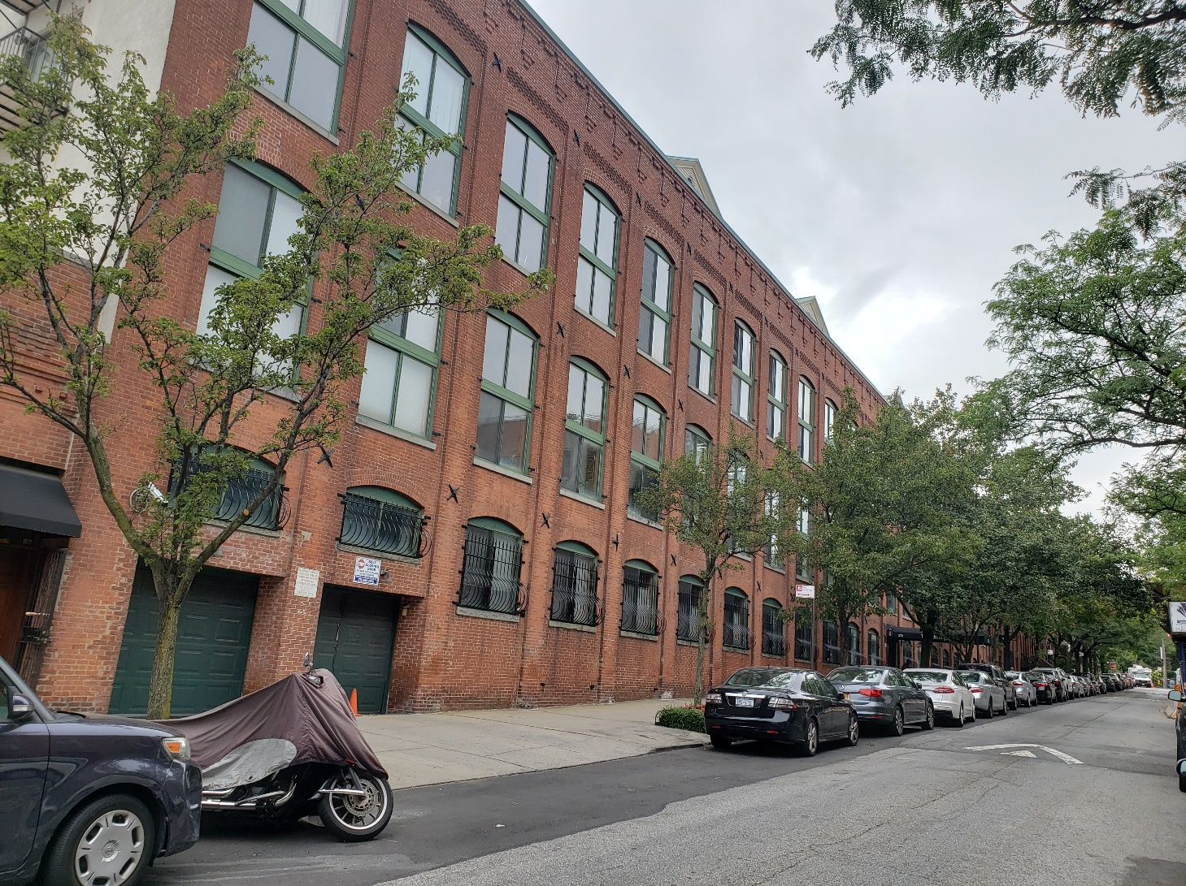
Select a meaningful image that captures your perception of the site we visited.

STUDENT NAME: Wantony Florian

PART 1: SITE OBSERVATIONS

- What are some general observations about the character of this neighborhood? What does it remind you of? How does it make you feel?
- Some general observations I did about the neighborhood is that the area seems to be a calm and quiet place when everybody is welcome to walk and visit it, it reminds me some other places out of NY such as Philadelphia or part of New Jersey. It makes me feel safe and in peace.

- How is the natural world contained or shaped by human activity or architecture? In what ways does the natural world invade or disrupt human activity, planning or architecture?
- In the area of Gowanus, must of the neighbors seems to be careless about the things that are happening in the environment of that area where companies dump waste contaminating the rivers.

- What people did you observe in the neighborhood and what activities are they engaged in?
- In my observation I saw friendly people walking, kids playing with their parents, it is a nice place to walk and relate to people, enjoying outside walking and going to the park with their kids.
- Reflect on a specific place you viewed in this neighborhood. A specific place means a single building, or an intersection, or an individual built structure, etc.
  - Insert 1 photograph and/or sketch and provide a creative caption for the image. The caption should be a word or short phrase that suggests a theme or conceptual association related to the photo or sketch.
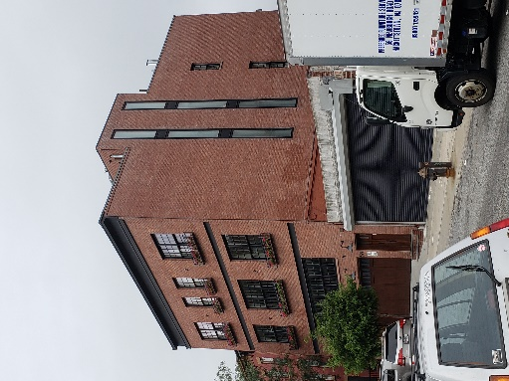
  - What is the program of the space? How are people meant to interact with one another and with the environment?
- The program of the space of this building is residential. People who lives in this area are very respectful with the environment, it is nice and quiet to have a walk because there are not too many car traffic or too many people.
  - describe a possible creative reuse of this specific space for a performance:
- Which areas are best for performers/activists and which areas are good for observers? Do these spaces overlap? Mention specific objects and structures in your answer.

- The best area to performance are open areas like parks.
  - Some areas that may be best for performers/activists are
  - Parks
  - Bridge
  - Work areas
  - Government areas

- What kinds of performance would work best (intimate or grand; processional or stationary; text and/or music; interactive or passive audience; etc.)?
  - Passive audience
  - Interactive

QUESTIONS for FURTHER RESEARCH. These should follow directly from your analysis section and be complex and specific enough to serve as the basis of a research project.
Questions might relate to architectural or environmental observations, socio-political problems and/or solutions, demography, history, zoning, civic processes, performance strategy, etc.
- Is there any solution for the environmental problem that is happening in Gowanus?
- How the neighbors can participate so the government can resolve the environmental situation?
- Is there any way to prevent environmental situation like this and, what does it cost?
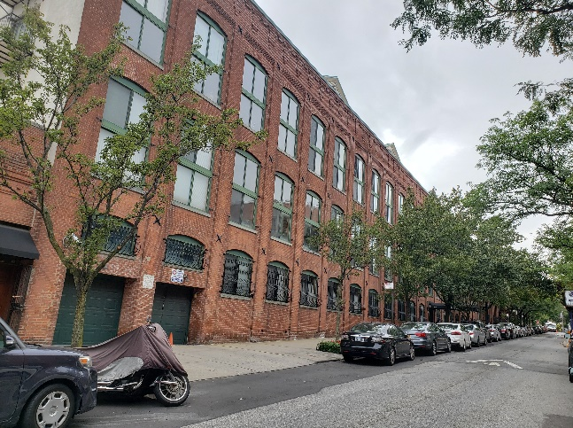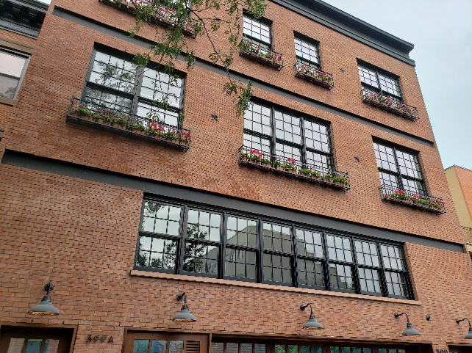
PART 2: RESEARCH
Choose and revise one of your research questions for further research.
Revised Research Question:

Find and cite 2 sources that address your question in MLA format. Respond to the questions below.

CITATION 1:
https://gowanuscanalconservancy.org/gowanuslowlands/

Why did you select this source? How does it address all or part of your research question?
- It address must of the part of my research question
Is the source credible? Why or why not?
- Yes, because it talks about how the government is trying to resolve the problem on Gowanus.

What further information would you need to answer your question? Where would you look for additional sources?
- For more additional sources I would look in government web side especially in the area of Gowanus to see when or how they are going to start the project.

CITATION 2:
https://gowanuscanalconservancy.org/partnerships/

Why did you select this source? How does it address all or part of your research question?
- Because it answer my question and it’s a really good source to look at.
Is the source credible? Why or why not?
- Yes, because it talks about can we help to improve the area like been a volunteer.

What further information would you need to answer your question? Where would you look for additional sources?
Brooklyn Daily Eagle for more information.
PART 3: Performance Reflection (after second site visit)
Write a 200 word reflection about how you felt during the second visit to the space and during the performance activities. How did this visit change your perception of the place and your relationship to the natural and built environments? Did the experience of ‘performing’ in the space (i.e., moving your body) teach you anything new about the landscape or architecture?
During the second visit to the space and after I went to the performance activity I felt good because I was having fun and the activity was something I never seems or did in my whole life. The activity experience was unique and fun, it was unique experience. Also, I believe people in the area have to be more alert about the environmental situation of Gowanus and all the pollution in Gowanus River. The government really has to do something about it, that also include the people who lives in this area too, I think we all have a responsibility to help and prevent to damage too much our planet because this is our only home like participating and demonstrating that we care about getting our home better by planting more trees, taking care of the environment area and not polluting.

