Learning Places Fall 2019
SITE REPORT #3
Mental Health Resources for City Tech Students
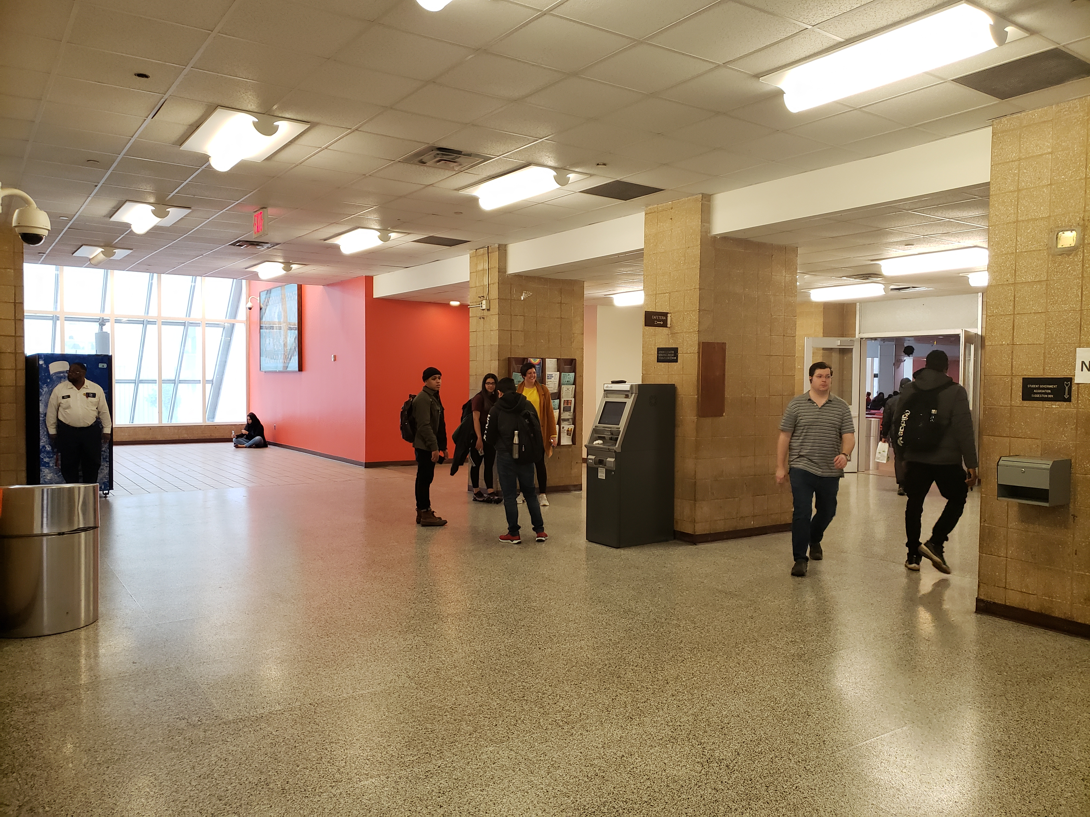

This is a recreational space where students are free to hang out and communicate with other students. A place where you can buy a cup of coffee and relax while you are waiting for your other classes.

STUDENT NAME: Wantony Florian

SITE OBSERVATIONS
- What are some general observations about the character of this place? What does it remind you of? How does it make you feel?
As a group we choose the outside space of the City Tech cafeteria located in the second floor of the Main building and, some observations I did was that it’s a nice space to interact with other people. Students usually go to the space to hang out with other students, spend some time eating and relaxing while they’re waiting for their next class. Another observation was that it’s an active and a very dynamic space where students are free to do some activities; there are enough space for the seating area and also free space where students can use to perform or make activities where other students can participate too. It makes me feel relax and good because I can freely talk and communicate with my friends, eat some lunch or just seat and relax, it reminds me any public space where you can hang out with your friends and have some fun.

- How does this place and its architecture relate to your performance? Think about the social meaning of the space (eg. civic, recreational, retail, etc.)

This place is a recreational space where you can freely use it to make any type of activity where students can participate, that’s one reason why this place and its architecture relate to our performance because it’s been used for many activities such as; Informative performance activity where students are allow to participate and know about it too. Also, interactive space where students also can meet and socialize with other students. We taking this place to our advantage to make our performance and let students know about the mental health resources also the place and its architecture relate to our performance because there are enough space to interact with other students about our idea to give them information about the mental health program that our school has and the benefits that students that can take the opportunity to get these benefits.

- Discuss the program of this space. How are people meant to interact with one another and with the environment?
The program is a recreational space where students interact one with another, and also eat their food. Sometimes there are some performance too where students can participate in those activities. The space is divided into different programs. One of them is the seating area where students can seat, hang out with other students or wait for their next class. This space it’s more recreational. Another program is the cafeteria where you can buy different type of food such as; cheeseburger, fries, chips, fruits, drinks, etc. It is an active place where you see students gathering and having a good time. There are some free spaces where you can use it to perform or make any type of activities.

- Describe some of the activities that people are currently engaged in. How might they interact with or respond to your performance when it is staged?

Some of the activities that students are currently engaged in this active space are interaction and communication. Also, you can see students relaxing, having a good time playing and eating, the space is mostly designed to recreate with your friends, enjoying a cup of coffee and chill. The might interact with our performance once they pass by because we will grab the attention talking to them, engaging to participate just for a moment and give them information about the mental health resources, how City Tech students with some mental problem can………………………..
- Draw a ground plan of your space with the performance site and audience clearly defined in your drawing.
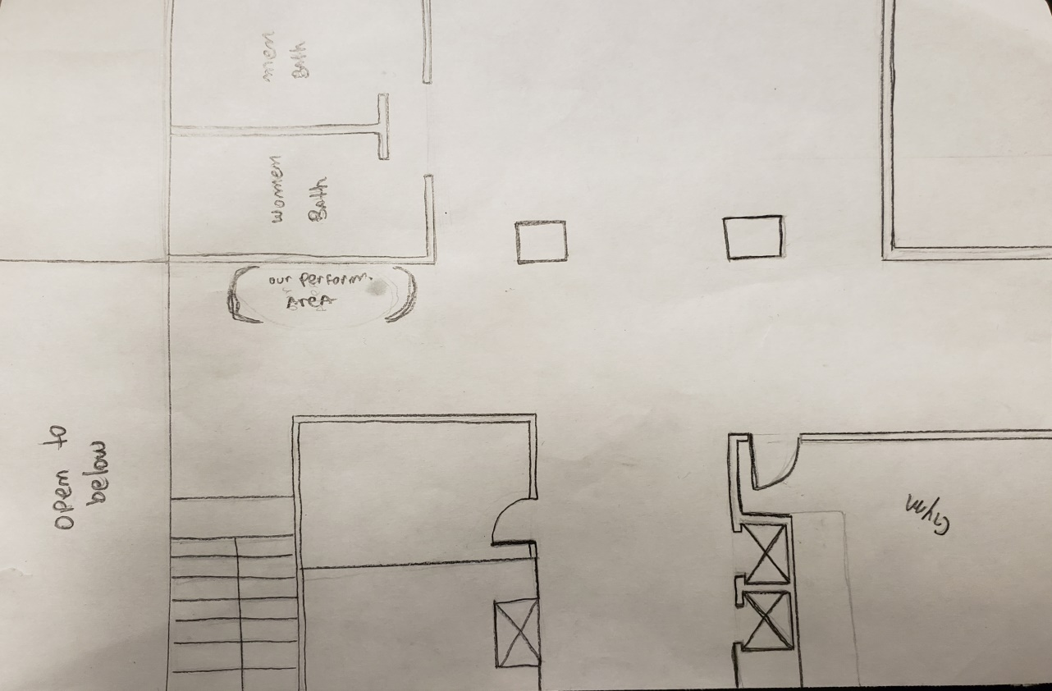
QUESTIONS for FURTHER RESEARCH. These should follow directly from your analysis section and be complex and specific enough to serve as the basis of a research project.
Questions should relate to information you will incorporate into your performance and/or share with audience members.
- What mental health resources do CUNY provide?
- How important is to know about mental health service for CUNY students?
- What kind of challenge do CUNY students with mental health issues have?

CITATION 1:
Counseling Center. “Mental Health Information and Resources.” June 2018, https://www.ccny.cuny.edu/accessability/mental-health-resources.

Why did you select this source? How does it address all or part of your research question?

I selected this source because this is the official CUNY’S website where it gives all the information and resources about mental health. It also mention the treatments that the City College of New York provide to students who has mental problems such as; Anxiety Disorder, Bipolar Affective Disorder, Post-Traumatic Stress disorder, etc. It also mentions what kind of services and accommodations that CUNY has for mental health treatment. For example; Classroom accommodation and exam accommodations. Also, all CUNY colleges have Psychological Resources and Psychiatric hospitals in some colleges too.
Is the source credible? Why or why not?
The source is 100% credible because all the information comes from the City College of New York.

CITATION 2:
Luis Manzo. “The Psychological Well-Being of CUNY Students” April 2011,
https://www.gc.cuny.edu/CUNY_GC/media/CUNY-Graduate-Center/PDF/Centers/Center%20for%20Human%20Environments/cunypsychwellbeing.pdf

Why did you select this source? How does it address all or part of your research question?
I selected this source because it provides information about the results of CUNY ungraduated students with mental health issues and how some students are not eating properly, not getting enough sleep or not being stable in their houses which can result with mental health issues. And, that’s why CUNY, School of Public Health and Hunter College are promoting health resources, food, housing and psychological needs for CUNY students.
Is the source credible? Why or why not?

The source is credible because it talks about important topics about food insecurity, housing instability, and psychological help for CUNY students which are mainly provided directly by the CUNY School of Public Health. They were defining depressive symptoms for all CUNY students in 2011 and the treatments that the City College of New York is providing for students who has mental health issues and to prevent students of being in that case.

