Learning Places Fall 2019
SITE REPORT #3
Mental Health Awareness: City Tech Edition

NAMING PROTOCOL. When saving and posting your site reports on OpenLab, please follow the following format: SiteReport#.LastnameFirstname. Here’s an example: SiteReport3.SwiftChristopher.
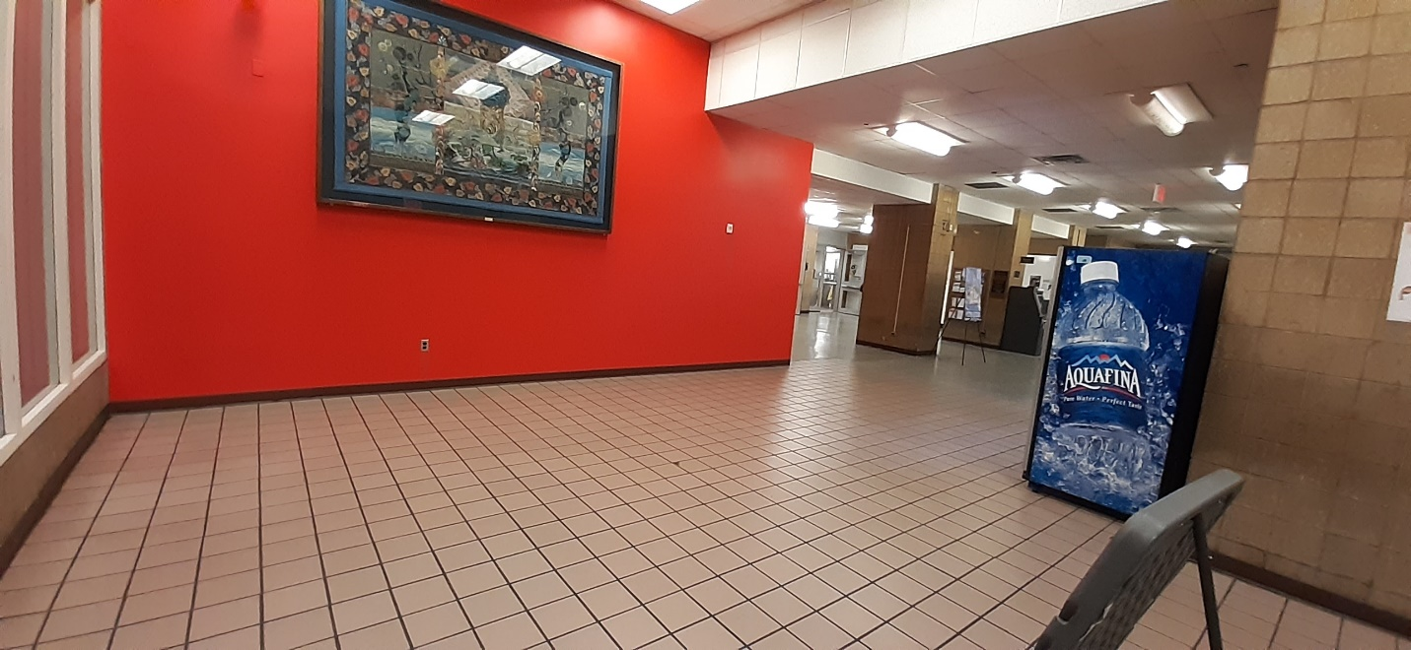
Every student walked this hall and kept going about their day.

Kelvin Chabla

SITE OBSERVATIONS
- What are some general observations about the character of this place? What does it remind you of? How does it make you feel?
This space picture above is usually filled with students coming from different directions of City Tech’s Namm building. It’s an open space hallway located between the 1st floor next to the entrance of the cafeteria and the elevators of the Namm building. Before this semester started, most students would enter this space from the Jay Street entrance. While Jay Street entrance has been close off since the beginning of this semester, this space is still unavoidable for most students as it’s a space use for meet ups and hang around for a while. In that sense, this spade reminds me of my days in high school where a lot of classmates if mine would usually hangout in the hallway, talking casually to each other for a few minutes before they have to go to their next class. It makes me feel a little bit nostalgic in that even though there are major changes from high school to college, there are still some elements of a student’s life that still stays the same, like being able to talk to friends or classmates in the hallway or just walking back and forth that same hallway everyday you’re in school.
- How does this place and its architecture relate to your performance? Think about the social meaning of the space (eg. civic, recreational, retail, etc).
A lot of students still pass by this space on a regular basis, despite the fact that the Jay Street entrance has been close off. Before the Jay Street entrance was closed, clubs would use this space to promote a fundraising events or representatives would set up tables to talk to students entering the school from the entrance about whatever program they were a part of. Most of those activities have moved to other nearby floor entrances, therefore there’s more space in this hallway for my group and I to standout when we perform. My group and I believe that there’s more than enough foot traffic to reach out to students in regard to the lack mental health resources in City Tech.
- Discuss the program of this space. How are people meant to interact with one another and with the environment?
As mentioned before, this space is use in that students walk pass this hallway everyday as they head off to whatever classroom or office they need to attend to in different directions. Students and staff can use this space to talk to one another, buy items from the vending machine, or just stand around in the space while they wait to meet up with someone else in that space.

- Describe some of the activities that people are currently engaged in. How might they interact with or respond to your performance when it is staged?
Currently, people tend to use this space to go to different directions on the Namm building. This space typically gets a lot of foot traffic in between class sessions, especially in the afternoon. Most students will walk pass by this space in a rush as they have to get to class on time or going to an office for an appointment. Some students just stand around, talking to one another casually, and there are times where I see one or 2 students sit down near the outlet to charge their phones. Those are the students I think my group can grab their attention more easily when we stage our performance, as they are not in a rush to go to any classes or other places in the building. Our group performance will include students writing down any negative feeling they have at the moment into a paper and then attempt to ‘throw away’ that negative feeling into the basket. After that, the students can then write down a positive attitude or outcome they would like to see more or achieve here in City Tech or life in general. They would write down on a Post-It and stick it on our “Rebound with Positivity” board that my group made. Every group member will provide a zine like booklet that has information of different mental health resources students may not be aware and can spread that information out to others.
- Draw a ground plan of your space with the performance site and audience clearly defined in your drawing.
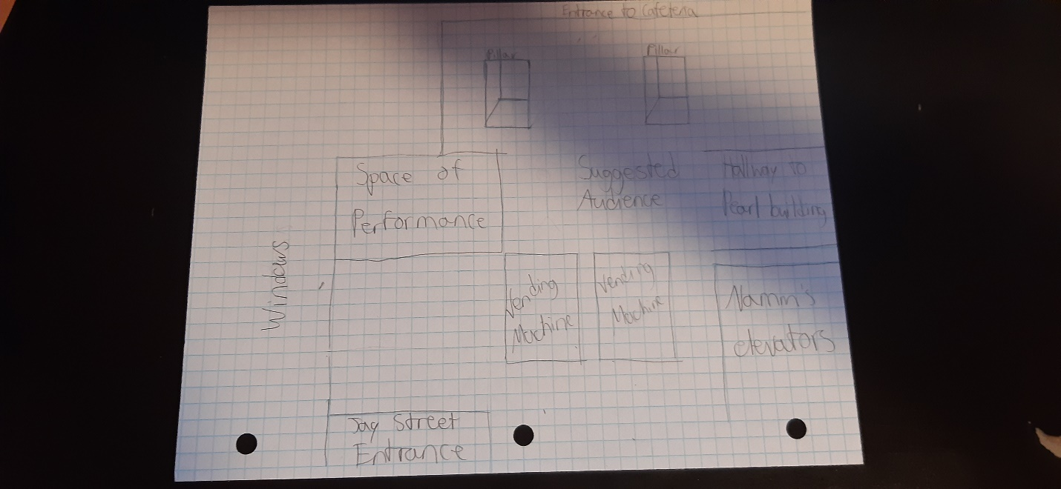
QUESTIONS for FURTHER RESEARCH. These should follow directly from your analysis section and be complex and specific enough to serve as the basis of a research project.
Questions should relate to information you will incorporate into your performance and/or share with audience members.
- How does space affect the mentality of students?
- In what way do we (CUNY students) benefit by caring about mental health issues?

FURTHER RESEARCH
Choose and revise one of your research questions for further research. Refine your question following from examples that we’ve discussed in class.
Revised Research Question: How can the program of a space affect students’ mentality?

CITATION 1:
Durán-Narucki, Valkiria. “School Building Condition, School Attendance, and Academic Achievement in New York City Public Schools: A Mediation Model.” Journal of Environmental Psychology, vol. 28, no. 3, 2008, pp. 278–286., doi:10.1016/j.jenvp.2008.02.008.
Why did you select this source? How does it address all or part of your research question?
I selected this source because this research article goes into details and provides evidence to suggest that the physical environments of a school’s building (the quality, design, whether or not it’s dangerous for students to be there, and overall interaction with the school’s space) can affect students’ mental state while they are in that building. After all, most students spend a majority of their time in the designated school building when they are not at home, it’s almost like their second home in that sense. If the space of the school building isn’t appealing enough for the students to be comfortable in, then they’re going to have a difficult time concentrating on school subjects and tend to be more stress about it. (280)
Is the source credible? Why or why not?
The source is credible in that it’s written by Valkiria Duran-Narucki, a Ph. D in Environmental Psychology from Graduate Center, CUNY. Since the mid 90s, she has conducted research and experiments regarding this very topic on how the physical environment can affect students’ mental health, especially in regards to school buildings and public facilities.

CITATION 2:
Bourdon, Jessica L., et al. “The Relationship between On-Campus Service Utilization and Common Mental Health Concerns in Undergraduate College Students.” Psychological Services, Oct. 2018. EBSCOhost, doi:10.1037/ser0000296.supp (Supplemental)

Why did you select this source? How does it address all or part of your research question?
I selected this source because it addresses the lack of resources most on-campus colleges have in regards to its students and mental health concerns. As stated in the first citation, school buildings are typically the second location most students spend their time in, yet these campuses don’t have enough service to help those students that require mental health needs. This can range from students suffering from anxiety, depression, stress, etc. and the exact same building space they’re in doesn’t have the resources (or lack of) to help those students out.
Is the source credible? Why or why not?
This source is credible as it’s a research article published the United States Educational Publishing Foundation. Jessica L. Bourdon is a Ph. D in Psychiatric and Behavioral Genetics and conducted this research with multiple colleges of hers in regards to the correlation between students’ mental health issues and lack of resources in campuses they’re in.

What further information would you need to answer your question? Where would you look for additional sources?
Further information needed to answer my question would be how are so many campuses lacking mental health resources to college students, especially in this day and age where the awareness of this issue is high among young adults. I would have to look for additional resources in psychological research articles and multiple mental health organization that are aware of this situation (SAMHSA, AHA, National Alliance on Mental Illness).

