Learning Places Fall 2019
SITE REPORT #3
Blood, Sweat, and Tears in City Hall Park.
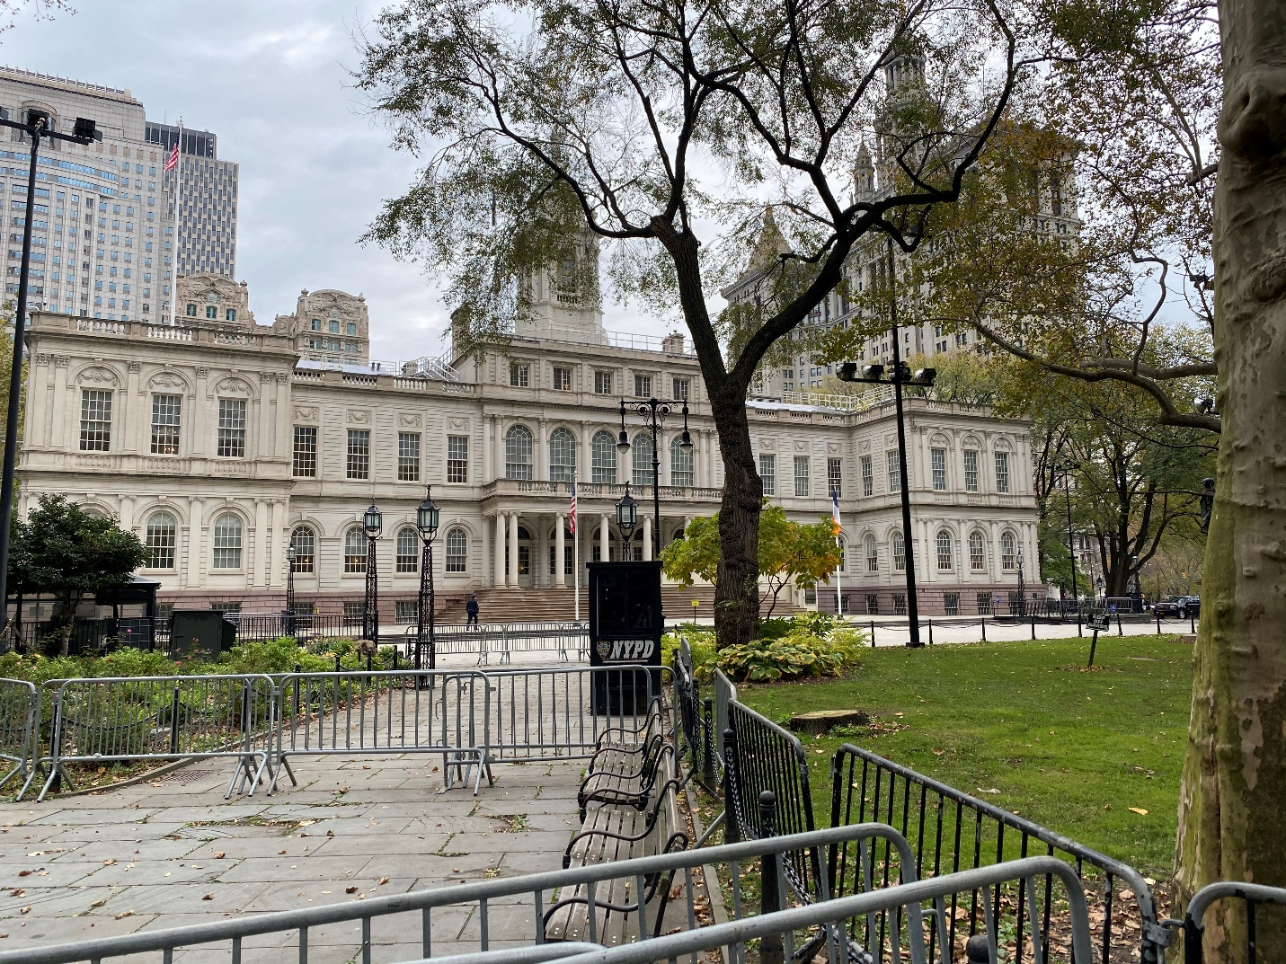
- Four levels of divide to get the help the people really need.

STUDENT NAME: Antonei Cepeda

SITE OBSERVATIONS
- What are some general observations about the character of this place? What does it remind you of? How does it make you feel?
- The location that we as a group have chosen is city hall park, which is adjacent to city hall. The area has an open space to it, with many exits/entrances from every direction. This area seems to be suited for sitting down and relaxing. I saw no visible signage in regards towards eating, and I did see a few people sitting and eating. There was a class of children towards the south end of the park, and they were all playing. In the north area of the park is city hall, which has an entrance from the park, but it is closed off by barricades and security guards. This put me off, as it just reminded me of just how closed off are the people in power from the people in need. Since there are streets on all sides, you can clearly hear traffic within the park. While this may be annoying to some people, I enjoy this sound as it means that people are working, and people are living. This area reminded me of Cadman park, in that the mood of the area was up and children were seen and heard playing. While I enjoyed Cadman park more (possibly because the weather was nice on the day of my visit), mostly because it is larger, so you have more room to seclude yourself, if need be. I felt calm in this park, however, because of the time of my visit was very cold, it made me feel like I just wanted to get away from the park. One thing that particularly put me down a bit was that the fountain at the center of the park was empty. Whenever I see a fountain that is running with water, I just think of life, and to see it empty just reminded me of the void of life. There were these large art pieces in the area that I have no idea what they are or what they represent, but they were nice to look at, and only stood to add to the scenery of the park.

- How does this place and its architecture relate to your performance? Think about the social meaning of the space (eg. civic, recreational, retail, etc).
- This area is especially important to our performance, as it is next to city hall. It is also across the street from the NYCHA headquarters, which will be the topic of our performance. Since all paths in the park lead to the fountain in the center, this will be our focal point. There is open space by the fountain, and I think this is important because I personally would not want to perform in an area where passerby have no choice but to walk through us. If they would like to get involved, they are more than welcomed, but we will not coax them, nor force them. From my comment in the previous question about the divide between the people in power and the people in need, this will play into our performance, as it shows just how disconnected city hall is from the plight of NYCHA residents. While the NYCHA headquarters may be a better choice, we are targeting city hall, as NYCHA receives their money from the city. There is seating all around the park, so people do not have to stand to see our performance, thus making it less of a chore to listen to us.

- Discuss the program of this space. How are people meant to interact with one another and with the environment?
- It was an open space with an entrance/exit on all four sides, and seating all along the pathway. There is not a great deal of signage in the area, but one that was clear was the one on the grass that said, “keep off the grass”. Since there is not much to this park, aside from a few large art pieces, this area is only meant for sitting. I would assume that the art pieces were meant to just be viewed, but some of the children were playing on it. Although not originally implement with the design of the park, the three barriers that lead towards the city hall building are clearly meant as a deterrent to anyone approaching. On the grass area there are different types of plant life, such as daffodils, but since they are in the grass area, they are meant to be viewed only. Also, along the entrance/exit portion of the park, there are waist high pillars that prevents four wheeled vehicles from entering the park. On top of each of these pillars is an engraving that states “no sitting”. I do not know the reason why is states this, but my guess would be to prevent loitering around the entrance/exit.

- Describe some of the activities that people are currently engaged in. How might they interact with or respond to your performance when it is staged?
- Most of the people in the park were sitting and conversing with other people. At one end of the park children were playing as their teacher watched them. There was a man sitting at one of the benches and he was feeding the squirrels. Children are always curious, so if they are in the park during our performance, there is a good chance that they will observe or get involved in the performance. There is quite a bit of foot traffic in this park, but I do not believe that they will involve themselves in out performance in any capacity, as most people were walking in the park in order to cut through it. I suspect that the people that are sitting will only observe our performance, because if they are sitting, why not observe. Due to this being New York we do not like to be stopped nor bothered, so if we can make a performance that gives people the option to observe/participate, then they may do so, just out of pure curiosity. The squirrel guy should be left alone with his squirrels.

- Draw a ground plan of your space with the performance site and audience clearly defined in your drawing.
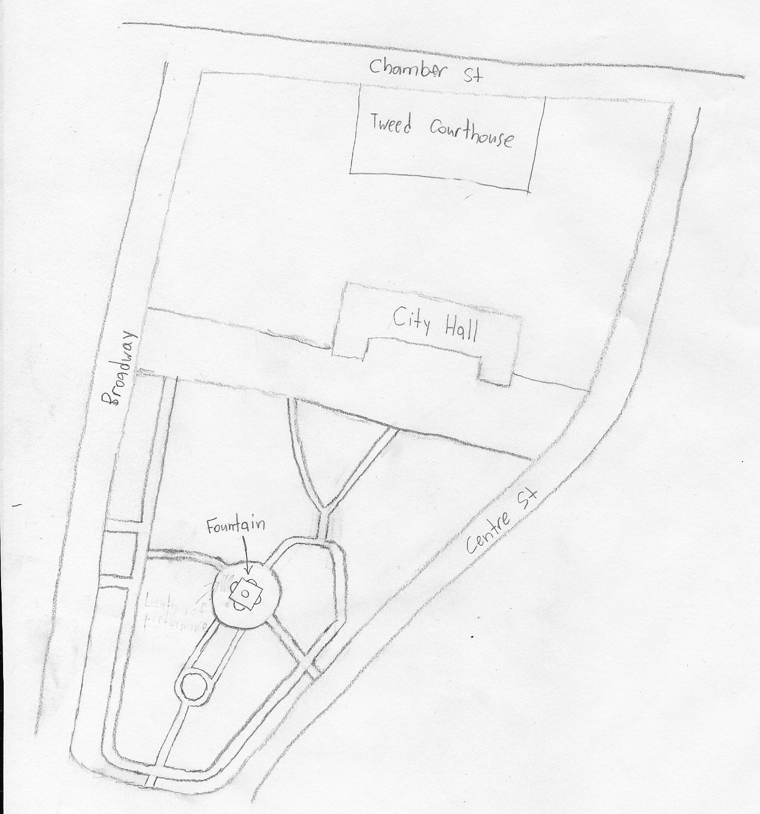
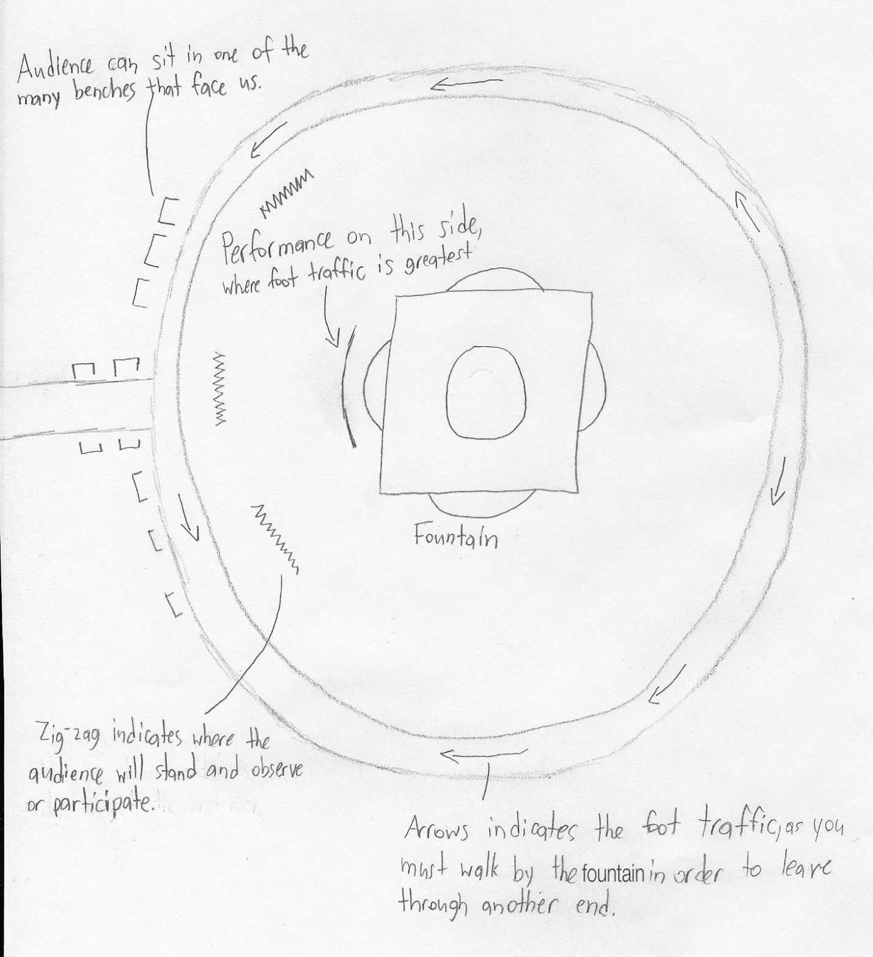

QUESTIONS for FURTHER RESEARCH. These should follow directly from your analysis section and be complex and specific enough to serve as the basis of a research project.
Questions should relate to information you will incorporate into your performance and/or share with audience members.
- Question?
- Is the money that is being allocated to NYCHA really going to the right places?
- Question?
- Are NYCHA buildings really in a bad state?
- Question?
- What is the rent average of NYCHA apartments, compared to non-NYCHA apartments?

FURTHER RESEARCH
Choose and revise one of your research questions for further research. Refine your question following from examples that we’ve discussed in class.
Revised Research Question:
- Where is NYCHA’s money going?

Find and cite 2 sources that address your question in MLA format. Respond to the questions below.

CITATION 1:
- “How Did We Get Here, and What Can We Do?” The Future of NYCHA, 2019, eportfolios.macaulay.cuny.edu/nycha/.

Why did you select this source? How does it address all or part of your research question?
- This is a fantastic source that pretty much covers all the questions regarding NYCHA that I have, such as who qualifies for NYCHA, the history of NYCHA, and the current financial issues of NYCHA. This article clearly shows a vast decline of funds being allocated towards NYCHA, as well as showing the effect that this lack of investment has cause to the NYCHA apartments. The article explains that 43% of its funds goes towards something called “personal services”, which is unknown as to what this is. The articles also go into detail about the financial future of NYCHA, stating that for NYCHA to receive any adequate money, it must reach to other sources of revenue. One of these sources is the Rental Assistance Demonstration (RAD), which has its own set of issues in regards towards NYCHA. Not only does this article answer my question, but it also does a good job at answering my second question, and briefly touches on answering my third question.

Is the source credible? Why or why not?
- This source is credible because this article is a compilation of other sources nyc.gov, hud.gov, and prospect.org, just to name a few. While I do not know if every single one of these sources are credible, there are enough sources that were used to suggest that this article that was written was thoroughly researched.
CITATION 2:
- Husock, Howard. “Public Housing and Rental Subsidies.” Manhattan Institute, 24 Feb. 2017, www.manhattan-institute.org/html/public-housing-and-rental-subsidies-10055.html.
Why did you select this source? How does it address all or part of your research question?
- This article discusses that initially, the federal government put great sums of money towards public housing, but had to actual plans, asides from building. This build was put into place to benefit developers more than low-income houses, as these buildings were not made to last for as long as they did. This article does a great job at pointing out how mismanagement of funds put public housing, such as NYCHA in such an awful state. As an aside, the article discusses how public housing complexes were erected in low income neighborhood, to incentivize this new influx of families to bring up the quality of the neighborhood. This clearly has the opposite effect. The article also explains that under the Trump administration, they will end failed programs, such as the public housing program, and institute new programs, which are more effective, but it does not explain what these new programs will entail. This article does a great job at detailing how every president since the 1930 did an even worse job towards public house than their predecessor, with president Trump outright eliminating it.

Is the source credible? Why or why not?
- I believe that this article is credible because this is a .org website. The author of this article is Howard Husock, who has done work for such publications as Wall Street Journal, New York Times, and Public Interest. Husock has also written many articles in regards towards public housing, which shows that he has a vested interest on the topic. After looking at the Manhattan Institute website, I see that it has articles that discusses current day issues that are serious, such as immigration, housing, and healthcare.
What further information would you need to answer your question? Where would you look for additional sources?
- In order to fully answer my question, I would require deeper financial information of how much money NYCHA receives, and specific places where it goes. I’m sure that in finding that answer, major issues will happen, so it is in the best interest of NYCHA to keep this information a secret.

