SITE REPORT #3
BOROUGH HALL

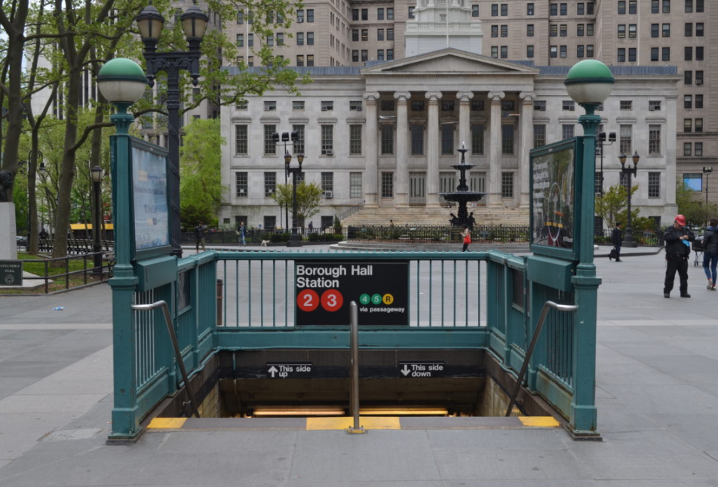

Caption: The movement passageway.

SITE OBSERVATIONS

1. What are some general observations about the character of this place? What does it remind you
of? How does it make you feel?
This space is the epicenter of downtown Brooklyn since there are different types of skating activities, selling products of all kinds such as coats, fruits, vegetables and accessories. It reminds me of Times Square, but on a smaller scale.
2. How does this place and its architecture relate to your performance? Think about the social
meaning of the space (e.g. civic, recreational, retail, etc.).

I think that thanks to the expansion, one has the possibility of greater perspective within the site and can observe the different types of buildings and how the passage of time is reflected in each construction system and materials used. and based on our topic of discussion is how to make a more sustainable architecture the difference of excessive use of glass is seen in contrast to the stone facades that are better from my point of view.

3. Discuss the program of this space. How are people meant to interact with one another and with
the environment?

This is a transitional space between closed and open, static and mobility as it serves as a platform to go to public transport by land and underground. the interaction with nature for my view is scarce although there are gardens, I think these can be improved and you can bet on a better permeable pavement, I see many waterproof surfaces on the site and this could be a good opportunity to help the sewer city ​​system.

4. Describe some of the activities that people are currently engaged in. How might they interact
with or respond to your performance when it is staged?

Basically, there are few areas of stay in contrast to areas of circulation. The activities are mostly to take the bus or go to the subway. Secondary way is the farmers market stand and the stairs that serve as a seat in front of the court.

5. Draw a ground plan of your space with the performance site and audience clearly defined in
your drawing.
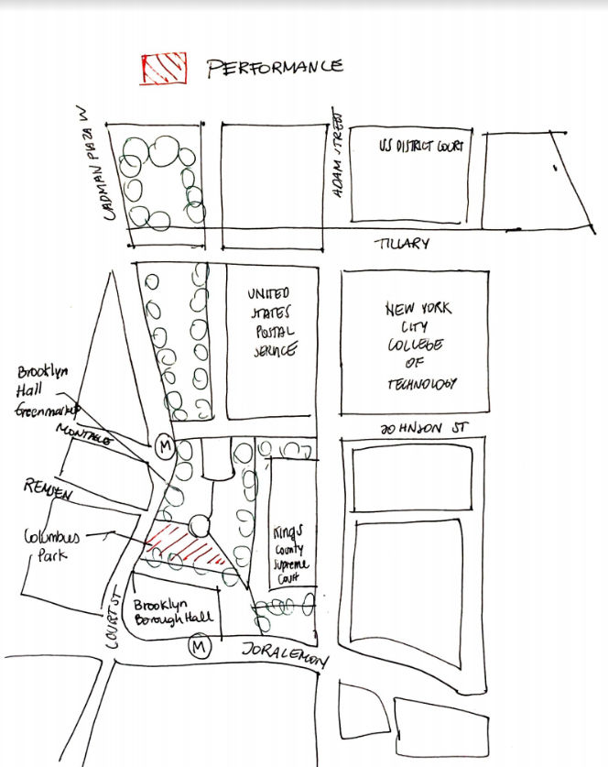

QUESTIONS for FURTHER RESEARCH.
Questions should relate to information you will incorporate into your performance and/or share with
audience members.
1 What is the amount of solid waste in buildings?
2 How can buildings reuse material to reduce waste?
3 how can buildings reduce carbon emissions?
FURTHER RESEARCH
Revised Research Question: which are the categories of solid waste in buildings and how we can use the waste within our buildings?
Citation 1:
Sillitoe, Paul, editor. Sustainable Development: An Appraisal from the Gulf Region. 1st ed., Berghahn Books, 2014. JSTOR, www.jstor.org/stable/j.ctt9qdd86.

Why did you select this source? How does it address all or part of your research question?
This Source helps me to make a specific category of types of garbage within the construction site and how to reuse elements and focus on standardized modules of panels such as walls and floor to avoid having to cut elements and generate greater losses of resources and money
Is the source credible? Why or why not?
This source is credible because it is information given by different countries based on case studies that includes statistical and analytical information.
Citation 2:
COHEN, STEVEN. The Sustainable City. Columbia University Press, 2018. JSTOR, www.jstor.org/stable/10.7312/cohe18204.
Why did you select this source? How does it address all or part of your research question?
Solid waste management is a challenge for large urban areas around the world and this book represents a good example in how to deal with the global issue in terms of organization and reuse of the material.
This source is credible because it is information given by Columbia University.

