hLearning Places Fall 2019
SITE REPORT #2
Newtown Creek’s Nature Walk

SiteReport2.GurungJatin.
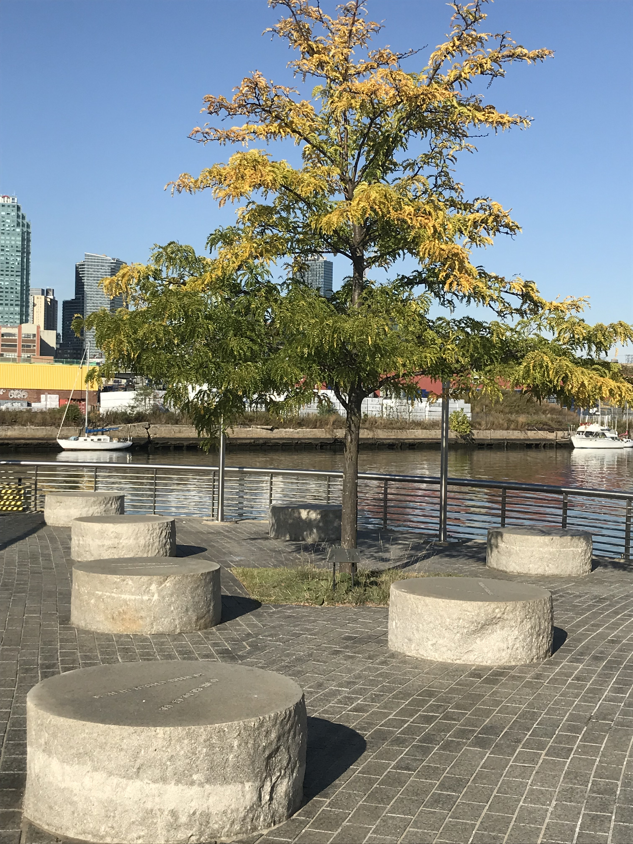

STUDENT NAME: Jatin Gurung

SITE OBSERVATIONS
- What are some general observations about the character of this place? What does it remind you of? How does it make you feel?
- A block before you reach the main entrance you are greeted by a big rock structure which is a remnant of a glacier. As you pass the entrance there’s a bridge that you would have to cross over which will bring you into a hallway which resembles a boat. As you walk along the hallway you see there's a couple of peep hole on the wall. One of the cool features about this hallway is that as you move along the hallway there’s a center stage that echoes. Past this you walk into another corridor which mimics a path of the water. The place actually reminded me of a retired ship being used as a museum. It was very nostalgic in a sense that I have always wanted to live in a ship and the place actually being by the water actually rejuvenated my fantasy.

- Historically, what are some of the important developments that have created the current environmental situation at Newtown Creek area. Refer not only to the reading and Prof. Spellane’s lecture, but also what you learned on the Newtown Creek Alliance tour (hint… estuaries, for instance)?
- The land was a native to Lenape Tribe. With the discovery of petroleum in Pennsylvania brought a lot of influx of ships and so did the construction of refineries and factories bringing in pollution along with it.

- In what ways is the natural environment contained or shaped by the architecture of the Newtown Creek Nature Walk? In what ways is the natural world repossessing, interacting with, or invading spaces that have been over-polluted or industrialized?
- The Nature Walk is still a work in progress. They have planted some cactus which is native to the Northeast. They have also planted honey locust tree. Since the land used to be covered by thousands of acres of salt marsh grasses. You can notice that they are trying to revive the salt marsh grasses in and around the creek and planted them on the supporting beam. The mussels can also be seen in the ground during low tide and also on the walls.

- Discuss the program of the nature walk. How are people meant to interact with one another and with the environment?
- The architecture of nature walk is built in such a way that it brings back memories about how the place used to be back in the days. The design is made to look like a ship at certain places and then also a path of water. Surrounding the honey locust tree is the seven circles which has names of native places etched on them. The place is definitely for people looking for some quiet time but the smell of the sewage doesn’t make it ideal for people looking to hang out.

- If you were to stage a performative intervention in a specific site (i.e., a single structural aspect of the walk or industrial remains) where would you stage it and why (how does the environment add meaning to the performance)?
- I would definitely go with the seven stones surrounding the tree. The stage would be underneath the honey locust tree and the audience would be seated on top of the seven stones. The site brings back memories about my village where performances took place in a similar setting.

- What message would your performance convey and who needs to hear this message?
- The performance would be about pollution and the consequences of it and the city environmental officials needs to hear the message.

QUESTIONS for FURTHER RESEARCH. These should follow directly from your analysis section and be complex and specific enough to serve as the basis of a research project.
Questions might relate to architectural or environmental observations, socio-political problems and/or solutions, demography, history, zoning, civic processes, performance strategy, etc.
- What steps are being taken to revive the plant and animal habitat in and around Newtown Creek?
- How safe is water in Newtown Creek?
- Who is directly responsible for the wellbeing of Newtown Creek?
FURTHER RESEARCH
Choose and revise one of your research questions for further research. Refine your question following from examples that we’ve discussed in class.
Revised Research Question:

Find and cite 2 sources that address your question in MLA format. Respond to the questions below.

CITATION 1: Kitses, John, et al. Newtown Creek Alliance, http://www.newtowncreekalliance.org/.

Why did you select this source? How does it address all or part of your research question?
I chose this source mainly because it is an organization that is working for the betterment of the Newtown Creek. They have been constantly working to restore the health, water quality, environment along the Creek.
Is the source credible? Why or why not?
The source is credible because of the fact that it is a community based organization. It has been working vigorously to restore the life and habitat in the Newtown Creek.

CITATION 2: Maqbool, Azlan, "Potential for human exposure to Legionella near Newtown Creek in Brooklyn, New York" (2019). Senior Projects Spring 2019. 176.
https://digitalcommons.bard.edu/senproj_s2019/176

Why did you select this source? How does it address all or part of your research question?
I selected this source because it was a paper submitted by a student recently. I am sure he’s done extensive research writing his paper. This addresses the part about if the water in Newtown Creek is safe at all. According to this research, the water could be home to bacteria called Legionella.
Is the source credible? Why or why not?
The source is credible because it’s a term paper submitted by a student. If you take a look at the paper itself he has listed his sources.
What further information would you need to answer your question? Where would you look for additional sources?
- I would definitely look into Department of Environmental Protection’s (DEP) website. Some of the other notable websites would be Newtown Creek Superfund, Riverkeeper, NYS Department of Health. I would also look into reputed journals for recent and previous articles being posted about Newtown Creek.

