SITE REPORT #2
Newtown Creek (Brooklyn Side)

NAMING PROTOCOL. When saving and posting your site reports on OpenLab, please follow the following format: SiteReport#.LastnameFirstname. Here’s an example: SiteReport2.SwiftChristopher.
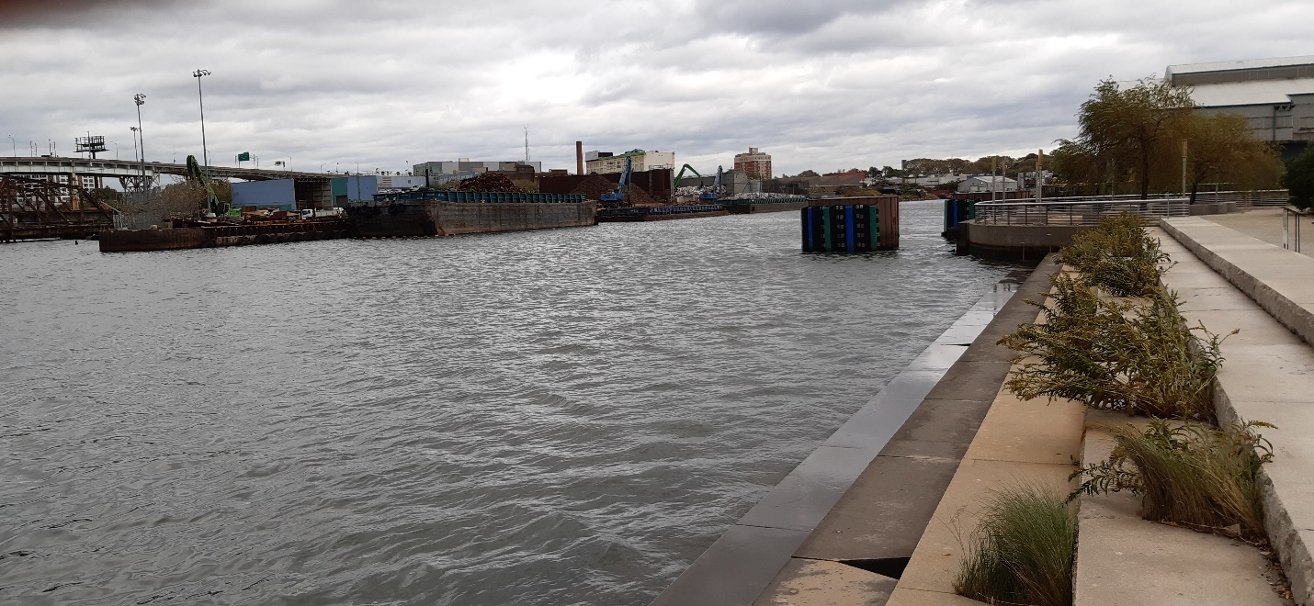
Newtown Creek River meets with man-made architecture and growing on them (stepping stones and plants on it)

Kelvin Chabla

SITE OBSERVATIONS
- What are some general observations about the character of this place? What does it remind you of? How does it make you feel?
When I visited New Creeks, I sense the definition of man-made environment. New Creeks reminded me of Gowanus Canal in the sense that its river is made up of made made structures like unused craters in the middle of the water. As the pictures shows above, New Creek River is already covering parts of the land (stone steps) and plants are sprouting from said step stones. Like Gowanus, it’s toxic and filled with garbage material that’s most likely come from the garbage disposal area near the creek.

- Historically, what are some of the important developments that have created the current environmental situation at Newtown Creek area. Refer not only to the reading and Prof. Spellane’s lecture, but also what you learned on the Newtown Creek Alliance tour (hint… estuaries, for instance)?
Similar to Gowanus Canal, aeration and a man-made sewer overflow are various developments that made New Creek River what it is now. Rain along with the structure of the sewers is the reason why the river is able to overflow the stone steps currently. Furthermore, New Creek is an estuaries, which allows muilple lands to meetup with the streams of the river and have easier access to dispose of garbage material.

- In what ways is the natural environment contained or shaped by the architecture of the Newtown Creek Nature Walk? In what ways is the natural world repossessing, interacting with, or invading spaces that have been over-polluted or industrialized?
Since New Creek River is an estuary, most streams end up meeting with lands. Most of these lands are staionary in that there are multiple waste stations aurrounding the river. It’s very easy fro these stations to throw any disposable items into the river, making it as toxic as it is now. Newtown Creek Nature Walk is shape the way it is to show how the river is mostly closed off from the ocean and instead surrounded itself in man-made architecture, over-polluting it along the shore.
- Discuss the program of the nature walk. How are people meant to interact with one another and with the environment?
When I ventured to the nature walk on my own, it felt unique in the senese of its structure. It had a wiggle-like strucutre but the space is closelt tight, especially if you go the nature walk with a groups of friends or classroom. To me, I think people are meant to feel tight next to each other as I felt the 2 sides of the nature walk represents nature and men blending in one another in a small space. In this case, that would be the New Creek River that’s a direct result of man-made environment.
- If you were to stage a performative intervention in a specific site (i.e., a single structural aspect of the walk or industrial remains) where would you stage it and why (how does the environment add meaning to the performance)?
If I were to stage a performative intervention, it would be right by the stone steps that’s covered by the water (the picture I provided). It’s the cloeset area that shows a prime example of nature and man-made being together and what’s wrong with that, as you can cleary see the disposable waste and the water that contains is already on land.

- What message would your performance convey and who needs to hear this message?
The message I would convey is to try to stop man-made environement keep on happening since there are muliple examples of pure narure areas that’s transform to this state due to human interference. Residents of New Creek would be my first choice of a group of people that need to listen to the message since they’re directly affected by how toxic the river and their quality of neigborhhood and well-being. This message should also be convey by the busniessmen who owns the garbage disposal area as they are causing the river what it is now.

QUESTIONS for FURTHER RESEARCH. These should follow directly from your analysis section and be complex and specific enough to serve as the basis of a research project.
Questions might relate to architectural or environmental observations, socio-political problems and/or solutions, demography, history, zoning, civic processes, performance strategy, etc.
- Why are areas like New Creek River and Gowanus being transform into man-made environemt more frequently?
- How are some plants only able to grow in a environment like New Creek River?
- Why does the city have garbage disposal area near an already man-made environment like New Creek River?

FURTHER RESEARCH
Revised Research Question:
Why are areas like New Creek River and Gowanus Canal being transform from pure nature into man-made environments more frequently?
CITATION 1:
“Waste Transfer Stations.” Newtown Creek Alliance, http://www.newtowncreekalliance.org/waste-transfer-stations/.

“Combined Sewer Overflow.” Newtown Creek Alliance, http://www.newtowncreekalliance.org/combined-sewer-overflow/.

Why did you select this source? How does it address all or part of your research question?
I selected this source since this website directly confronts and explains all the important information regarding Newtown Creek River. It explains multiple reasons as to why the river went from pure nature into currently a man-made environment.

Is the source credible? Why or why not?
The source is credible as it’s owned by Newtown Creek Alliance, a community-based organization trying to restore the river what it once was before human interference began. This is also the website with the most accurate information regarding the river and its current formation.

CITATION 2:
“NEWTOWN CREEK Site Profile.” EPA, Environmental Protection Agency, 20 Oct. 2017, https://cumulis.epa.gov/supercpad/SiteProfiles/index.cfm?fuseaction=second.Cleanup&id=0206282#bkground.

Why did you select this source? How does it address all or part of your research question?
I selected this source as the is coming from EPA, the agency that handles all environmental protection in the country. This agency has plenty of information regarding Newtown Creek River, from its origins, how human interference shaped the river to its current state, and plans on how to restore it. It also explains part of the reason why man-made environments continue to happen, such as rivers and creek being an easy target for the city to dispose of its garbage, despite not knowing how dangerous that makes the river is to its residents.

Is the source credible? Why or why not?
The source is credible because as mention before, EPA is the largest agency when it comes to the country’s environment and its plans on how to restore and protect it, including Newtown Creek River.

What further information would you need to answer your question? Where would you look for additional sources?
Additional information I would need to answer my question would be to look up rivers or creeks that have been affected similarity to Newtown Creek River. If so, there could be reoccurring trends human interference tend to do that can be further explored and approach a way to stop the continue activities from it.

