Learning Places Summer 2019
SITE REPORT #2
name of site report

NAMING PROTOCOL. When saving and posting your site reports on OpenLab, please follow the following format: SiteReport#.LastnameFirstname. Here’s an example: SiteReport2.SwiftChristopher.
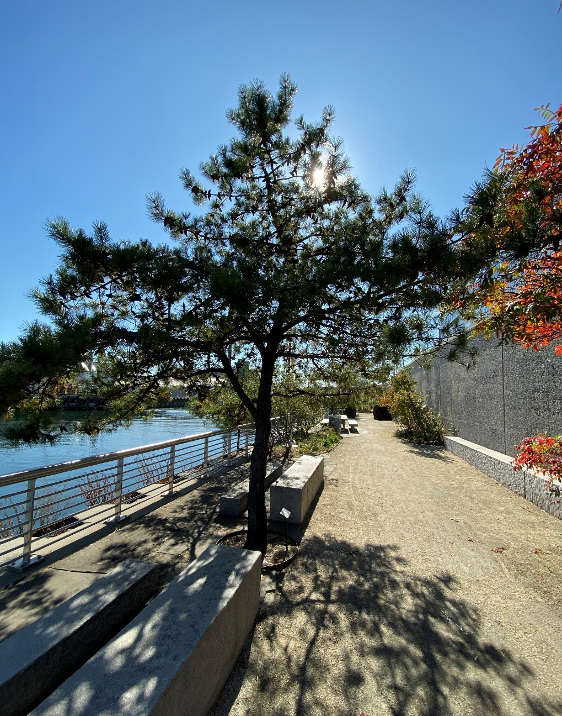
- I chose this image because this tree is almost completely shadowed. This is very symbolic of how Newtown Creek has overshadowed its natural environment.

STUDENT NAME: Antonei Cepeda

SITE OBSERVATIONS
- What are some general observations about the character of this place? What does it remind you of? How does it make you feel?
- There is a great calm to this area because of the lack of people, since there are rarely any residential buildings in the area. This area reminds me of the industrial part of Lawrence, Massachusetts. When I used to live in Lawrence as a child, my father worked for the Boeing plane manufacturing factory, and the entire area was surrounded by warehouses. This area gives me some sort of reassurance because it shows that there are still workers in this country, and that their work hasn’t been sent abroad yet.
- Historically, what are some of the important developments that have created the current environmental situation at Newtown Creek area. Refer not only to the reading and Prof. Spellane’s lecture, but also what you learned on the Newtown Creek Alliance tour (hint… estuaries, for instance)?
- As industrialization began to flourish in the Newtown Creek area, more and more of its natural environment was removed. In the late 1800s, roughly 85% of the area’s wetlands was removed to make way for the economic boom. In today’s current time, there is no wetlands in Newtown Creek. This action caused many living creatures that depended on the wetlands to either die off, or migrate. The nature-walk is looking to return some plant life back into Newtown Creek, but it pales in comparison to the 16,000 acres of wetlands that once thrived.
- In what ways is the natural environment contained or shaped by the architecture of the Newtown Creek Nature Walk? In what ways is the natural world repossessing, interacting with, or invading spaces that have been over-polluted or industrialized?
- The natural environment was meticulously placed by the designer, and they seem to be placed in areas that has wide places to walk in. This area is well maintained, and for this reason, I find this area to be considered less of a natural environment than that of Gowanus. Since Gowanus is a mixture of industrial and residential, the natural environment runs wild, despite the effort to contain it. Here in the nature walk, the natural environment is encased in tons upon tons of concrete. While there is a great deal of plant life in this area, many of which I have never seen in my life, I don’t ever see them repossessing the area. Instead, I see the plant life as showing that even through the sludge and muck of industrial manufacturing, nature can coexist.
- Discuss the program of the nature walk. How are people meant to interact with one another and with the environment?
- One thing that I noticed from this nature walk is it is aiming to bring plant life that is not indigenous in the area, but it once was. Another thing is the nature walk looks to educate its walkers of Newtown Creek during the 1800s and early 1900s. This is done by using many materials from the times of the 1800s, such as concrete, and wood. The nature walk uses no modern materials to my knowledge, and many of the areas were built with Newtown of 1800s in mind, such as “The Vessel”. Speaking of “The vessel”, this area feels very imposing and made me feel uncomfortable as I was walking through it, noticing the port holes. The area was built sharp and direct, kind of like it is letting people know that you cannot wander. Also, because this area has a one-way entrance and exit, people that enter are entering this are doing so to experience the nature walk, and are not walking through the area. People that enter this area are meant to walk along the area, and relax, by taking a seat on many of the concrete seating. At the entrance to the nature walk there is signage which mentions no pets, no food, no bikes, etc. On my visit, I saw a few joggers, other people sitting down and chatting, and even one man riding his bike along the nature walk. Since I saw no visible signage in the area, I assume that touching the plant life and smelling them is acceptable, which is what I did. This one plant life in particular smelled heavenly:
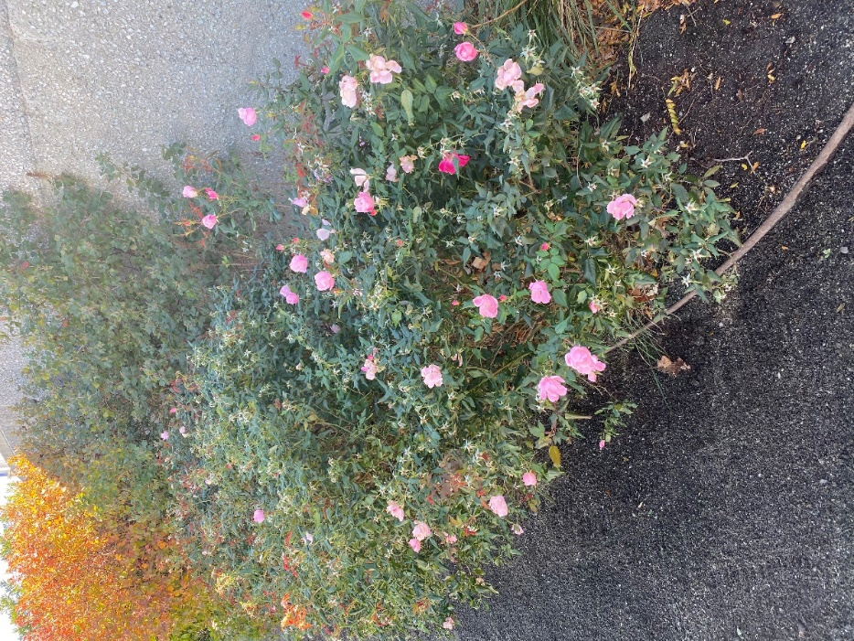
- If you were to stage a performative intervention in a specific site (i.e., a single structural aspect of the walk or industrial remains) where would you stage it and why (how does the environment add meaning to the performance)?
- My idea is to have a performance at the “Native Plants” area. There is a great contrast between the death of the water and the life of the nature walk. This black and white contrast is similar to how the surrounding factories in the area used to think and continue to think, in the sense that profit is all that matters. When profit is the only thing that matter, proper waste procedures fall by the waist side, because it requires more effort or cost. The performance can be in full dialog where life begins at the native plants area, and then immediately dies the moment it treads on to the water beside it. The area is perfect because many of the plant life in the area can be used for medicinal purposes, but none of them can overcome the ailment of water pollution. Due to this area having plant life along the high concrete wall and by the waterside, it is somewhat narrow, which lends to the idea of a natural environment being closed in by the pollution around it.
- What message would your performance convey and who needs to hear this message?
- The performance is meant to be heard by the factory workers who work along the Newtown Creek, and more importantly, its owners. These are the people that are causing the most harm to the water, and perhaps this performance can make them reform their current ways.
QUESTIONS for FURTHER RESEARCH. These should follow directly from your analysis section and be complex and specific enough to serve as the basis of a research project.
Questions might relate to architectural or environmental observations, socio-political problems and/or solutions, demography, history, zoning, civic processes, performance strategy, etc.
Question?
- Is there currently a rezoning happening in Newtown and is there any opposition from the resident or the workers?
Question?
- With all of the factories still functional in the area, there still has to be a good amount of pollution happening in the waterway, and what effect has it had to its surroundings.
Question?
- How much of Newtown’s industrial work force accounts for New York’s overall industrial work force?

FURTHER RESEARCH
Choose and revise one of your research questions for further research. Refine your question following from examples that we’ve discussed in class.
- Revised Research Question: Are the factories of Newtown still polluting the water and what effect has this had on the residents?

Find and cite 2 sources that address your question in MLA format. Respond to the questions below.

CITATION 1:
Enman, Scott. “There Are 3 Active Oil Spills on Newtown Creek.” Brooklyn Eagle, 20 May 2019, brooklyneagle.com/articles/2019/05/20/there-are-3-active-oil-spills-on-newtown-creek/.
Why did you select this source? How does it address all or part of your research question?
- I selected this source because it talks about exactly one part of my question; which is “Are factories still polluting the waters of Newtown”. This article talks about this very topic, and goes into detail about oil spills that are happening in Newtown Creek. This article addresses the part of is this still happening, because this article is from May 2019, so it is as current as you can get. It also talks about any effort that is being made to contain the oil spills. By the amount of effort that is being put towards removing the oil spills, you can tell just how much of a concern this issue is.
Is the source credible? Why or why not?
- This is a credible source because it comes from the Brooklyn Daily Eagle. This website is a digital publication of the original Brooklyn Daily Eagle, which was a source of news the people of Brooklyn since 1841. The articles of this website are not click bait, nor does it give out false information. The digital version was released in 1996, and it has over 20 years of giving the people of Brooklyn information about where they live. The writer of this article is Scott Enman. He is a young writer who has written for the Brooklyn Daily Eagle and The New York Times.

CITATION 2:
Fortis, Bianca. “City's Pumping Air Into Polluted Newtown Creek Has Critics Worried.” City Limits, 8 Aug. 2018, citylimits.org/2018/08/08/citys-pumping-air-into-polluted-newtown-creek-has-critics-worried/.

Why did you select this source? How does it address all or part of your research question?
- I selected this source as it discusses how the water pollution is having a negative effect of the residents. While the article does talk about how the aeration process that is happening in the creek is spreading bacteria through the air, it does not discuss whether people have been affected by these bacteria yet.
Is the source credible? Why or why not?
- The website that I used is citylimits, which is a .org website, which gives it some credence. I am unfamiliar with this website, but after spending some time on the website, nothing comes out to me that seems like a click-bait or that is money motivated. In fact, this website seems to discuss issues that is currently plaguing us, such as transit, climate change, and borough specific issues. The author of this article is Bianca Fortis. In addition to writing for City Limits, she has also written for NBC, Vice, and PBS. She is a young writer, but has worked with many well-known publications.
What further information would you need to answer your question? Where would you look for additional sources?
- To further answer the question about the factories actually having a negative health effect on the residents, I would have to look at the health of Newtown residents, compared to a different location. I would probably focus of asthma cases and I would go looking for that information under medical statistics in the Newtown area. This might be difficult, because I believe that information like that is protected under HIPPA.

