Learning Places Summer 2019
SITE REPORT #2
Newtown Creek
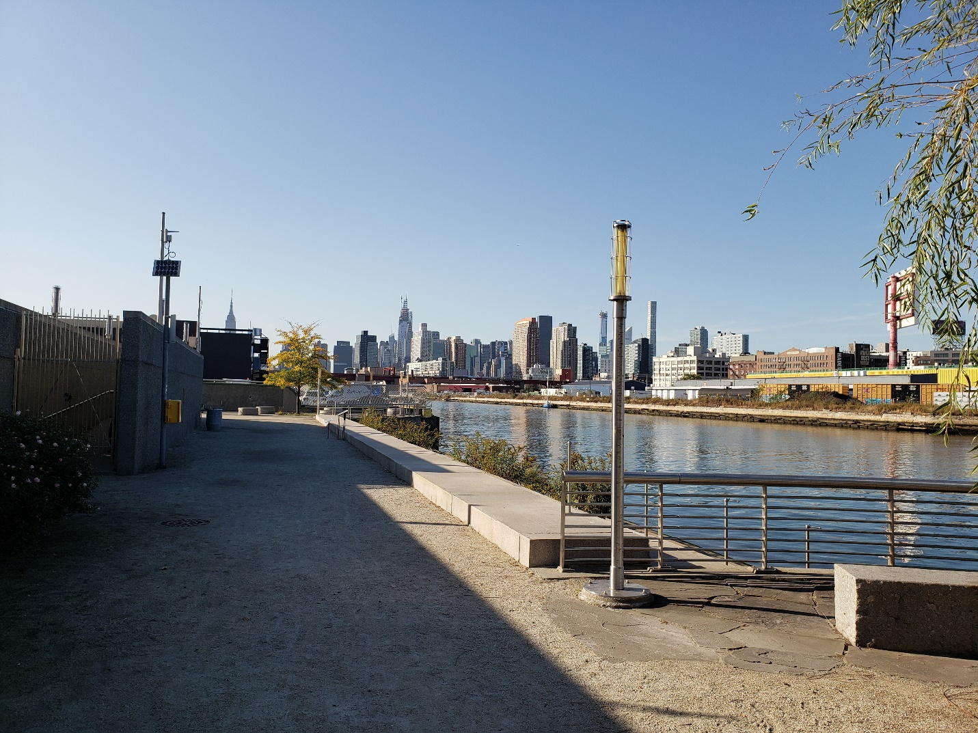
One of the reasons I choose this image is because of the beauty of the architectural and environmental space of Newtown Creek where you are surrounded by different kind of plants.

STUDENT NAME: Wantony Florian

SITE OBSERVATIONS
- What are some general observations about the character of this place? What does it remind you of? How does it make you feel?
- Some general observations about this place is that I felt a little bit intimidated once I saw the entrance and kind of confuse because it didn’t feel welcome or something that gives you the motivation to go with the narrow space of the entrance but once you enter and keep walking it feels like you entering in a great place to stay and enjoy with some of the different kind of plants and how the architect designed the space in that area, once you keep walking you feel more in peace and welcome to the space.

- Historically, what are some of the important developments that have created the current environmental situation at Newtown Creek area. Refer not only to the reading and Prof. Spellane’s lecture, but also what you learned on the Newtown Creek Alliance tour (hint… estuaries, for instance)?

- Historically the water in Newtown Creek had been polluted through the time with factories dumping all the pollution into this water making it one of the most polluted places in New York City affecting drastically the environment and the living things in the area.

- In what ways is the natural environment contained or shaped by the architecture of the Newtown Creek Nature Walk? In what ways is the natural world repossessing, interacting with, or invading spaces that have been over-polluted or industrialized?
- Although the water on Newtown Creek had been polluted with factories, one of the most fascinating things about this place and how the environment is connected to the architectural design on the space with

- Discuss the program of the nature walk. How are people meant to interact with one another and with the environment?
- One of the main purposes of the design program of this area has to do with how people interact in the space and how you can be connected more to nature where there are different types of plants, sitting areas where you can enjoy the view and be in a calm space as you walk in.

- If you were to stage a performative intervention in a specific site (i.e., a single structural aspect of the walk or industrial remains) where would you stage it and why (how does the environment add meaning to the performance)?

- If I were to stage a performative intervention in a specific site it would be by the steps to show the people know how much polluted is the water and what can we do to deal with this situation bringing some kind of solutions by reducing the chemicals, planting different types of plans around the area to help cleaning the water in Newtown Creek. Each person can participate in planting a tree that can help cleaning the water and the air.
- What message would your performance convey and who needs to hear this message?
- In order to prevent or reduce the water pollution in Newtown Creek is very important that the people who are responsible for this situation can hear it specially people who throw chemicals and other stuff in the water. For example; factory companies owners and also the mayor of New York City to send support and take actions to solve these problems.

QUESTIONS for FURTHER RESEARCH. These should follow directly from your analysis section and be complex and specific enough to serve as the basis of a research project.
Questions might relate to architectural or environmental observations, socio-political problems and/or solutions, demography, history, zoning, civic processes, performance strategy, etc.
- What can the residents and business do to reduce pollution in Newtown Creek?
- Is there any business/companies taking action to resolve water pollution in Newtown Creek?
- Is it too late to restore or clean up the river in Newtown Creek?
- How the Environmental Department is dealing with the pollution of the waterway in Newtown Creek?

FURTHER RESEARCH
Choose and revise one of your research questions for further research. Refine your question following from examples that we’ve discussed in class.
Revised Research Question:

Find and cite 2 sources that address your question in MLA format. Respond to the questions below.

CITATION 1:
“Newtown Creek Vision Plan” River keeper. Chrissy Remein N.p. 2019. Web.
https://www.riverkeeper.org/campaigns/restore-nyc-waterways/newtown-creek-vision-plan/
Why did you select this source? How does it address all or part of your research question?
I choose this source because it talks about how “Riverkeeper” and the NCA are taking action to restore Newtown Creek. Their vision is to clean up the waterway, create recreational communities and have a barrier to reduce pollution in the area. Now their vision is to restore and protect NYC waterways including NC which according to them, this place has great potential to be a wonderful space for people to interact with nature and the beauty of NYC.

Is the source credible? Why or why not?
This source is credible because it has an author and the source comes from the website called “Riverkeeper.com” which talks about news, events and cases about what’s happening in NYC and how some small business are trying to make a difference in places like Newtown Creek.

CITATION 2:
“Water Quality Sampling” New Town Creek Alliance. N.p. 2019. Web.
http://www.newtowncreekalliance.org/water-quality-sampling/

Why did you select this source? How does it address all or part of your research question?
The reason I selected this source is because it highlighting the process of improving the water quality in Newtown Creek with the support of “Greenpoint Community Environmental Fund” the “Office of the New York State Attorney General” and the “New York State Department of Environmental Conservation”. These companies are making all the effort to improve the waterway by monitoring finding samples of the type of bacteria, chemicals, and how much residents of this community can help improve this area.

Is the source credible? Why or why not?
This source doesn’t seem to have an author or someone who wrote about this article but, it’s directly from the website of “newtowncreekalliange.org” which talks about events, their impact, issues and actions that is been taken in this area.

