learning Places Summer 2019
SITE REPORT #2
Newtown Creek
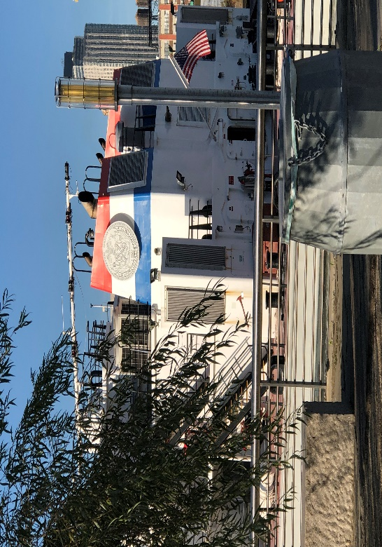
Select a meaningful image to that captures your perception of the site we visited and provide a caption explaining what the image is.

STUDENT NAME: Shayina Dubuisson

SITE OBSERVATIONS
- What are some general observations about the character of this place? What does it remind you of? How does it make you feel?
I really liked this site because of the plants and trees, I felt like I was in a peaceful and spiritual environment even though the site isn’t spiritual it gave a feel that you are safe. It’s kind of reminds of space here you can go to clear your head when your upset or angry.
- Historically, what are some of the important developments that have created the current environmental situation at Newtown Creek area. Refer not only to the reading and Prof. Spellane’s lecture, but also what you learned on the Newtown Creek Alliance tour (hint… estuaries, for instance)?
They are trying to keep the industrial image of Newton’s Creek, but they are also trying to keep it clean as possible. Its difficult to keep it clean due to toxic waste and garbage that gets thrown into the lake on daily basis. To reduce the amount of waste that goes into the Creek the DEP has volunteers around the environment to not shower or flush until all clear alert is issued and at least 700 members have signed up.
- In what ways is the natural environment contained or shaped by the architecture of the Newtown Creek Nature Walk? In what ways is the natural world repossessing, interacting with, or invading spaces that have been over-polluted or industrialized?
The architecture around the site was very history and it showed meaning that the space has been the for decades and the DEP fixed it up and made it look a lot better and the plants and trees made it look very eye catching and calming. It gives the site an identity to let people know that they can come to feel at ease. The plants and trees also help the area to get clean air to breathe since the water is very polluted.
- Discuss the program of the nature walk. How are people meant to interact with one another and with the environment?
The walk was very educational and people are meant to come to the walk way and enjoy the nature and the history of the site.
- If you were to stage a performative intervention in a specific site (i.e., a single structural aspect of the walk or industrial remains) where would you stage it and why (how does the environment add meaning to the performance)?
I would stage my performance near the steps that goes into the creek’s water because I want to bring awareness of the polluted water and I would have gallons of clean water next to me so people can dump into the creek. This can send a message to consumers to stop polluting it and start taking care of it because it is affecting the air that we breathe, it is bad for the water, and it is making it difficult for others to enjoy the water and do activities such as fishing or putting their hands in it because it’s so filthy.
- What message would your performance convey and who needs to hear this message?
To stop or try to prevent the discharging of waste and other toxic objects from going into the water because it is causing it to be dirty. The people who needs to hear this message are people who are constantly dumping things into the water and people who aren’t aware that the water from their showers and the flushing from their toilets are causing this problem as well
QUESTIONS for FURTHER RESEARCH. These should follow directly from your analysis section and be complex and specific enough to serve as the basis of a research project.
Questions might relate to architectural or environmental observations, socio-political problems and/or solutions, demography, history, zoning, civic processes, performance strategy, etc.
- Are the plants and trees around the creek making the air cleaner since the water is very polluted?
- Did the architecture help to change the site in to a more positive space?
- Are there other ways to bring awareness about the pollution in the creek?

FURTHER RESEARCH
Choose and revise one of your research questions for further research. Refine your question following from examples that we’ve discussed in class.
Revised Research Question:
What are some ways the government is helping to treat and prevent pollution in the Newtown Creek?
CITATION 1: IMOA International Molybdenum Association. “Stainless Steel Lets Wastewater Treatment Plant Shine.” Newton Creek Wastewater Treatment Plant, https://www.imoa.info/molybdenum-uses/molybdenum-grade-stainless-steels/architecture/newton-creek-plant.php.

Why did you select this source? How does it address all or part of your research question?
I selected this so because it discusses how they are trying to eliminated the odor that’s in the water to make the walk more comfortable for visitors to walk through. Although doesn’t solve all the problems about the pollution that’s in the water but it’s a start to making it more suitable to be around overly filth that’s in the water.
Is the source credible? Why or why not?
Yes, this source is credible because it discusses in details why they made the 316 stainless digester that are called the “eggs” for short.

CITATION 2: Enman, Scott. “Newtown Creek's Cleanup Could Begin 5 Years Ahead of Schedule.” Brooklyn Eagle, 20 Sept. 2019, https://brooklyneagle.com/articles/2019/09/20/newtown-creeks-cleanup-could-begin-5-years-ahead-of-schedule/.

Why did you select this source? How does it address all or part of your research question?
I choose this source because it provides evidence that it can improve Newtown Creek’s water in less than 5 years and the plan of the remediation is supported by the EPA.
Is the source credible? Why or why not?
Yes, this source is credible because it discusses how one of the government’s environmental programs are getting involved to help.
What further information would you need to answer your question? Where would you look for additional sources?
I would look for additional information on NYCgov to look for more evidence to see how the government is getting involved to put a solution to this problem.

