Learning Places Fall 2019
SITE REPORT #1
The Gowanus
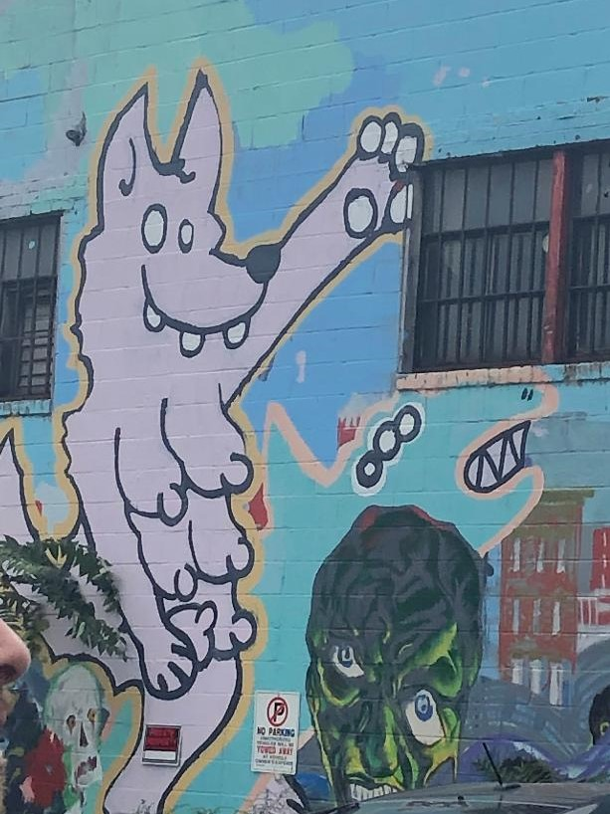
Select a meaningful image that captures your perception of the site we visited.

STUDENT NAME: Shayina Dubuisson

PART 1: SITE OBSERVATIONS

- What are some general observations about the character of this neighborhood? What does it remind you of? How does it make you feel?
The neighborhood is very urban. The brown stone housing made me feel like I was walking into a historical neighborhood.
- How is the natural world contained or shaped by human activity or architecture? In what ways does the natural world invade or disrupt human activity, planning or architecture?
The smell of the Gowanus water makes people not want to enjoy the nice view of the Gowanus river. I personally didn’t like how the water looks so green.
- What people did you observe in the neighborhood and what activities are they engaged in?
There wasn’t a lot of people around the around the area, but that I saw looked like a typical New Yorker who trying to go to school or work.
- Reflect on a specific place you viewed in this neighborhood. A specific place means a single building, or an intersection, or an individual built structure, etc.
  - Insert 1 photograph and/or sketch and provide a creative caption for the image. The caption should be a word or short phrase that suggests a theme or conceptual association related to the photo or sketch.
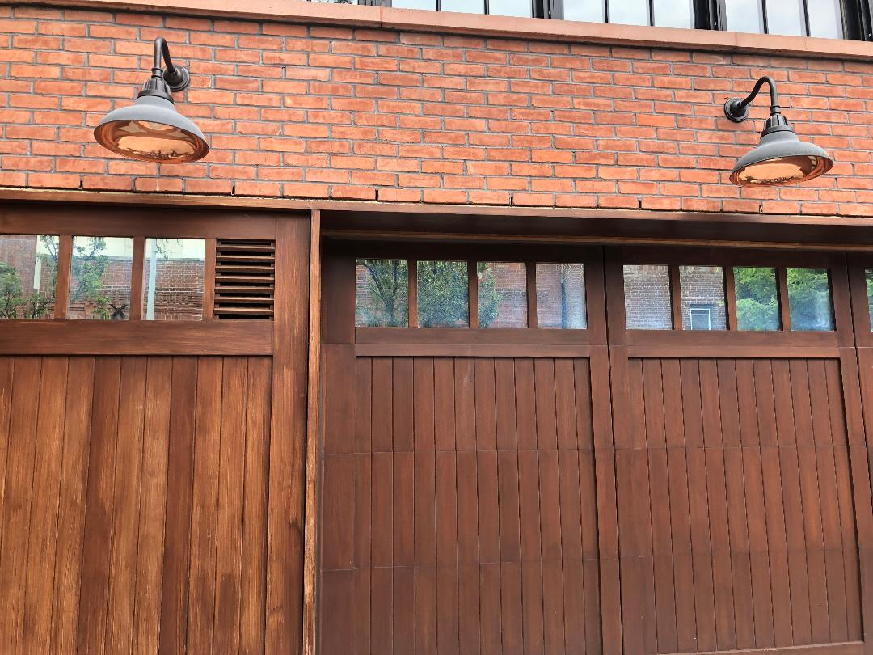
Image 1
Brown
  - What is the program of the space? How are people meant to interact with one another and with the environment?
The program of space is mostly water that’s below a bridge and people use this space to interact with one another.
  - describe a possible creative reuse of this specific space for a performance:
- Which areas are best for performers/activists and which areas are good for observers? Do these spaces overlap? Mention specific objects and structures in your answer.
Carroll Garden and the Gowanus bridge are good places for observer. The beginning of the Gowanus with the graffiti of the dog is good for performers because there’s a lot of open space.
- What kinds of performance would work best (intimate or grand; processional or stationary; text and/or music; interactive or passive audience; etc.)?
A group of friends can ride their skateboards or ride their bikes in this area. This area can be for kids who are trying to have fun because there’s so much space where they can run around and fun.

QUESTIONS for FURTHER RESEARCH. These should follow directly from your analysis section and be complex and specific enough to serve as the basis of a research project.
Questions might relate to architectural or environmental observations, socio-political problems and/or solutions, demography, history, zoning, civic processes, performance strategy, etc.
- Question?
Why did they decide to keep a lot of the historian places there?
- Question?
Why couldn’t they make the manufacturers safer and enforce labor laws instead of removing them completely?
- Question?
What are the solutions to make the Gowanus less polluted?
PART 2: RESEARCH
Choose and revise one of your research questions for further research.
Revised Research Question: What are the solutions to make the Gowanus less polluted?

Find and cite 2 sources that address your question in MLA format. Respond to the questions below.

CITATION 1: Matson, Malone. “How Can We Clean Up the Gowanus?” ECO BROOKLYN, 27 July 2012, ecobrooklyn.com

Why did you select this source? How does it address all or part of your research question?
It discusses what is polluting the Gowanus and how it is trying to make it less polluted.
Is the source credible? Why or why not?
Yes, because they have diagrams and proof on how the Gowanus is getting polluted.
What further information would you need to answer your question? Where would you look for additional sources?
I would like to know more about the EPA (Environmental Protection Association)
CITATION 2: Ink, Social. “Cleaning up Brooklyn's Gowanus Canal-the Right Way.” Riverkeeper, https://www.riverkeeper.org/news-events/news/stop-polluters/contaminated-sites/cleaning-up-brooklyn’s-gowanus-canal—the-right-way/.
Why did you select this source? How does it address all or part of your research question?
Because it gives information on how the Gowanus can be cleaned up.
Is the source credible? Why or why not?
Yes, because it discusses how the EPA is trying to make it more cleaner and it also let consumers know there plan to make I better.
What further information would you need to answer your question? Where would you look for additional sources?
I would look for additional sources on the library’s database.
PART 3: Performance Reflection (after second site visit)
Write a 200 word reflection about how you felt during the second visit to the space and during the performance activities. How did this visit change your perception of the place and your relationship to the natural and built environments? Did the experience of ‘performing’ in the space (i.e., moving your body) teach you anything new about the landscape or architecture?
The second space that we visited which was Thomas Greene Park made me feel a little bit uncomfortable because I felt like it was kind of weird that the EPA instructor was trying to get me to sense what the environment is telling me based off of body movement. She made me realize that there were different types of smells that was around the environment that I probably would have never paid attention to because I would probably been more cautious about the things that is happen around me. When she split us into groups so we could identify the smells one of my group members said that they smelled marijuana. Although I didn’t smell it while walking, I realized that it is normal to smell that drug around the area because an average weed smoker tries to find an area that is not surrounded by law enforcements to smoke it. While my classmate smelled marijuana, I smelled wet leaves and this observation made me conclude that fall is coming.
After she made us acknowledge the smells that were around the environment, she made us observe the clouds, the water, and the plants that were around the Gowanus for seven minutes. As my group members and I observe these environmental facts we realized that there was a lot of random things and objects that was in the water such as a shopping cart and garbage, the plants we moving a little bit because it was sunny, but there wasn’t any clouds because it was a sunny day. Once we were done making this observation, she made us make a dance and the performance didn’t really help me to connect nor understand the landscape. What helped me to comprehend the architecture was the observations and the smells that she made us realized that was there.

