Learning Places Spring 2019

SITE REPORT #1
Two Roads To One Destination
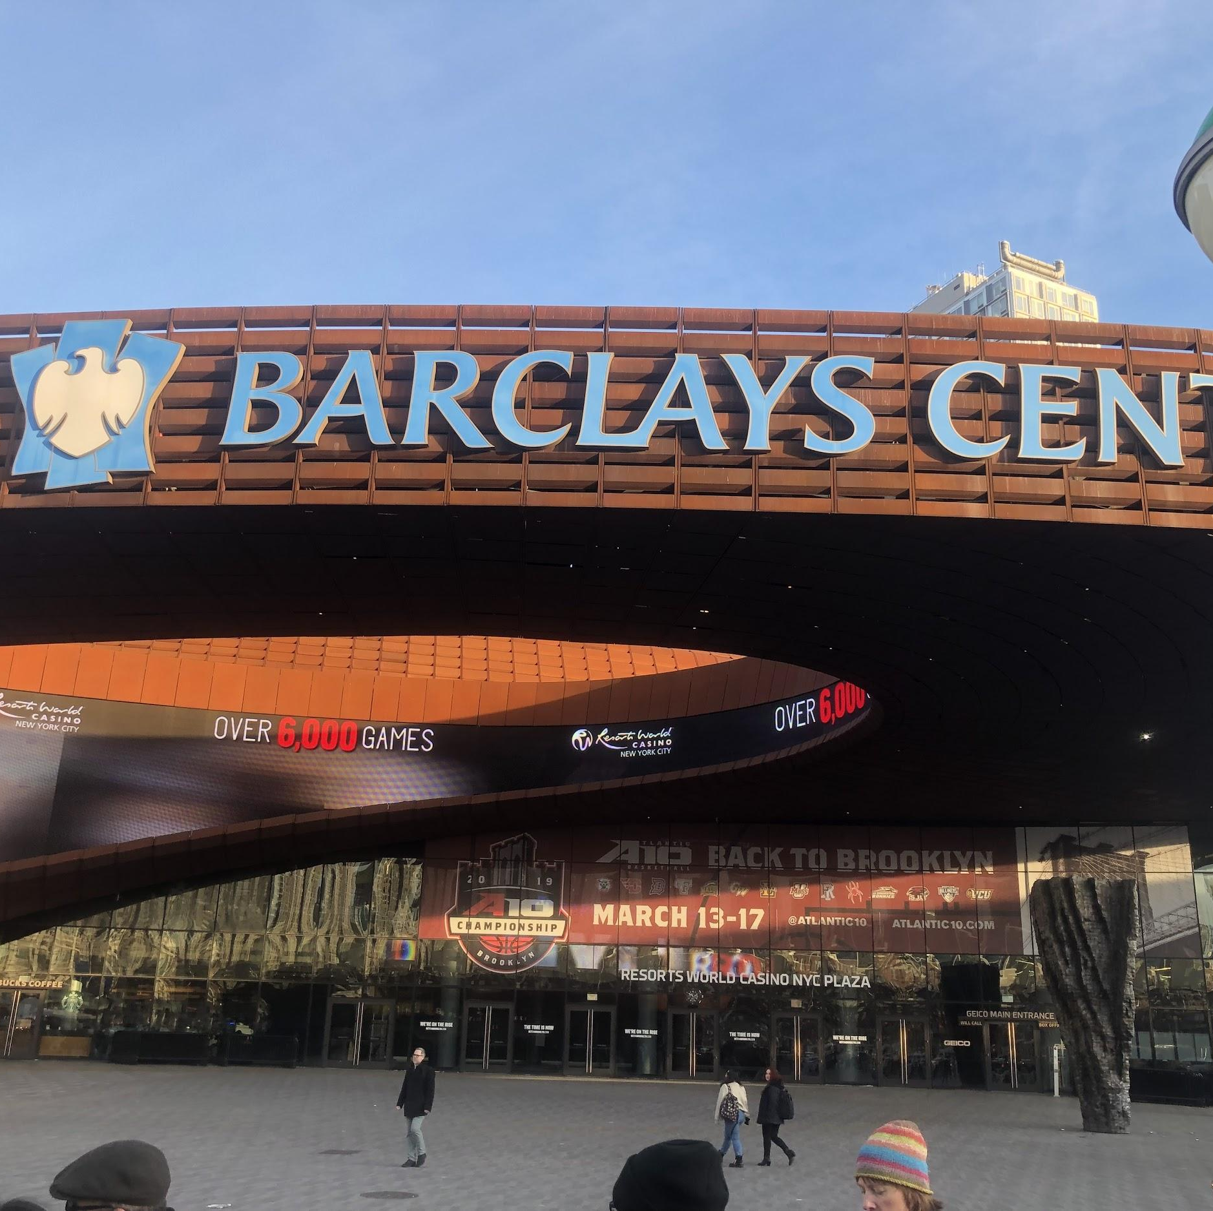

Marvin Bourdeau
02.24.2018

INTRODUCTION

After watching films like my Brooklyn, human scale, and Citizen Jane we were able to pick up a sense of change happening in our own city . We set out as a group to one destination, the Barclays Center in downtown, Brooklyn on two different occasions. The first walk was through Fulton street to see the changes good, bad or any at all. The second walk was in a beautiful section of downtown called Boerum hill. Each walk was different from the other. Fulton street was filled with corporate name brand stores and the demographics of the area seemed new with tourist and faces that I wouldn’t have seen 10 years ago. The second walk was in a cozy area but the atmosphere seemed so rich. So in the same way my body found comfort I found discomfort, as well. Because the area looked so rich, I felt out place.

Brooklyn Borough Hall
*At least 1 photo of archive / library space & 1 photo of a resource found required per site visit
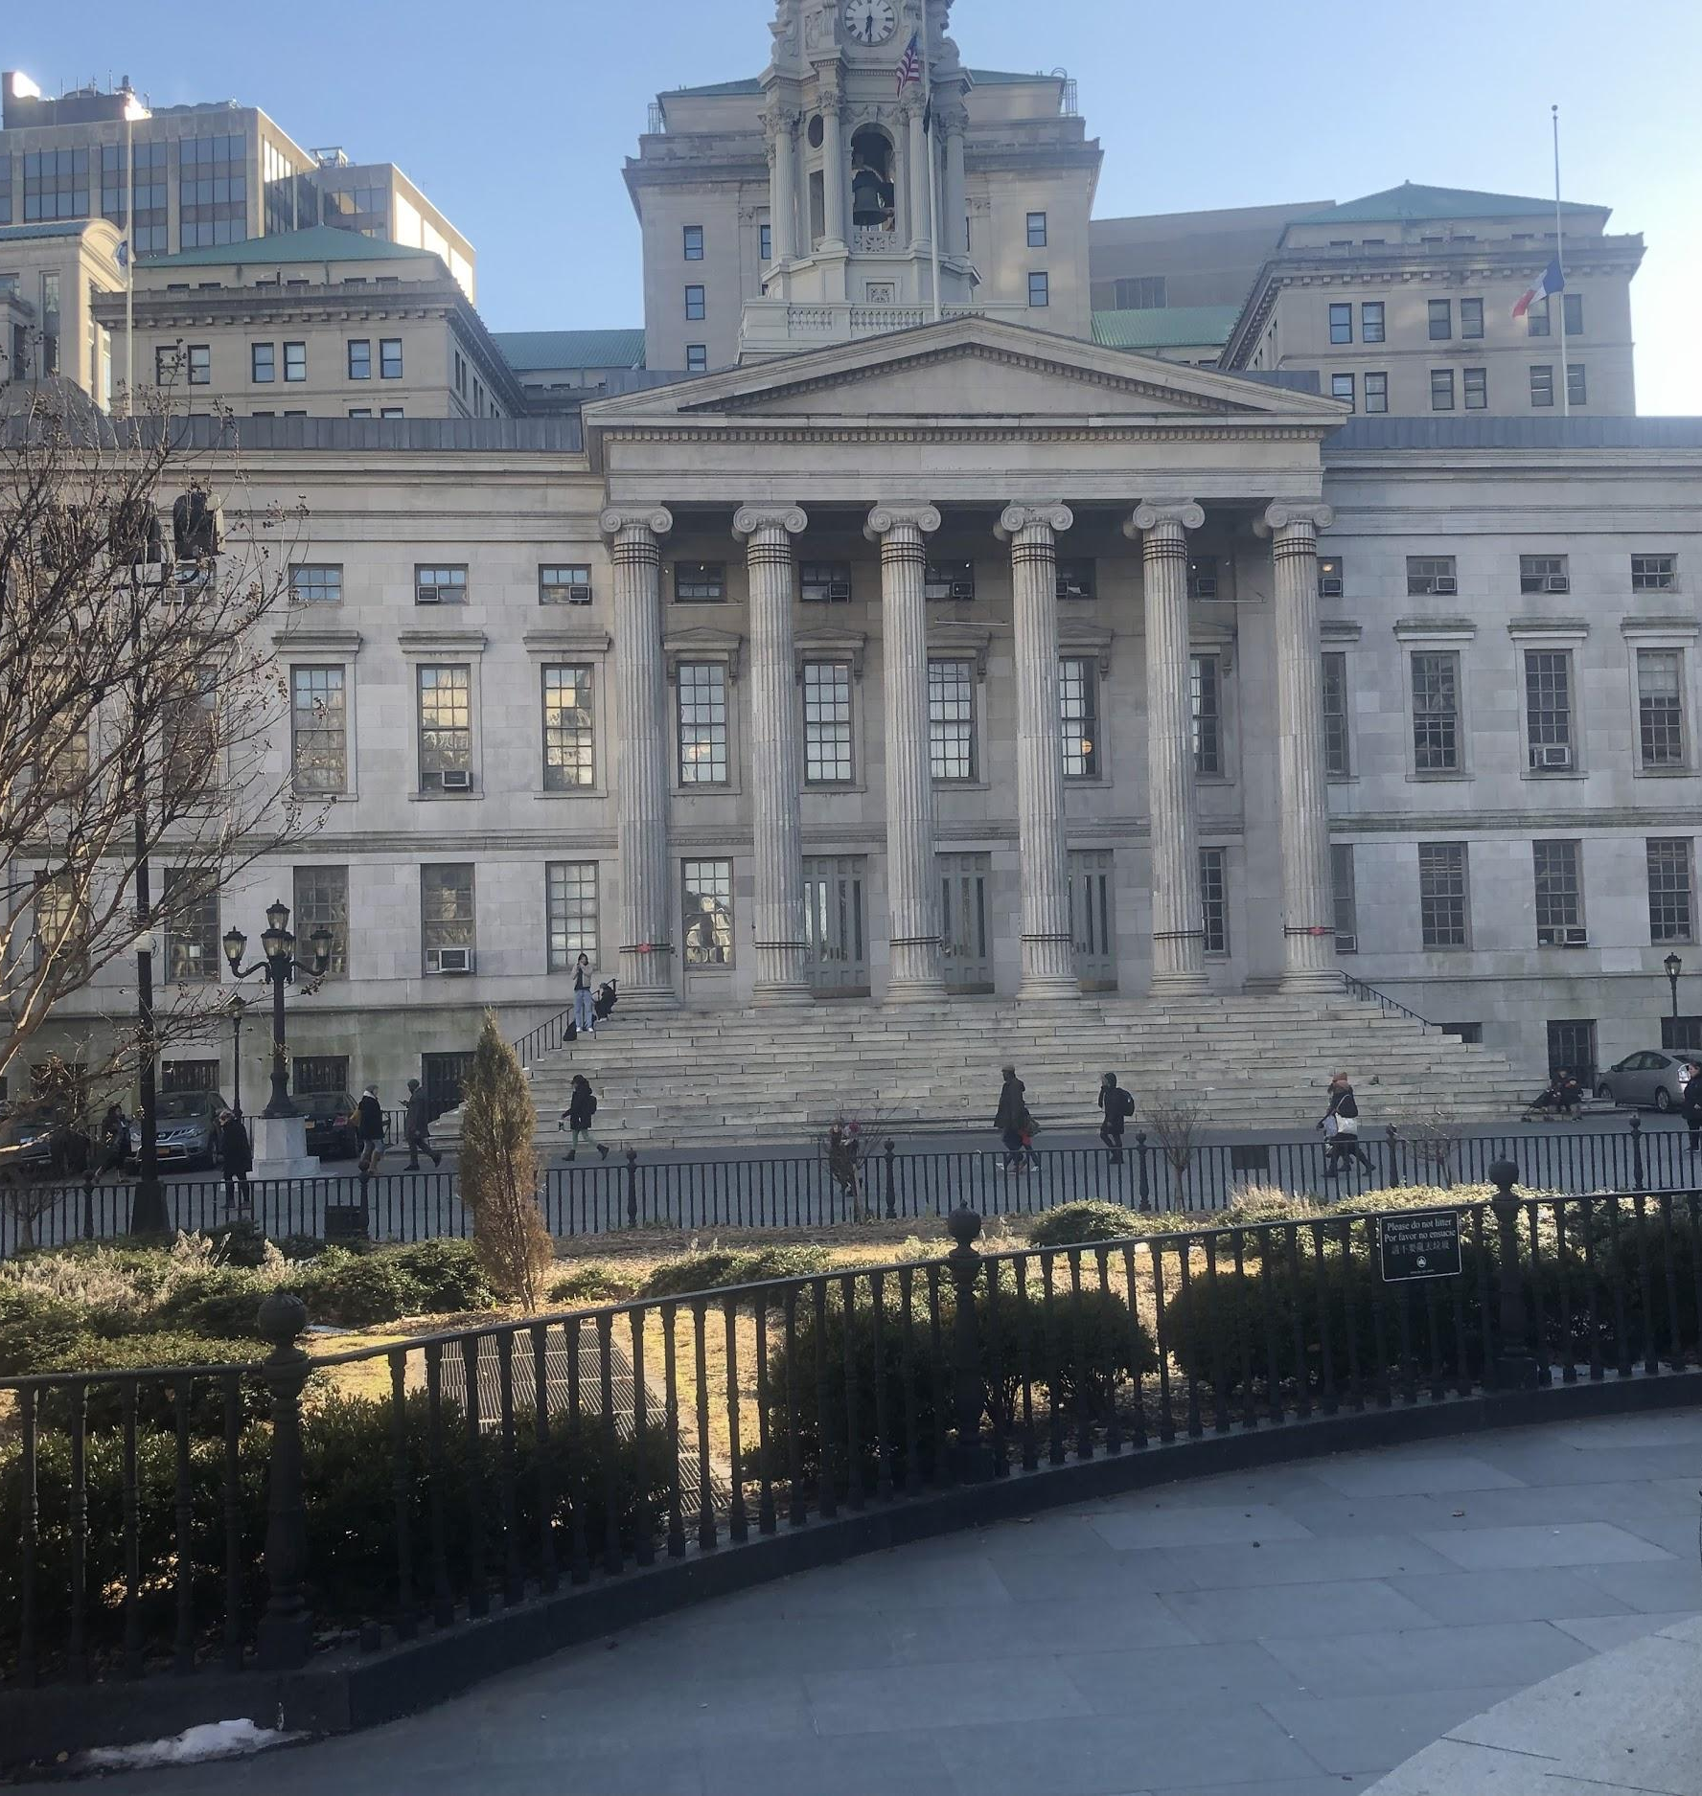

Brooklyn Borough Hall: On the first site visit I learned a lot about this building and how significant it is. It was built for Brooklyn and completed in 1848 at the time Brooklyn was considered an independent city (borough) making borough hall at the time their city hall. In 1898 Brooklyn joined the rest of the City and became a borough. I find it interesting because this building has so much history and I only knew it for it’s amazing public space.

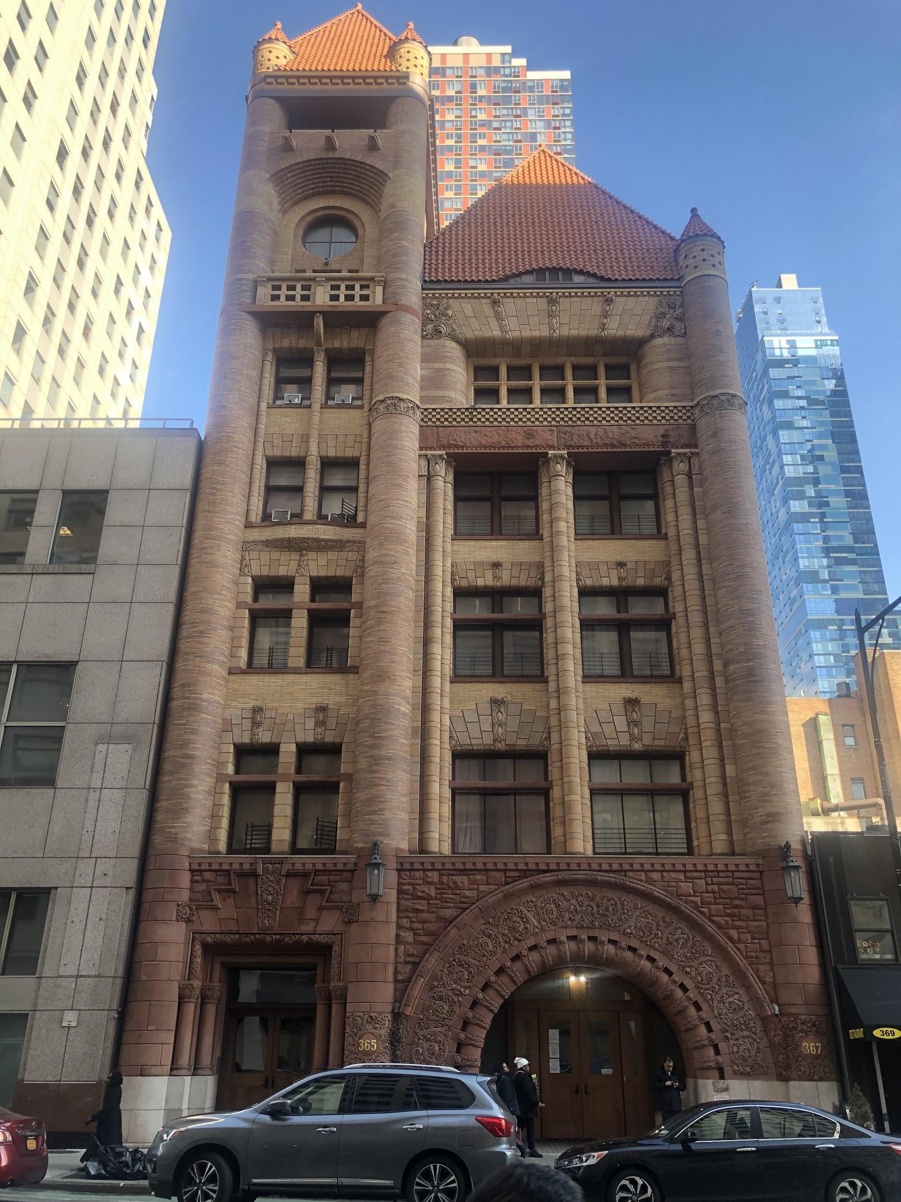
We stopped by this building on the second site walk and it caught my eye, because of how beautiful it is especially in the area it’s located in. Jay street has predominantly court buildings and even thought this building does not fit on jay street I believe the colors from the building gives that block life. You can see in the background of the photo newly constructed high rises that in time can over shadow this buildings beauty.

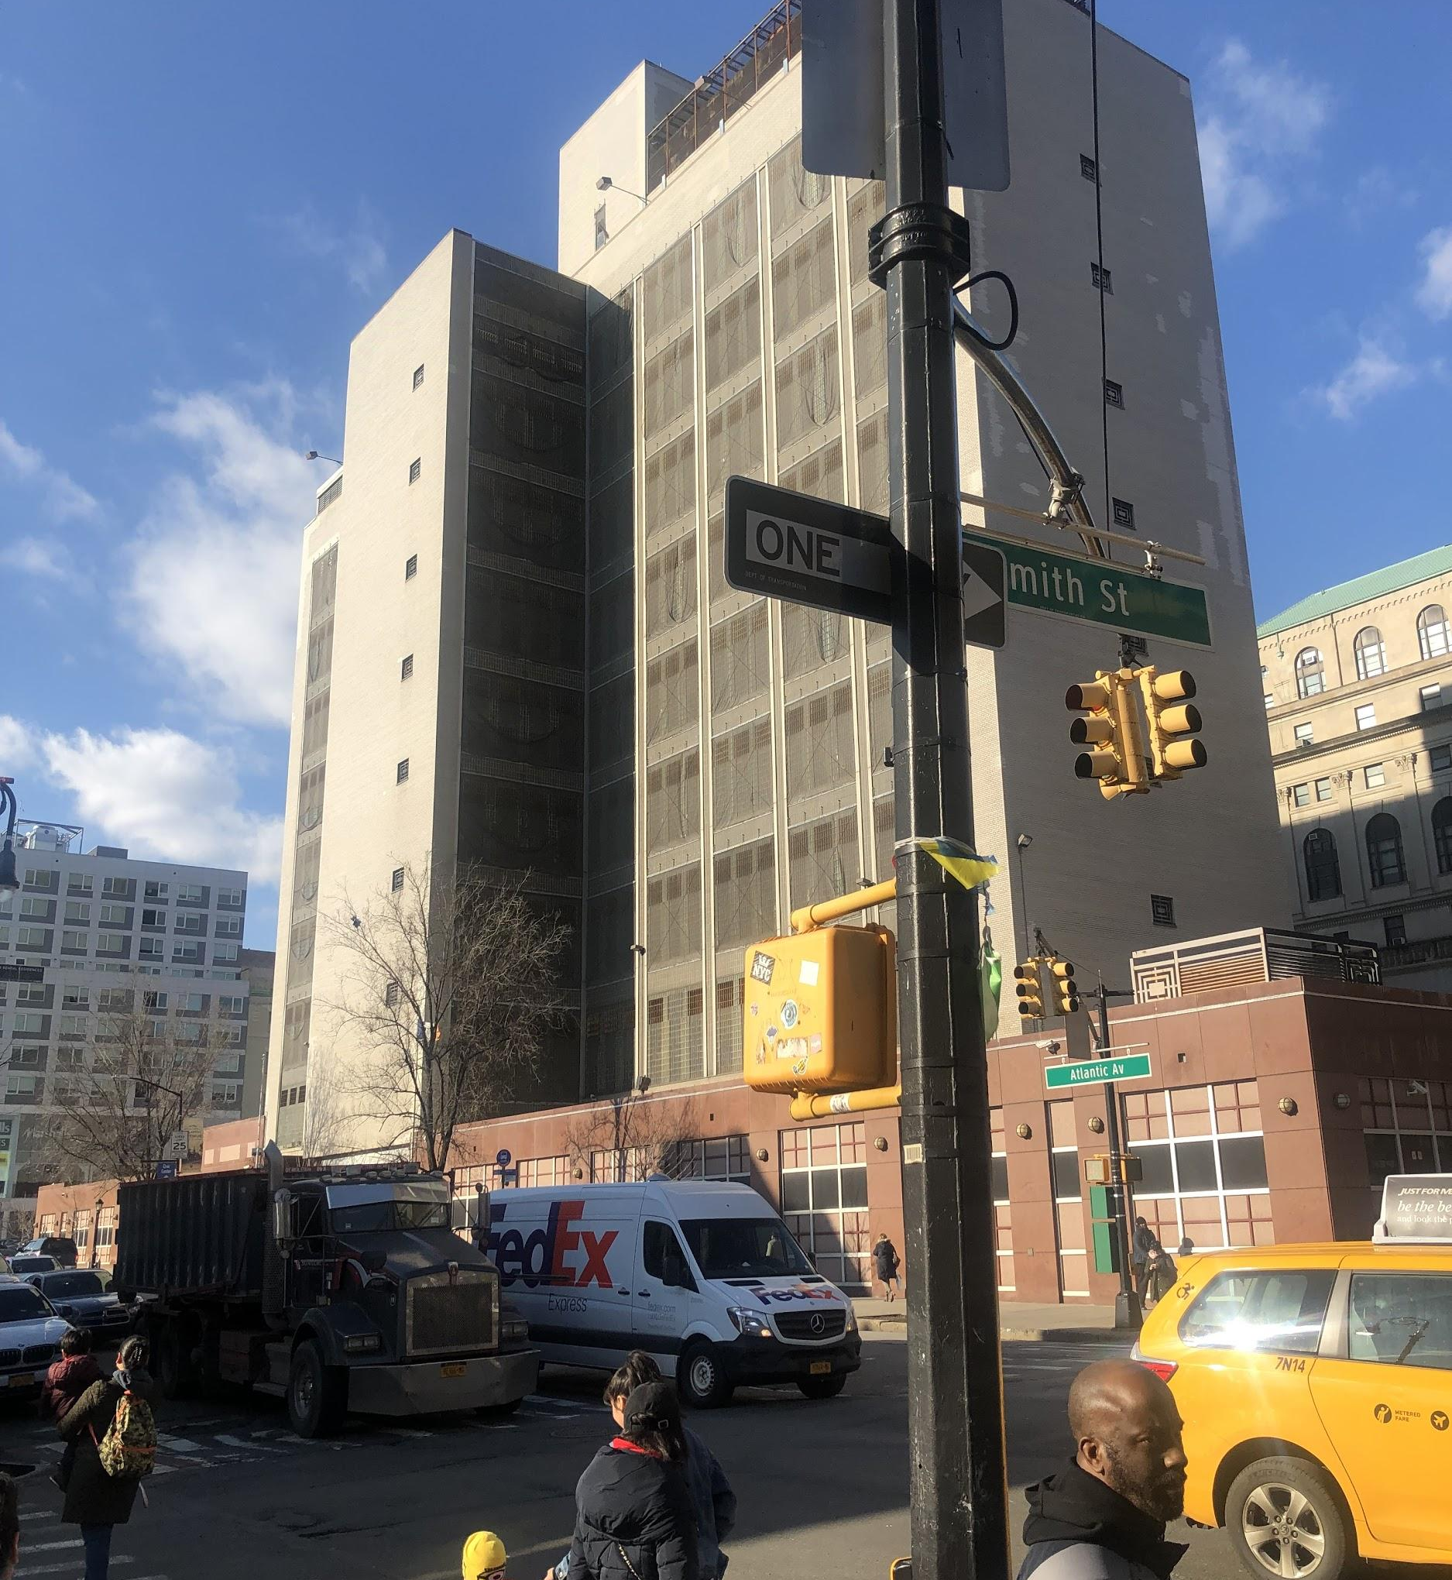
On our second site visit this building caught my attention, because while watching the progression of making downtown more elite and gentrified here stands this big prison building. It is called the Brooklyn house detention center. It made me question, as well, why would anybody want to live near a prison or any holding center for people who committed crimes.
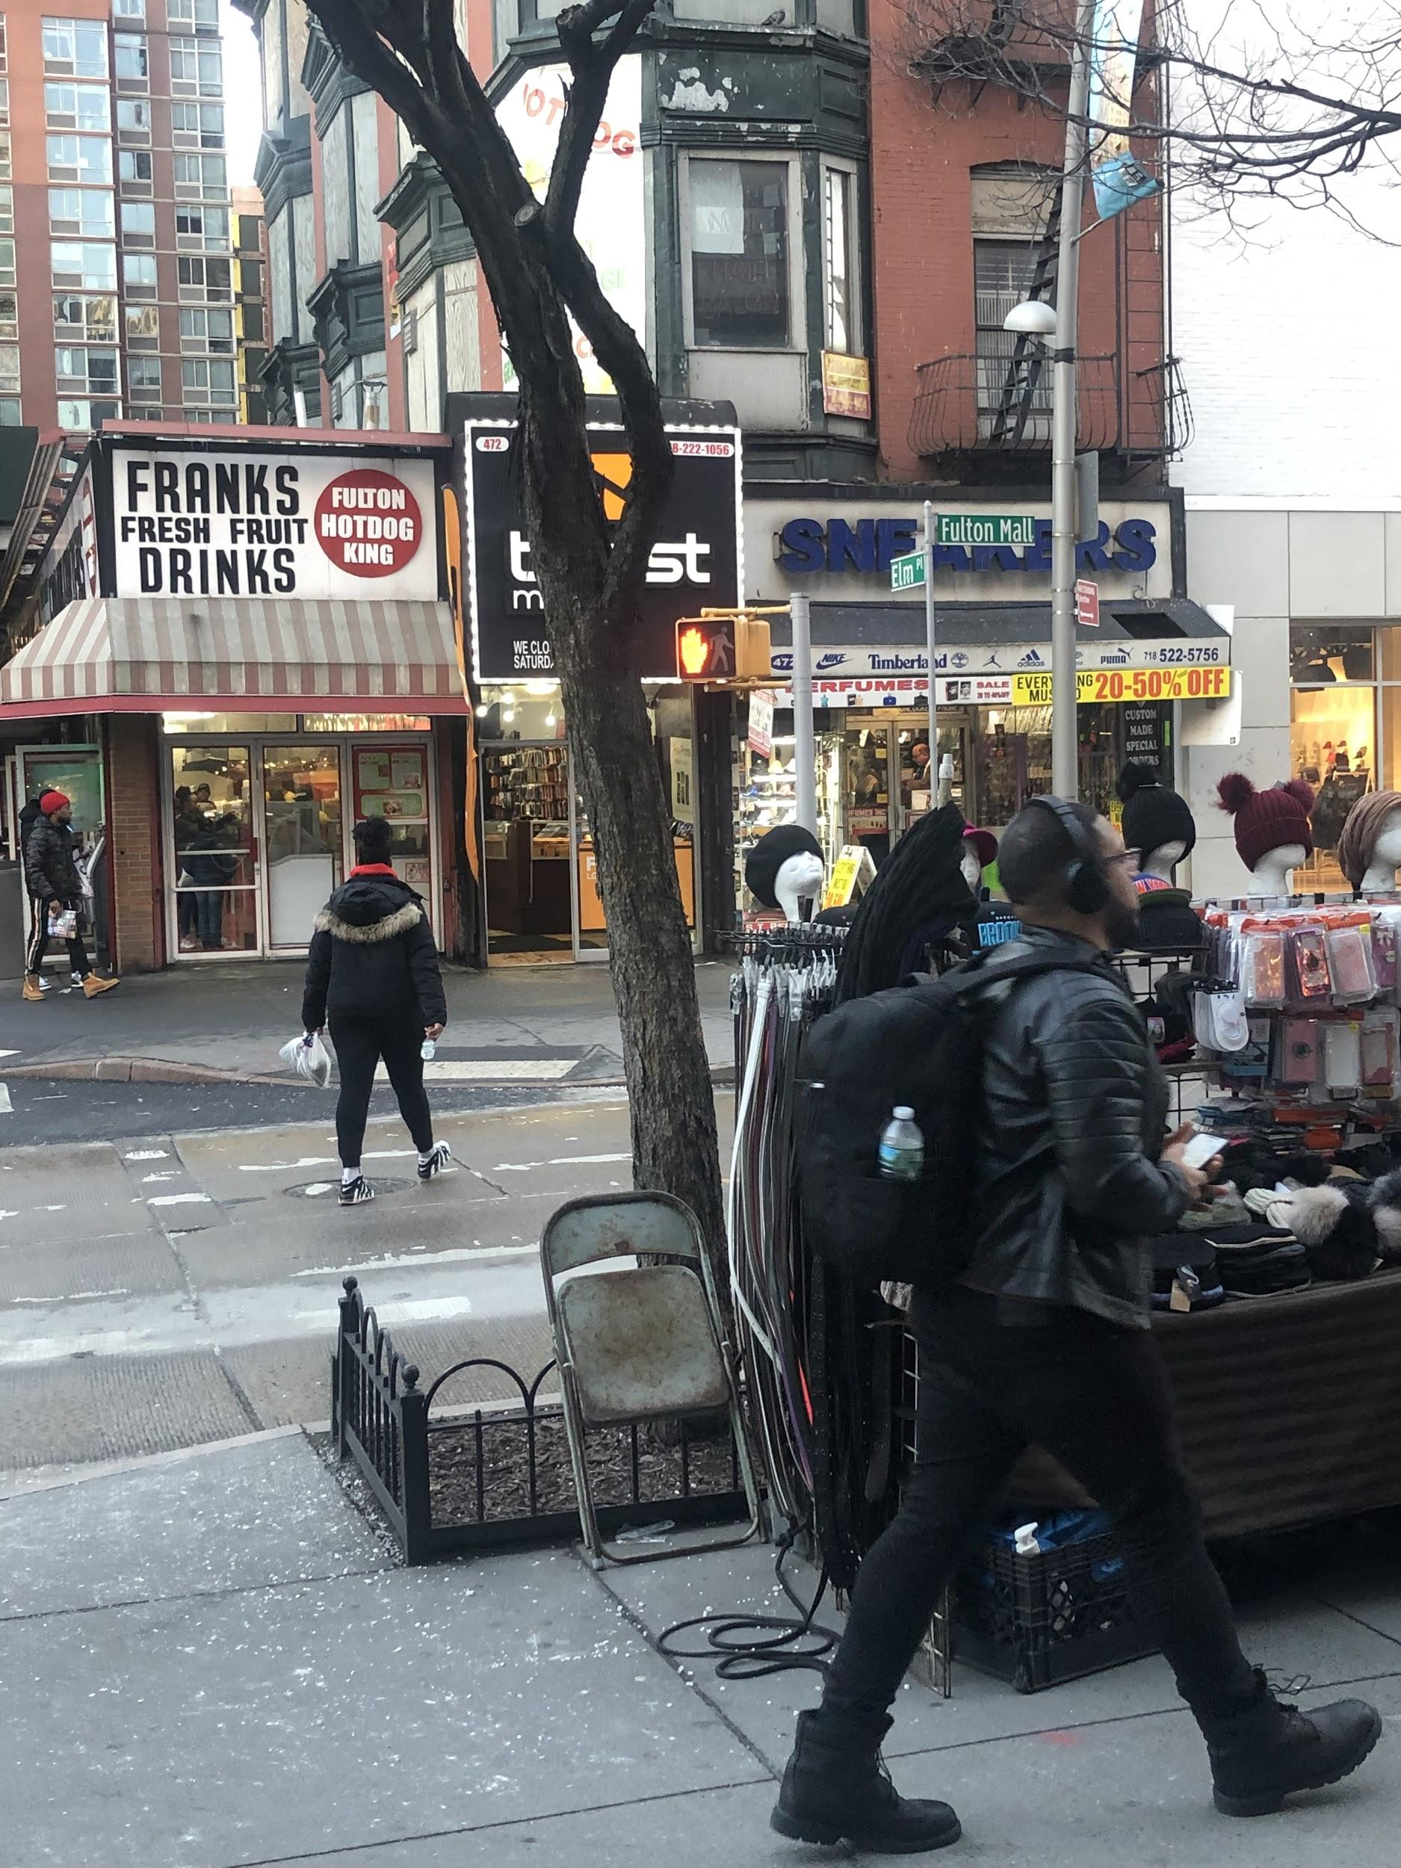

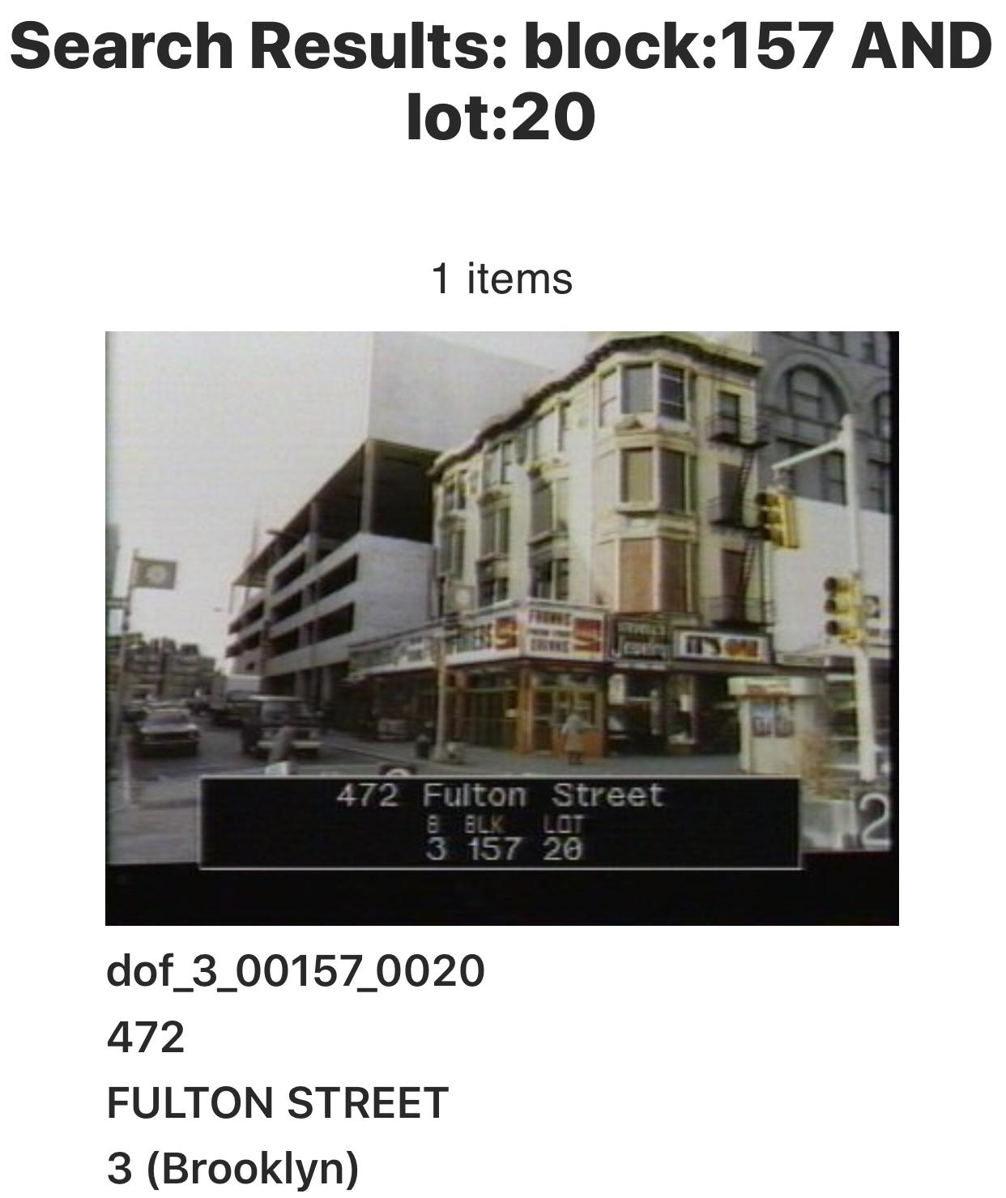

(http://nycma.lunaimaging.com/ll/thumbnailView.html?startUrl=%2F%2Fnycma.lunaimaging.com%2Fluna%2Fservlet%2Fas%2Fsearch%3Fos%3D0%26lc%3DRECORDSPHOTOUNITBRK~1~1%26q%3Dblock%3A157%20AND%20lot%3A20%26sort%3Didentifier%2Cborough%2Cblock%2Clot%26bs%3D10) (Cite of photo)

472 Fulton street (Fulton Hot dog King) has been on Fulton street since the early 80s and somehow throughout the gentrification and the hike in rent, this building has managed to stay around. If you notice the windows of the buildings above the hot dog king have remained the same and so has the other two buildings on the block, as well.

SITE DOCUMENTATION (sketches*)
*2 sketches minimum required per site visit
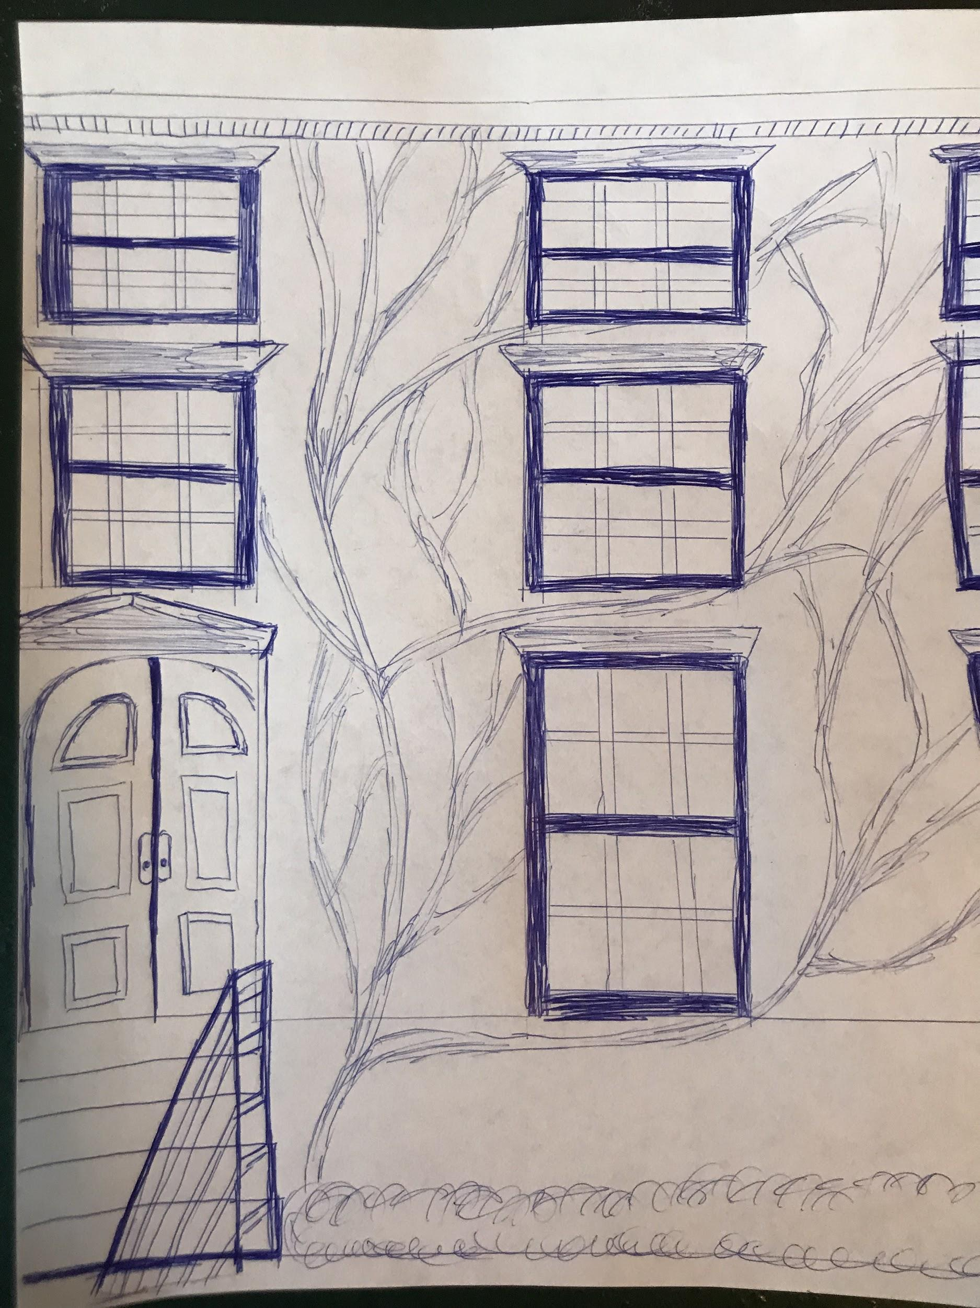

These two sketches are significant to me because of how they each represent unique features that were known in past structures. The first picture was taken in boerum hill of a brownstone. The vines are what caught my eye the most. It’s beautiful to see the balance of natural vines amongst the brink wall. Some older brownstones were known for their natural additional features to the architecture usually as vines and plants. It is hard to find amongst all the newly construction throughout the city. This drawing of the post office in downtown Brooklyn is significant because of how it is one of the few building left with amazing traditional style detail and symmetry on its structure. I found the form and design very interesting. It’s fascinating to see the building with an old gothic style look to it.

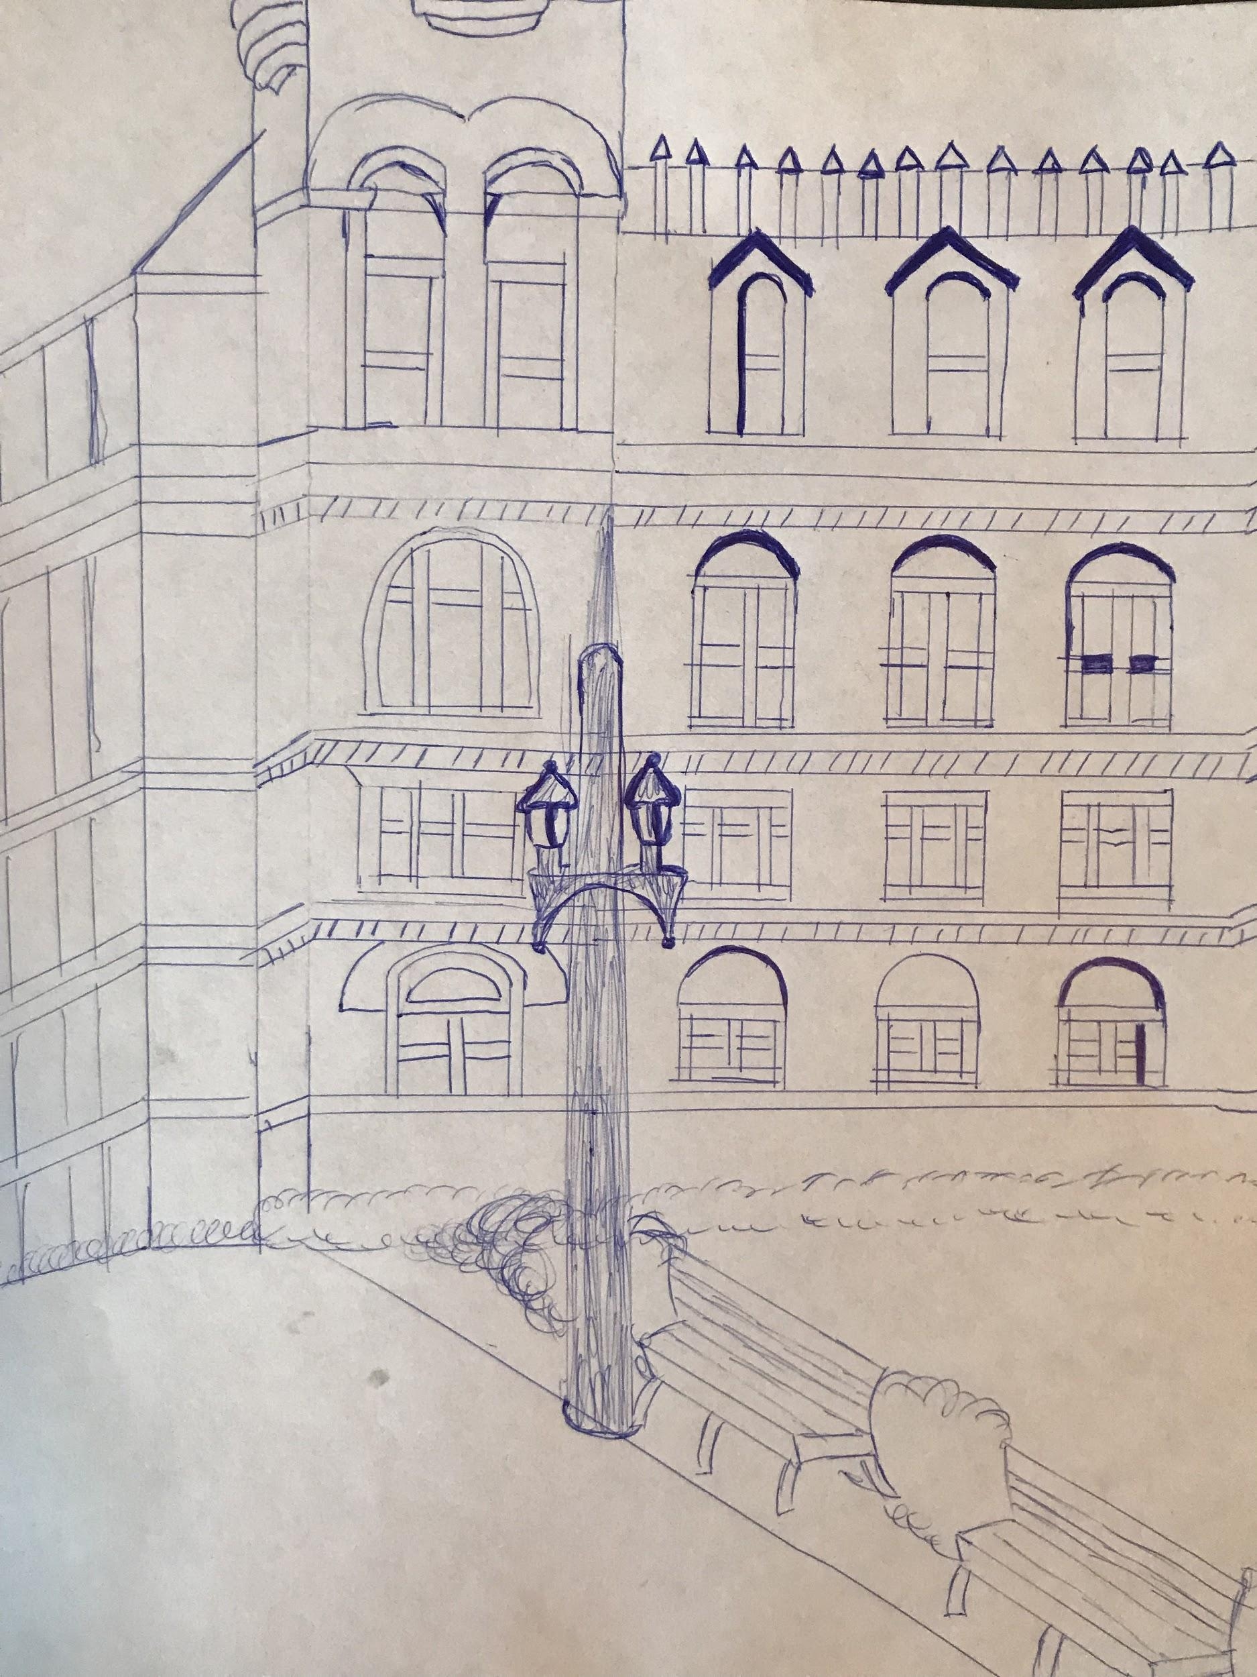

GENERAL NOTES:
- Fulton street was named after a man named Robert fulton which once had steam ferries in order to get from Brooklyn to Manhattan.
- Brooklyn was an independent city until the 1900s.
- Boerum Hill is a historical landmark making it so that no change can be made in that neighborhood. When you cross Atlantic Avenue, you can see the shift from busy high rises to comfy brown stones homes.
- Stoops were created by the Dutch and the idea was used on New York buildings to promote socializing.
- New York City’s choice of materials to build a house were bricks and stone because wood catches fire to quickly and due to the Great Fire Of 1835.

INSIGHTS/DISCOVERIES
On the first day of classes we watched my Brooklyn which really hit home for me because I remember being a part of the Fulton street community. Fulton mall was not just a mall, it was a place to hang out for a lot of kids who really had nowhere to go besides prison. Albee square mall was a hang out for a lot of teenagers that would hang outside the mall and smoke weed . My mother would turn and yell at me “I better never catch you down here” . So when I was told we had a trip to Fulton mall I was excited for a number of reasons. Since that’s my original hang out spot majority of the local mom and pop shops know me on a first name based and the local vendors. The first sight walk showed me it’s no longer Fulton mall . What makes Fulton so good is the ying and yang, the good and bad. The fact that I didn’t sense danger I know the old community of Fulton mall was gone. I learned a lot about constructing houses and why they are built on a angle and why some buildings resembles others because of the same maker. I’ve been part of the downtown Brooklyn community for years and never have I walked Boerum hills it was a amazing to see the inside of that area and how they live and shop.

KEYWORDS/VOCABULARY & DEFINITIONS
Gentrification- The process of renovating and improving a house or district so that it conforms to middle-class taste.
Open space- Any open piece of land that is undeveloped (has no buildings or other built structures) and is accessible to the public. Open space can include: Green space (land that is partly or completely covered with grass, trees, shrubs, or other vegetation
Tenement housing- A run-down and often overcrowded apartment house, especially in a poor section of a large city.
Historical landmark- A National Historic Landmark is a building, district, object, site, or structure that is officially recognized by the United States government for its outstanding historical significance
Paid open space- A usable outdoor area is considered to be private open space. It can include balconies, terraces, decks, front gardens and areas between a dwelling and the boundary. ... Single dwellings require two different types of open space - private open space and principal private open space.

QUESTIONS for Further RESEARCH
- Will there be a cap to the amount of high rise buildings? Or will construction continue until the boroughs
- Is there any program or set up where the rent is cheaper/less on specific sections of a building, such as the lower levels are less rent than the top?
- How hard is gentrification affecting all five boroughs?

