Learning Places Spring 2017

SITE REPORT #4
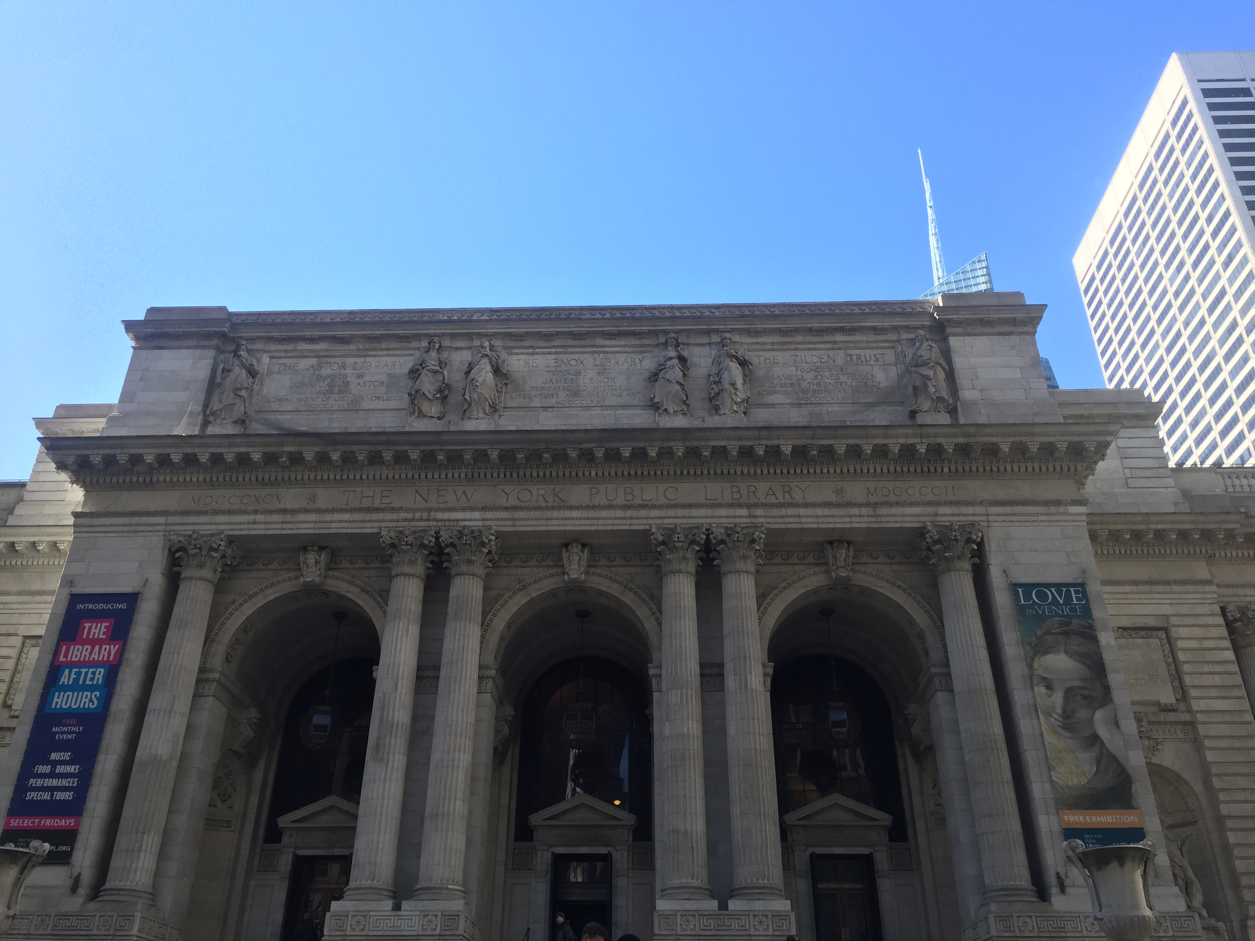
Mohammad Rasouly
3/29/2017

INTRODUCTION
As our professor prepared a visit to the New York public library on 42nd street and 5th avenue. As I got to the library we were one room where the librarian really explained how to get the information about our topics. He also explained how to use the map to get information about specific topic. Our hypothesis was about the Navy yard. Our group focused on the map of the navy yard and how the navy yard impacted the neighborhood of vinegar hill.

OBJECTIVES
As I got to the New York public library, I got useful information about the navy yard. I took pictures of the navy yard which I found in the red maps. This map shows vinegar hill, Dumbo and navy yard area. I found information about the population in Brooklyn in the 1900 to 1960s. I found a map which gives me the information about the dry docks and the piers in the navy yard from the Redi Sanborn from 1988.

PRE-VISIT REFLECTION
Before visiting the New York public library, I was excited and I was thinking I would get to
Learning about the library first because I had never been to that library. I would try to use as many as possible resources to get useful information about my topic to make my hypothesis better. Since I am learning more about the navy yard, I would change my thesis to how rebuilding the navy yard would impact the area such as vinegar hill. I would do more research on the new thesis to make it stronger.
SITE DOCUMENTATION:

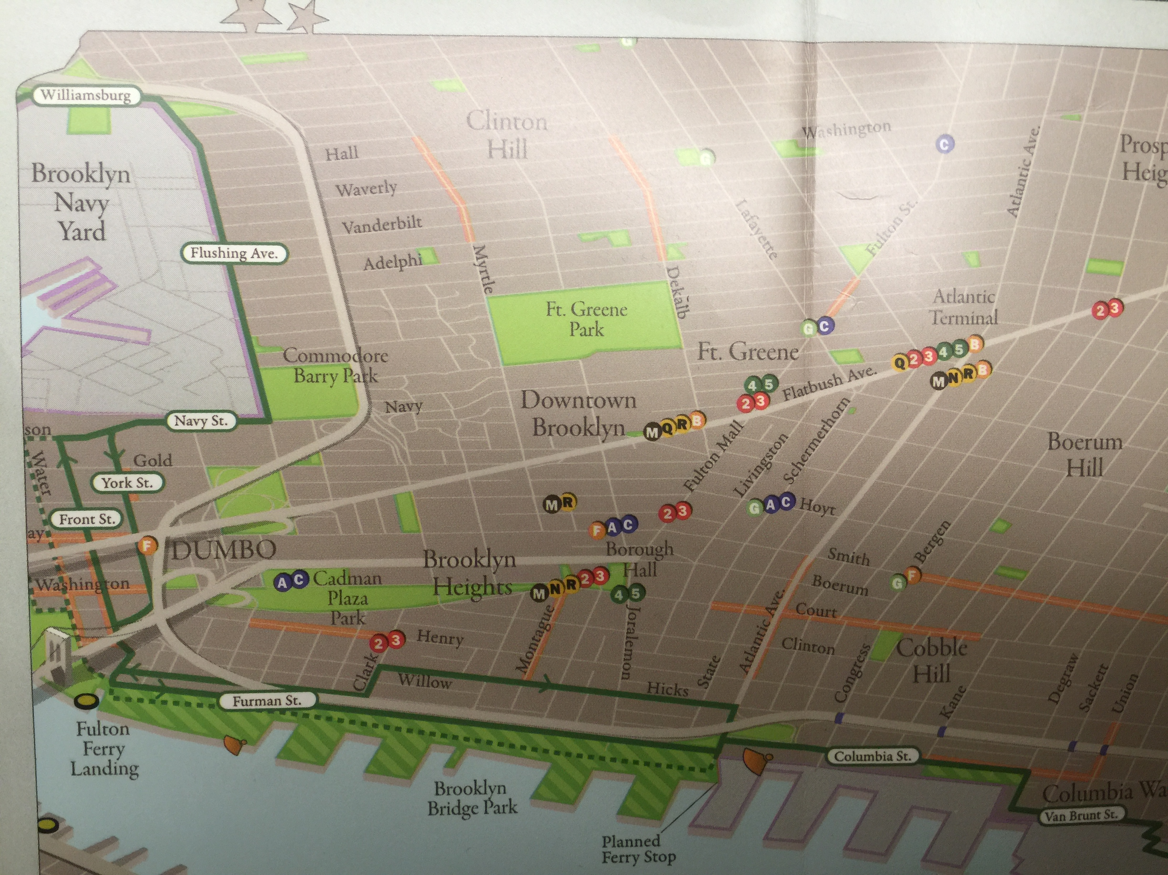
Brooklyn Greenway initiative 2009
This map shows the navy yard on the upper left corner. It shows the location of the navy yard and the greenway going around the navy yard along the east river which is a bicycle route. This greenway will be a fourteen mile long path. This path will connect neighborhoods to four major parks. This will allow cyclists and joggers to exercise and relax it the water edge. There is F train line very close to the navy yard.

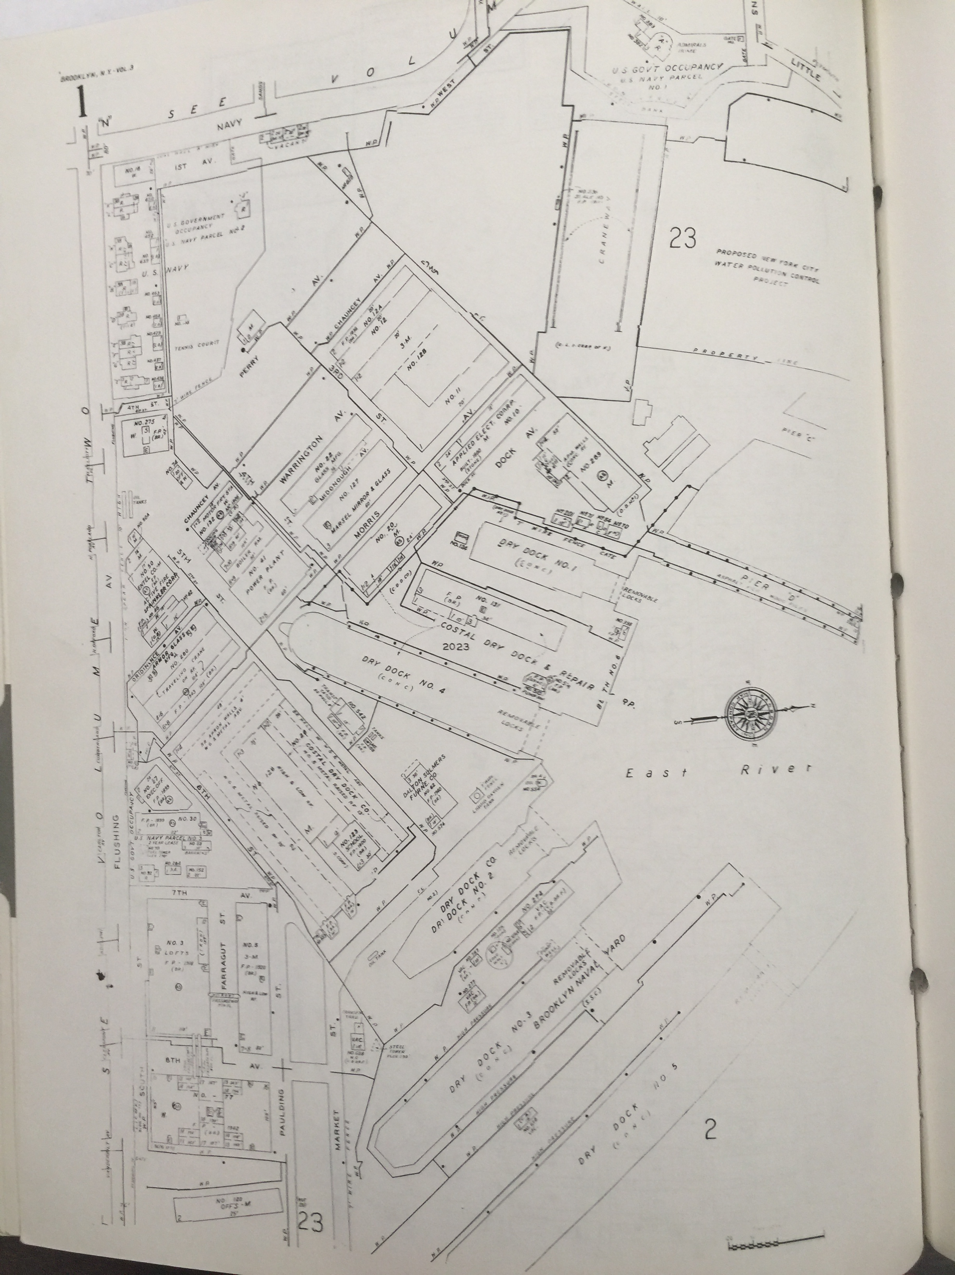
Brooklyn Navy Yard 1901
This picture show the Brooklyn Navy Yard. This picture is from 1901 inside the Brooklyn Navy Yard. I found at in the REDI SANBORN Atlas volume 1 to 3, 1989 in New York public library. This Map shows all the docks, dock numbers and the piers where each pier is located. It also shows all the streets, in some cases the streets are only one block long.

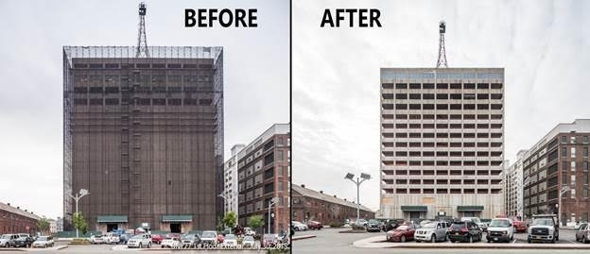
Brooklyn Navy Yard Building 77, Gateway to the yard
This picture is the building 77 inside the Navy Yard. It will increase employement at the Navy Yard. It will bring new jobs. They are modeling the ground floor for food hall which will be a space for food manufacturing. This will have good impact on the out side neighborhood such as vineger hill. If there is more people employed in the navy yard more businesses will open outside.

SITE OBSERVATIONS:
- I Liked the ways everything was explained with specific time period
- Information about my new thesis which more Employment in the navy yard stronger community in the neighborhood such as vinegar hill
- I used one atlas which give me information about the population of Brooklyn on specific time period
- I found information on the map about the greenway going around the navy yard
- Rebuilding the navy yard pictures, financial speeding and time.

QUANTITATIVE DATA:
Subject | Data
Atlas of Brooklyn | 2, “SANBORN” Atlas of Brooklyn FROM 1989
MAPS | 3, Maps, Brooklyn Greenway initiative 2009
Map Division | 1, POPULATION OF BROOKLYN 1969

QUESTIONS AND HYPOTHESIS
QUESTIONS:
- What was the most important information I found in the New York public library?
- How does the Greenway benefit the neighborhood?
- Which information can make my hypothesis stronger?
HYPOTHESIS:
- I found different maps of the navy yard.
- The Greenway information I found was very important.
- I need to make my hypothesis stronger.

SUMMARY
As I visited the New York public library, I most information about my topic. I read some maps and Atlases which give me in idea that how I can change my hypothesis and make at stronger. I did charge my hypothesis but similar. I read the maps about the navy yard, saw the greenway which goes around the navy yard and saw the piers in the navy yard where they were located. I also found information about the population of Brooklyn and the rebuilding the buildings in the navy yard which will help me with my new hypothesis. I need to do more re search about my topic on how to make a good thesis and then move to the next step.

PRELIMINARY REFERENCES FOR PRIMARY SOURCES:
- Regional plan association (New York NY) Cartographer.” A users Guide to the Brooklyn waterfront Greenway 2009-2010/regional plan association”. the New York public library, 2009, WWW.BROOKLYNGREENWAY.ORG

- REDI Maps, “Brooklyn – Dumbo, ft. Greene, Downtown, park slope: the essential guide to neighborhoods, restaurants – for urban explorers.” New York: west 16th street Map Co Inc. 2016.

- SANBOURN. ”Building and property Atlas of Brooklyn New York.” 2015 Core logic.

