Learning Places Spring 2017

SITE REPORT #4

Visit to the New York Public Library

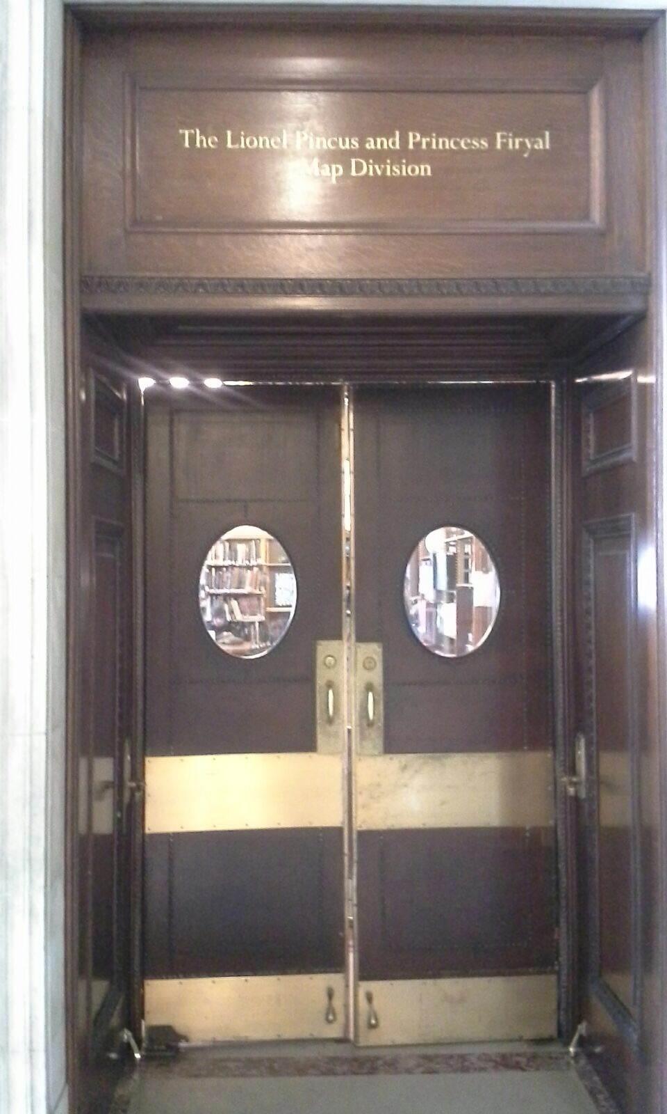
Stacey Battice
00.00.2017 INTRODUCTION
This visit was to the New York Public Library. We were placed in groups to look at the map division. A male librarian was onsite and explained to us what was kept at the library. He explained that this map division is the largest in the United States with ½ a million maps from the 16th, 17th 18th and 19th centuries. The subject area of these maps is New York State. He further stated that there were 26, 000 atlases and they are in the process of digitalizing maps and so far a total of 7000 are digitalized.

Describe Scope of Activity
Development and Preservation Group will gather all information of maps, atlases, articles and books at the New Yok Public Library to try and develop, analyze and apply to a hypothesis for Vinegar Hill.
OBJECTIVES
This visit objectives was to deal specifically with the group’s hypothesis.
PRE-VISIT REFLECTION
I went to this visit with hope of finding all the information my group needed because of its name New Your Public Library, My imagination led me to think of a large place with information. The name made me think that everything about New York will be store here and it would be easy to source information and answer the hypothesis.

Site Documentation Photos
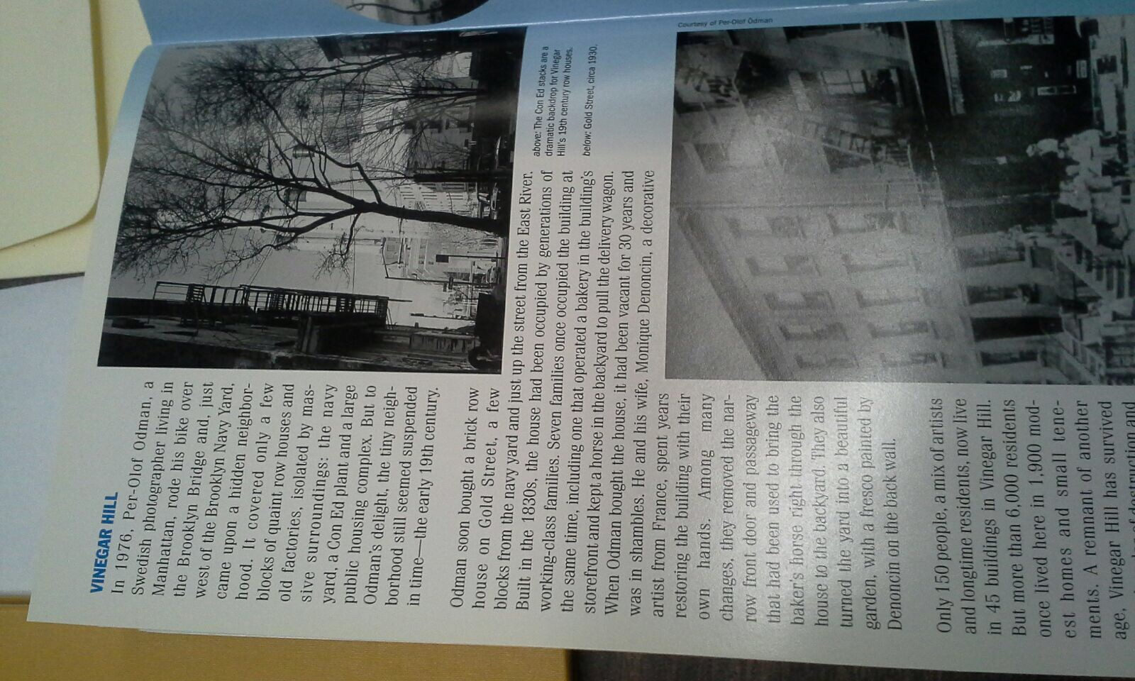
Photos give an insight of what made up Vinegar Hill and its residents. One resident spoke of when he and his family took up residence here and the renovations done his their home.

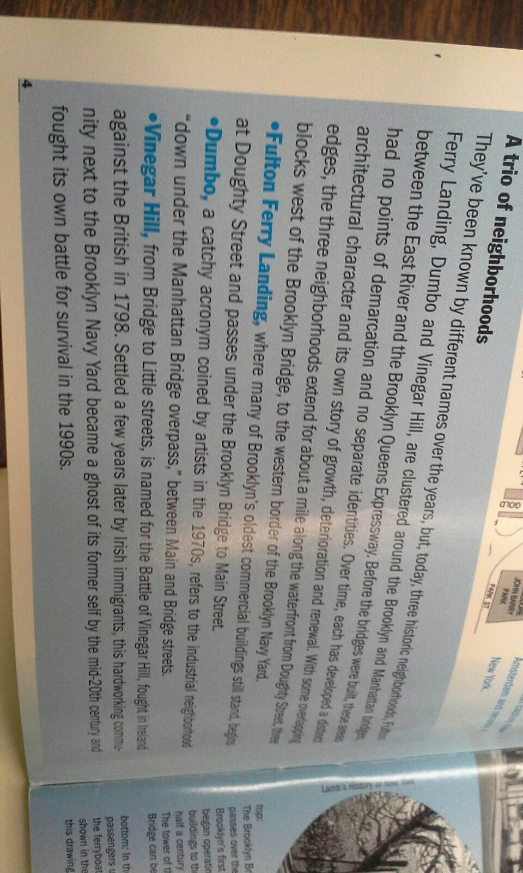
In reference to clip that speaks of Vinegar Hill, It still appears to be a ghost town without residents up to now as it was in the 17th century.

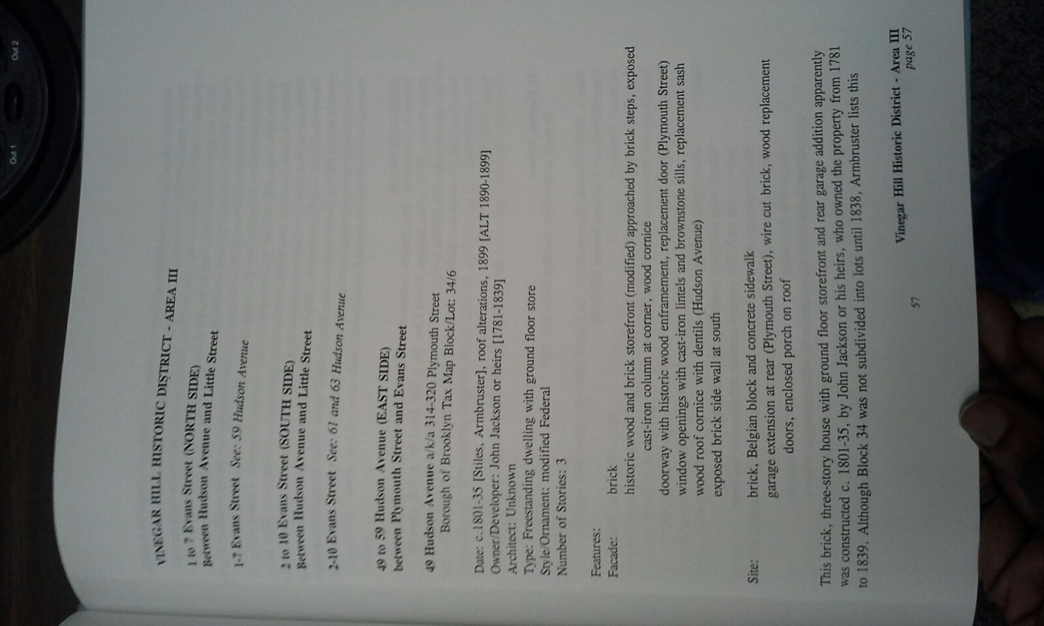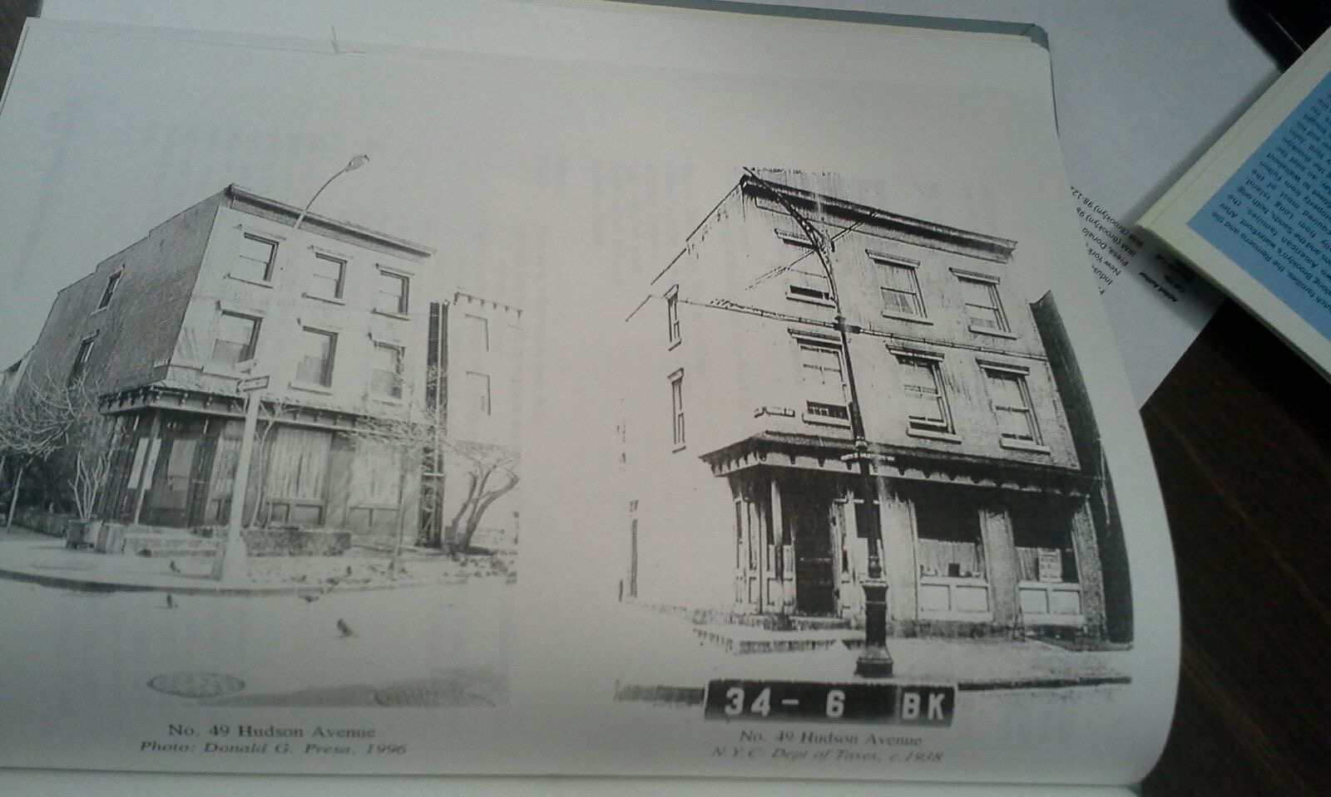
Photo 1 shows detail information of the resident’s homes on 49 Hudson Avenue. Photo 2 shows the historic district of Vinegar Hill showing the wood brick houses of residents on 49 Hudson Street.

SITE OBSERVATIONS:
- Maps and Atlases from 16th, 17th, 18th and 19th century
- Very limited information in regards to groups hypothesis
- The librarian seems very knowledgeable
- Fire maps had current information pasted on them
- Most books were very broad with information covering downtown Brooklyn and not specific to Vinegar

QUANTITATIVE DATA:

Subject | Data
Atlases | I looked at one atlas
Maps | There were 2 maps
books | 1 book with 2 pages of Vinegar Hill

QUESTIONS AND HYPOTHESIS
QUESTIONS:
- Were there any town hall meetings in Vinegar Hill?
- When will Vinegar Hill residents renovate these dilapidated houses?
- As known to be an historical District why is Vinegar Hill still a Ghost Town?
HYPOTHESIS: From the questions you wrote above, select the most important question for your own research topic. Propose an explanation made on the basis of the evidence you have so far as a starting point for further investigation.
- The residents of Vinegar Hill were not interesting in hearing from outsiders.
- It is too expensive why residents not renovating homes.
- Residents and visitors visit Vinegar Hill more at night time and on the weekend.
SUMMARY / POST VISIT REFLECTION / NEXT STEPS?
The Visit was very interesting although I may have not found enough information at New York Public Library. I enjoyed the architecture of the place and even visited another quiet area for map divisions. Hopefully I would look online as stated by the Librarian for any further information needed to move forward with group’s hypothesis.
PRELIMINARY REFERENCES FOR PRIMARY SOURCES:
- Photographer, Anonymous. Black and White Photographic Print, Brooklyn Collection, https://www.nypl.org/
- https://www.nypl.org/collections/nypl-recommendations/guides/fire-topo-property-maps

