This topic is about development and preservation. The purpose of using the Digital Public Library of America was because it quick, accessible and narrowed the searched easily. I was able to use the key word Bridge Street and came across some very interesting photos of a demolished area in Vinegar Hill. Why indeed did the Brooklyn Union Gas Co. tank was demolished? This fits into the topic of development and preservation as now the group can re visit and see what has now gone in that spot. This source raise the questions of how do items end up here? Also, are there any physical copies of items? The best place to look for answers would be through the World Wide Web.

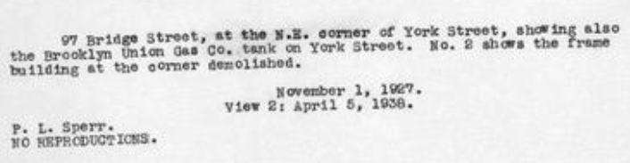
Picture 2
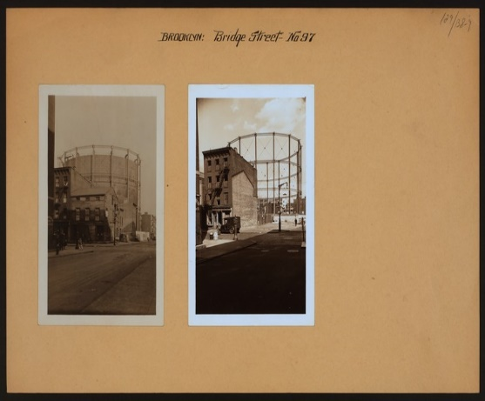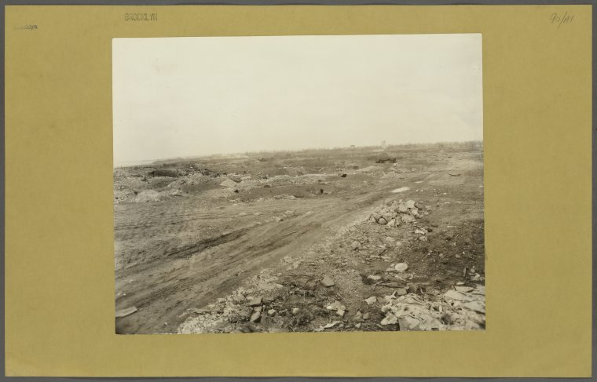

http://digitalcollections.nypl.org/items/510d47dc-c6b9-a3d9-e040-e00a18064a99

