Learning Places Spring 2017

SITE REPORT

COVER IMAGE: PLACE AN IMAGE PRODUCED BY YOU THAT BEST EXPRESSES THE IDEAS OF YOUR QUEST
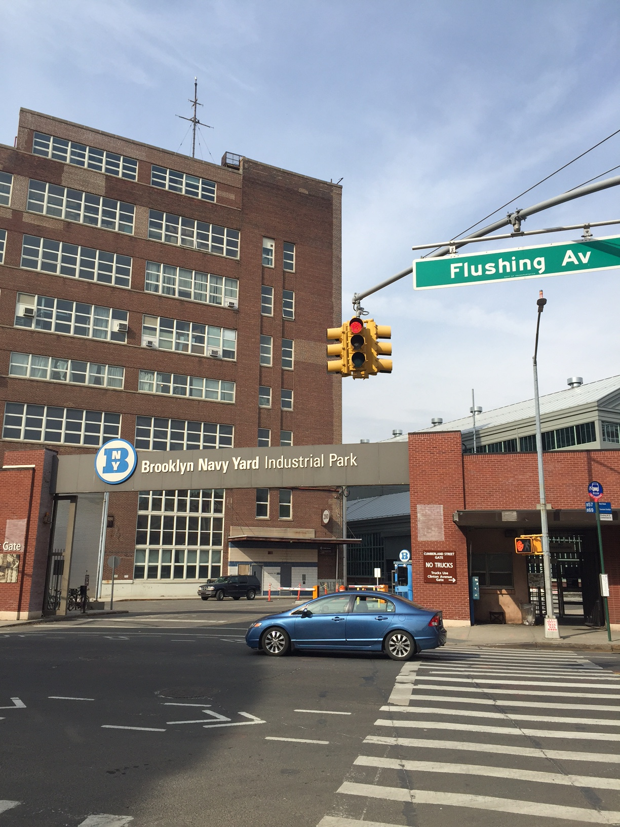
Mohammad Rasouly
3/4/2017
INTRODUCTION
The Brooklyn navy yard which used to be a shipyard. The navy yard located in down town Brooklyn. It has many entrances from different sides of the streets. Its bounded by navy street, flushing avenue and Kent avenue. As I walked with my group, we observed many different entrances to the navy yard.
PRE-VISIT REFLECTION
Before visiting the sites, I had no idea how down town Brooklyn looked like. I had been to Dumbo but not Vinager hill. Vinager hill is very interesting which gives you all the historical ideas about the neighborhood. I would like to learn more about Vinagar hill. My topic for the site report this time is the navy yard. Navy yard also have some interesting things to be visited.
SITE DOCUMENTATION I:
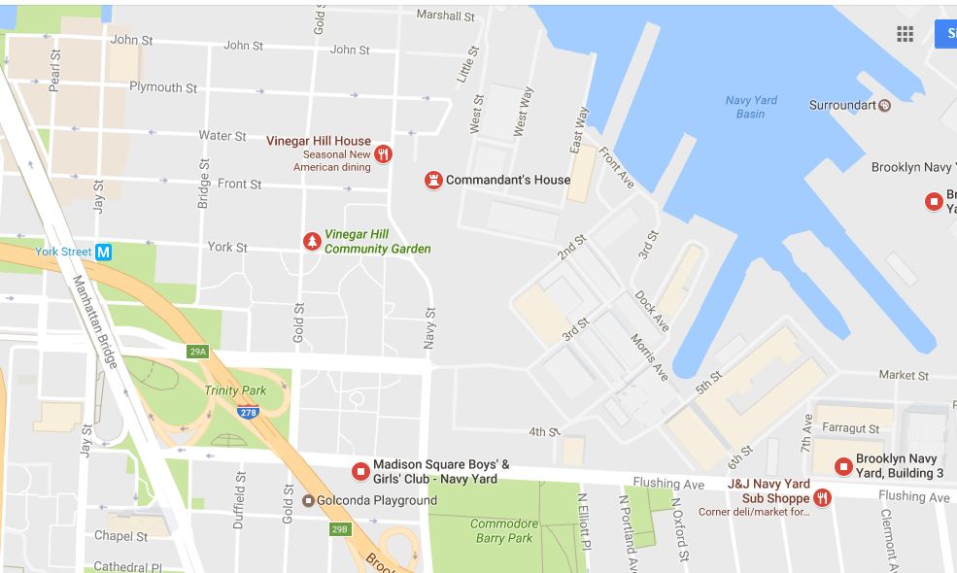

SITE DOCUMENTATION II: photos/sketches for 2-3 significant stops. lanations –y is image shown Siloration



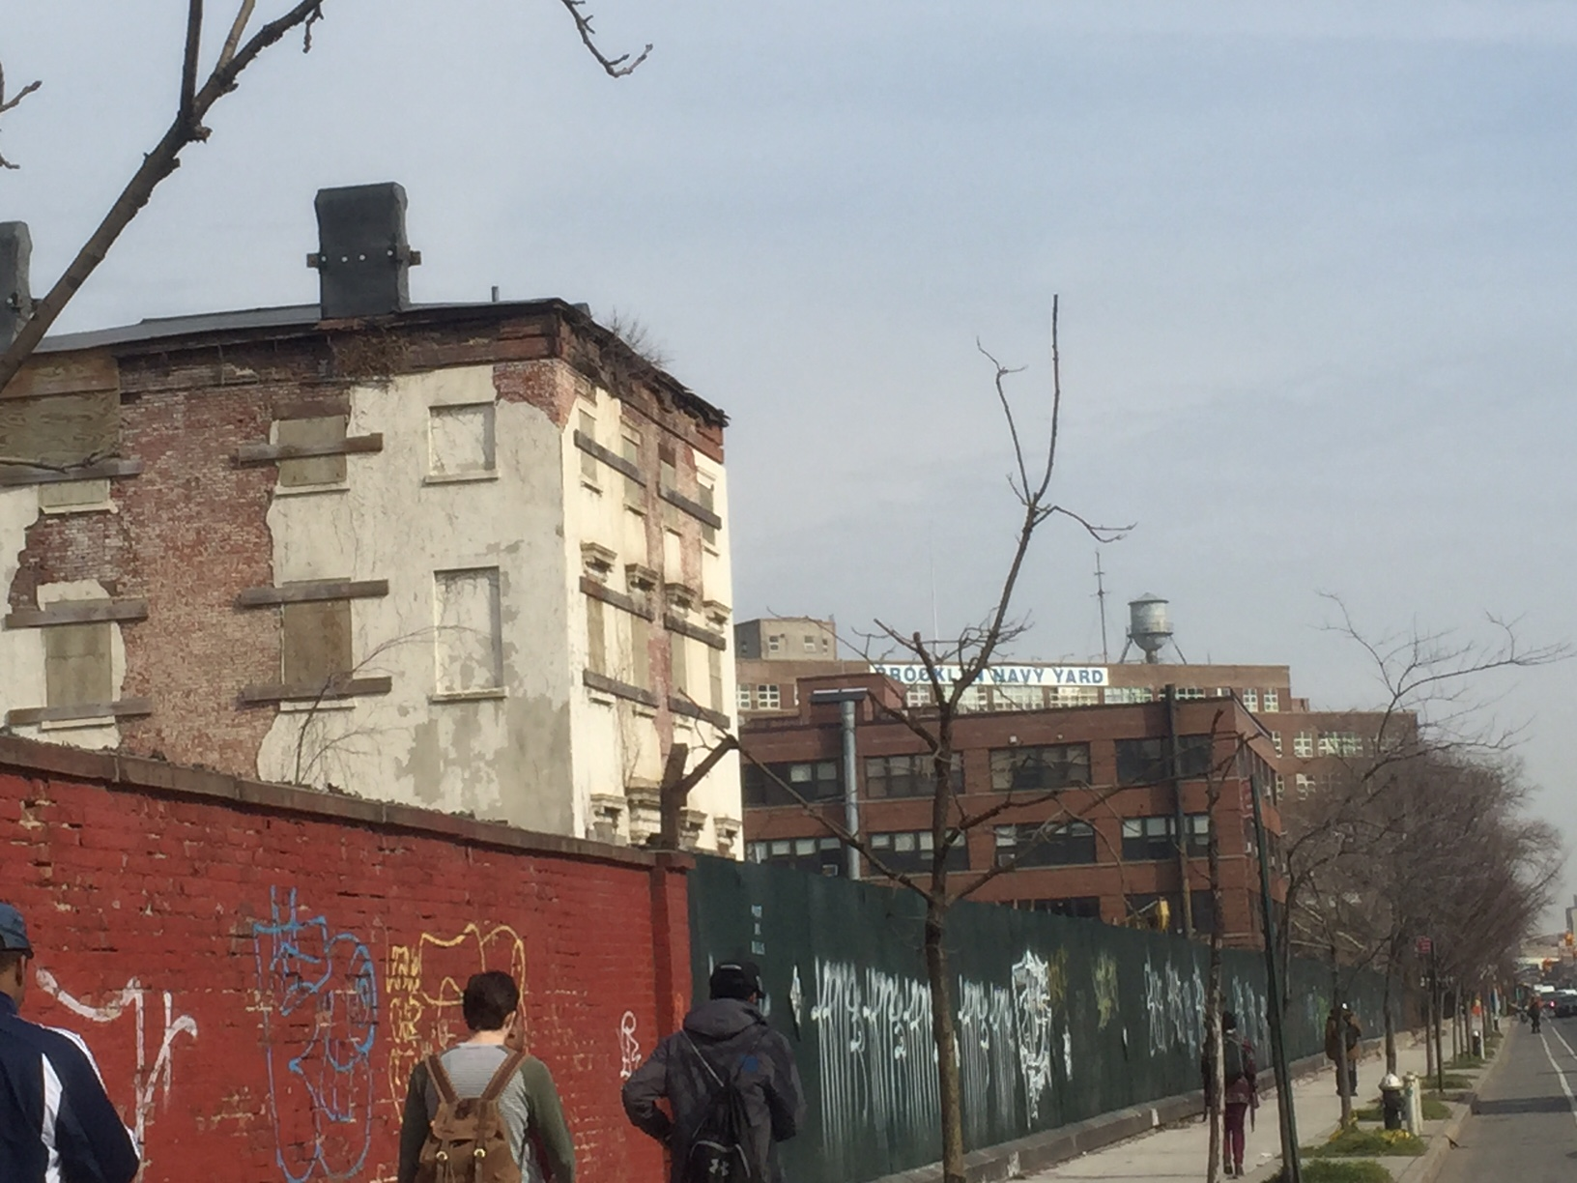

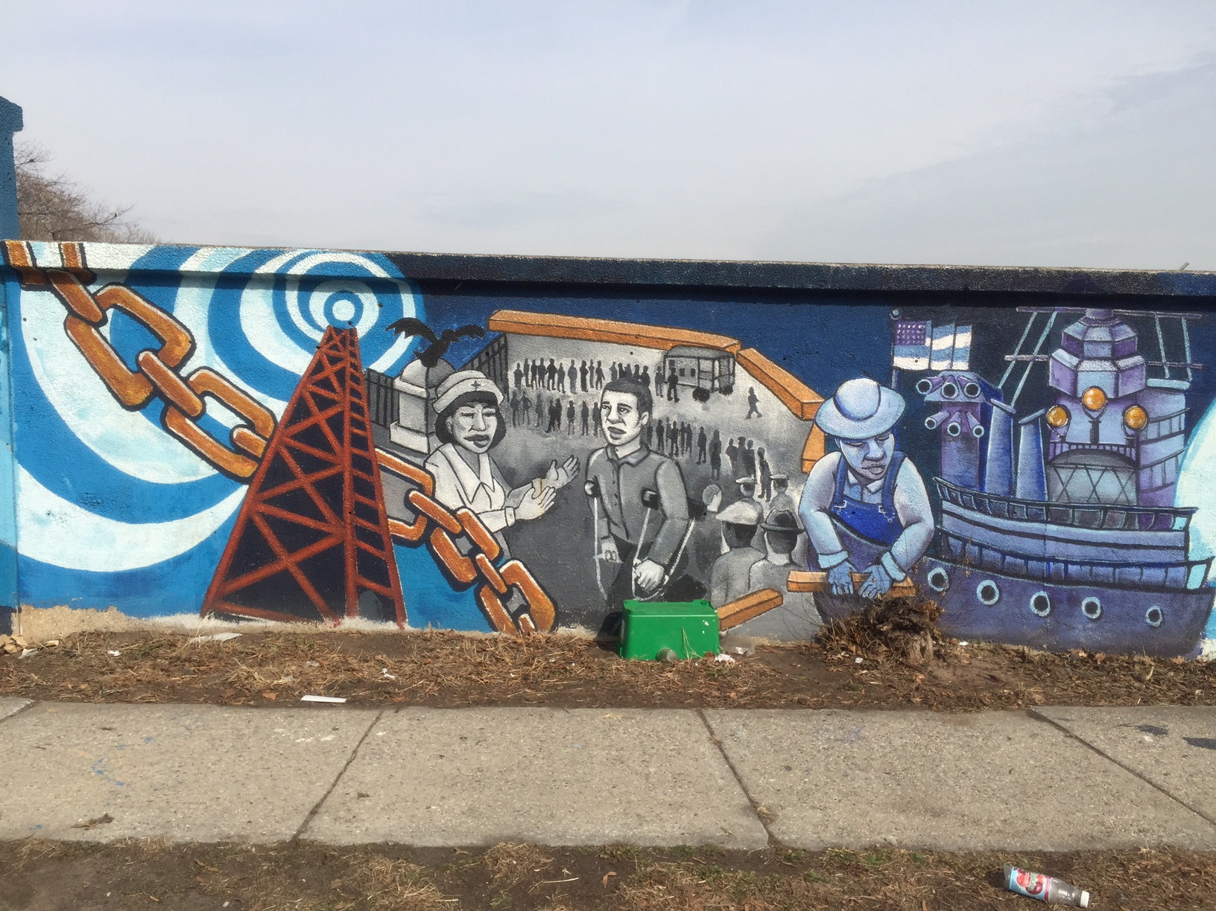

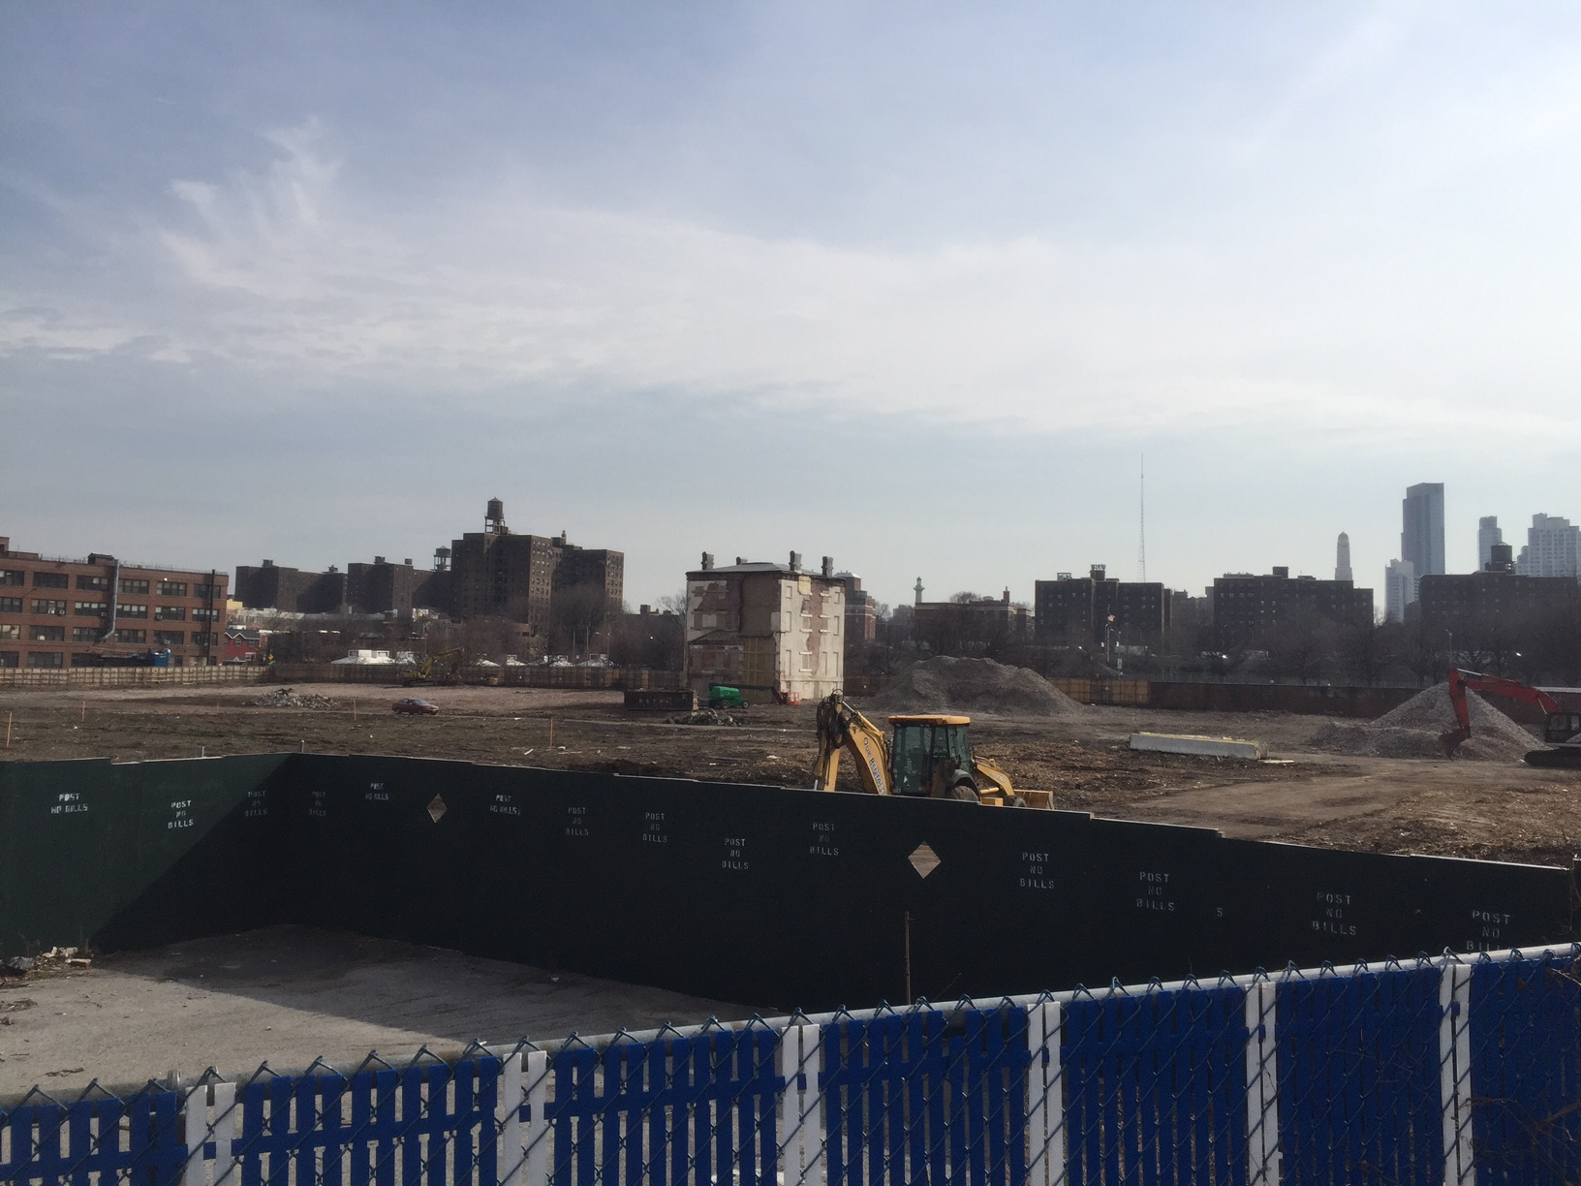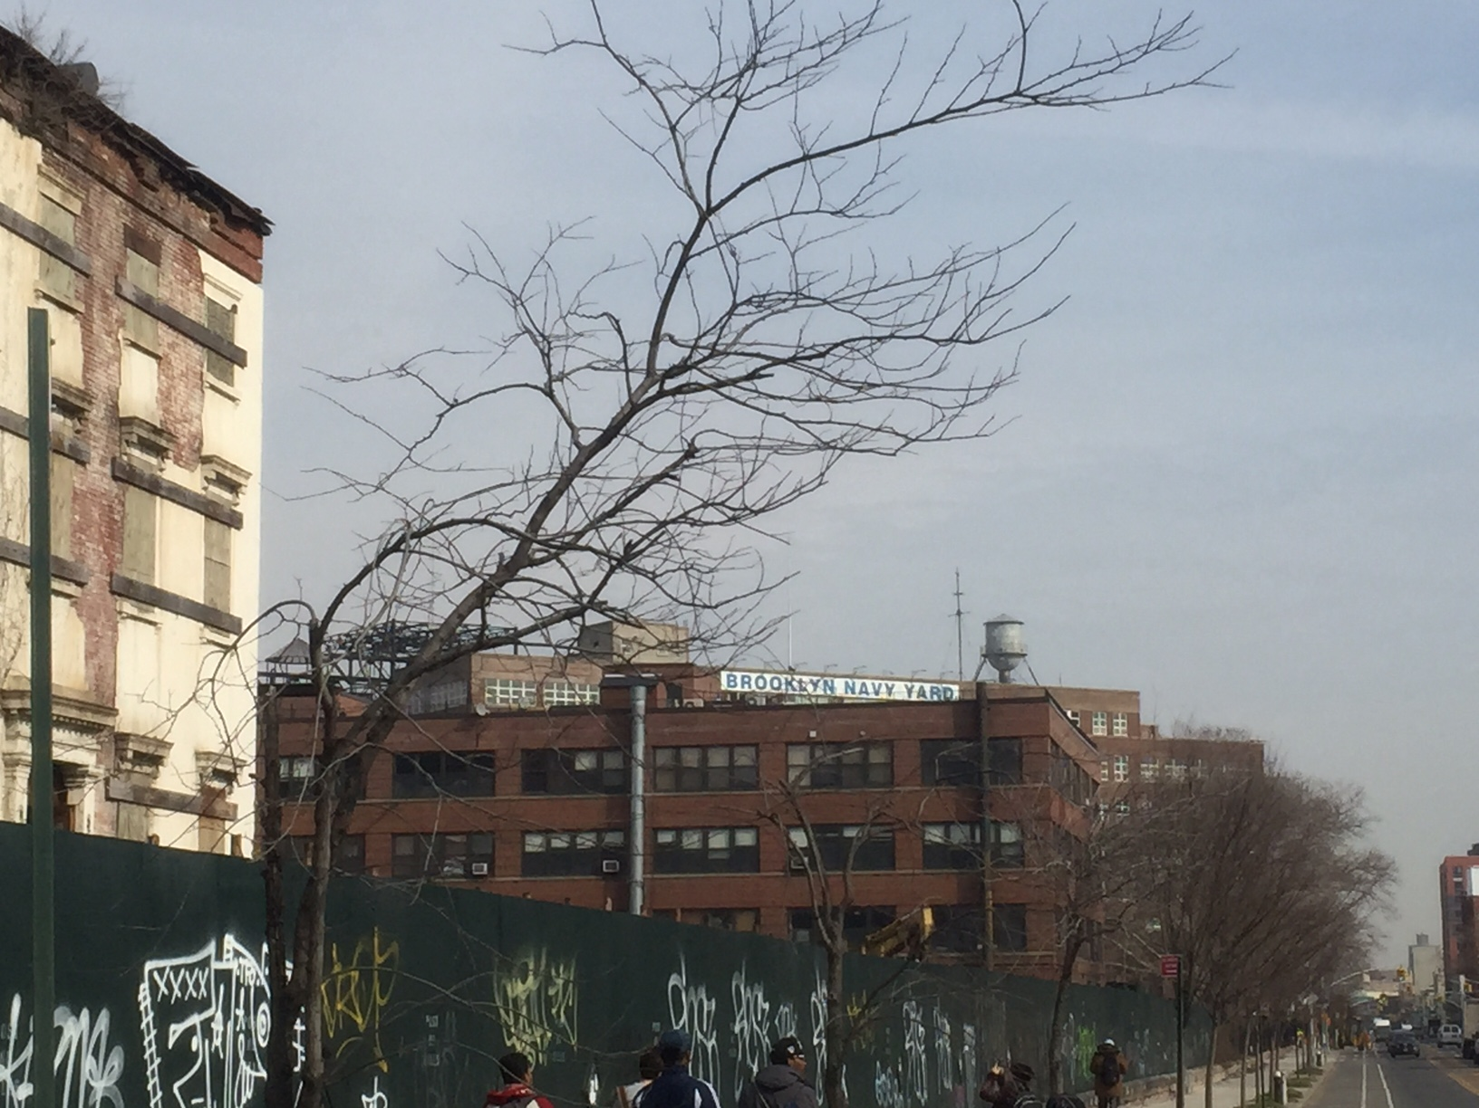
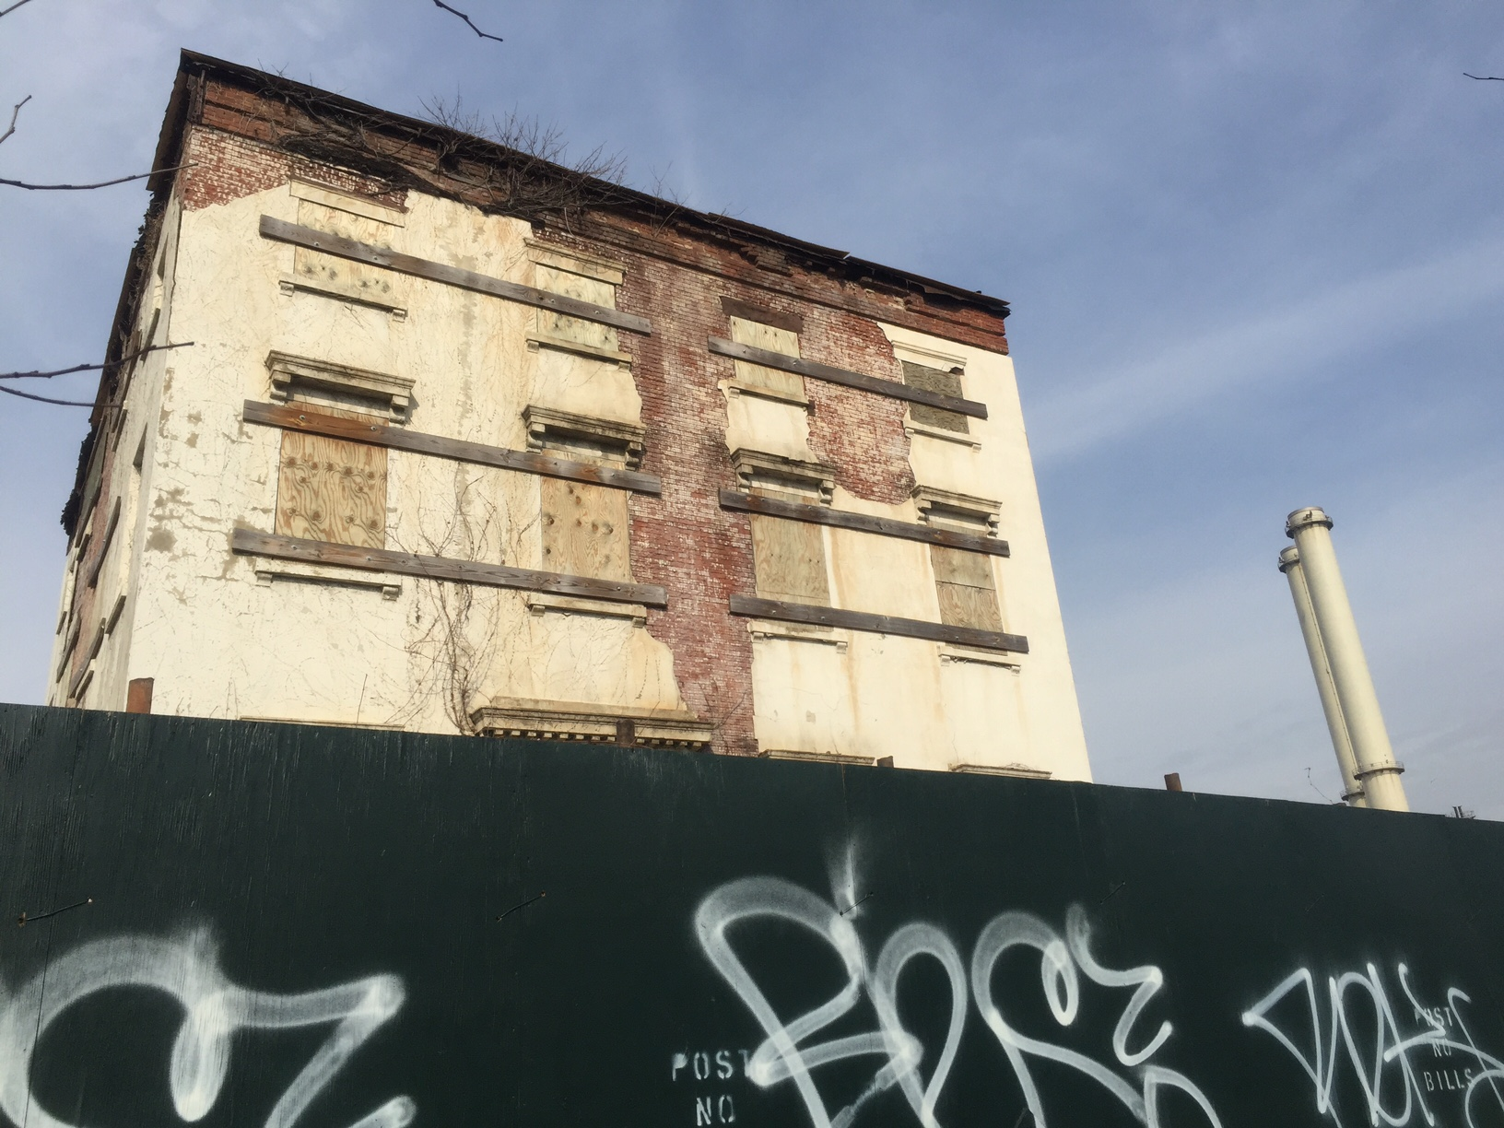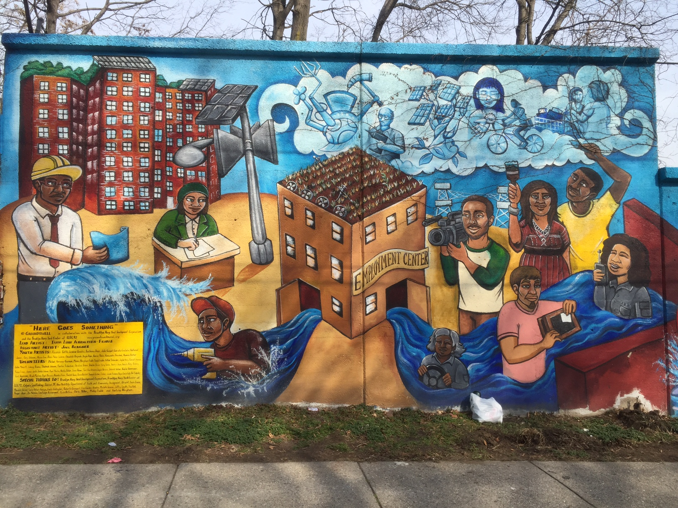

SITE OBSERVATIONS:
- A big lot with in old building in the middle
- Navy street side wall with a lot of panting
- There were three entrances to navy yard with one main entrance
- The opposite side of the street public housing
- Security guard on the entrance
- MTA bus
- Many solar panels

QUANTITATIVE DATA: under “subject” list the topic; Under “data” describe your findings and the quantity found
Subject | Data
Old building | 1
Big Lot | 1
Entrances | 3

QUESTIONS AND HYPOTHESIS
QUESTIONS:
- How old is the navy yard
- Why is it in Vinager hill
- Why was their solar panel walking to navy yard
HYPOTHESIS:
- Build in 1801
- It is closer to the historical neighborhood of Vinager hill
- There are many solar panels
SUMMARY / POST VISIT REFLECTION / NEXT STEP? –
I would go back to the museum and find out more about the navy yard. The visit to navy yard was very helpful more me to write my report. There was a big lot with one building in their which has been left alone in that big yard. I think they have to rebuild some of the buildings in the yard. I would go back and find more information about the open lot inside the navy yard.

PRELIMINARY REFERENCES TO EXPLORE HYPOTHESES:
- GLENN BLAIN. “Cutting-edge solar panels light the way to renewable energy at Brooklyn Navy yard.” SEP 26 2016,
- C. J. HUGHES. “Reinventing the Brooklyn Navy Yard.” The New York Times, OCT 30, 2015,

