Learning Places Spring 2017

SITE REPORT

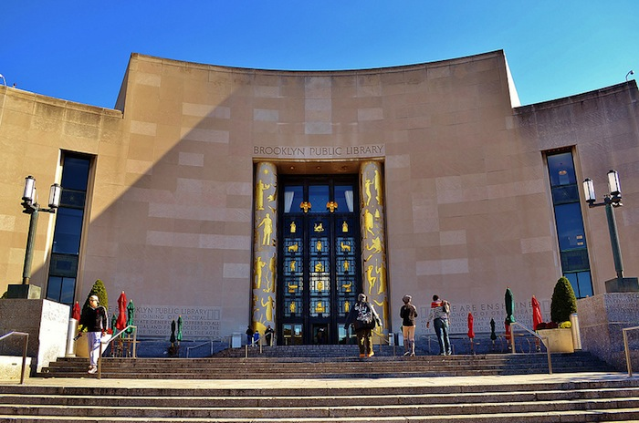
DeandraAnthony
Art & Gentrification
02.22.2017

Introduction
This week we went to the Brooklyn Public library in Grand Army Plaza. We visited the picture collection and had help looking for article/pictures pertaining to our subject. Orlando, Iesha, and I had a hard time finding articles about Art & Gentrification about Vinegar Hill and Dumbo specifically. We did find articles about gentrification in Williamsburg, prospect Park and crown heights. Art seemed to play a huge part in the Williamsburg area. They called it a hippie area. It seems that the areas close to the water tend to have some sort of art/hippie vibe to it.
PRE-VISIT REFLECTION
We thought that it would be pretty easy finding articles pertaining to both Vinegar Hill and Dumbo (dumbo especially.) Dumbo is one of the more gentrified and most expensive area to love in Brooklyn. We came to the conclusion that maybe because it has been in this process of being gentrified for such a long time, it is not being written about.
SITE DOCUMENTATION II: This is an article about the forced eviction tenants are going through by the landlords of the building. Fake Marshalls knocking on the door and telling tenants they have to be out or they will be arrested.
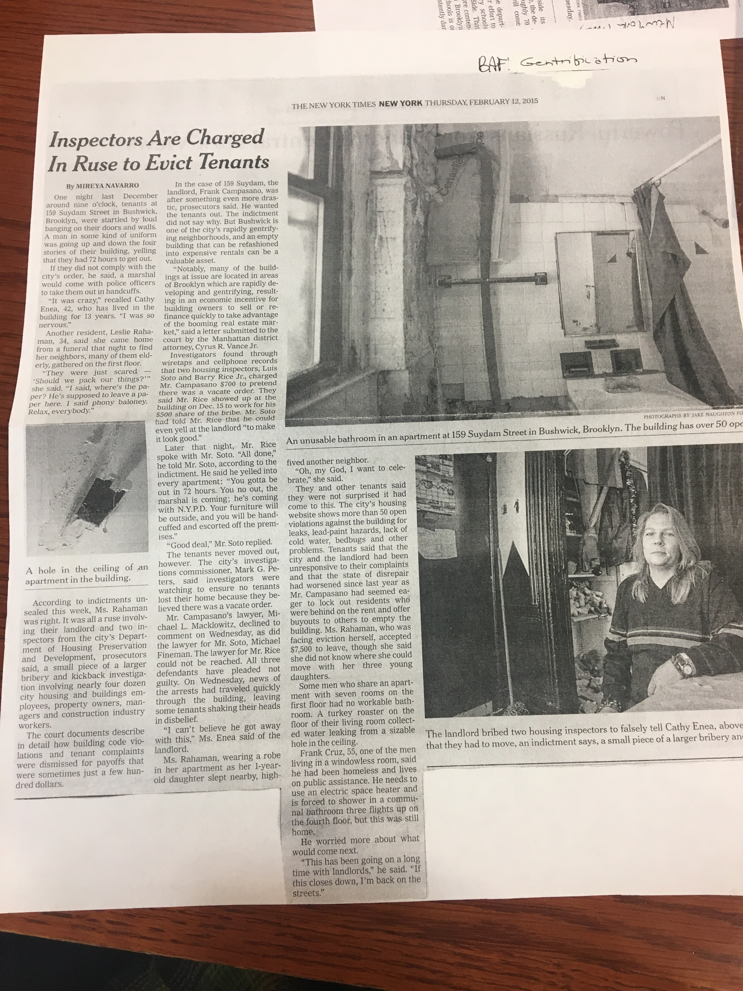.
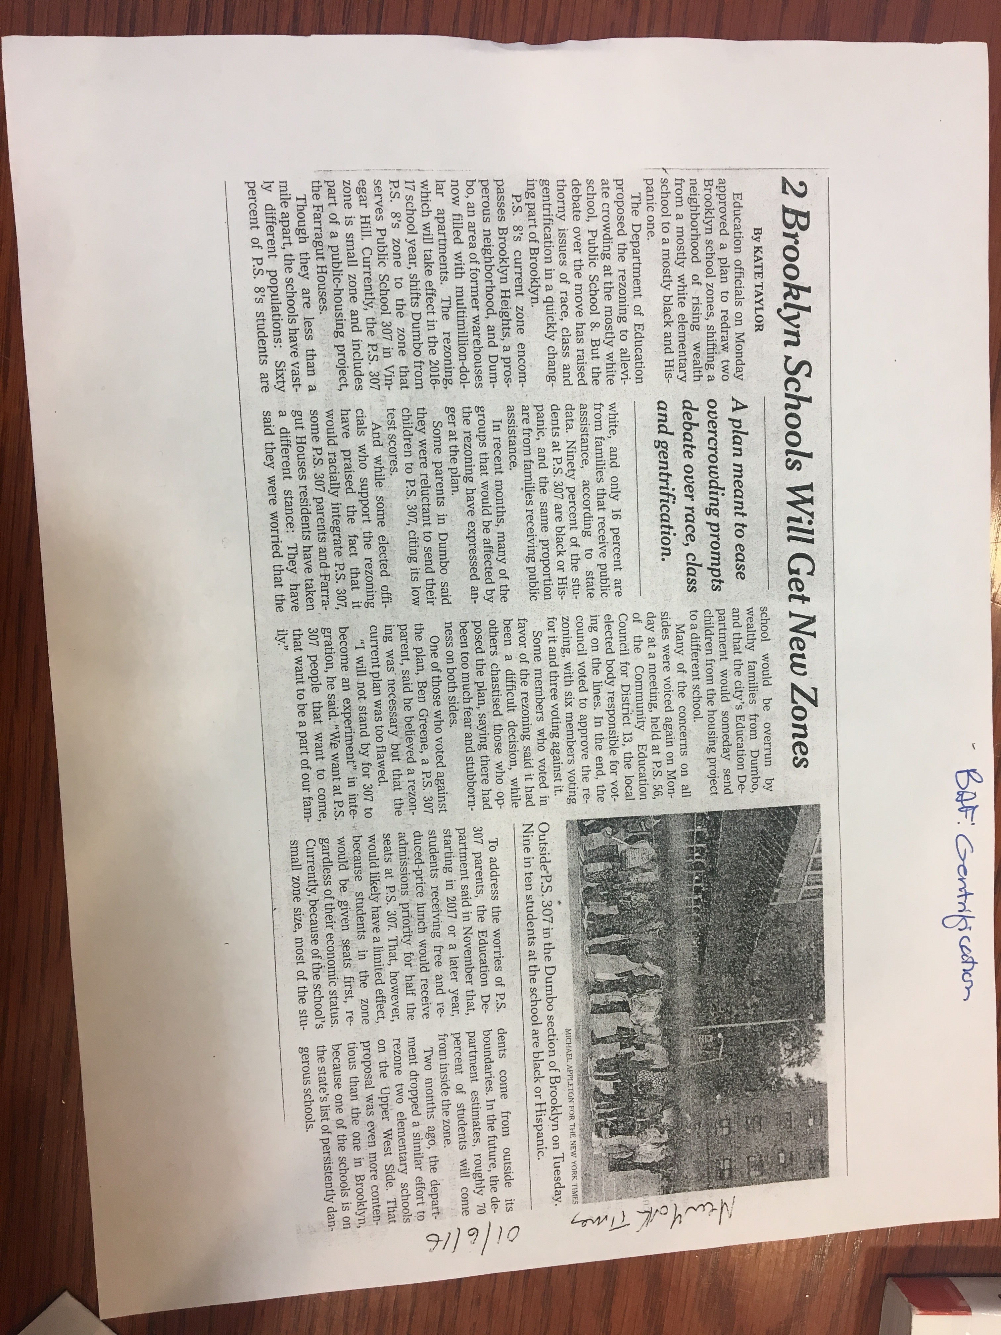

In this article you see the problems that come with zoning schools. A school across from Farragut housing is worried that the kids that come from Dumbo schooling will eventually kick them out.

SITE OBSERVATIONS: Note conditions you found and explain how they relate to the topic of your investigation
- Not many articles on art in comparison to gentrification.
- Gentrification articles to find for both Dumbo and Vinegar Hill.
- The scamming that is going on with the landlords of buildings.
QUANTITATIVE DATA: under “subject” list the topic; Under “data” describe your findings and the quantity found
Subject | Data
Gentrification | It was hard to find articles on gentrification in our selected neighborhood. What we did find was that the tenants that being kicked out of there apartments. The tenants moving in are being charged more for the same apartment. Tenants don’t have great living conditions (i.e bathrooms that work) and the building owners are not answering calls.
Art | Articles on art were very hard to find. The ones that we did find were also not about our area. Art was also used in conjunction with hippie and antique.

QUESTIONS AND HYPOTHESIS Consider the data found during your site visit and review the material you included so far in this report.
QUESTIONS:
- Why is Dumbo not written about in conjunction with gentrification?
- Is Vinegar Hill not a known place to think about gentrification?
- What is Vinegar Hill going to look like in the next 5 years?
HYPOTHESIS: From the question you wrote above - select the most important question for your own research. Propose an explanation made on the basis of the limited evidence you have so far as a starting point for further investigation
- Dumbo has been in the process of gentrification for such a long time that they are focusing on the newer areas.
- Vinegar Hill is right next to Dumbo so maybe people see it as one. Or maybe a lot of people don’t know about it.
- Vinegar Hill is going to be DUMBO part 2.
SUMMARY / POST VISIT REFLECTION / NEXT STEP? --
I think the next step would be realm in deeper into articles. Keep on digging until we find something.
PRELIMINARY REFERENCES TO EXPLORE HYPOTHESES:
- www.dnainfo.com/new-yrok/20170207/vinegar-hill/forgotton-farragut-houses-documentary-gentrification
- dumbonyc.com/blog/2010/04/19/nymag-genesis-of-dumbos-gentrification/
- dailynews.com/opinion/goodness-new-brooklyn-article-1.293812

