Learning Places Spring 2017

# SITE REPORT #3

# 

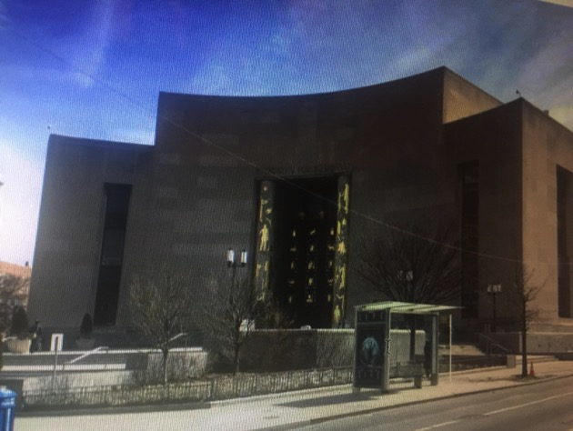

Brooklyn Public Library

Mohammad Rasouly

03/17/2017

INTRODUCTION

As I want to the Brooklyn collection. I found many historical collections of the navy yard. there were many articles about the navy yard. The navy yard has been

changed in many ways. I found different Maps from different time period of the navy yard. I also found Articles from newspapers about the navy yard which give me more information about the navy yard. I checked to different Atlases from 1903 and another one which was showing different maps of the navy yard. the one from 1903 was with information inside the navy yard and the otheir one was empty. I collected more picture, Articles which will help me finish my site report and make a better hypotheses for the next report.

OBJECTIVES

On Wednesday March 8, My group decided, that we will look for the map of the Navy Yard. We will look for New Paper Articles for the Navy Yard. We will find as much information as we can to see how Navy Yard have been change for time to time. We also decided to check the map of the navy yard to see what it show in the earlier time of the navy yard and what we see know. I wanted to look for the pictures of the ship at the Navy Yard which I found.

PRE-VISIT REFLECTION

Before visiting the Brooklyn public library, I did not have much information about the navy yard. I also did not know about the Brooklyn collection. I have passed by the Brooklyn collection many times but I had no idea what that building was. As I visited the Brooklyn collection It was very useful for me and made it easier for me to work on my site report. The information I found in Brooklyn collection could have been hard for me to find somewhere else. I would go back for more information for the future site reports I will have to write.

SITE DOCUMENTATION:

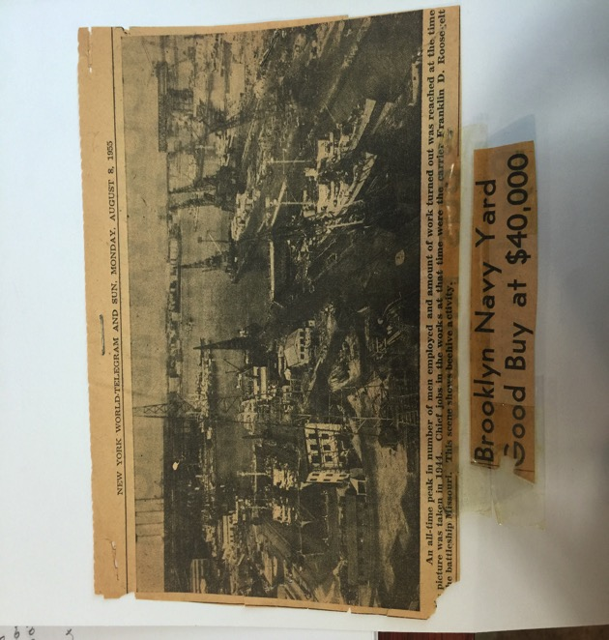 Brooklyn, Navy yard, 1944

This Image shows the ships which were used at the Brooklyn Navy Yard. This Image was taken in 1944. This time the employment at the Navy Yard was High. People lived very closed to the Navy Yard for the employment purepose.

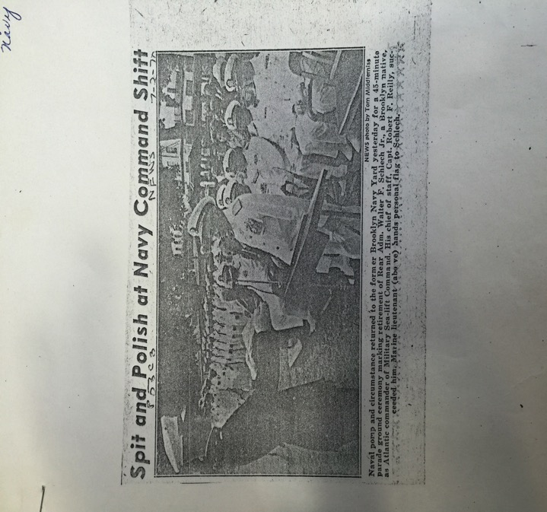

Navy Yard Command Ship, July 2, 1970

This Image was taken by Tom Middlerniss on july 2, 1970 at the Brooklyn Navy Yard. This is the parade ground ceremony marking the retirement of the officiers.

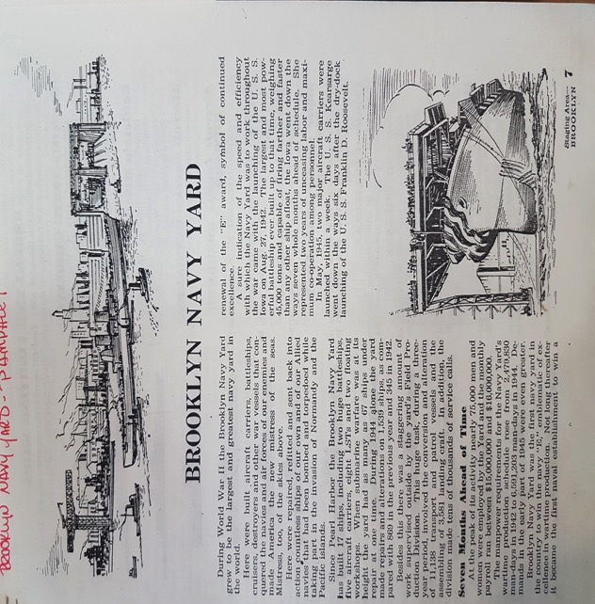

Brookly Navy Yard, August 27, 1942

The Image on the top is showing the Brooklyn Navy Yard and the ship going away and coming back to the Navy Yard. This Image is showing the time of the world war 11. The Navy Yard was at the peak on its employment rate.

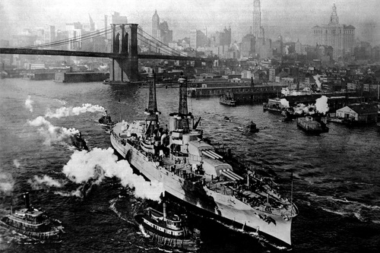

In the East River, New York City, 1915. Naval History

This Image shows the east river New York City in 1915. It show the Brooklyn Bridge and ships going toward the navy yard. The ship looks like there is a lot of people in their.

SITE OBSERVATIONS:

1. Many Atlas Map Books.
2. Different Articles from different Time period
3. Atlas Book from 1903 used to check for maps of Navy Yard
4. Folders with information for Navy Yard
5. Digital collection , Articles, Photos

QUANTITATIVE DATA:

|  |  |
| --- | --- |
| Subject | Data |
| Atlas Book from 1903 | 1 |
| Articles | 7 |
| Pictures of a Navy Yard | 8 |

QUESTIONS:

1. Why was the Navy yard sold?
2. When was the largest ship build?
3. Where is the main entrance of the Navy Yard located?

HYPOTHESIS:

1. The Navy Yard can be rebuild and improved for the future.
2. There were many large ships build in used.
3. There are many entrances to the Navy Yard.

SUMMARY / POST VISIT REFLECTION / NEXT STEPS?

As I visited the Brooklyn collection where I found many information about the navy yard. I found pictures of the navy yard from the past. I found Map of the navy yard which give me a good idea how the navy yard was in the past and how it is in the present. I did not think, the Brooklyn collection would have the pictures and the articles I would from the past about the navy yard. I would want to go back to the Brooklyn collection again and look in to the navy yard information again. I would look into the information from time to time and the differences from the different time periods.

PRELIMINARY REFERENCES FOR PRIMARY SOURCES:

1. Albert Davila. “Mural at the Navy Yard a tribute to Adm. Guest.” Daily News, Brooklyn public Library, December 25, 1978.
2. Polly Kline. “Generate proposal to sell Navy Yard power to Con Ed.” Daily News, Brooklyn public Library, Friday 8 18, 1972: Page.3.

3. Tom Middlerniss. “Split and Polish at navy Command shift.” News Photo, Brooklyn public Library, July 2, 1970. Page.63.