Learning Places Spring 2017

SITE REPORT #3

COVER IMAGE: PLACE AN IMAGE PRODUCED BY YOU THAT BEST EXPRESSES THE OBJECTIVES OF YOUR VISIT
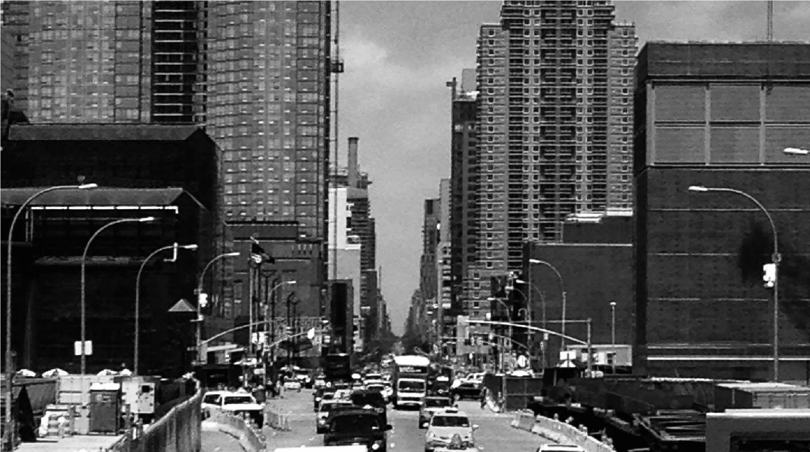
STUDENT NAME
00.00.2017 INTRODUCTION
Describe Scope of Activity
OBJECTIVES
Record the objectives that your group generated in class on Wednesday, March 8
PRE-VISIT REFLECTION
PRIOR to site visit, reflect on what you anticipate learning or seeing during the visit given what you have learned so far about your topic of interest, your previous site visits, and your explorations in digital archives.
SITE DOCUMENTATION: photos/sketches of 2 or 3 significant primary sources. Provide captions and explanations – why is the image shown significant for your topic of exploration?
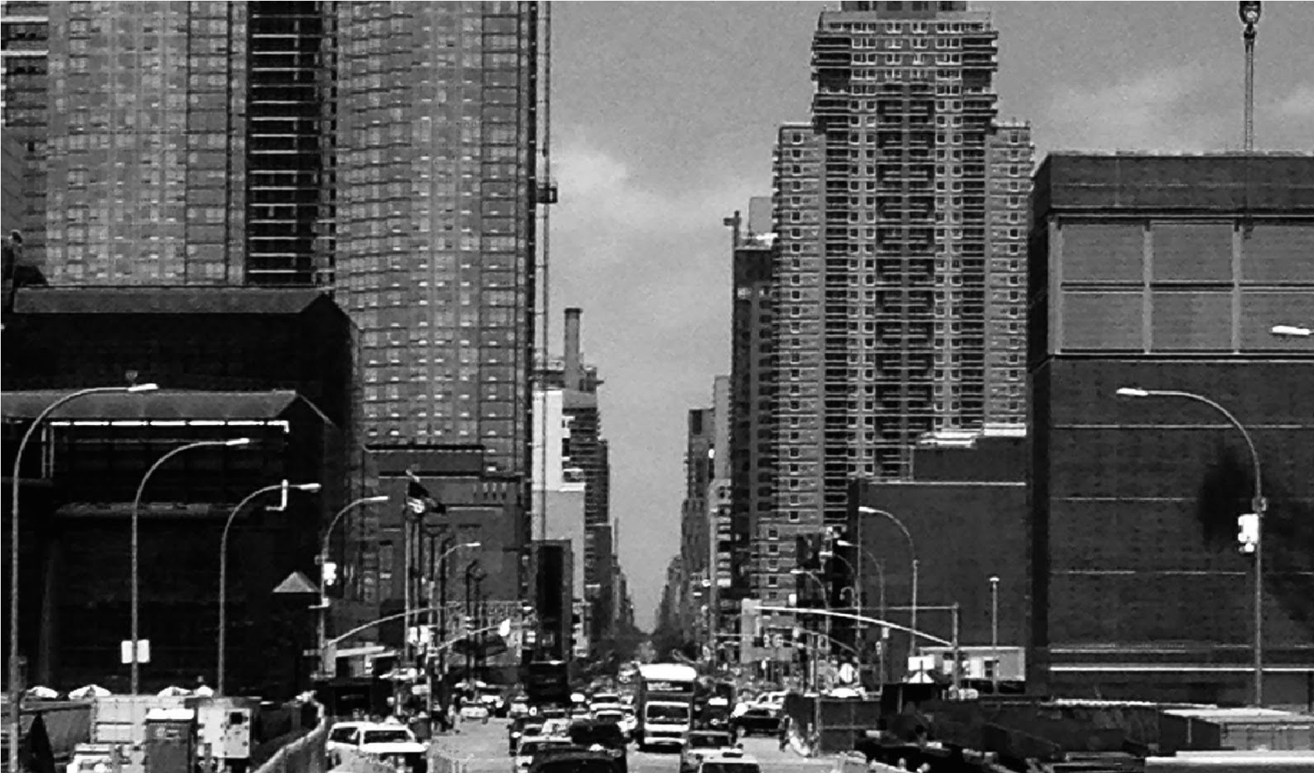
Add a caption to each image 1
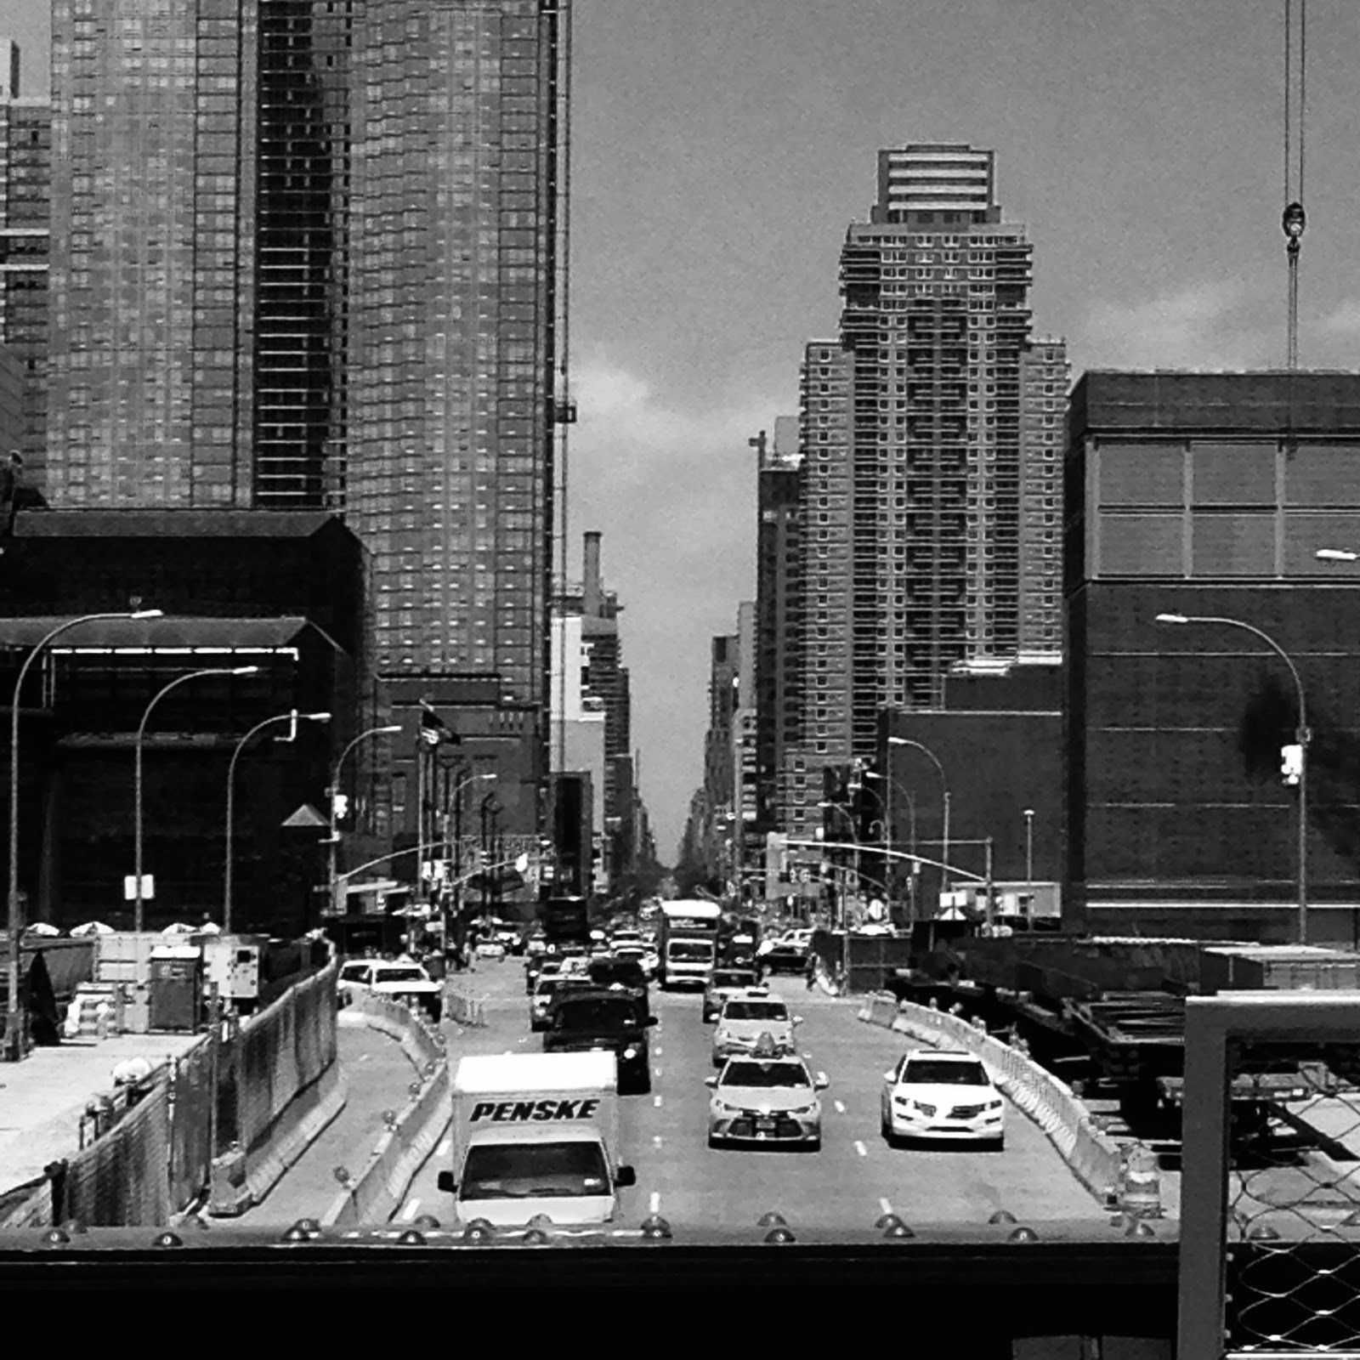
Add a caption to each image 2

SITE OBSERVATIONS: One or 2 general notes about the Brooklyn Collection, and 2-3 specific observations about how the primary sources you found are connected to the topic of your investigation
- Lorem ipsum dolor sit amet
- Consectetuer adipiscing elit
- Sed diam nonummy nibh euismod
- xxx
- xxx

QUANTITATIVE DATA: under “subject” list the topic; Under “data” describe your findings and the quantity found
Subject | Data
Lorem ipsum
Lorem ipsum
Lorem ipsum

QUESTIONS AND HYPOTHESIS Consider the primary sources found during your visit and review the material you included so far in this report.
QUESTIONS:
- Lorem ipsum dolor sit amet?
- Consectetuer adipiscing elit?
- Sed diam nonummy nibh euismod?
HYPOTHESIS: From the questions you wrote above, select the most important question for your own research topic. Propose an explanation made on the basis of the evidence you have so far as a starting point for further investigation.
- Lorem ipsum dolor sit amet
- Consectetuer adipiscing elit
- Sed diam nonummy nibh euismod
SUMMARY / POST VISIT REFLECTION / NEXT STEPS?
Lorem ipsum dolor sit amet, consectetuer adipiscing elit, sed diam nonummy nibh euismod tincidunt ut laoreet dolore magna aliquam erat volutpat. Ut wisi enim ad minim veniam, quis nostrud exerci tation ullamcorper suscipit lobortis nisl ut aliquip ex ea commodo consequat.
PRELIMINARY REFERENCES FOR PRIMARY SOURCES:
Record the essential information that you might use to create a citation for 3-4 primary sources you examined. Don’t worry about creating a perfect or conventionally formatted citation; record the information that someone would need to find it again. Include a variety of sources: photographs, maps, articles, manuscripts, etc.
- Photographer, Anonymous. “View from Brooklyn Warehouse.” Black and White Photographic Print, Brooklyn Collection, 1900. http://bklynlibrary.org/nnnn
- Magical Map Company. “Fire Insurance Map of Fulton Street, Brooklyn.” New York, NY:1887.
- Lee’s Café. “Lunch Menu.” Lee’s Café, 00 Sands Street, Brooklyn, NY: 1943.
- And so on.

