Learning Places Spring 2017

SITE REPORT #3
Art and Gentrification of DUMBO and Vinegar Hill
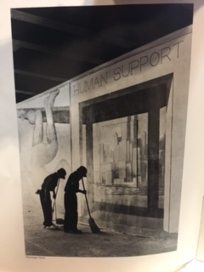
Aissa Sonko
03.22.2017 INTRODUCTION
Recently we have visited the New York Public Library in Brooklyn. We visited the archives to find some historical documents on art and gentrification in DUMBO and Vinegar Hill
OBJECTIVES
In class, we discussed how we would try to see whether the gentrification process was a negative or positive for the neighborhood. We explored how the neighboring residents might feel about the situation. Also, we tried to think how the art aspect contributes in the gentrification process and how the neighborhoods might look in a couple of years.
PRE-VISIT REFLECTION
Prior to my visit, I wasn’t sure what to expect. I’ve been to the public library a couple of times in the Bronx but I had never visited any archives and I was really eager to see what I would find.
SITE DOCUMENTATION: photos/sketches of 2 or 3 significant primary sources. Provide captions and explanations – why is the image shown significant for your topic of exploration?
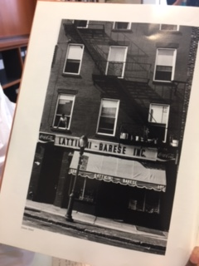
Store front that used to reside in Vinegar hill

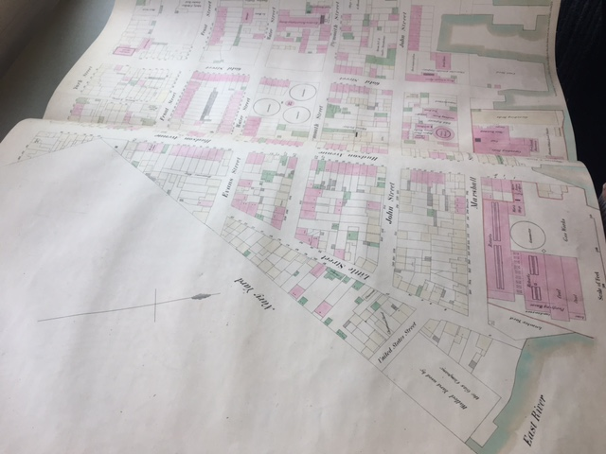
Atlas view of early DUMBO and Vinegar Hill
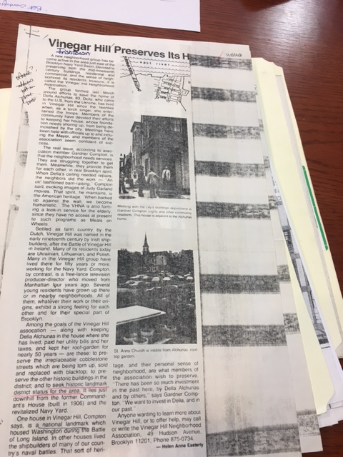
News paper article of Vinegar Hill and changes

SITE OBSERVATIONS:
- Most of the archives were old newspaper letters that helped with informing what was going on during the gentrification changes
- Many old images of how the neighborhoods used to look and how they were set up
- There was more visible art back then rather than now

QUANTITATIVE DATA:
Subject | Data
Atlas | 8
Store front images | 4
Mural painting | 1

QUESTIONS AND HYPOTHESIS Consider the primary sources found during your visit and review the material you included so far in this report.
QUESTIONS:
- Are the people of DUMBO and Vinegar hill really happy with the changes being made?
- Who will benefit from the changes and gentrification?
- Are the changes really helping the community and neighborhood or does it just benefit a hand full or people?
HYPOTHESIS: From the questions you wrote above, select the most important question for your own research topic. Propose an explanation made on the basis of the evidence you have so far as a starting point for further investigation.
- I don’t believe that any neighborhood is happy with changes that may result in losing the feel of home
- People who consider these neighborhoods home are being removed from their homes
- What would the long term effects of the gentrification of these neighborhoods would be and how would it affect the art aspect of the neighborhoods?
SUMMARY / POST VISIT REFLECTION / NEXT STEPS?
So far I have come up with data that leads me into the direction that gentrification is not really a beneficial aspect for the majority of the neighborhood. It only supports people who are able to afford which is not many and it doesn’t think of the struggling class.
PRELIMINARY REFERENCES FOR PRIMARY SOURCES:
- http://archives.nypl.org/search/results?utf8=%E2%9C%93&q=vinegar+hill
- https://digitalcollections.nypl.org/

