Learning Places Spring 2017

SITE REPORT #3
Visit to Brooklyn Public Library
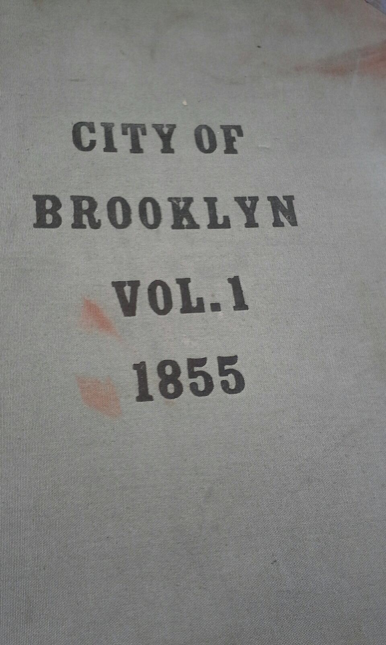
Stacey Battice
03 21 2017 INTRODUCTION
The Development and Preservation group sat as a team and were given documents and maps related to this topic by the library hostess. The Scope of the activity of this assignment was to explore any possible changes of vinegar hill as it appears today and to look closely at maps.
OBJECTIVES
To obtain a wider and more detailed view of maps related to Vinegar Hill about:
- Transportation maps
- Open lot maps
- Neighborhood maps
In search of related information in newspaper about Vinegar Hill with:
- Projects proposals
- Petitions
- Real Estates
- Developers
To obtain the latest Census for:
- Population of Brooklyn
- Population of Vinegar Hill
To find out the People of interest in Vinegar Hill
- Residents
- Developers
- Potential renter/home owners

PRE-VISIT REFLECTION
I had a positive interest in visiting the Brooklyn Public as a first timer. The volume of information in small place keep coming to mind with thoughts of, would our group find any information on Vinegar Hill? Coming from a British colony, St Kitts and Nevis in the Caribbean was wondering if I would have been lost in learning American History.

SITE DOCUMENTATION: PHOTOS

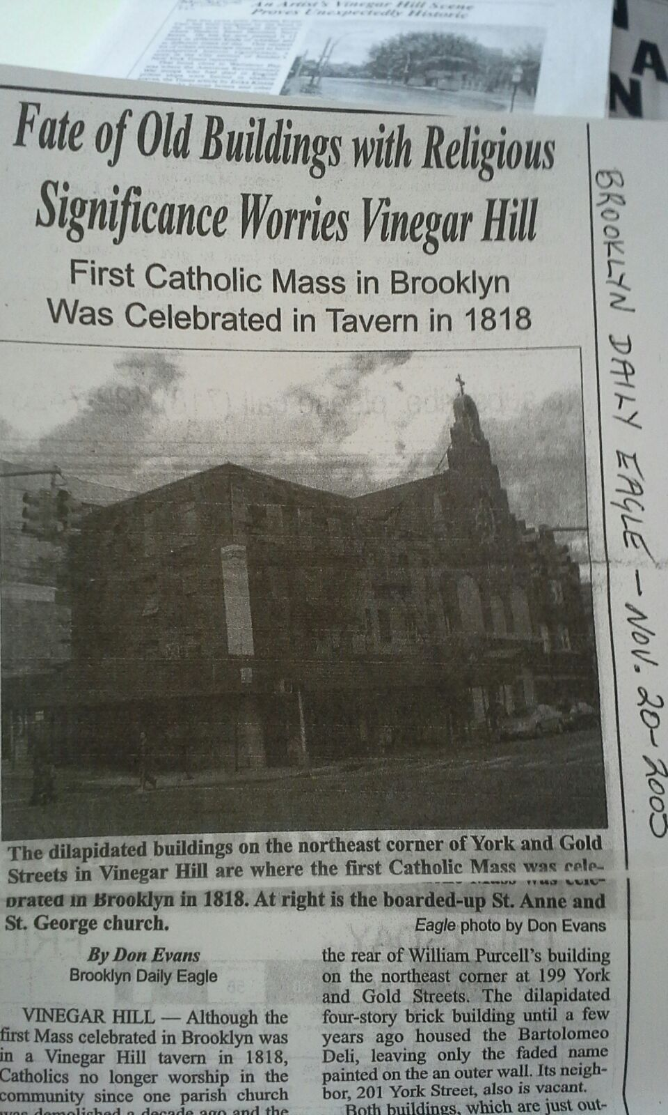
This was a Catholic Church in Vinegar in the 18th century, however this church has since then been demolished and no longer are Catholics worshippers in the Vinegar Hill area. This pictures indicate that with the demolition of these buildings that there are vacant lots.
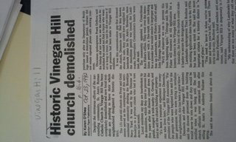

This factory is a landmark in Vinegar Hill on the corner of Bridge Street, It is located by the pink area on the map. The map is compliments of (Landmarks Preservation Commission, 2017).
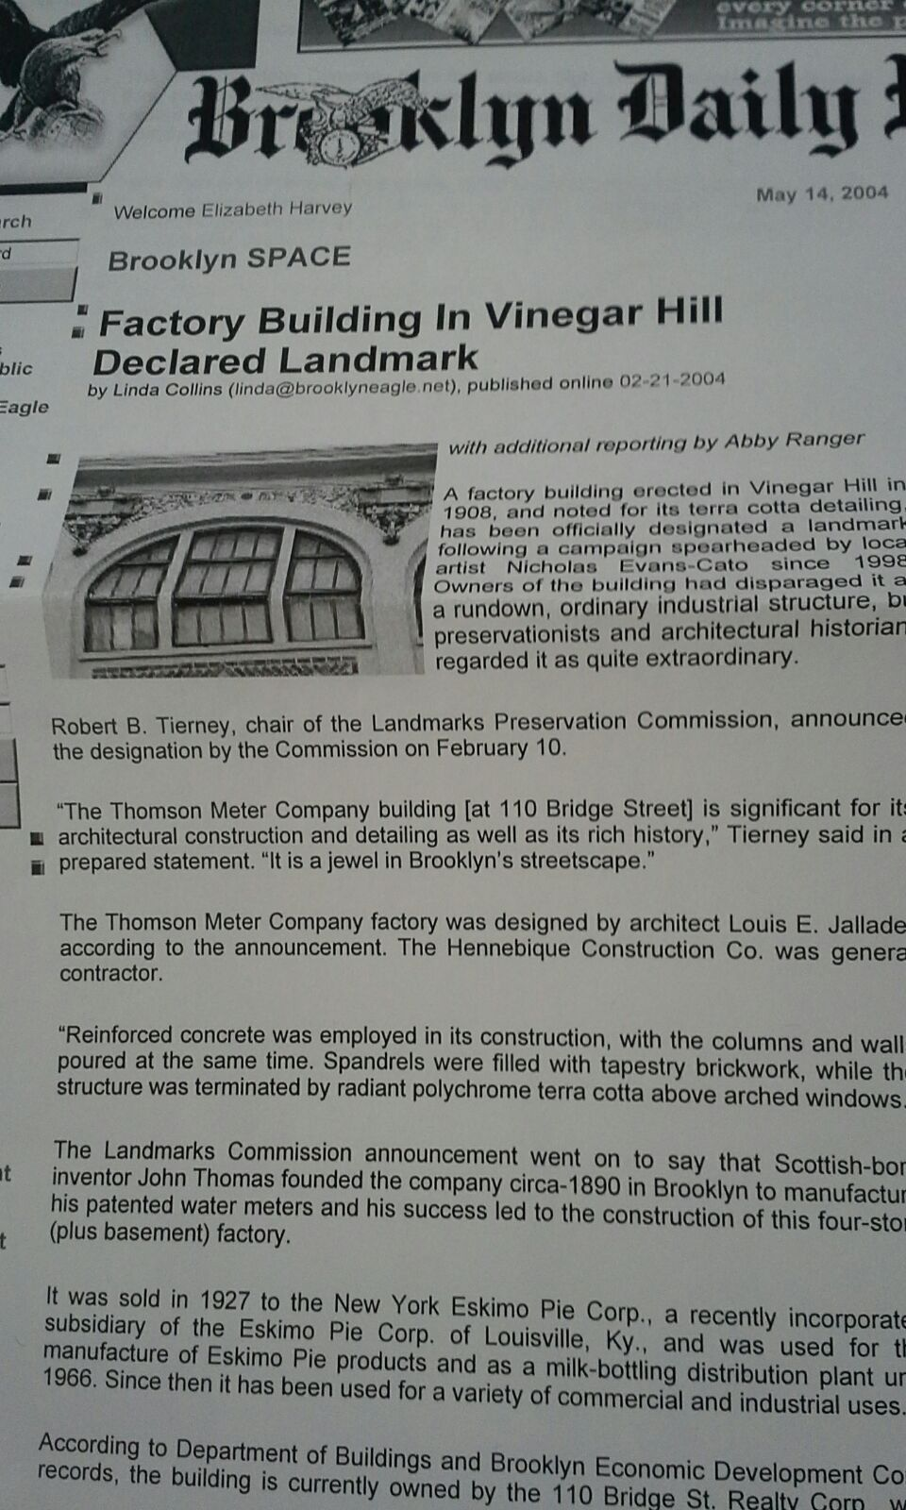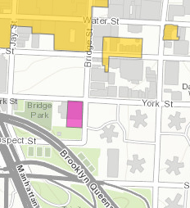
Hope is on its way for Vinegar Hill, there is hope for developers and real estate’s marketing
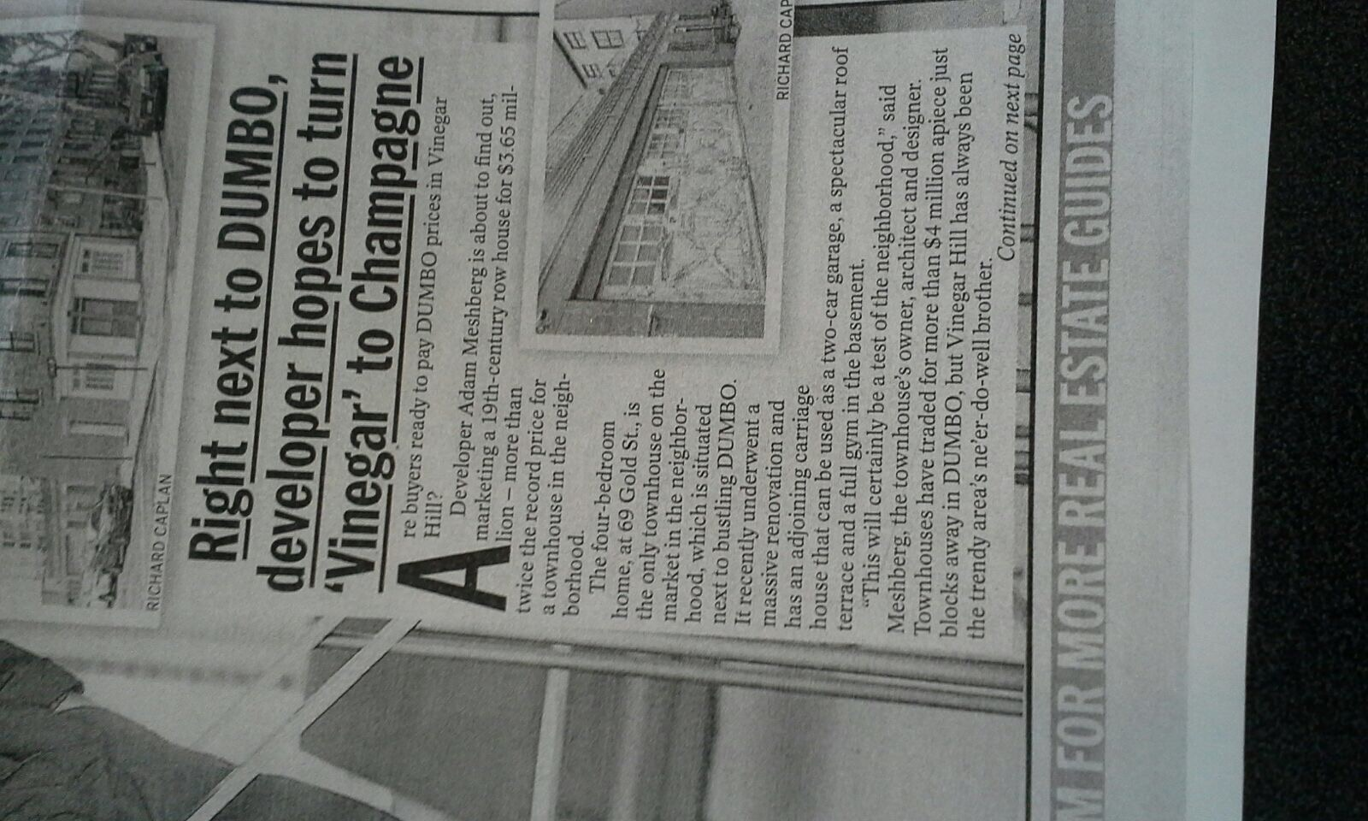

Renovation in the Vinegar Hill for potential homeowners/renters in the Vinegar Hill area at very high cost. There is definitely hope to see the Vinegar Hill area developed just like DUMBO.
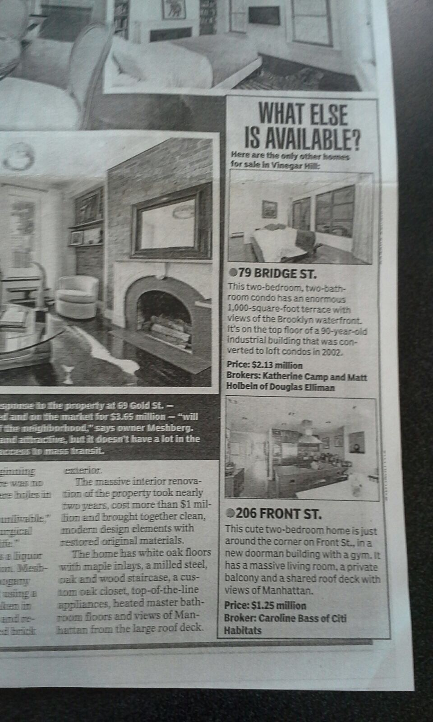

SITE OBSERVATIONS: The Brooklyn Collection has a large volume of information of Brooklyn and to an extent parts of Manhattan including the bridges. The room was very conducive to learning as we were not disturbed by any other visitors to the library. The newspapers and articles were nicely placed and labelled in folders which made it quite easy to follow. My team were able to used newspapers, articles and maps to better able understand our investigation into the development and preservation of Vinegar Hill.
- The Eagle Newspaper
- Fire Insurance Maps
- Digital source of the Brooklyn Public Library
- Maps
- Articles

QUANTITATIVE DATA:

Subject | Data
Folders consisting of newspapers and articles | 5
City of Brooklyn Volumes 1 | 1
Books | 2

QUESTIONS AND HYPOTHESIS
QUESTIONS:
- Is it possible to have Vinegar Hill more populated?
- How soon will development start in the Vinegar area?
- Is it possible to change Vinegar Hill’s housing structures?
HYPOTHESIS:
It is about the residents in Vinegar Hill who will determined whether the area become developed or remain the quiet town of Brooklyn.

SUMMARY / POST VISIT REFLECTION / NEXT STEPS?
This was an overwhelming site visit. The librarian was very clear and helpful in presenting us with the material about Vinegar Hill we needed on development and preservtion. Next step is to the New York Public Library to look at maps.
PRELIMINARY REFERENCES FOR PRIMARY SOURCES:
Landmarks Preservation Commission. (2017, March 21). Retrieved from Discover NYC Land Marks: http://www1.nyc.gov/site/lpc/index.page

