Learning Places Spring 2017
Colin Grant
SITE REPORT #3
Brooklyn Public Library Visit

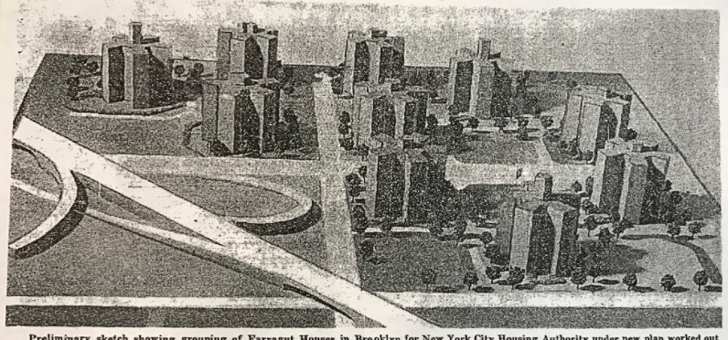

Brooklyn Public Library Brooklyn Collections
Farragut Houses
New York Times
1/19/94

Introduction
On Monday, March 13th our class got a chance to visit the Brooklyn Public Library and examined many newspaper articles, historical layouts and photographs that related to our topic of the Farragut Houses. My objective was to find articles relating to the crime and historical maps on the area before the complex was made.

Objectives
- Find 2 newspaper articles pertaining to crimes that have happened in Farragut Houses
- Find maps of the area before the building was constructed to see what was there before
- Gather information regarding the church of the open door in the complex.
- Learn about the overall design of the housing development and ideas behind it

Pre-Visit Reflection
I could not wait to see the maps and documentation about what buildings were there before the creation of this project. I also learned that crime is also very common in the area, so for me to be able to find some articles about this would be helpful. I also wanted to know how this may have played a role of the overall background of the community and how certain residents felt at the time.

Site Documentation

This picture shows the New York City Housing Authority design of Farragut Houses. It took over five blocks at the time and incorporated the idea of “using asterisk-type towers, which floated randomly in a sea of green space.” This design was incorporated by Fellheimer, Wagner, and Vollmer who help bring the projects to completion in 1952.

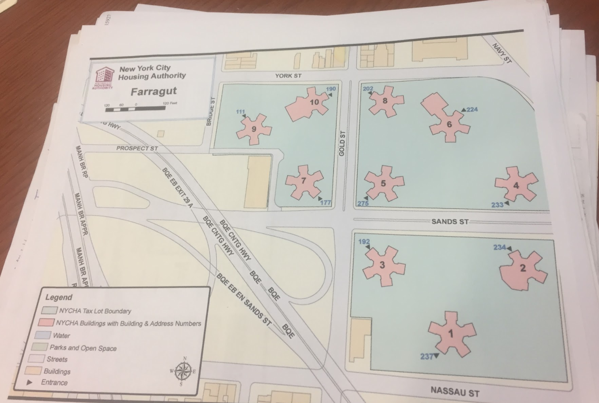

New York City Housing Authority
Layout Sheet (Brooklyn Collections)
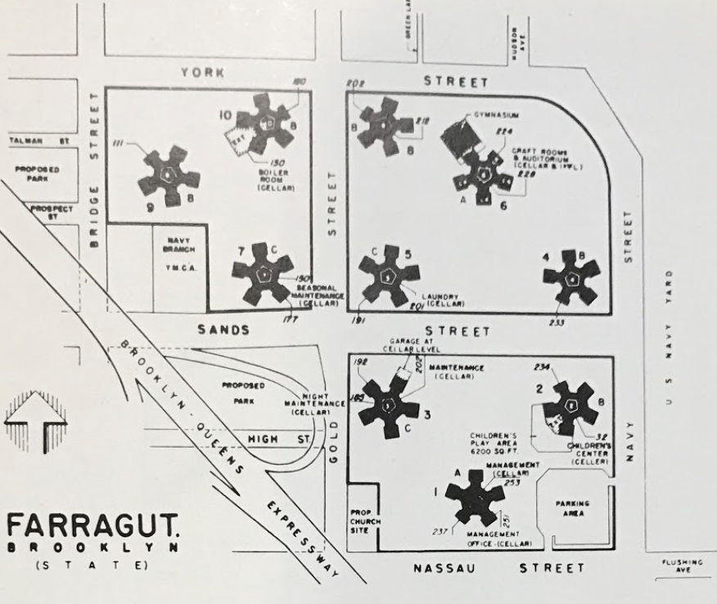
Fellheimer, Wagner, and Vollmer
Concept Design of Farragut

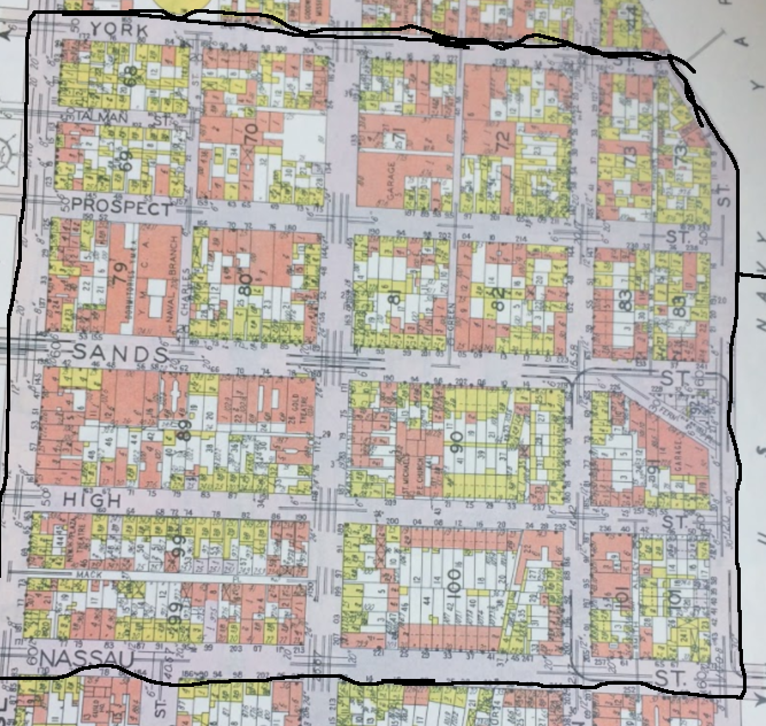

Brooklyn Collections
City of Brooklyn Volume 2
(1855)

People were surprised with the idea that the complex was being built this way and with the addition of the Brooklyn Queens Expressway, the location of the complex was also a divide of the community. The location gave access for many people that were working near the complex at The Brooklyn Navy Yard, but as years went by, many residents were threatened by the sudden realization that crime and corruption would peruse in the future.
Crime was very present in the area at the time and continues to be a popular trend that seems to follow the complexes history. This has put a bad reputation upon Vinegar Hill and continues to produce the same outcome every so often. This was many of the articles found on our trip but I chose one that was most recent. There are more serious offences such as the one presented in the photo below as recent as 1994 as explained in the Daily News.

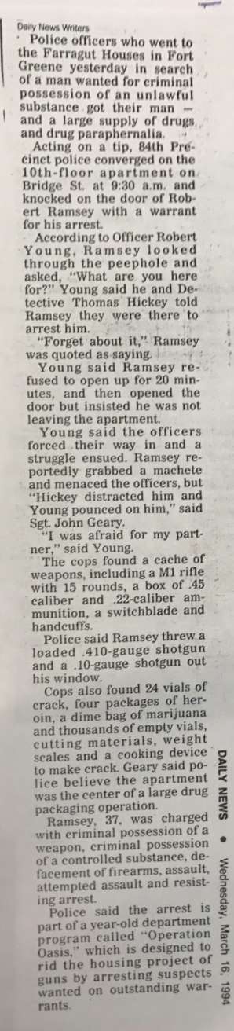
Daily News Article
March 16, 1994

Many of the residents felt like most of the leaders of Vinegar Hill did not do the proper measures to take care of certain area remodels which would have enhanced the overall look of the area. Here was an article describing an idea of a new supermarket in the area that never really went into effect due to “post-Sandy insurance premiums.

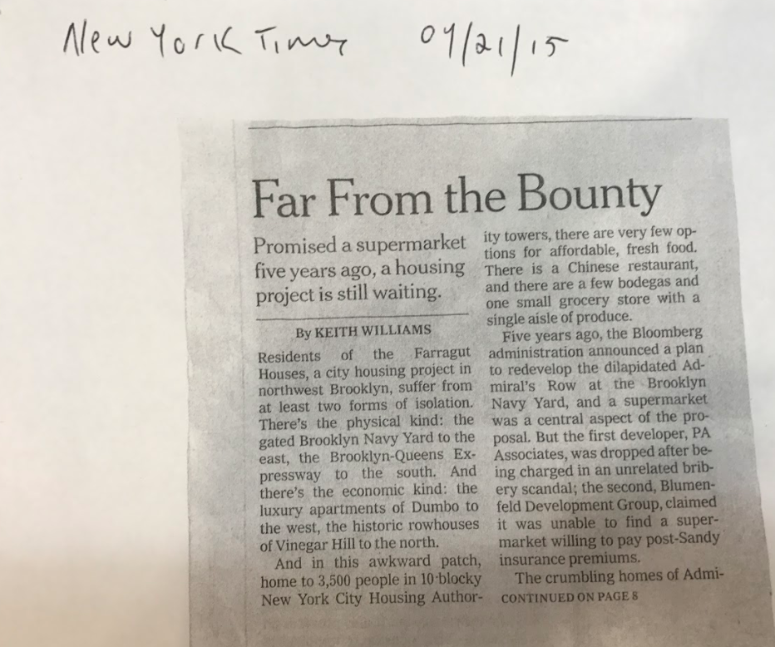

Sadly, residents know where they stand when it comes to changes in the area, either they don’t get what is needed or are forced to deal with changes they don’t even know about like the addition to the parking lot for The Church of the Open Door.

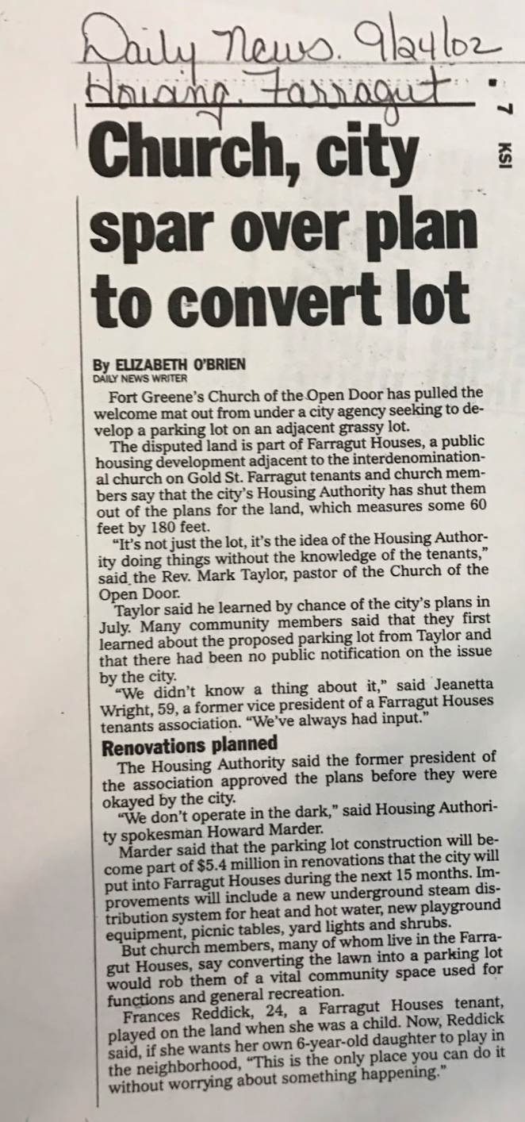

Site Observations

- Learned more about the earlier developments in the area before the complex such as brick and wooden frame buildings and businesses.
- Mostly Crime articles happening in the housing area.
- Not many articles pertaining to the creation of the complex or NYCHA documentation

Quantitative Data

Subject | Data
Newspaper Articles | 10
Maps | 3
Construction Photos | 1

Questions/Hypothesis

Questions
- Do many residents feel safe living in or near the complex with the criminal history that envelops the area?
- Does the design and placement of Farragut Houses play a role in the overall community, with the distancing of buildings and the wall?
- Do residents feel like they have a say of what goes on in the community?

Hypothesis
- I highly doubt that residents feel safe around the area due to the continuous crime. But for many people, this is their only option of living so it’s something they may have to deal with for a long time.
- I feel like the community’s buildings being placed so far apart shows the divide in the area. The closer the people are, the more action you will see in the community. But many of Farragut’s residents are not seen coming together to defeat any of the problems in the complex.
- I do not feel like residents have a say of what goes on in the community. With the building of the parking lot of their church, not many residents knew what was going to happen. And when residents don’t have say, that’s when the community will suffer due to lack of informing. Many people would not feel like trying to save a neighborhood that doesn’t listen to them.

Summary/Post Visit Reflection/Next Steps

The visit to the Brooklyn Public Library presented some useful information on the history of Farragut Houses and the surrounding area of Vinegar Hill. It showed that crime has flooded the media to create a false reality surrounding around the housing complex’s rich history. Our group was able to grasp a better understanding of how the creation of project units only leads to bad results. The next step would be to see how this plays a role in the community and how residents feel like the future of Farragut Houses will be. This cannot continue to be the life that Farragut is destined to live. With few renovation options and a rising crime rate, we now know where the crimes stem from, but now we need to know how change this to better benefit the lives of future and existing residents.

Preliminary References

1. Ryley, Sarah, Rocco Parascandola, Barry Paddock, and Greg B. Smith. "NYCHA residents live in fear as major crime in public housing soars." NY Daily News. N.p., 06 Apr. 2014. Web. 27 Mar. 2017.

- Chin, Heather. "Man Shoots 15-Year-Old In Both Legs Outside Farragut Houses And Brooklyn Navy Yard." BKLYNER. Heather Chin, 04 Apr. 2016. Web. 27 Mar. 2017. <http://bklyner.com/man-shoots-15-year-old-outside-farragut-houses-brooklyn-navy-yard-fortgreene/>.

- Leon, Alexandra. "WATCH: Documentary Aims to Give a Voice to 'Forgotten' Farragut Houses." DNAinfo New York. N.p., 07 Feb. 2017. Web. 27 Mar. 2017. <https://www.dnainfo.com/new-york/20170207/vinegar-hill/forgotten-farragut-houses-documentary-gentrification>.

