Learning Places Spring 2017

SITE REPORT 2

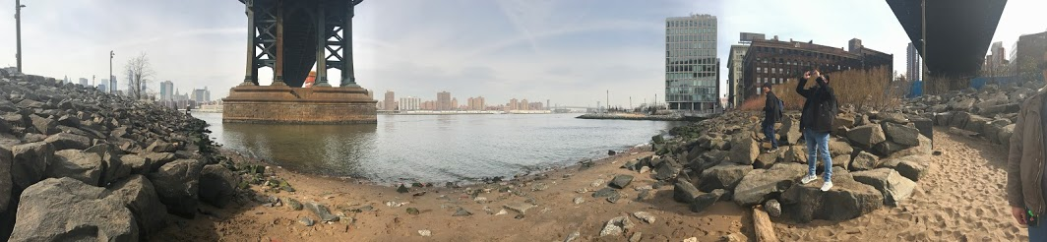

Jeferson Castro
03.05.2017 INTRODUCTION
This site visits purpose was to get into our newly assigned groups and scout the area out with our group members. My group and I walked along Dumbo’s waterfront to see if we could find anything that would help us understand a bit more of the areas history.
PRE-VISIT REFLECTION
Prior to site visit, I wasn’t expecting to spend most of the visit in Dumbo. I was expecting to visiting vinegar hill again trying to see different areas of the neighborhood. However It was an interesting experience getting the input from three other classmates on what they thought of the visit.

SITE DOCUMENTATION I: MAP OF AREA OF INVESTIGATION
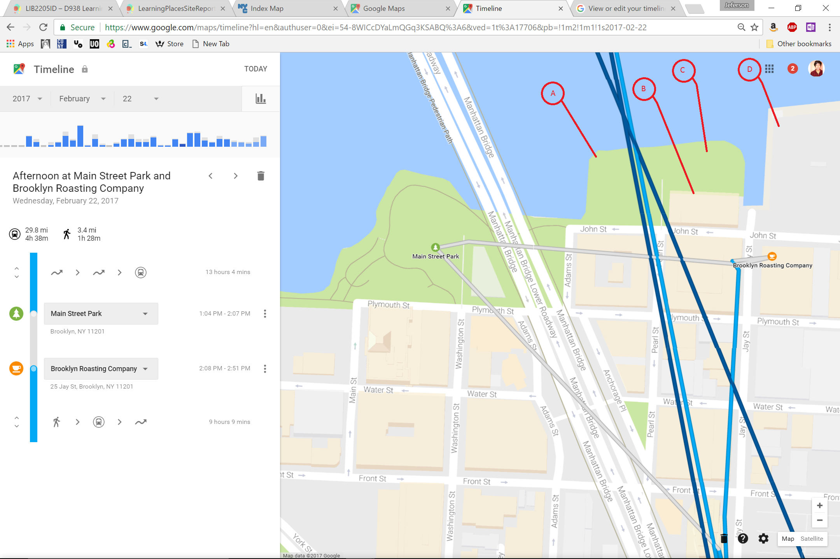
Leader A: Here we found one of the few signs that contain information about the waterfront and how the community is giving back to its community.
Leader B: Here you can see construction on the side of a building, you can tell that the building is pretty old since the steel bars look rusty.
Leader C: Here you can find another sign that gives you information about some of the history of the waterfront about what the docks were used for.
Leader D: Located here we have the Con-ED power plant which stretches all the way to vinegar hill. You can also see that there are old copper hooks that were once used to dock boats.

SITE DOCUMENTATION II:

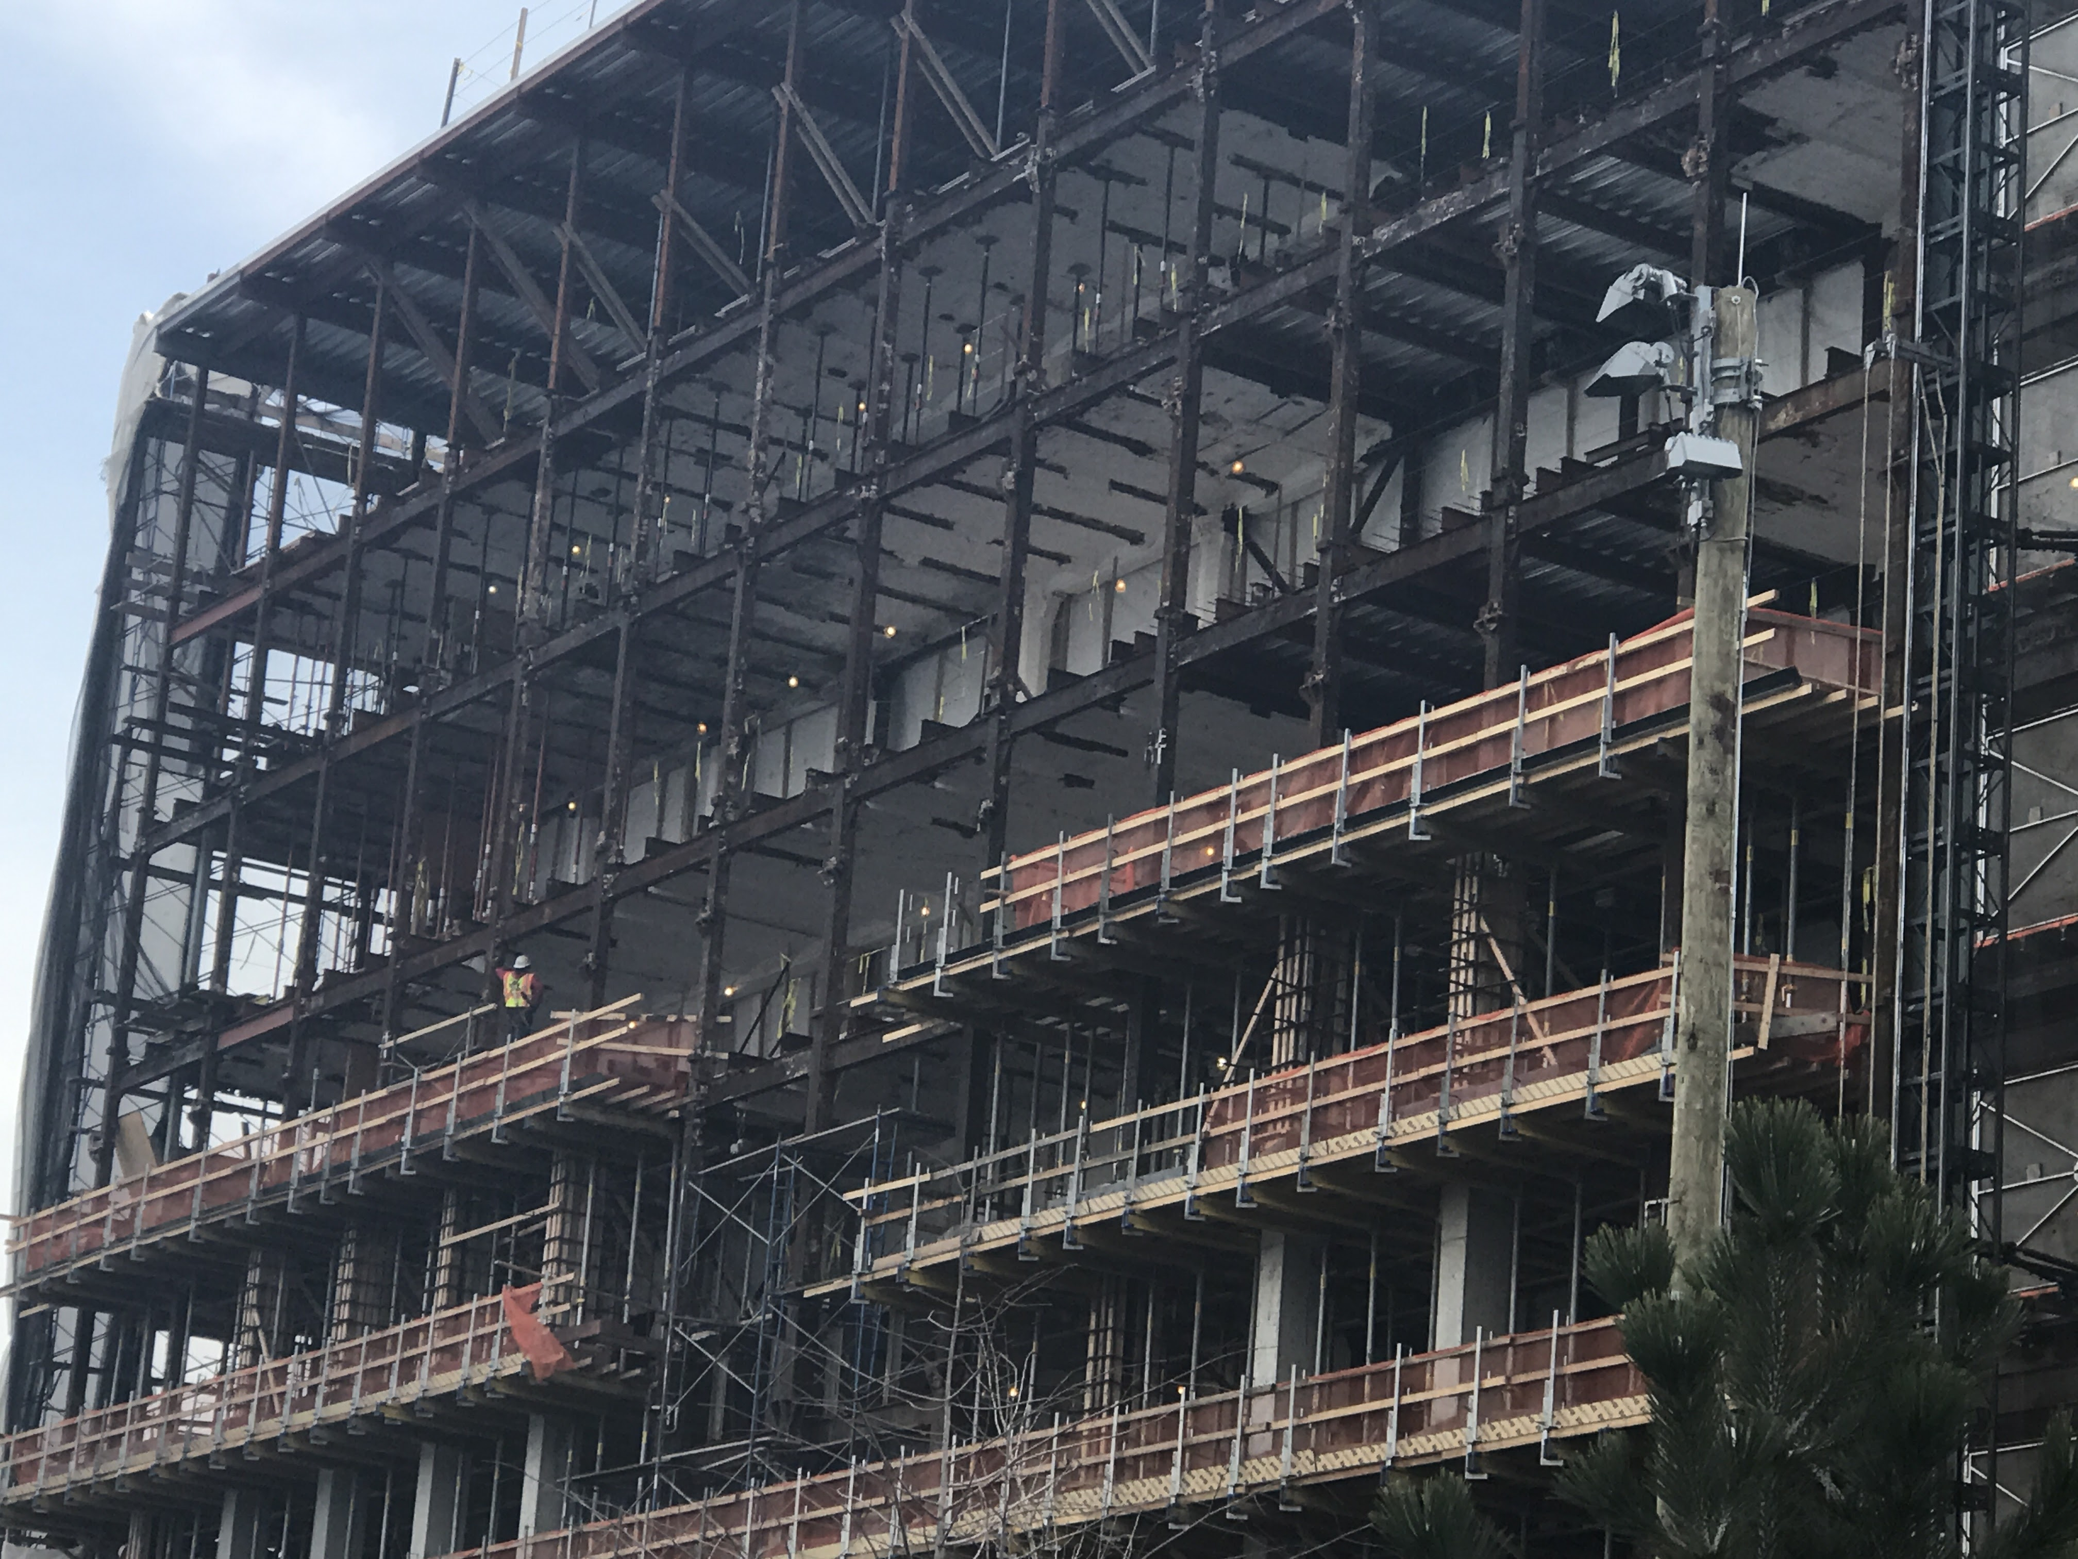
Figure 1 This is the construction site that was mentioned in Leader B, One thing I noticed is that DUMBO has a lot more movement and construction done on its side rather than Vinegar Hill.

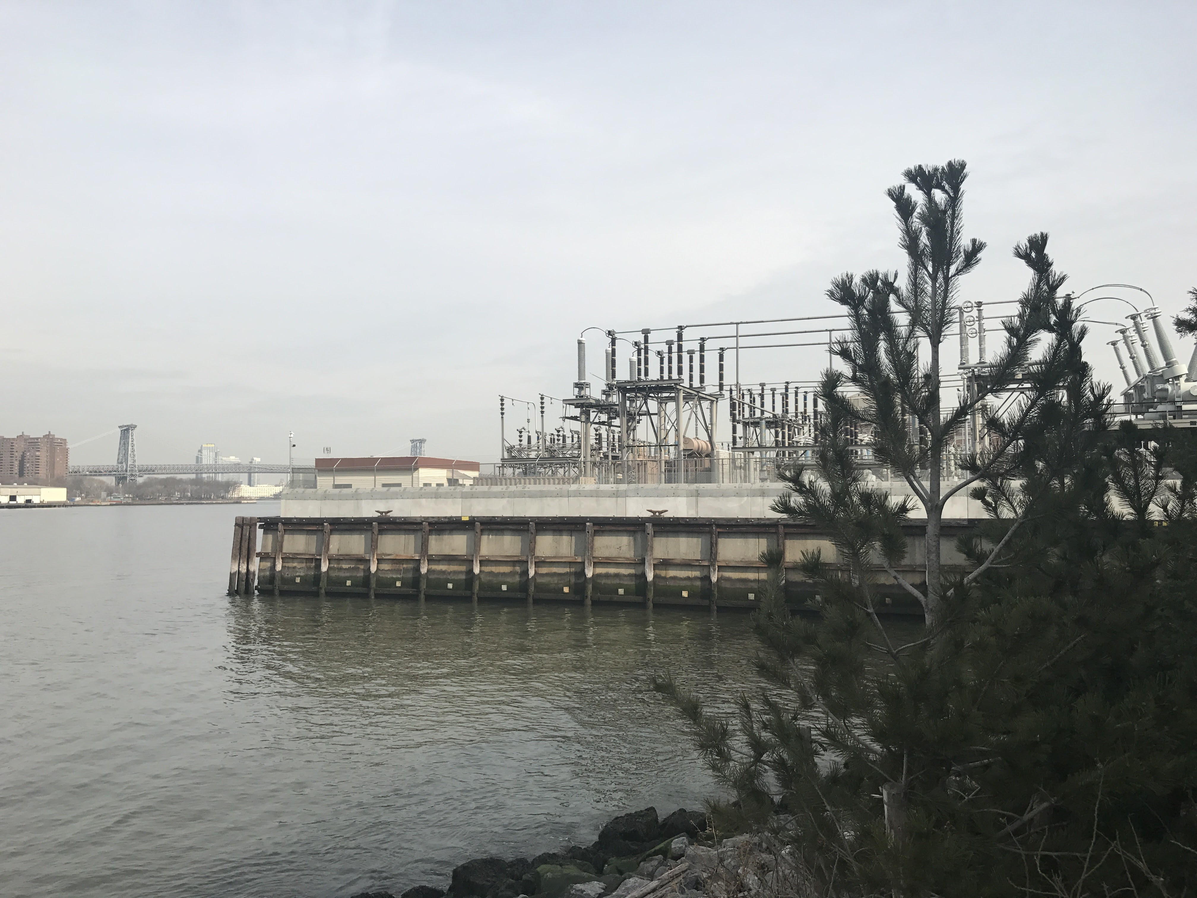
Figure 2 Here is where the Con-ED power plant is now located. It stretches along the water front towards the navy yard. You can see that there are some hooks that boats used to keep their boats docked at the piers.

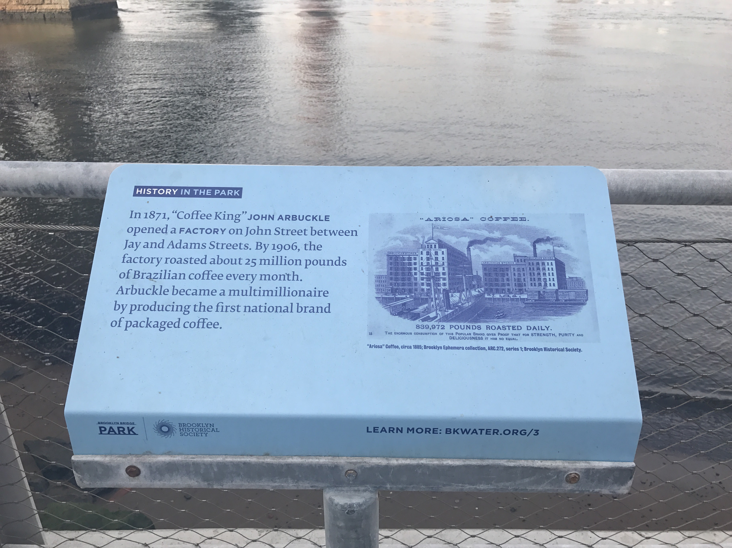
Figure 3 These are one of the many signs that are posted along the waterfront that contain a piece of information about the history, surrounding, and the impact that the community has on the area. These signs are provided by BKWATER.org

SITE OBSERVATIONS:
- Dumbo is a lot more lively than Vinegar hill, there are more people on that side
- Both neighborhoods are well kept, the streets are clean and there isn’t much garbage found on the streets
- The scenery from Dumbo is a lot better than the one Vinegar had to offer even if the power plant were there

QUANTITATIVE DATA:
Subject | Data
Beaches | At Dumbo there were two beach like areas, one containing sand and the other rocks. Both beaches had people taking pictures of the scenery but the rock beach had more people since it had seating stones and benches.
Brooklyn Water Signs | Along Dumbo, as well as Brooklyn Bridge Park, you’ll find a good amount of Brooklyn Water signs which provides information on the location your in.
Tourists | This area had many people compared to vinegar hill, but it didn’t seem like they were residents rather they were tourists. Most of the people were seen taking pictures or going to the nearby attractions.

QUESTIONS AND HYPOTHESIS Consider the data found during your site visit and review the material you included so far in this report.
QUESTIONS:
- Why isn’t there work or renovations being done at Vinegar Hill rather than Dumbo?
- If Vinegar Hill were to have a park similar to Dumbo where the power plant is, would it be well kept like dumbo?
HYPOTHESIS: From the question you wrote above - select the most important question for your own research. Propose an explanation made on the basis of the limited evidence you have so far as a starting point for further investigation
- I believe that the renovations and such rely on the residents on the area of Vinegar Hill.
- Neighborhoods aren’t responsible for keeping their parks clean always, there may be some people that volunteer to clean but normally there are people who work for nyc parks.
SUMMARY / POST VISIT REFLECTION / NEXT STEP? --
Now that I’ve had the chance to explore the other side of the waterfront, I want to look back into the history of both places. I would like to explore the differences of these neighborhoods and to see what really differentiates one from the other.

