Learning Places Spring 2017
SITE REPORT I
Vinegar Hill
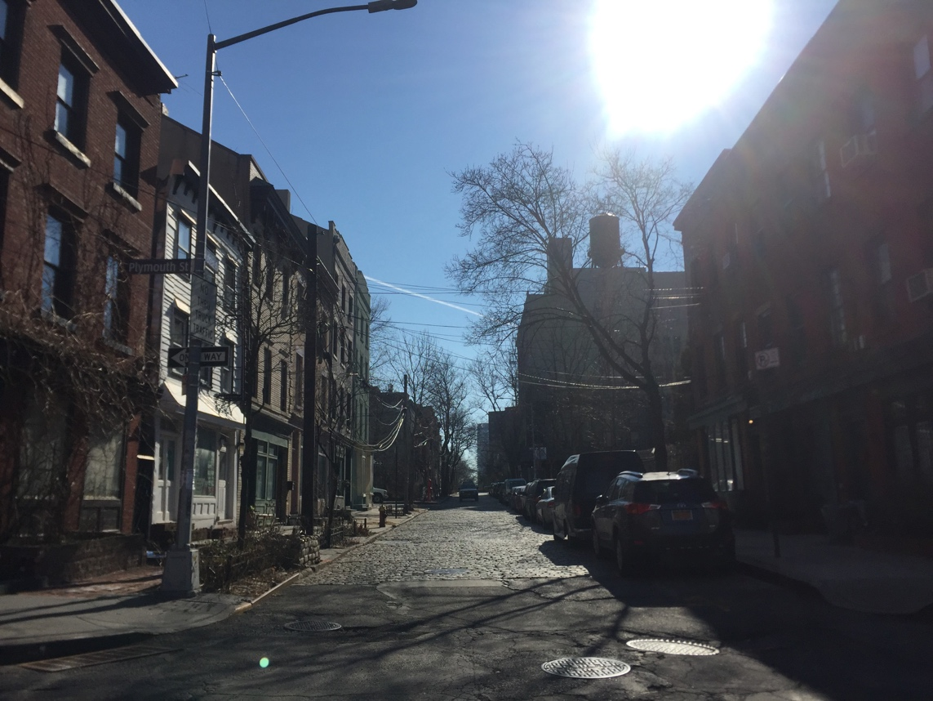

Orlando J. Ramos
02.13.2017

INTRODUCTION
Our first trip of the semester was one that I was excited about. Not really having any expectations of what it consists of and still trying to figure out what exactly this class is about, I was just grateful for being out of the classroom. Who would’ve known that this lone trip was going to be an awesome glimpse of what is to come. A look at the past, and how we got to what we called the present. Questioning and exploring what is around us. Hypothesis, fact checking, opinions and reflections. Learning about places is exactly what we’re doing.

PRE-VISIT REFLECTION
Having talked about the location beforehand in class I knew we were going to a few places in the neighborhood including some public housing. My thought process was that we were going to focus on the architecture of the buildings and the streets and why everything is built in the way it is. Sketching was expected and something I was looking forward to.

SITE DOCUMENTATION (photos/sketches)

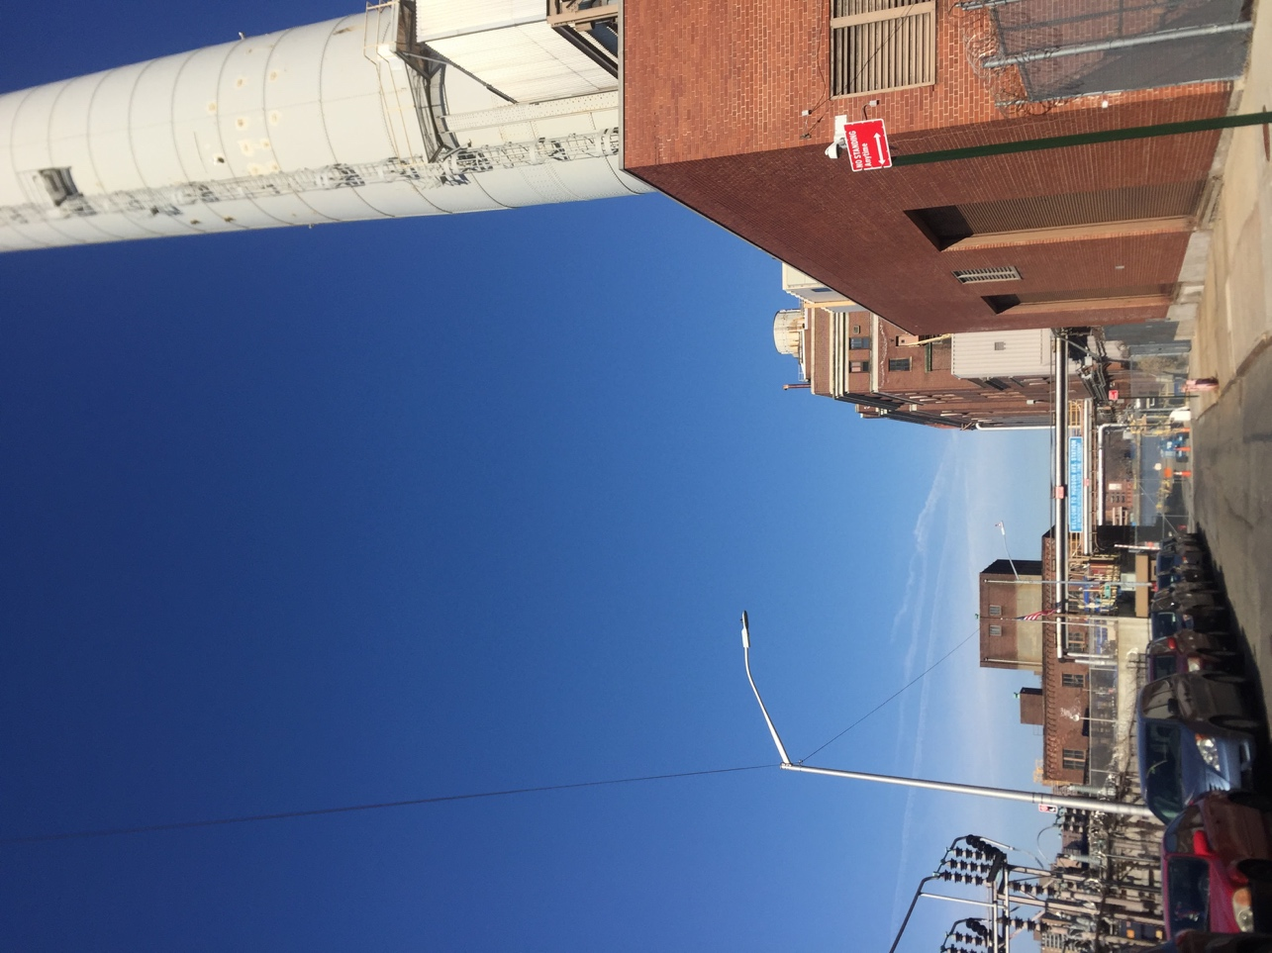

Power plant by the water, in the midst of the community.

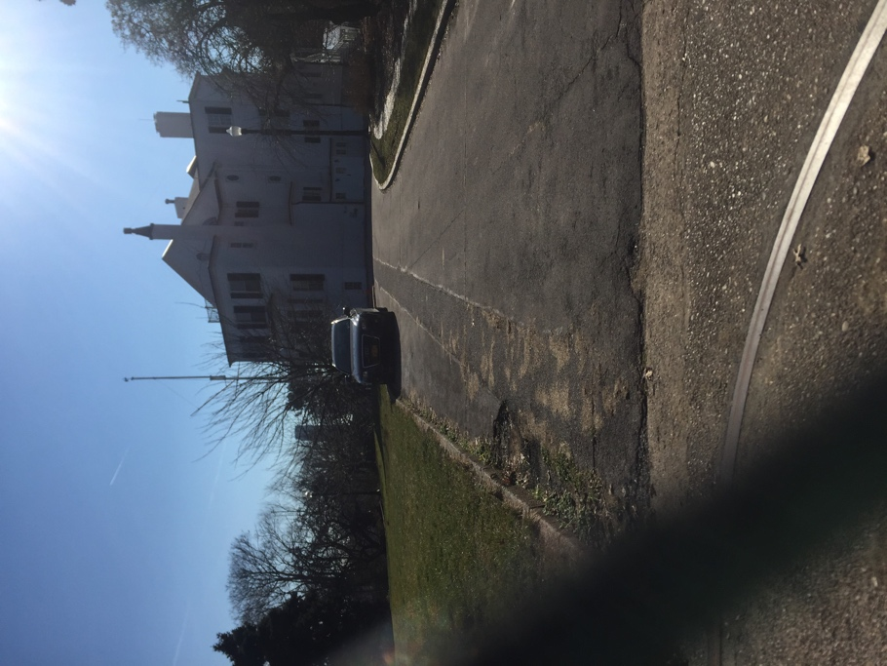

Vinegar Hill House

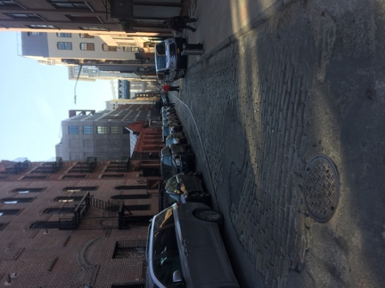
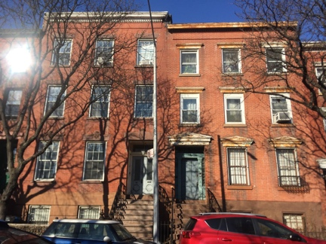
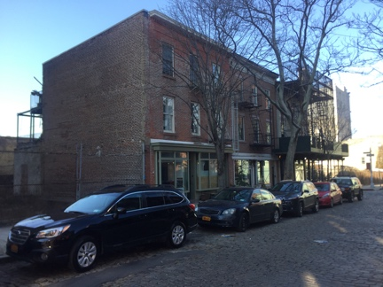

- Building with old Greek façade and storefronts
- Building with no storefront.
- Bricks in the street along where the track used to be.

OBSERVATIONS
- The contrast between the old and the new.
- The brick streets.
- The secluded housing.
- Not many businesses.
- No sense of community
- A power plant in the midst of it.
- The navy yard is like the backyard.

QUANTITATIVE DATA
Subject | Data
Public Housing | 10 buildings
Food shops | 4
Community Garden | 1

QUESTIONS AND HYPOTHESIS
QUESTIONS:
- Why is there no longer a sense of community?
- Why did the businesses close/ why aren’t there any?
- Why doesn’t the city invest more on its surroundings?
HYPOTHESIS:
- I assume the constructions that have occurred, like the highway, has taken away a lot of the connection that used to exist.
- The businesses lost lot of customers once the community was interrupted due to the constant construction.
- I think they don’t feel the investment might be a difference or worth investing.

SUMMARY / POST VISIT REFLECTION
Vinegar Hill made me curious of its past, its history, its politics and community. I enjoyed in being able to learn about this small neighborhood in Brooklyn, which has, although not very well known, a rich history of a small community in the Old New York City. It made me glad to have explored and envision the past as I was walking. The people walking, the trains passing by, and the how the businesses were everywhere. Definitely made question a lot more of why the things around us are placed exactly there.

REFERENCES TO EXPLORE HYPOTHESIS

